Practical# 3

# Exploring Data and Advanced Visualizations of Data

### Question: 1

Write python code that

1. Loads the seeds dataset into a dataframe.
2. Creates a slice of your dataframe that only includes the **area** and **perimeter** features
3. Creates another slice that only includes the **groove** and **asymmetry** features
4. Creates a histogram for the 'area and perimeter' slice, and another histogram for the 'groove and asymmetry' slice. Set the optional display parameter: **alpha**=0.75

Answer:

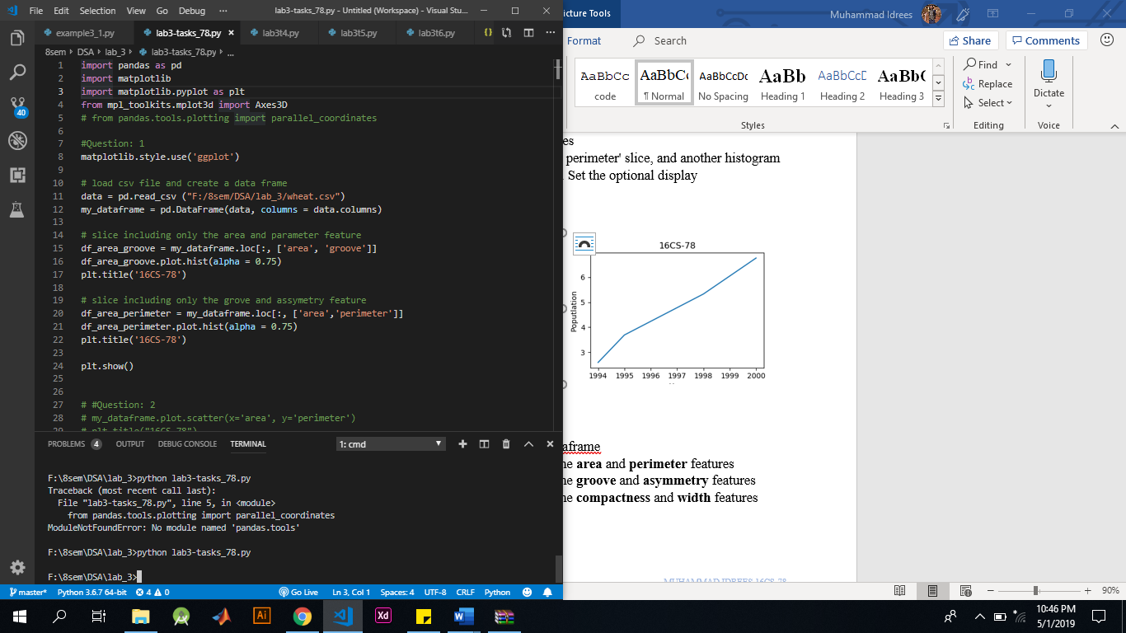

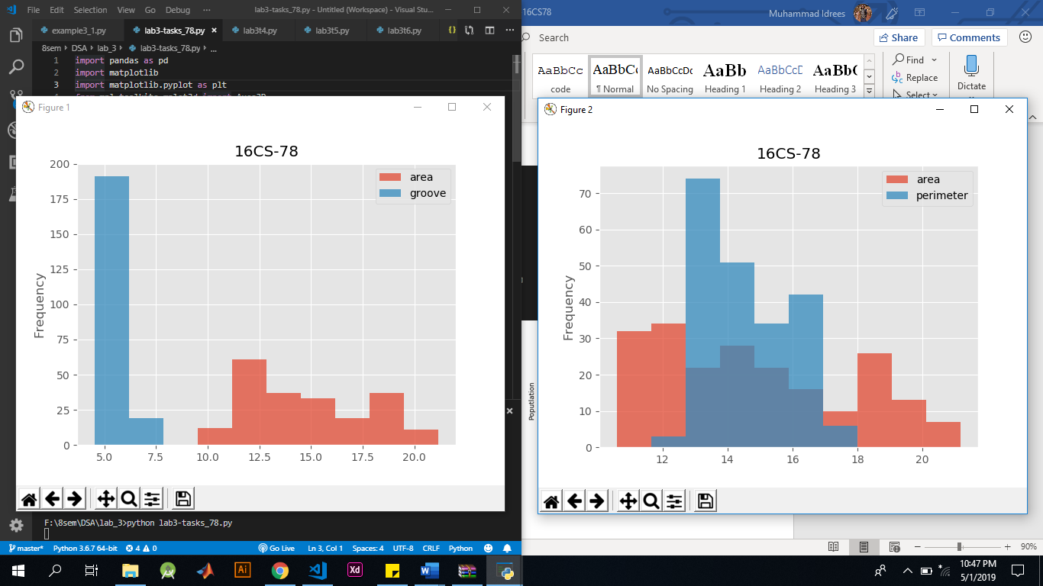 

### Question: 2

Write python code that

1. Loads up the seeds dataset into a dataframe
2. Create a 2d scatter plot that graphs the **area** and **perimeter** features
3. Create a 2d scatter plot that graphs the **groove** and **asymmetry** features
4. Create a 2d scatter plot that graphs the **compactness** and **width** features

Answer:

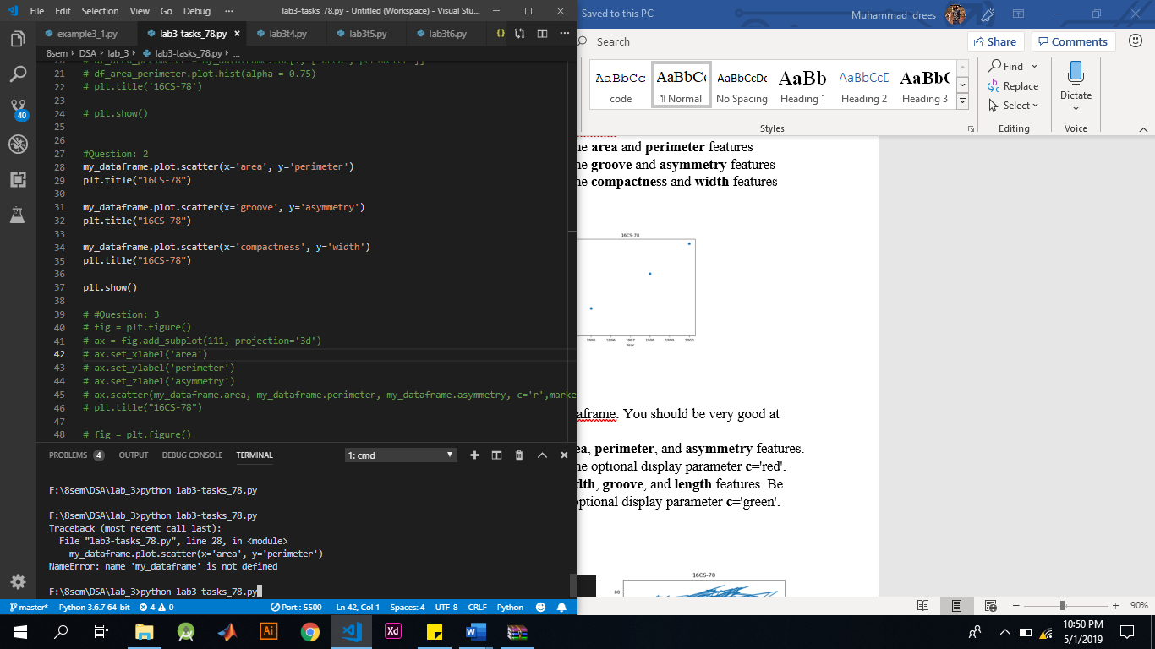

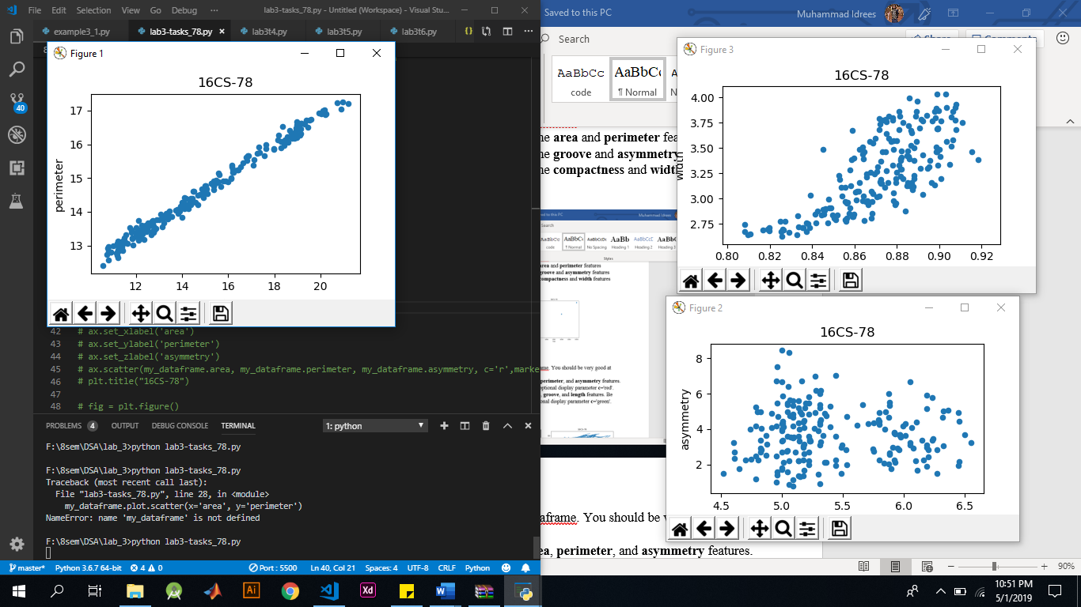  

### Question: 3

Write python code that

1. Loads up the seeds dataset into a dataframe. You should be very good at doing this by now.
2. Graph a 3D scatter plot using the **area**, **perimeter**, and **asymmetry** features. Be sure to label your axes, and use the optional display parameter **c**='red'.
3. Graph a 3D scatter plot using the **width**, **groove**, and **length** features. Be sure to label your axes, and use the optional display parameter **c**='green'.

Answer:

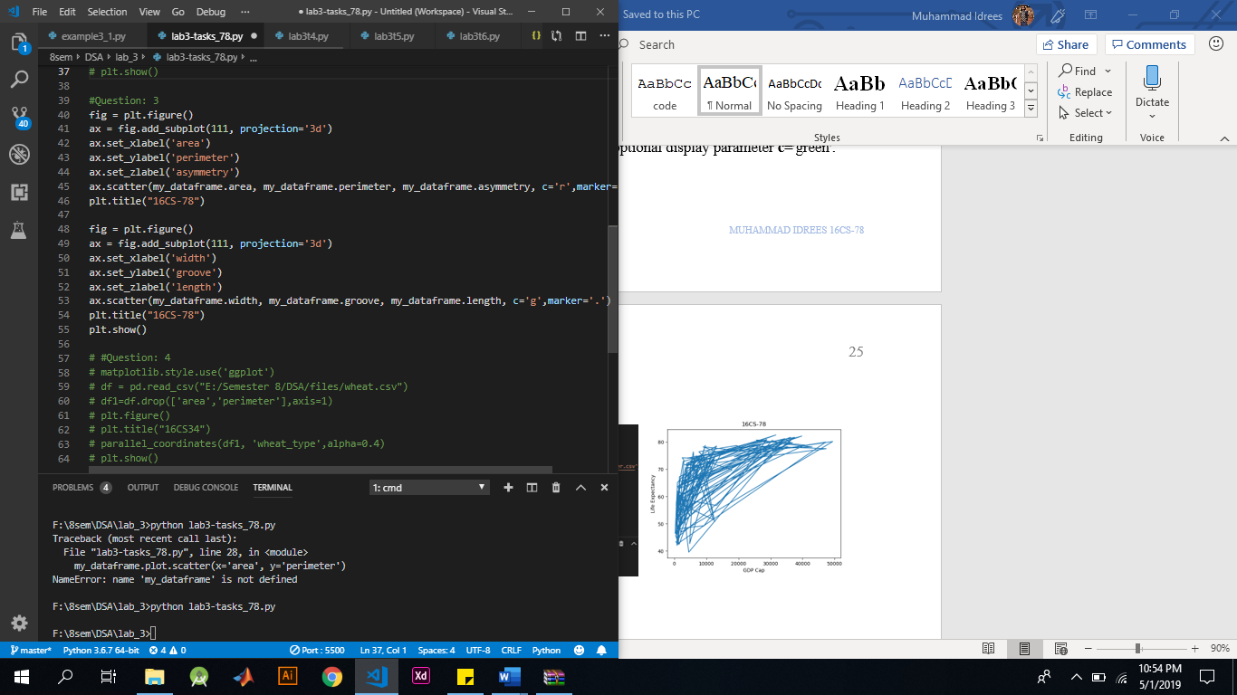

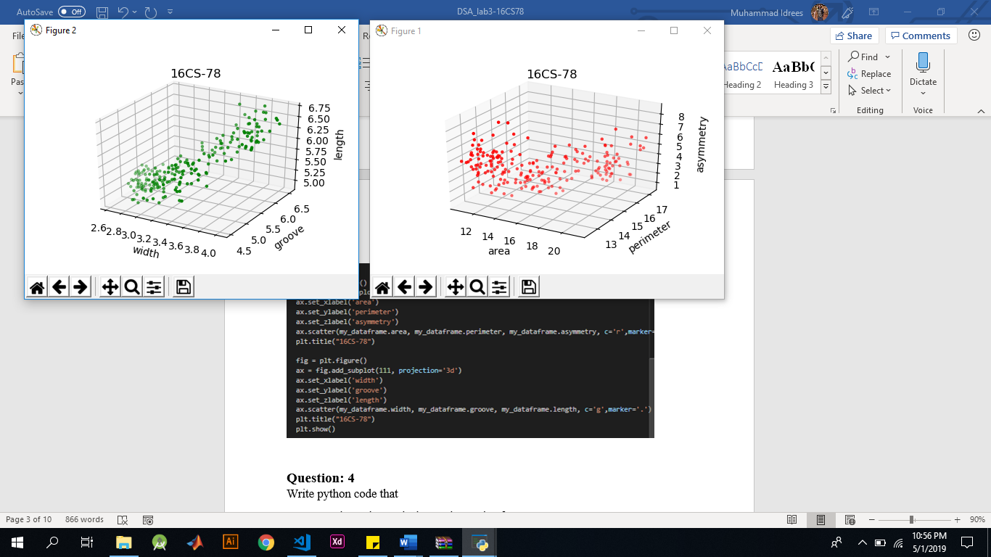 

### Question: 4

Write python code that

1. Loads up the seeds dataset into a dataframe
2. Drop the **area**, and **perimeter** features from your dataset. Use .drop method on data frame to drop specified columns
3. Plot a parallel coordinates chart, grouped by the **wheat_type** feature. Be sure to set the optional display parameter **alpha** to 0.4

Answer:

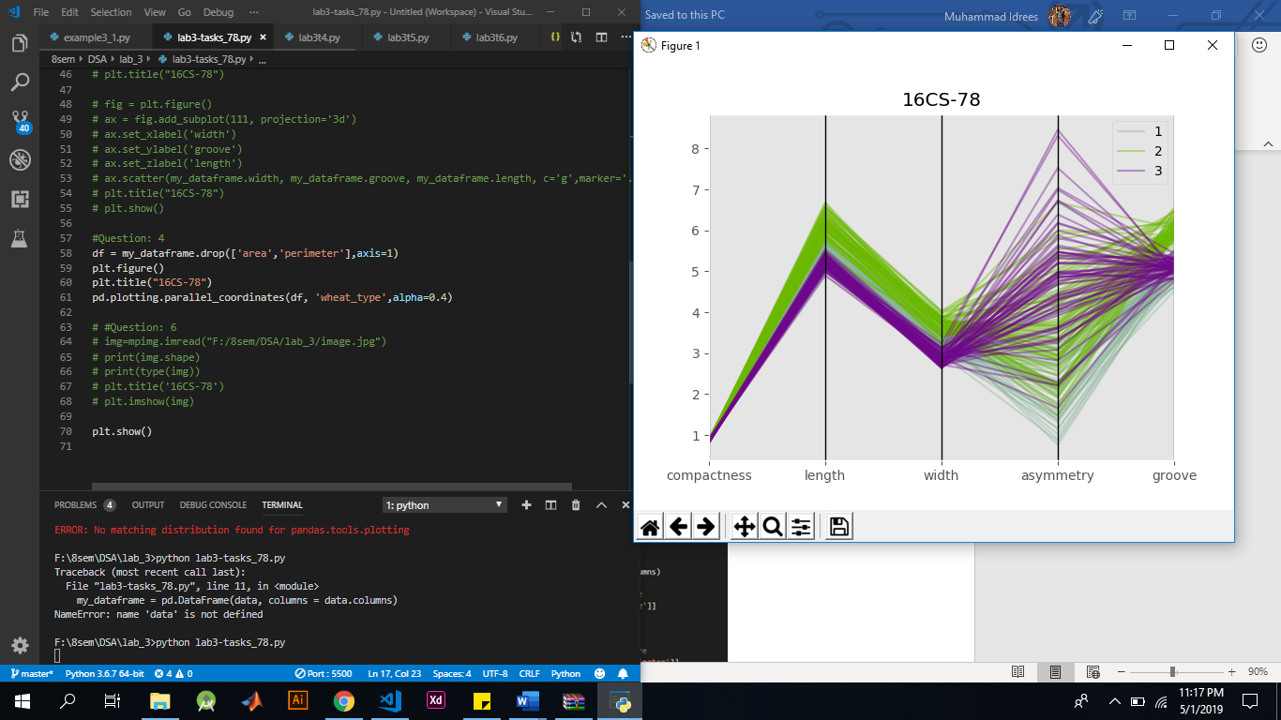 

### Question: 5

Write python code that

1. Loads up the seeds dataset into a dataframe
2. Plot anandrew’s curve chart, grouped by the **wheat_type** feature. Be sure to set the optional display parameter **alpha** to 0.4

Answer:

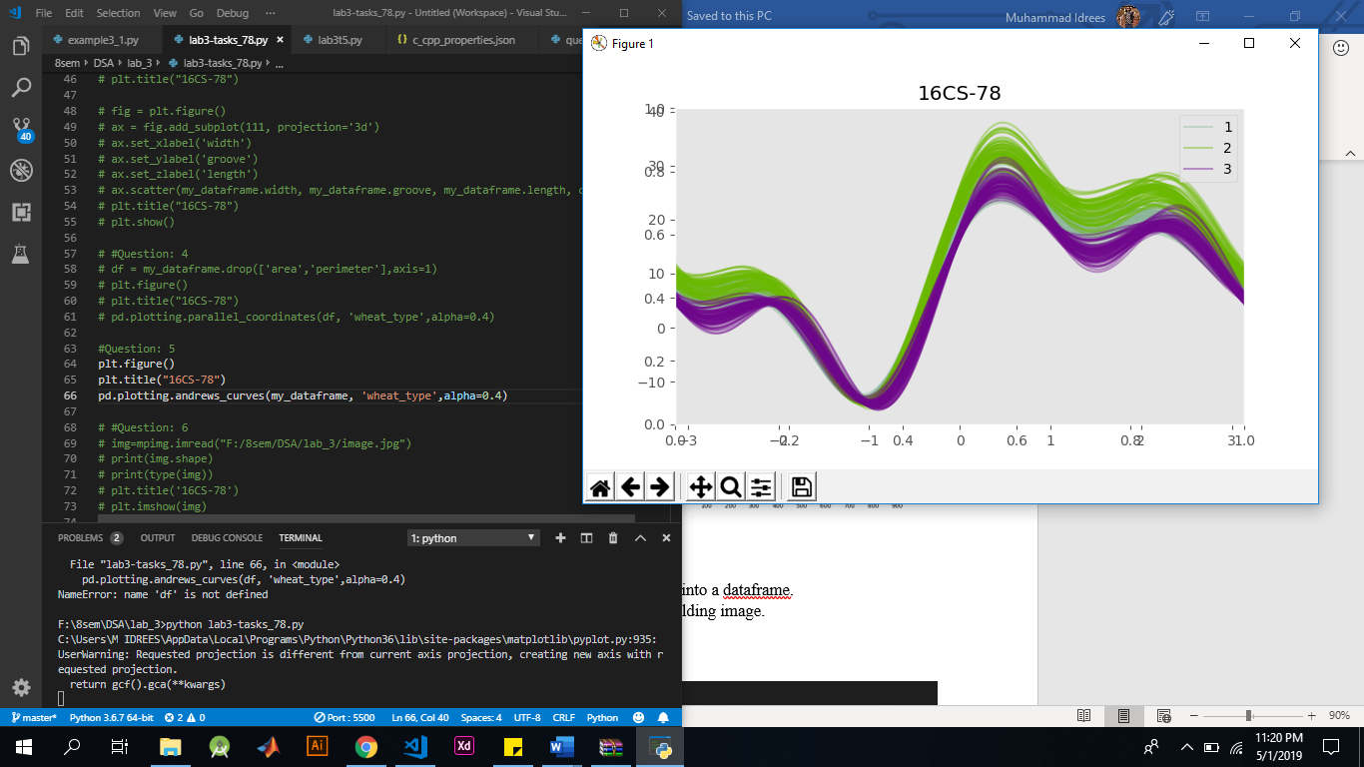 

### Question: 6

Write python code that

1. Loads up any image of your choice, into a dataframe.
2. Print shape and type of the object holding image.
3. Plot image using **imshow.**

Answer:

