Add Song:
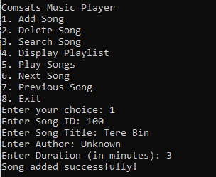
Search Song:
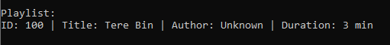
Delete Song:
