DENTEX Tooth Detection: Project Overview
AI that finds dental problems on X-rays and says how sure it is
Muhammad Ishaq · September 2026

1. What the project is about
Dentists use panoramic X-rays, a single wide image of the whole mouth, to spot problems such as tooth decay, infections at the root tip and wisdom teeth that are stuck under the gum. Reading these images takes time, and small problems are easy to miss.
This project trains an AI model that looks at a panoramic X-ray and draws a box around each problem it finds, labelled with the type of problem. Most dental AI projects stop there. This one also measures how much each prediction can be trusted, so that a dentist knows which findings are solid and which need a second look.
- Model: YOLO26, the newest version of the widely used YOLO object-detection family (Ultralytics, 2026), fine-tuned on a laptop GPU.
- Trust layer: calibrated confidence scores, conformal prediction (statistically guaranteed error ranges) and MC-dropout (asking the model the same question 20 times and checking whether it agrees with itself).
- Usable output: a web app where you upload an X-ray and get the findings, plus an online version deployable on Vercel.

2. The dataset: DENTEX
DENTEX (Dental Enumeration and Diagnosis on Panoramic X-rays) is a public benchmark released for the DENTEX challenge at MICCAI 2023, a leading medical-imaging conference. It is published on Hugging Face (ibrahimhamamci/DENTEX) under the CC BY-NC-SA 4.0 licence, which allows non-commercial research use.

What is in it
The X-rays are annotated hierarchically, following the FDI numbering system dentists use. Each box can carry up to three labels:
- Quadrant: which quarter of the mouth (upper right, upper left, lower left, lower right).
- Tooth number: which tooth, 1 to 8, within that quadrant.
- Diagnosis: what is wrong with the tooth.
DENTEX subset | X-rays | Labels
Quadrant only | 693 | quadrant
Quadrant + tooth | 634 | quadrant, tooth number
Fully labelled (used in this project) | 1,005 | quadrant, tooth number, diagnosis
Unlabelled | 1,571 | none (for pre-training)

The four diagnoses
Diagnosis | What it means
Impacted tooth | A tooth that has not grown into its normal position, most often a wisdom tooth.
Caries | Tooth decay in the outer layers of the tooth.
Deep caries | Decay that reaches close to the nerve; usually needs a root canal or extraction.
Periapical lesion | A dark area at the tip of the root, typically a sign of infection.

How the data was used
Split | X-rays | Impacted | Caries | Periapical Lesion | Deep Caries
Training | 605 | 517 | 1860 | 134 | 491
Calibration (held out) | 100 | 87 | 329 | 24 | 87
Validation | 50 | 40 | 101 | 9 | 32
Test | 250 | 221 | 747 | 75 | 190

- The 705 official training X-rays were split into 605 for training and 100 kept aside to tune the trust layer, so it is never tuned on images the model learned from.
- The official 50 validation and 250 test X-rays were used for model selection and final results.
- Caries is by far the most common finding and periapical lesions the rarest, which makes lesions the hardest to learn.
- Images are large (about 2,900 × 1,300 pixels) while many problems cover only a small part of the image.
Note on the test set. The released test labels use Turkish treatment codes (for example "root canal" or "extraction") rather than the four diagnoses. They were translated into diagnoses using a data-driven check, and the validation set, which uses the original labels, is treated as the clean benchmark.

3. Results

How accurate is the model?
AP50 is the standard detection score (0 to 1, higher is better). It rewards finding each problem with a box that overlaps the true one by at least half. Precision is the share of predicted findings that are correct; recall is the share of real problems that were found.
Diagnosis | AP50 validation | AP50 test | Precision (test) | Recall (test)
Impacted | 0.897 | 0.932 | 85.3% | 92.8%
Caries | 0.449 | 0.482 | 49.7% | 42.7%
Periapical Lesion | 0.491 | 0.431 | 56.7% | 37.3%
Deep Caries | 0.640 | 0.434 | 49.1% | 53.2%
All four | 0.619 | 0.569 | 60.2% | 56.5%

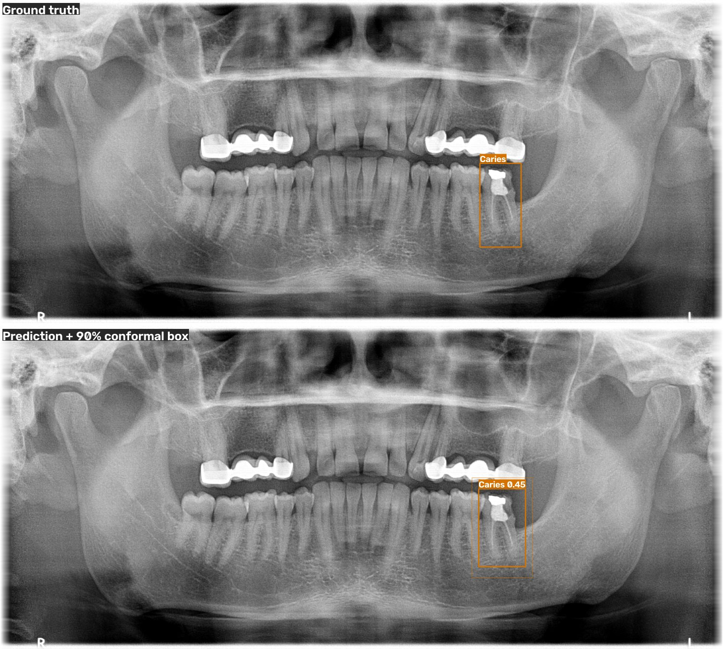
Example on an unseen X-ray. Top: dentist's annotation. Bottom: the model's finding (caries, 0.45) with its 90% error range shown as a thin outer box.

How trustworthy are its confidence scores?
Trust measure | Result
Confidence scores match reality (calibration error, lower is better) | 0.070 before → 0.037 after calibration
90% error range contains the true box: Impacted | 88.2%
90% error range contains the true box: Caries | 92.9%
90% error range contains the true box: Periapical Lesion | 100.0%
90% error range contains the true box: Deep Caries | 96.5%
Spotting wrong findings: single prediction (AUROC) | 0.767
Spotting wrong findings: MC-dropout, 20 passes (AUROC) | 0.818

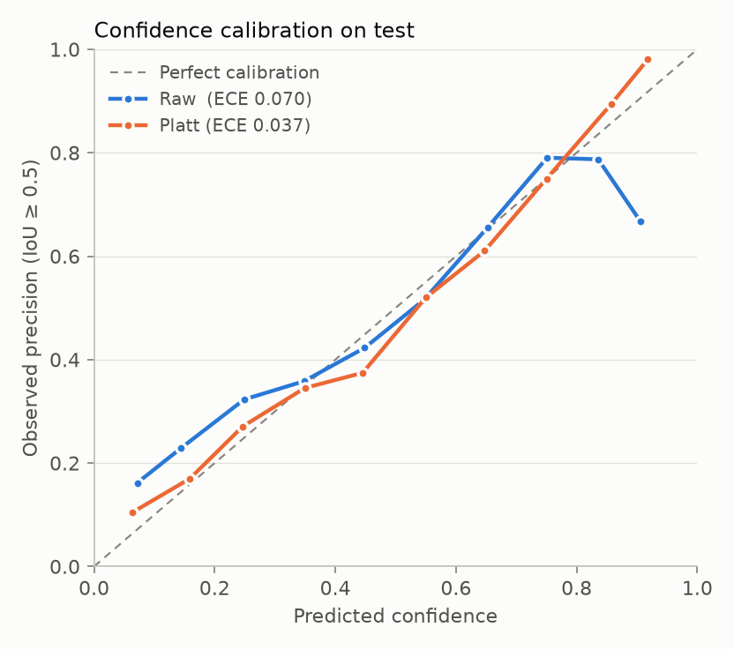
Before calibration the model is over-confident at high scores; after calibration its confidence matches how often it is actually right.

4. Key findings
- Impacted teeth are reliably detected. AP50 0.932 with 92.8% of impacted teeth found on the test set. This is close to a solved problem.
- Caries and deep caries are hard to tell apart. About a third of cases are confused in each direction, because they are two severity levels of the same disease.
- Periapical lesions are the weakest class. They are rare in the data and have fuzzy edges; about one in five is missed entirely.
- Calibration halves the confidence error. Calibration error drops from 0.070 to 0.037, so a score of 0.7 really means roughly 70%.
- The error ranges keep their promise. The 90% conformal boxes contained the true lesion 88–100% of the time on the test set, as guaranteed.
- Honest limits on sensitivity. The conformal analysis shows the model can promise "at most 10% missed" only for impacted teeth. For caries and lesions no threshold reaches 90% sensitivity, which a simple fixed cut-off would have hidden.
- MC-dropout helps flag mistakes but costs accuracy. Asking the model 20 times spots wrong findings better (AUROC 0.818 vs 0.767), but lowers AP50 (0.496 vs 0.547). It works best as a "please review" flag.
- The dataset needed checking. The official test labels did not match the stated diagnoses, and auditing them was essential for honest results.

5. Limitations and next steps
- Only 605 training X-rays; more data, especially lesions, would help most.
- Higher-resolution or tooth-by-tooth analysis should raise sensitivity for small caries and lesions.
- Predicting exact tooth numbers (not just the quadrant) would make findings easier to act on.
- This is a research prototype, not a medical device, and must not be used for clinical decisions.

6. Try it
- Local web app: conda activate dentex, then python app/app.py, and open http://127.0.0.1:7860. Upload an X-ray (examples in data/yolo/images/test/).
- Online: deploy the deploy/vercel folder to Vercel (set Root Directory to deploy/vercel).
- Code and full technical report: github.com/MuhammadIshaq-AI/dentex-tooth-detection, docs/DENTEX_Project_Report.docx.
Dataset and model credits: Hamamci, I. E. et al., DENTEX: An Abnormal Tooth Detection with Dental Enumeration and Diagnosis Benchmark for Panoramic X-rays, arXiv:2305.19112 (2023). Ultralytics YOLO26, docs.ultralytics.com.

