Q1. Change the Pending Restaurants, Approved Restaurants and Rejected Restaurants sections to a modern, clean, and professional UI/UX layout.
- Use a modern card/table-based design with proper spacing, typography, icons, and responsive styling.
- Keep the existing functionality and data unchanged.
- Make both sections visually consistent with the overall admin dashboard design.
- Ensure the layout is fully responsive on desktop, tablet, and mobile.
- If there are no restaurants in a section, do not show an empty table or unnecessary UI. Instead, display a simple centered message such as:
“pending restaurants shows here.”
or an appropriate message based on the section, such as:
“No approved restaurants found.”
“No rejected restaurants found.”
- Keep the design simple, modern, clean, and user-friendly without overcomplicating the UI.

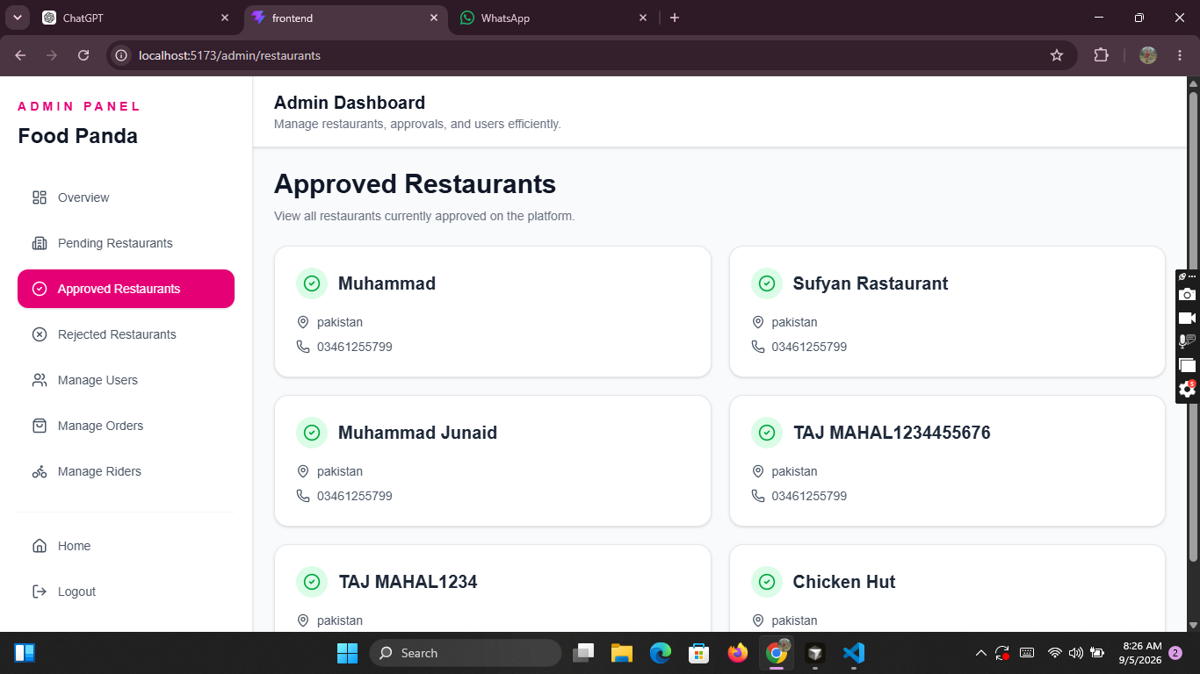
Q2 And also check all the dashboards for quick check and make the design modern and add animations if needed with out any making bugs in code.

Q3. Now my restaurant product card design change to modern design just like foodpanda.
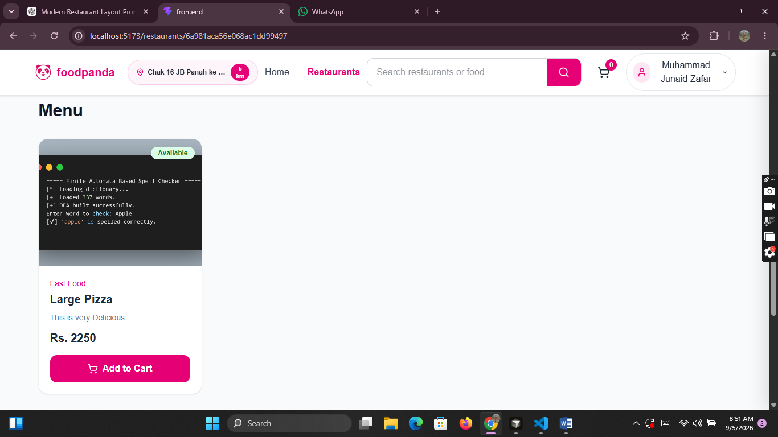
Q. And Give the static Pages and text related to website for all Footer Routes and in navbar Remove offers route (no need of offers)

Create a separate About Us page for the website and add its route/link in the Footer.
- Design the About Us page with a modern, clean, and professional UI/UX.
- Add suitable content explaining the website, its purpose, services, and mission.
- Use a visually appealing layout with proper sections, spacing, typography, and relevant icons/images where appropriate.
- Make the page fully responsive for desktop, tablet, and mobile.
- Add an “About Us” link in the Footer that navigates to this separate page.
- Make sure the route works correctly and does not affect any existing routes or functionality.
- Keep the design consistent with the overall website theme.
