

**Project Report 2020**

**On**

**Quiz App**

**Submitted by**

**Huzaifa Aslam**

**CSC-18F-093**

**BSCS-4B**

**Assembly Language**

**Submitted To**

**Mam Sahar Jumani**

**INTRODUCTION**

Online Examination System is a technology-driven way to simplify examination activities like defining exam patterns with question banks, defining exam timer, objective/ subjective question sections, conducting exams using the computer or mobile devices in a paperless manner.

Online Examination System is a cost-effective, scalable way to convert traditional pen and paper-based exams to online and paperless mode.

Candidates can appear for the exam using any desktop, laptop, or mobile device with a browser. Exam results can be generated instantly for the objective type of questions.

 It can simplify overall examination management and result in generation activity.

**OBJECTIVE OF THE PROJECT**

The objective of Quiz app is to provide a platform to the Students where they can attempt their quiz any where.The situation of now days is very dangerous due to Corona so that is decided to developed such type of platform.

**WORK BREAKDOWN STRUCTURE**

|  |  |  |
| --- | --- | --- |
|  | **Description of Work** | **Start and End Dates** |
|  | Projects Assigned | 07th August, 2020 |
| **Phase One (Analysis)** | Search for the basic Information of the Project and Proposal Submission.   * Collection of relevant data through research papers, books, and videos. * Organization of the collected data per type of the implementation work. | 9th August , 2020–  13th August , 2020 |
| **Phase Two (Design)** | Designing the project consecutively with the analysis phase.   * How and what input the program would take from the user. * How the program would process the given input. * What coding should be done for every specific task the program would perform. | 15th August , 2020 – 18 August , 2020  (Phase two started consecutively with the Analysis phase) |
| **Phase Three (Implementation)** | Would be implementing the design and related information of the project. | 19th  August , 2020 – 23th August , 2020 |
| **Phase Four (Testing)** | Test launch the project. If any problem occurs it would be fixed in the margin of few days. Project submission. | 24th August , 2020 – 26th  August , 2020 |
|  |  |  |

**ALGORITHM & FLOWCHART OF SCIENTIFIC CACULATOR**

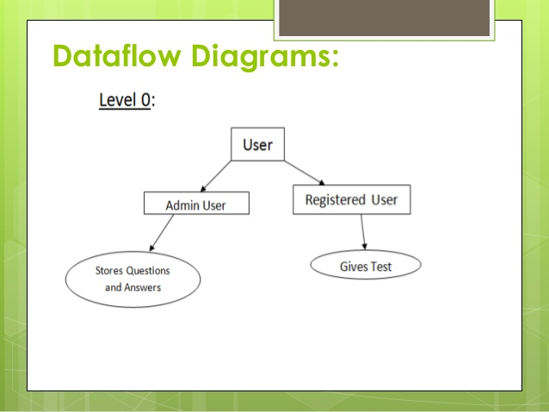

**WORK DISTRIBUTION STRUCTURE:**

|  |  |
| --- | --- |
| PHASE ONE  (ANALYSIS) | * Book reviews * Searching through net * Read lectures * Organization of the collected data per type of the implementation work. * Collect information through research paper. * Collection of data through videos and tutorials. |
| PHASE TWO  (DESIGN) | * How and what input the program would take from the user. * search Functions. * search scientific notations. * How the program would process the given input. * Process details. * Input details. * What coding should be done for every specific task the program would perform. * Output details. |
| PHASE THREE  (TESTING) | * Debug the program * Would be implementing the design and related information of the project. |

**CURRENT STATUS OF WORKDONE IN PROJECT:**

* 100% work has been completed.
* Code is ready to compile
* Project is ready for submission

**CODE:**

NL macro

mov ah , 2

mov dl,0AH

int 21h

mov dl,0dh

int 21h

endm

.model huge

.stack 100h

.data

ms1 db "..............***Welcome to Quiz Developed by Huzaifa Aslam***...............$"

ms2 db " *Our Policy*$"

ms3 db " 1.Your Correct Answer will add 1 in your score$"

ms4 db " 2.Yout Wrong Answer will minus 1 from your score$"

ms5 db "please Press Enter to contunue$"

ms6 db "Wow its Correct$"

ms7 db "Sorry Its Wrong$"

ms8 db "Successfully Completed$"

ms9 db "Your score is : $"

ms10 db "Press 1 for Continue and 0 for Quit$"

ms11 db "Best of Luck$"

Q1 db "1. Instructions which won’t appear in the object program are called as?$"

QA1 db " a)Redundant instructions b)Exceptions c)Comments d)Assembler Directives$"

Q2 db "2. The directive used to perform initialization before the execution of the code is$"

QA2 db " a)Reserve b)Dataword c)Store d)EQU$"

Q3 db "3. what directive is used to specify and assign the memory required for the block of code$"

QA3 db " a)Reserve b)Set c)Assign d)Allocate$"

Q4 db "4. what directive specifies the end of execution of a program$"

QA4 db " a)Return b)Terminate c)Stop d)End$"

Q5 db "5. The last statement of the source program should be$"

QA5 db " a)Stop b)Return c)OP d)End$"

.code

main proc

mov ax,@data

mov ds,ax

lea dx, ms1

mov ah,09

int 21h

NL

lea dx, ms2

mov ah,09

int 21h

NL

lea dx, ms3

mov ah,09

int 21h

NL

lea dx, ms4

mov ah,09

int 21h

start:

NL

lea dx,ms5

mov ah, 9

int 21h

mov ah,1

int 21h

cmp al,0dh

je Que1

jne start

Que1:

NL

lea dx,Q1

mov ah,09

int 21h

NL

lea dx,QA1

mov ah,09

int 21h

NL

mov ah,01

int 21h

cmp al, 'd'

je True1

jne False1

True1:

NL

lea dx,ms6

mov ah,09

int 21h

inc bl

call Que2

NL

mov ah , 01

int 21h

cmp al , 'd'

je True2

jne False2

False1:

NL

lea dx,ms7

mov ah,09

int 21h

dec bl

call Que2

Que2:

NL

lea dx,Q2

mov ah,09

int 21h

NL

lea dx,QA2

mov ah,09

int 21h

NL

mov ah,01

int 21h

cmp al, 'b'

je True2

jne False2

True2:

NL

lea dx,ms6

mov ah,09

int 21h

inc bl

NL

call Que3

False2:

NL

lea dx,ms7

mov ah,09

int 21h

dec bl

NL

call Que3

Que3:

NL

lea dx,Q3

mov ah,09

int 21h

NL

lea dx,QA3

mov ah,09

int 21h

NL

mov ah,01

int 21h

cmp al, 'a'

je True3

jne False3

True3:

NL

lea dx,ms6

mov ah,09

int 21h

inc bl

NL

call Que4

False3:

NL

lea dx,ms7

mov ah,09

int 21h

dec bl

NL

call Que4

Que4:

NL

lea dx,Q4

mov ah,09

int 21h

NL

lea dx,QA4

mov ah,09

int 21h

NL

mov ah,01

int 21h

cmp al, 'd'

je True4

jne false4

True4:

NL

lea dx,ms6

mov ah,09

int 21h

inc bl

NL

call Que5

False4:

NL

lea dx,ms7

mov ah,09

int 21h

dec bl

NL

call Que5

Que5:

NL

lea dx,Q5

mov ah,09

int 21h

NL

lea dx,QA5

mov ah,09

int 21h

NL

mov ah,01

int 21h

cmp al, 'd'

je Exit

jne ExitW

Exit:

NL

lea dx, ms6

mov ah,09

int 21h

inc bl

NL

NL

lea dx,ms8

mov ah,09

int 21h

NL

lea dx, ms9

mov ah, 09

int 21h

add bl,48

cmp bl,57

je Irt

mov ah,02

mov dl,bl

int 21h

jmp Exit1

ret

ExitW :

NL

lea dx,ms7

mov ah,09

int 21h

dec bl

NL

NL

lea dx,ms9

mov ah,09

int 21h

add bl,48

mov dl,bl

mov ah,02

int 21h

jmp Exit1

ret

Irt:

mov ah,02

mov dl, "1"

int 21h

;mov dl,"0"

;int 21h

jmp Exit1

ret

Exit1:

NL

NL

lea dx,ms10

mov ah,09

int 21h

NL

mov ah,01

int 21h

cmp al,'0'

je close

jmp start

close:

NL

lea dx, ms11

mov ah,09

int 21h

mov ah,4ch

int 21h

main endp

end main

**POSSIBLE OUTCOMES:**

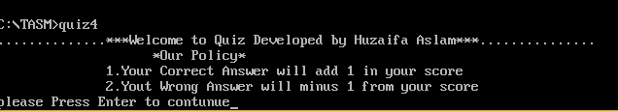

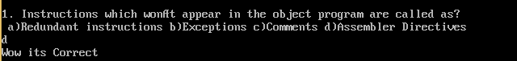



**References**

<https://www.google.com/search?q=online+quiz+diagram&sxsrf=ALeKk003DerooCnaFgvlrAO4p_BMDjZEcw:1598900954504&source=lnms&tbm=isch&sa=X&ved=2ahUKEwiGjrKbksbrAhUOA2MBHQ_SCrAQ_AUoAXoECAwQAw&biw=1366&bih=657#imgrc=Fb9oceJvQKjeCM>