TEYZIX
AI-Powered Document Summarizer

─────────────────────────────

Internship Project — Task 1
Ref ID:
TC-INT-18991230-778

Submitted by:
Muhammad Maheem

Organization:
TEYZIX CORE

Date:
June 2026

Table of Contents
Executive Summary 3
1. Project Overview 3
2. System Architecture 4
3. Technology Stack 5
4. Core Features 6
5. NLP Pipeline 8
6. Summarization Algorithms 9
7. API Reference 11
8. Installation & Setup 13
9. Screenshots 14
10. Testing 16
11. Security 17
12. Project Structure 17
Conclusion 18

Executive Summary

TEYZIX is a production-ready web application that uses Natural Language Processing (NLP) and optional deep-learning to automatically distill long documents into concise, accurate summaries. Built as Internship Task AI-INT-1, the project demonstrates end-to-end engineering from NLP algorithm implementation through REST API design to a responsive browser interface.
The system supports four distinct summarization approaches — frequency-based, TF-IDF, a combined weighted method, and neural abstractive summarization using Facebook's BART large model. It detects the input language automatically (16+ languages), handles batch multi-document processing, provides analytical visualizations, and exports results as TXT or PDF files.
The backend is built with Flask 3.0 using the App Factory pattern with feature-modular Blueprints. The frontend uses Vanilla JavaScript with Chart.js for visualizations. The codebase includes 22 automated tests covering analytics, preprocessing, and route handlers.

22  Automated Tests | 4  Summarization Methods | 16+  Languages Supported | 5  REST API Endpoints

1. Project Overview

1.1 Problem Statement
In an age of information overload, professionals and students frequently need to extract key insights from lengthy reports, research papers, and articles. Reading a 10-page document to find three key points is time-consuming and inefficient. TEYZIX solves this by automating the extraction of the most important content from any text document.
1.2 Objectives
- Implement multiple NLP summarization algorithms to give users choice between speed and quality.
- Build a clean REST API that can be integrated with any frontend or third-party service.
- Provide language-aware preprocessing so the system works on non-English documents.
- Support batch processing for users who need to process multiple documents simultaneously.
- Include analytics (keyword extraction, frequency charts, sentence scoring) to give users deeper insight.
- Demonstrate production-ready engineering practices: app factory, blueprints, validation, rate limiting, testing.
1.3 Scope
TEYZIX covers:
- Text input via paste, single-file upload (.txt / .pdf), and multi-file batch upload (up to 10 files)
- Four summarization methods with user-configurable output length (10–90% ratio slider)
- Analytics panel: word frequency bar chart, keyword tags, per-sentence importance scoring
- Export to plain text (.txt) or styled PDF via reportlab
- Dark and light UI themes with localStorage persistence
2. System Architecture

2.1 High-Level Architecture
TEYZIX follows a three-tier architecture with a clear separation between the presentation, business logic, and processing layers:
┌─────────────────────────────────────────────────────┐
│ BROWSER (Frontend) │
│ Vanilla JS · Chart.js · Dark/Light Theme │
└─────────────────────┬───────────────────────────────┘
│ HTTP / JSON
┌─────────────────────▼───────────────────────────────┐
│ FLASK APPLICATION SERVER │
│ Blueprints: summarizer | file_handler │
│ Service Layer → Validation → Rate Limiter │
└──────┬──────────────┬──────────────────┬────────────┘
│ │ │
┌──────▼──────┐ ┌────▼───────┐ ┌───────▼──────────────┐
│ NLP Core │ │ Analytics │ │ File Handler │
│ NLTK+spaCy │ │ Freq/KW │ │ pdfplumber+reportlab │
│ TF-IDF │ │ Scoring │ │ Uploads/Exports │
│ BART(opt.) │ └────────────┘ └──────────────────────┘
└─────────────┘
2.2 App Factory Pattern
The Flask application is created via a `create_app()` factory function rather than a module-level global. This enables multiple isolated app instances (development, testing, production) with different configurations — a critical requirement for reliable automated testing.
2.3 Feature-Modular Blueprints
Code is organized by feature (what it does) rather than by type (models/, views/, utils/). Each feature owns its routes, service, schemas, and exceptions. Changes to one feature cannot accidentally break another.
Blueprint | URL Prefix | Responsibility
summarizer | /api | Text summarization (single + batch)
file_handler | /api | Upload, read, export files

3. Technology Stack

Component | Technology | Version | Purpose
Web Framework | Flask | 3.0.3 | HTTP routing, request handling
NLP Tokenization | NLTK | 3.8.1 | Sentence/word tokenization, stopwords
NLP Entity/POS | spaCy | 3.8.x | Noun-chunk keyword extraction
ML / TF-IDF | scikit-learn | 1.4.2 | TF-IDF vectorization
Abstractive NLP | Transformers+PyTorch | 4.40+ | BART neural summarization (optional)
PDF Read | pdfplumber | 0.11 | Extract text from PDF files
PDF Export | reportlab | 4.2.2 | Generate styled PDF summaries
Language Detect | langdetect | 1.0.9 | Identify input language
Rate Limiting | Flask-Limiter | 3.5+ | Per-IP API rate limiting
CORS | Flask-CORS | 4.0+ | Cross-origin request handling
Visualization | Chart.js | Latest | Word frequency bar chart (frontend)
Production Server | Gunicorn | 22.0 | WSGI production server
Testing | pytest | 8.0+ | Automated test suite

4. Core Features

4.1 Four Summarization Methods
Method | Type | Speed | Description
Frequency | Extractive | < 0.5 s | Scores sentences by normalized word occurrence count
TF-IDF | Extractive | < 0.5 s | Penalizes common words; rewards rare, informative terms
Combined | Extractive | < 0.5 s | Weighted blend of Frequency + TF-IDF with positional bias
Abstractive | Generative | 5–30 s | Facebook BART-large-CNN generates new paraphrased sentences

4.2 Language Support
TEYZIX auto-detects the document language by sampling the first 500 characters using the `langdetect` library (Naive Bayes classifier trained on 55 languages). The detected language ISO code is used to select the correct NLTK stopword list, ensuring that French stopwords are removed from French documents, Spanish stopwords from Spanish documents, and so on.
Supported languages include: English, French, German, Spanish, Portuguese, Italian, Dutch, Polish, Russian, Arabic, Chinese, Japanese, Korean, Hindi, and more.
4.3 Batch Processing
Up to 10 documents can be submitted in a single batch request, with two processing modes:
- **Combined mode** — all documents concatenated and summarized as one; returns a single executive summary
- **Individual mode** — each document summarized independently; returns an array of summary objects
4.4 Analytics Panel
- Top 15 most frequent meaningful words — displayed as an interactive bar chart (Chart.js)
- Keyword extraction — TF-IDF top terms combined with spaCy noun-chunk phrases
- Per-sentence importance scoring — each original sentence scored and labeled high / medium / low
- Compression statistics — original word count, summary word count, compression percentage, reading time
4.5 File Handling
- Accepts .txt (UTF-8) and .pdf (text-based) files up to 5 MB
- Validates by file extension AND magic-byte signature (%PDF header check for PDFs)
- Files saved temporarily to uploads/, read, then immediately deleted — no user data stored on disk
- PDF text extracted page-by-page via pdfplumber with newline preservation
4.6 Export
- .txt — plain text with timestamp header, served as file attachment
- .pdf — professionally styled PDF generated in-memory via reportlab with brand accent color (#7c6aff)
- Both formats generated in-memory and served as download attachments — nothing written to disk
4.7 Rate Limiting
Endpoint | Limit | Notes
POST /api/summarize | 15 req/min | Core summarization endpoint
POST /api/summarize-batch | 5 req/min | Batch processing (more expensive)
POST /api/upload | 30 req/min | Single file upload
POST /api/upload-multiple | 10 req/min | Multi-file upload
POST /api/export | 30 req/min | Result export

5. NLP Pipeline

Every document passes through a four-stage preprocessing pipeline before scoring. The pipeline is implemented in `app/features/preprocessor/pipeline.py`:
Raw Text
│
▼ Stage 1: Sentence Segmentation (NLTK Punkt tokenizer)
│ ["Dr. Smith arrived at 5 p.m.", "He was tired."]
│
▼ Stage 2: Word Tokenization (NLTK word_tokenize)
│ [["Dr", "Smith", "arrived", "pm"], ["tired"]]
│
▼ Stage 3: Token Filtering (alpha-only, length > 1)
│ Removes punctuation, numbers, single characters
│
▼ Stage 4: Stopword Removal (NLTK, language-aware)
│ Removes 'the', 'is', 'at', 'de', 'le', etc.
│
▼ PreprocessResult
├── raw_sentences (original text, used in output)
├── token_lists (clean tokens per sentence, used in scoring)
└── flat_tokens (all tokens combined, used in analytics)
5.1 Positional Bias
Research in NLP shows that key information in structured documents (reports, articles, emails) tends to cluster at the beginning (abstract/introduction) and end (conclusion/recommendations). The sentence ranker applies a 0.1 bonus to sentences at positions 0, 1, and the last position:
if i in (0, 1) or i == n - 1:
score = min(score + POSITIONAL_BOOST, 1.0) # POSITIONAL_BOOST = 0.1
6. Summarization Algorithms

6.1 Frequency-Based Scoring
Words that appear frequently in a document are likely important. Sentences containing many high-frequency words receive high importance scores.
- Count raw word occurrences using Python's Counter
- Normalize frequencies to [0, 1] by dividing by maximum count
- Score each sentence as the sum of normalized frequencies of its tokens
- Normalize sentence scores again to [0, 1]
Weakness: favors repetitive words. A word repeated 20 times may score higher than a rare but significant term. TF-IDF addresses this limitation.
6.2 TF-IDF Scoring
TF-IDF (Term Frequency–Inverse Document Frequency) penalizes words that appear in many sentences (high document frequency), rewarding words that are discriminating and informative:
TF(word, sentence) = count of word in sentence / total words in sentence
IDF(word) = log(total sentences / sentences containing the word)
TF-IDF(word, sent) = TF × IDF
Sentence score = sum of TF-IDF weights for all its terms
Implemented using `sklearn.feature_extraction.text.TfidfVectorizer` treating each sentence as a document. Row-wise matrix sum gives each sentence's total TF-IDF importance.
6.3 Combined Method
The recommended default. Blends both scores with configurable weights:
combined_score = (0.5 × frequency_score) + (0.5 × tfidf_score) + positional_bias
6.4 Abstractive Summarization (BART)
Unlike extractive methods that copy sentences, BART generates entirely new sentences. The model used is `facebook/bart-large-cnn`, pre-trained on 300,000 CNN/DailyMail article-summary pairs.
- **Encoder** (bidirectional): reads the full input simultaneously, builds contextual meaning representation
- **Decoder** (auto-regressive): generates summary tokens one at a time, conditioned on encoder output
- **Long document chunking**: splits documents into 800-word chunks, summarizes each, then re-summarizes the concatenated chunk summaries
- **Lazy loading**: model (~1.6 GB) downloads and loads only on first abstractive request, then stays cached in memory
- **Graceful fallback**: if transformers/torch not installed, returns clear 422 error; other methods unaffected
7. API Reference

All endpoints return JSON. Error responses include `{"success": false, "error": "<message>"}`.
7.1 POST /api/summarize
Rate limit: 15 req/min
Field | Type | Values | Default
text | string | 100 – 50,000 characters | required
method | string | frequency / tfidf / combined / abstractive | combined
ratio | float | 0.1 – 0.9 (summary length as fraction of original) | 0.3

Response includes: summary text, summary_type, original_word_count, summary_word_count, compression_ratio, detected_language, detected_language_name, and analytics object (top_words, keywords, sentence_scores).
7.2 POST /api/summarize-batch
Rate limit: 5 req/min | Max 10 documents per request | Abstractive not supported in batch mode
Field | Values | Notes
documents | Array of strings | Each 100 – 50,000 chars
names | Array of strings | Display names for each document (optional)
method | frequency / tfidf / combined | No abstractive in batch
ratio | 0.1 – 0.9 | Applied to each document
mode | combined / individual | Combined returns one summary; individual returns array

7.3 POST /api/upload
Rate limit: 30 req/min | Multipart, field name: `file` | Max size: 5 MB | Types: .txt, .pdf
Response: `{"success": true, "text": "...", "char_count": 3842}`
7.4 POST /api/upload-multiple
Rate limit: 10 req/min | Field name: `files` (multiple) | Max 10 files per request
Response: `{"texts": [...], "names": [...], "char_counts": [...], "errors": [...]}`
7.5 POST /api/export
Rate limit: 30 req/min
Field | Values | Notes
summary | string | The summary text to export
format | txt / pdf | txt = plain text; pdf = styled document with brand colors

Response: file attachment (Content-Disposition: attachment). Generated in memory — no server-side disk write.
7.6 GET /api/health
Health check. Response: `{"status": "ok"}` with HTTP 200.
8. Installation & Setup

Step 1 — Clone and create virtual environment
git clone <repo-url> TEYZIX
cd TEYZIX
python -m venv venv
source venv/bin/activate # Windows: venv\Scripts\activate
Step 2 — Install dependencies and NLP models
make setup
# Equivalent to:
# pip install -r requirements.txt
# python -m nltk.downloader punkt averaged_perceptron_tagger stopwords
# python -m spacy download en_core_web_sm
Step 3 — Configure environment
Create a `.env` file in the project root:
SECRET_KEY=your-secure-random-key
FLASK_ENV=development
FLASK_DEBUG=false
CORS_ORIGINS=*
MAX_UPLOAD_BYTES=5242880
MAX_BATCH_COMBINED_CHARS=150000
Step 4 — Run the development server
make run
# or: python run.py
# Open: http://127.0.0.1:5001
Step 5 — Production deployment
gunicorn wsgi:app --workers 4 --bind 0.0.0.0:8000
Note: SECRET_KEY must be set as an environment variable. The app raises a RuntimeError at startup if it is missing in production mode.

9. Screenshots

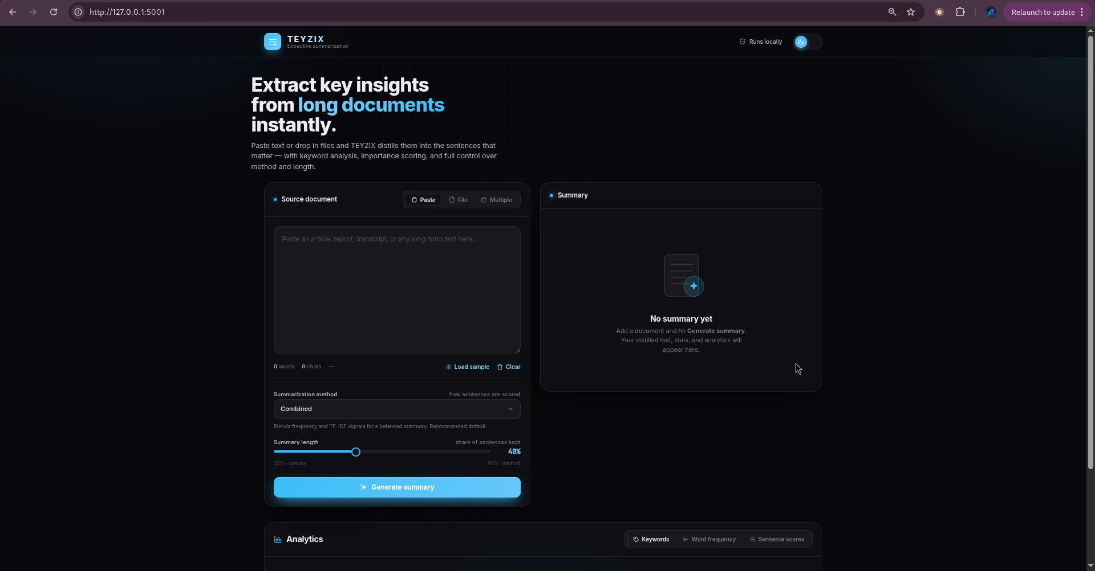
Figure 1 — Application home screen with Paste Text tab active (dark theme)
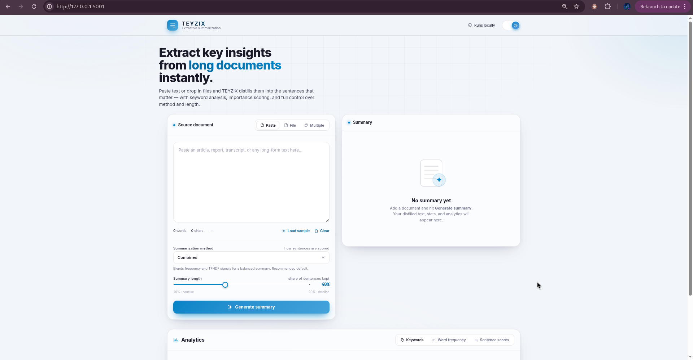
Figure 2 — File upload interface showing supported file types and upload controls
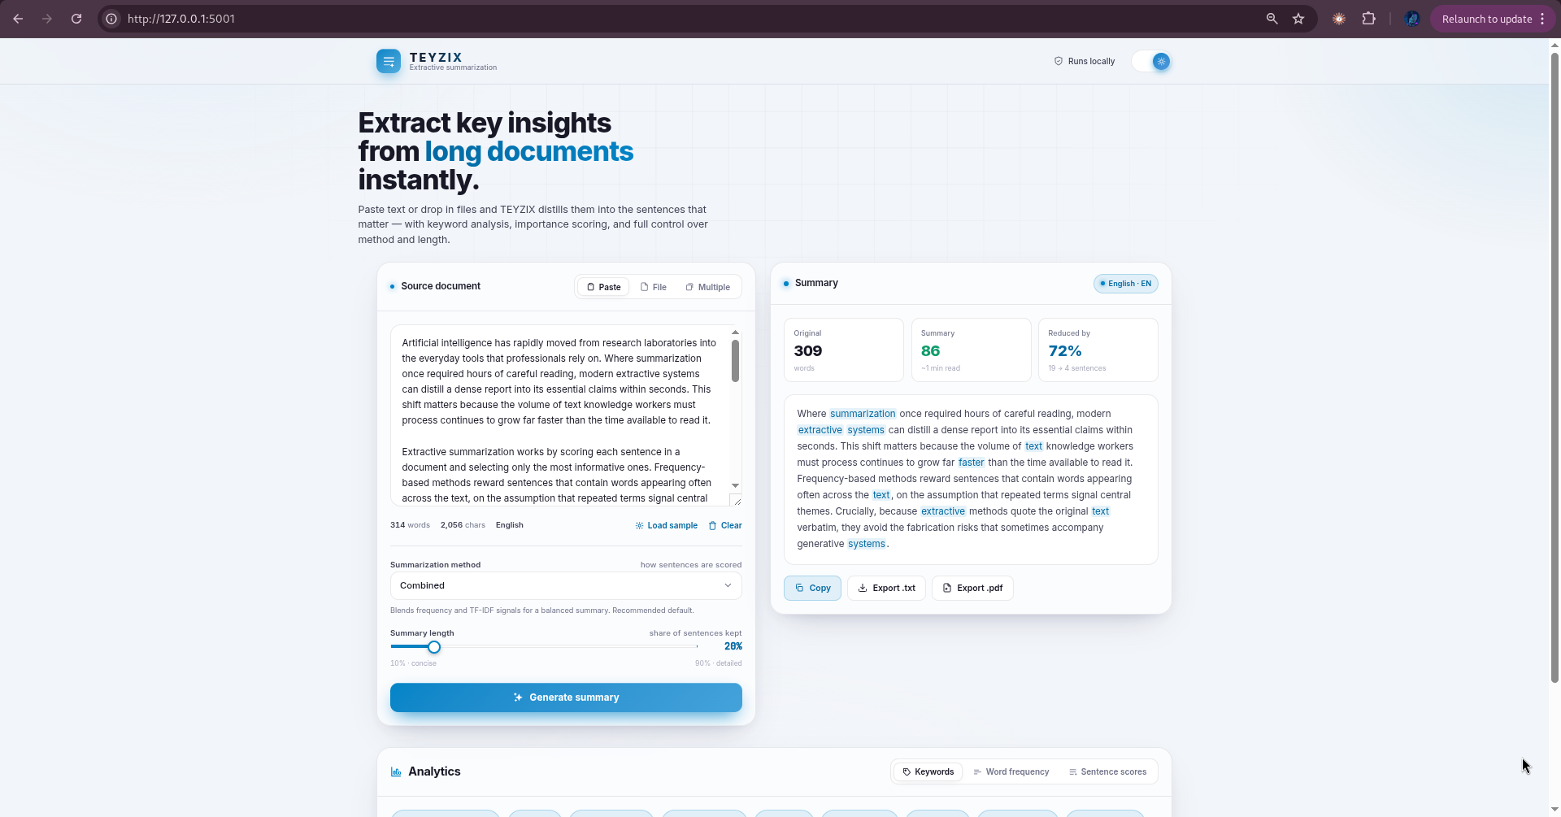
Figure 3 — Summarization result with analytics panel open
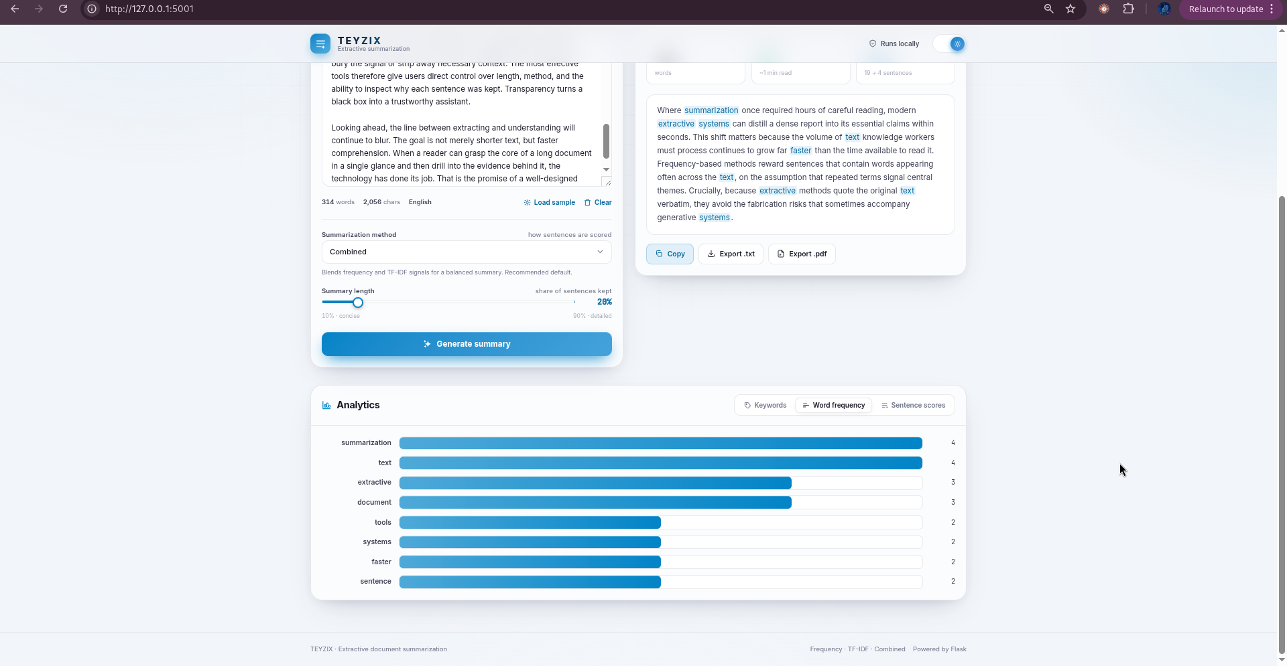
Figure 4 — Word frequency bar chart and keyword tags
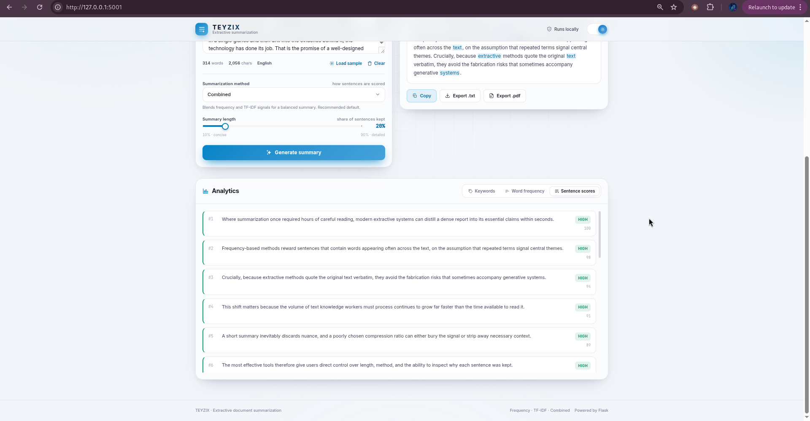
Figure 5 — Per-sentence importance scoring table (high / medium / low labels)
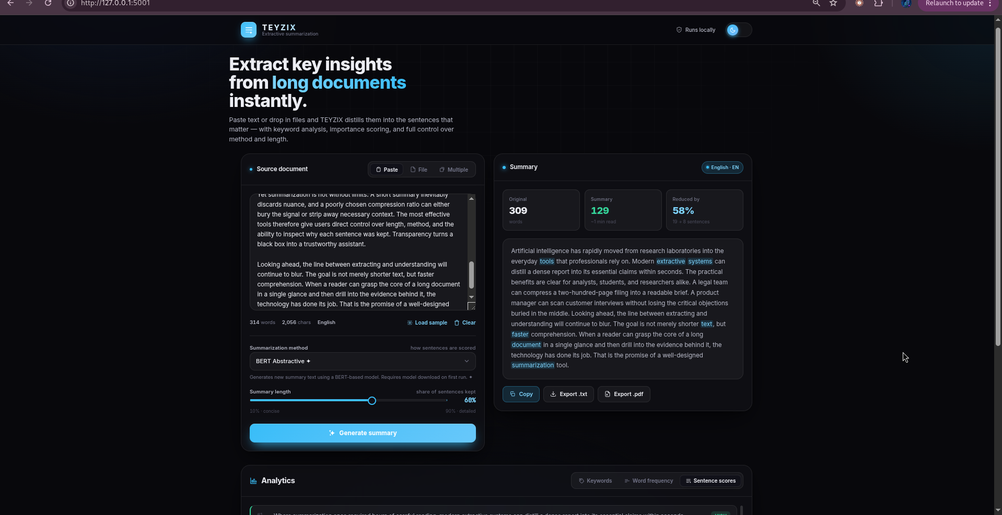
Figure 6 — Light theme view with batch processing interface
10. Testing

TEYZIX includes 22 automated tests across three test modules, run with pytest:
make test
# or: python -m pytest tests/ -v
Test Module | Tests | Coverage Area
test_analytics.py | 5 | Word frequency counter, keyword extractor, sentence scorer
test_preprocessor.py | 8 | Sentence tokenization, word tokenization, stopword removal, language detection
test_summarizer.py | 9 | Route handlers, batch logic, request validation, error responses
Total | 22 | All core features covered

The test suite uses Flask's test client (`app.test_client()`) so routes are tested with real HTTP requests without needing a running server. All NLP components are tested with short in-memory text samples — no external files required.
11. Security

Control | Implementation | Purpose
File type validation | Extension check + %PDF magic-byte verification | Prevents disguised file uploads
Upload cleanup | Files deleted immediately after reading | No user data retained on disk
In-memory export | PDF/TXT generated in-memory, served as blob | No export files stored server-side
Rate limiting | Per-IP limits via Flask-Limiter on all write endpoints | Prevents API abuse and DoS
CORS configuration | Configurable via CORS_ORIGINS env var | Restricts cross-origin access in production
Secret key enforcement | RuntimeError if SECRET_KEY missing in production | Forces secure session configuration
Debug mode guard | FLASK_DEBUG off by default | No debugger exposed in production
Input validation | Server-side schema validation for all inputs | Rejects malformed or malicious requests

12. Project Structure

Ai-summerizer/
├── app/
│ ├── __init__.py # App factory — CORS, limiter, NLP init, error handlers
│ ├── config.py # Dev / Prod / Testing config classes
│ ├── extensions.py # Flask-Limiter singleton
│ ├── core/
│ │ ├── algorithms/
│ │ │ ├── frequency_scorer.py # Word occurrence scoring
│ │ │ ├── tfidf_scorer.py # TF-IDF vectorization
│ │ │ ├── sentence_ranker.py # Combined scoring + positional bias
│ │ │ └── abstractive_summarizer.py # BART with chunking
│ │ └── nlp/
│ │ └── model_loader.py # NLTK + spaCy lazy singletons
│ ├── features/
│ │ ├── summarizer/
│ │ │ ├── routes.py # POST /api/summarize, /api/summarize-batch
│ │ │ ├── service.py # Business logic orchestrator
│ │ │ ├── batch_service.py # Multi-document batching
│ │ │ ├── schemas.py # Request/response dataclasses
│ │ │ └── exceptions.py # Custom error classes
│ │ ├── file_handler/
│ │ │ ├── routes.py # POST /api/upload, /api/export
│ │ │ ├── reader.py # Text + PDF extraction
│ │ │ ├── validators.py # Extension + magic-byte + size checks
│ │ │ └── writer.py # TXT + PDF export generation
│ │ ├── preprocessor/
│ │ │ ├── pipeline.py # 4-stage NLP pipeline
│ │ │ ├── tokenizer.py # Sentence + word tokenization
│ │ │ ├── text_cleaner.py # Stopword removal
│ │ │ └── language_detector.py # langdetect wrapper
│ │ └── analytics/
│ │ ├── frequency.py # Top-N word frequency
│ │ ├── keywords.py # TF-IDF + spaCy noun chunks
│ │ └── scoring.py # Sentence importance labels
│ ├── static/ # app.js, styles.css, charts.js
│ └── templates/index.html # Server-rendered SPA
├── tests/
│ ├── test_analytics.py # 5 tests
│ ├── test_preprocessor.py # 8 tests
│ └── test_summarizer.py # 9 tests
├── samples/ # climate_report.txt, ai_research.txt, business_email.txt
├── Screenshots/ # 6 application screenshots
├── run.py # Development server entry point
├── wsgi.py # Production WSGI entry point
├── Makefile # setup / run / test / clean targets
└── requirements.txt # All dependencies pinned

Conclusion

TEYZIX demonstrates a complete, production-quality NLP application built from first principles. The project goes beyond a simple tutorial implementation by applying real software engineering practices: feature-modular architecture, service layer separation, type-safe dataclass schemas, custom exception hierarchies, per-IP rate limiting, and comprehensive automated testing.
From an NLP standpoint, the system implements three classical extractive algorithms (frequency, TF-IDF, combined with positional bias) and integrates an optional state-of-the-art neural model (BART) with intelligent chunking for long documents. Multi-language support is implemented using auto-detection and language-specific stopword lists.
The frontend demonstrates that a clean, responsive, feature-rich browser application can be built without heavy JavaScript frameworks — reducing complexity, bundle size, and dependencies.
Key Learning Outcomes
- Implemented TF-IDF from first principles and via scikit-learn vectorizer
- Understood encoder-decoder transformer architecture (BART) and applied it to real summarization
- Designed a feature-modular Flask application using App Factory and Blueprint patterns
- Built a language-aware NLP preprocessing pipeline supporting 16+ languages
- Applied production engineering: rate limiting, file security, in-memory processing, testing
- Created a complete REST API with validation, custom exceptions, and structured error responses
Live demo :
https://ai-powered-document-summarization-system.onrender.com
─────────────────────────────────────────
TEYZIX · Muhammad Maheem · TEYZIX CORE · Task AI-INT-1 · June 2026

