# Personality Prediction Model

## 1. Introduction

This project is a machine learning-based application that predicts whether a person is an **Introvert** or an **Extrovert** based on their social behavior. The model is built using a **Support Vector Machine (SVM)** classifier and trained on a dataset of behavioral features.

## 2. Technologies Used

* Python
* scikit-learn
* pandas, numpy
* matplotlib, seaborn
* Virtual environment (venv)

## 3. Dataset

The dataset contains several features related to social behavior, including:

* Time spent alone
* Stage fear (Yes/No)
* Social event attendance
* Enjoyment of going outside
* Drained after socializing (Yes/No)
* Friend circle size
* Social media post frequency

The target column is **Personality**, which indicates whether the person is an Introvert or Extrovert.

### Dataset Preview:

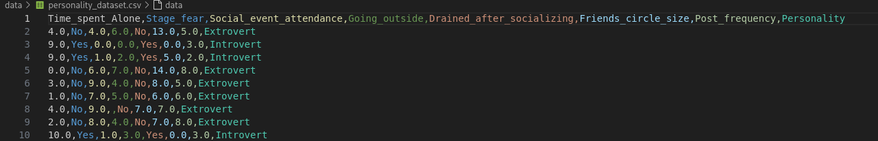

## 4. System Workflow

1. Data loading and cleaning
2. Train/test split (80/20)
3. Model training (SVM + StandardScaler)
4. Save model as **Personality.pkl**
5. User input collected from console
6. Prediction output as Introvert/Extrovert

## 5. Setup & Running

1. Run setup script (creates venv, installs dependencies):

./setup.sh

1. Activate virtual environment:

source venv/bin/activate

1. Run the app:

python app.py

1. Answer the questions in the terminal.
2. Get prediction: **Introvert** or **Extrovert**.

## 6. Screenshots

### 