|  |  |  |  |  |
| --- | --- | --- | --- | --- |
|  | | | | |
|  |  |  | |  |
| website on star classes  E-project of ACCP (1st Semester)  Star Classes computer Education  Submitted By   * Muhammad Mouhid {ST ID :1395352} * Wajahat Chugtai {ST ID : } | | |
| STAR CLASSES | | Gulistan e Johar, Karachi |

|  |  |
| --- | --- |
|  |  |
| **ACKNOWLEDGEMENT**  We are thankful to almighty, **ALLAH** with his grace and mercy for giving us strength and ability to make us complete this e-Project website. I hereby presenting my project in your hands.  We have tried our best to take all relevant and important topics in consideration so that this project may become more effective & a better outlook to come. This project has been developed with the help of “Visual Studio”.  We earnestly hope that this project will provide all the necessary information required for the user to fulfill their requirement. However, suggestions for improvement of the project will be thankfully acknowledge.  **PREFACE**  First of all, we would like to thank **ALLAH** the almighty, who gave us mind to think and heart to feel creativity & creation depends on thinking.  Many people contributed to this project, and I would like to thank all of them. Very special thanks to our teacher **SIR HAMZA** of **STAR CLASSES** for his expert advice and brilliant suggestion and always encourage us to do the best. Indeed, class fellows are very important and we would like to thank all of them for their kind appreciation, encouragement and moral support.  We would also like to express our deepest gratitude to our parents whose well wishes enabled us to transform our dream into a reality.  Finally, our sincere thanks to our teacher **SIR HAMZA** for all their assistance in making this concept a reality.  **Introduction**  Star Classes is into business for more than a decade. They have been advertising about their coaching classes through newspapers, pamphlets, television. Now with changing times, they have decided to go online as most of the students today are frequent users of Internet. They have planned for a website with complete details about the Coaching classes.  **Purpose**  Website is very important for your coaching class as it shows to aspiring students that what you are offering. It also gives updates to the student and students can easily enroll themselves in your coaching classes.  It provides correct guidance to the children that empowers them to utilize their extra time in covering various subjects. Hence, coaching also benefits the students as it helps them to learn the technique of studying. It also makes a student maintain a daily routine.  With benefits such as accessibility, affordability, flexibility, and access to life-long learning, it is obvious that online coaching is superior. It is also less expensive and allows for self-paced learning. Online coaching is here to stay, and it will only grow in popularity as time goes on  **FEATURES**  You can easily manage and find our courses with easy accessible Filtration option  You can easily contact us and find us easily Through contact us feature.  You can easily get to know us Through About us.  You can view our success stories and achievements by just sitting At home viewing our website  Star Classes is the pioneer in IT education & training since 1986. We have helped build the careers of 68 lakh professionals in 40 countries.  Star Classes prepares students to be a part of this growing industry through its courses and various placement assistance activities  Star Classes offers a variety of career programs for students who want to join IT sector as well professionals who want to enhance their skills. There are also basic IT programs for school students, housewives/senior citizens etc.  Star Classes has a dedicated placement team to help students get job placements in various IT job roles with major companies  See what successfully placed former students have to say about their experience with Star Classes.  The Institute also provides recruitment assistance to students. Based on the companies' job requirements, our students are shortlisted to get interviewed & placed with the organization in need of a skilled professional.  STAR CLASSES came to Pakistan in 1998, when the concept of vocational education in I.T. was only up-to learning of MS Word and Spreadsheets. STAR CLASSES Computer Education gave exposure to Pakistani youth towards global learning in I.T. education. Within the short span of time it became the leading I.T. training provider of the country with its presence in all the major cities. Since last decade, all of our franchise centers are providing Quality Education with international standards and an international certificate acceptable and transferable worldwide. During this tenure we have served the I.T. Market of Pakistan by producing thousands of quality professionals serving at key positions of several MNCs, Software Houses, Banks and other Public and Private sectors across Pakistan and abroad. Being the global organization, STAR CLASSES is maintaining global standards at every step right from the admission of a student to teaching and training, administration to accounts, examination to certification and marketing to student placement.    **INTERFERACE**    **ABOUT US**  **OUR ACHIVEMENTS** | |
| **OUR COURSES** | |  |
| OUR COURSE OUTLINE | |  |
| **Our Faculty** | |  |

**Our Trusted Partners**



**Our Testimonials**

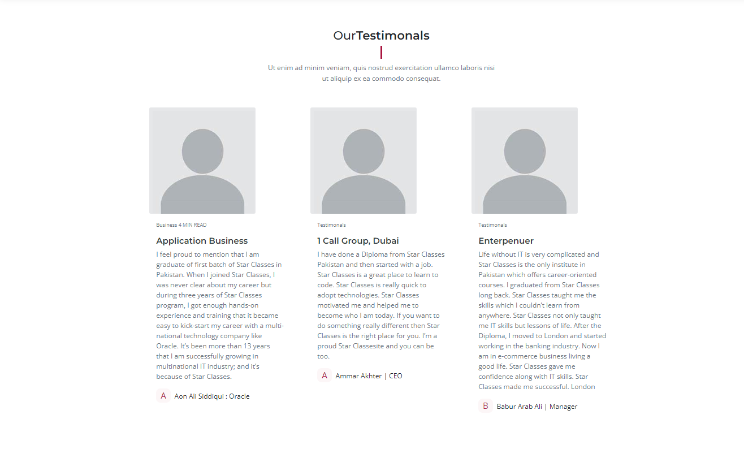

**Contact Get In Touch**



