|  |  |
| --- | --- |
| **Name: Muhammad Mouzzam Mustafa** | **EE-272L Digital Systems Design** |
| **Reg. No: 2023-EE-111** | **Marks Obtained: ____________** |

**Lab Manual**

**Experiment 1  
MOSFET as an Inverter**

|  |  |  |  |  |  |
| --- | --- | --- | --- | --- | --- |
| **DSD Lab Manual Evaluation Rubrics** | | | | | |
|  |  |  |  |  |  |
| **Assessment** | **Total Marks** | **Marks Obtained** | **0-30%** | **30-60%** | **70-100%** |
| **Code Organization (CLO1)** | **3** |  | **No Proper Indentation and descriptive naming, no code organization.**  **Zero to Some understanding but not working** | **Proper Indentation or descriptive naming or code organization.**  **Mild to Complete understanding but not working** | **Proper Indentation and descriptive naming, code organization.**  **Complete understanding, and proper working** |
| **Simulation (CLO2)** | **5** |  | **Simulation not done or incorrect, without any understanding of waveforms** | **Working simulation with errors, don't cares's(x) and high impedance(z), partial understanding of waveforms** | **Working simulation without any errors, etc and complete understanding of waveforms** |
| **FPGA (CLO2)** | **2** |  | **Not implemented on FPGA and questions related to synthesis and implementation not answered.** | **Correctly Implemented on FPGA or questions related to synthesis and implementation answered.** | **Correctly Implemented on FPGA and questions related to synthesis and implementation answered.** |

|  |  |
| --- | --- |
| Task 1: Apply 5V at A, what is the voltage at terminal B? Does the LED glow? Ans: No, the LED doesn’t glow when 5V is applied at terminal A. | Task 2: Apply 0V at A, what is the voltage at terminal B? Does the LED glow? Ans: Yes, the LED does glow when no voltage is supplied at terminal A. |

**Experiment 1:**

Task 3 (1kHz, 5Vp):

When the input goes from high to low voltage, the propagation delay is approximately 40ɥs

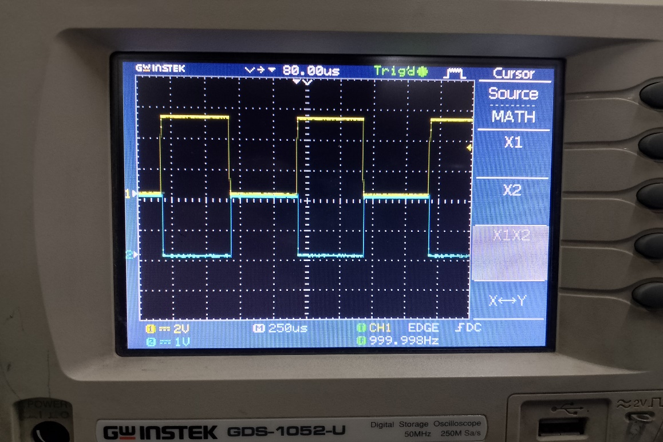

Task 4 (100kHz, 5Vp):

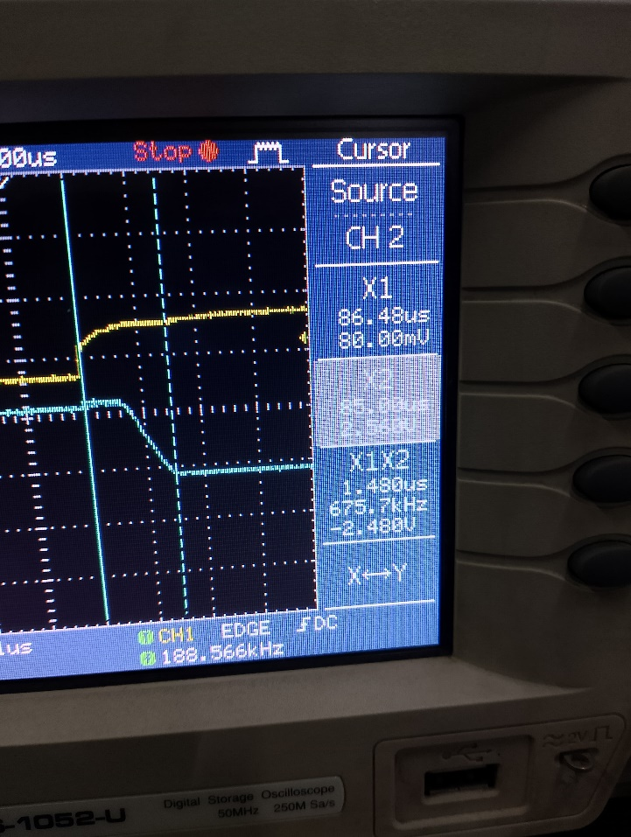When the input goes from high to low voltage, the propagation delay is approximately 1.48ɥs

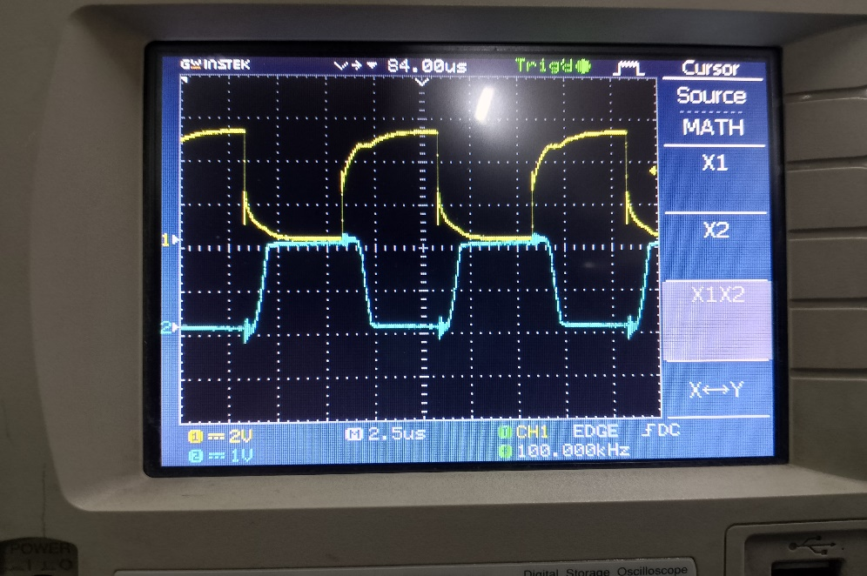

Task 5: How does the change of frequency affect the mode of operation of a transistor?  
Ans: For 1kHz frequency, the output gets enough time to completely transition from high voltage to low voltage since Time Period T for 1kHz is 1ms which is a long time for the transition to occur so the propagation delay reaches a value of ~40ɥs.  
While on the other hand, when a square wave of 100kHz is supplied at terminal A, the Time Period for this wave is comparatively small, 10ɥs. That’s why it doesn’t give the stray capacitances within the MOSFET to completely charge and discharge but after just a short time, it again changes states while the propagation delay decreases to 1.48ɥs as seen from the figure.