**ERD DIAGRAM:**

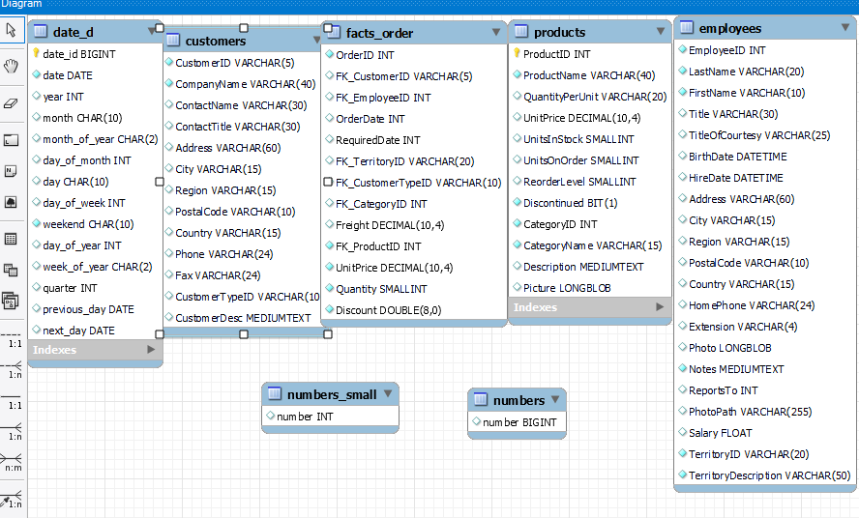

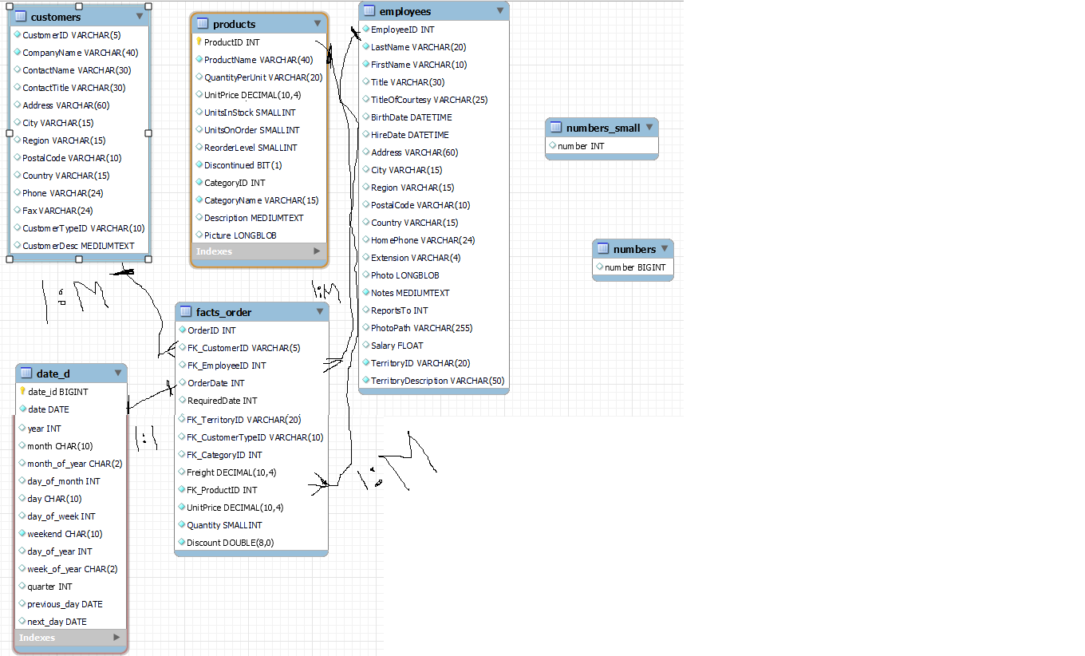

**Explanation of work :**

In olap we reduce columns of oltp because in olap we read or analyze the data not insert the data.

So we reduce columns by making dimension table and fact table .

In dimension all primary keys comes and showthey give who, what, where of a fact.

e.g: who customer Name, what Product Name

means dimension itself not show action but through dimension we view the

facts.

So in above diagram customer, employee ,products are dimensions through

this we view the fact_orders.

In fact table all the foreign keys and numeric value like measurements,quantity,

Price etc come.

e.g : in above diagram I do how many product order for customer.

So products and customer show orders(facts) means customer na is products ka suppose 3 order diya or description of orders orderdetails ma ha.

**Starflow or starschema**

**DateDimension**

[**https://classroom.google.com/c/NTYyNzQ5MjY4NjYz/m/NjAyMzg2NTEwNzI2/details**](https://classroom.google.com/c/NTYyNzQ5MjY4NjYz/m/NjAyMzg2NTEwNzI2/details)

**I copy sir date dimension script and make from here date diemsion.**

**-- products**

CREATE TABLE `products` (

`ProductID` INTEGER NOT NULL ,

`ProductName` VARCHAR(40) NOT NULL,

`QuantityPerUnit` VARCHAR(20),

`UnitPrice` DECIMAL(10,4) DEFAULT 0,

`UnitsInStock` SMALLINT(2) DEFAULT 0,

`UnitsOnOrder` SMALLINT(2) DEFAULT 0,

`ReorderLevel` SMALLINT(2) DEFAULT 0,

`Discontinued` BIT NOT NULL DEFAULT 0,

`CategoryID` INTEGER NOT NULL ,

`CategoryName` VARCHAR(15) NOT NULL,

`Description` MEDIUMTEXT,

`Picture` LONGBLOB

);

**-- customers**

CREATE TABLE `Customers` (

`CustomerID` VARCHAR(5) NOT NULL,

`CompanyName` VARCHAR(40) NOT NULL,

`ContactName` VARCHAR(30),

`ContactTitle` VARCHAR(30),

`Address` VARCHAR(60),

`City` VARCHAR(15),

`Region` VARCHAR(15),

`PostalCode` VARCHAR(10),

`Country` VARCHAR(15),

`Phone` VARCHAR(24),

`Fax` VARCHAR(24),

`CustomerTypeID` VARCHAR(10) NOT NULL,

`CustomerDesc` MEDIUMTEXT

);

**-- Employees**

CREATE TABLE `Employees` (

`EmployeeID` INTEGER NOT NULL AUTO_INCREMENT,

`LastName` VARCHAR(20) NOT NULL,

`FirstName` VARCHAR(10) NOT NULL,

`Title` VARCHAR(30),

`TitleOfCourtesy` VARCHAR(25),

`BirthDate` DATETIME,

`HireDate` DATETIME,

`Address` VARCHAR(60),

`City` VARCHAR(15),

`Region` VARCHAR(15),

`PostalCode` VARCHAR(10),

`Country` VARCHAR(15),

`HomePhone` VARCHAR(24),

`Extension` VARCHAR(4),

`Photo` LONGBLOB,

`Notes` MEDIUMTEXT NOT NULL,

`ReportsTo` INTEGER,

`PhotoPath` VARCHAR(255),

`Salary` FLOAT,

`TerritoryID` VARCHAR(20) NOT NULL,

`TerritoryDescription` VARCHAR(50) NOT NULL

);

**-- Fact_order**

CREATE TABLE `Facts_order` (

`OrderID` INTEGER NOT NULL AUTO_INCREMENT,

`FK_CustomerID` VARCHAR(5) ,

`FK_EmployeeID` INTEGER ,

`OrderDate` INT ,

`RequiredDate` INT,

`FK_TerritoryID` VARCHAR(20) ,

`FK_CustomerTypeID` VARCHAR(10) ,

`FK_CategoryID` INTEGER ,

`Freight` DECIMAL(10,4) DEFAULT 0,

`FK_ProductID` INTEGER NOT NULL ,

`UnitPrice` DECIMAL(10,4) NOT NULL DEFAULT 0,

`Quantity` SMALLINT(2) NOT NULL DEFAULT 1,

`Discount` REAL(8,0) NOT NULL DEFAULT 0

);

**Store procedure:**

**Employees store procedure:**

DELIMITER //

Create procedure insertinto_dim_employees()

Begin

SET FOREIGN_KEY_CHECKS=0;

truncate table starflow.employees;

-- SET FOREIGN_KEY_CHECKS=1;

insert into starflow.employees (

EmployeeID, LastName, FirstName, Title, TitleOfCourtesy, BirthDate, HireDate, Address, City, Region, PostalCode, Country, HomePhone,

Extension, Photo, Notes, ReportsTo, PhotoPath, Salary, TerritoryID, TerritoryDescription

)

SELECT

e.EmployeeID, e.LastName, e.FirstName, e.Title, e.TitleOfCourtesy, e.BirthDate, e.HireDate, e.Address, e.City,

e.Region, e.PostalCode, e.Country, e.HomePhone,

Extension, Photo, Notes, ReportsTo, PhotoPath, Salary,t.TerritoryID, t.TerritoryDescription

FROM northwind.employees as e

left join northwind.employeeterritories as em on em.EmployeeID=e.EmployeeID

left join northwind.territories as t on t.TerritoryID = em.TerritoryID;

end

//

DELIMITER ;

call starflow.insertinto_dim_employees();

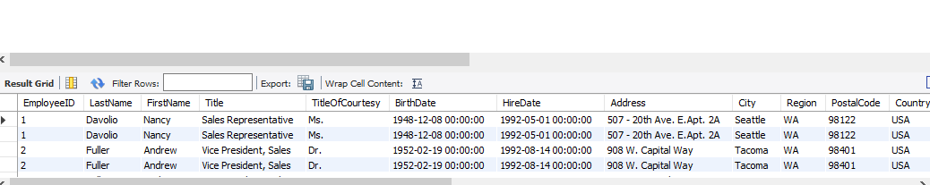

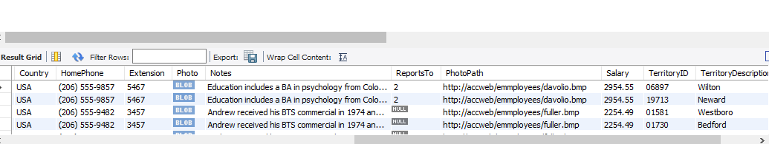

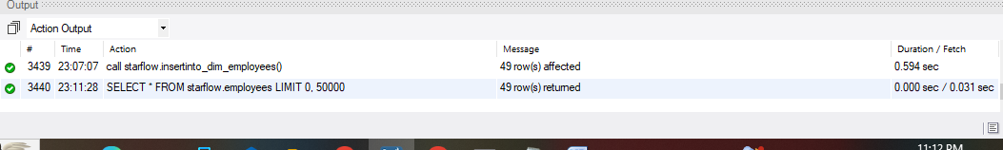

**Customers store procedure :**

DELIMITER //

Create procedure insertinto_dim_customers()

Begin

SET FOREIGN_KEY_CHECKS=0;

truncate table starflow.customers;

SET FOREIGN_KEY_CHECKS=1;

insert into starflow.customers (

CustomerID, CompanyName, ContactName, ContactTitle, Address, City, Region, PostalCode, Country, Phone, Fax, CustomerTypeID,

CustomerDesc

)

SELECT

c.CustomerID, c.CompanyName, c.ContactName, c.ContactTitle, c.Address, c.City, c.Region, c.PostalCode, c.Country, c.Phone, c.Fax,

cc.CustomerTypeID,cd.CustomerDesc

FROM northwind.customers as c

left join northwind.customercustomerdemo as cc on cc.CustomerID =c.CustomerID

left join northwind.customerdemographics as cd on cd.CustomerTypeID = cc.CustomerTypeID

WHERE c.CustomerID IS NOT NULL ;

end

//

DELIMITER ;

call starflow.insertinto_dim_customers();

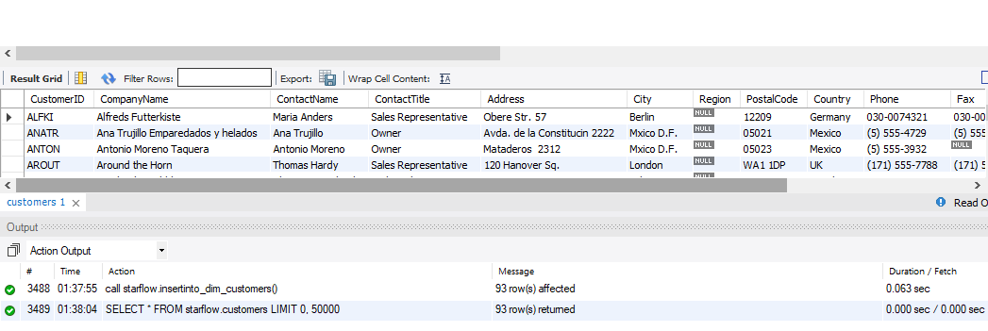

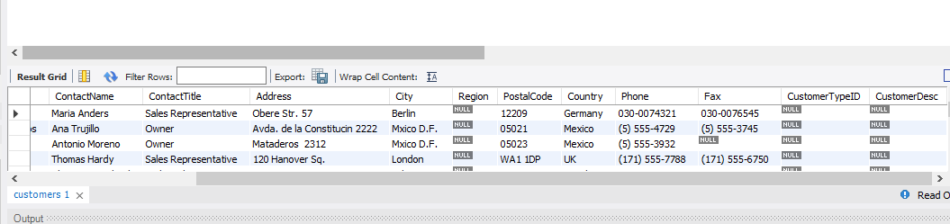

**Products store procedure:**

DELIMITER //

Create procedure insertinto_dim_products()

Begin

SET FOREIGN_KEY_CHECKS=0;

truncate table starflow.products;

SET FOREIGN_KEY_CHECKS=1;

insert into starflow.products (

ProductID, ProductName, QuantityPerUnit, UnitPrice, UnitsInStock, UnitsOnOrder, ReorderLevel, Discontinued, CategoryID, CategoryName,

Description, Picture

)

SELECT

ProductID, ProductName, QuantityPerUnit, UnitPrice, UnitsInStock, UnitsOnOrder, ReorderLevel, Discontinued,

c.CategoryID, c.CategoryName,c.Description,c.Picture

FROM northwind.products

left join northwind.categories as c on c.CategoryID = products.CategoryID

WHERE ProductID IS NOT NULL ;

end

//

DELIMITER ;

call starflow.insertinto_dim_products();

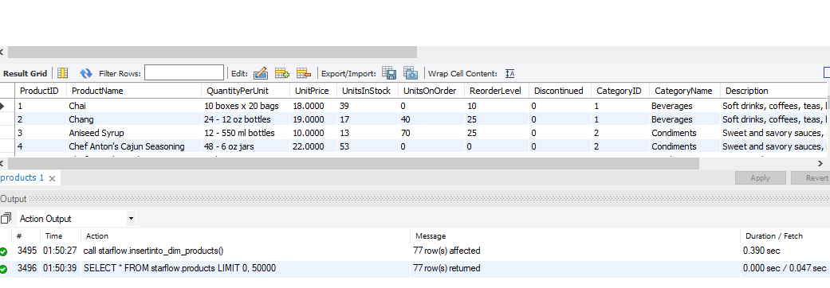

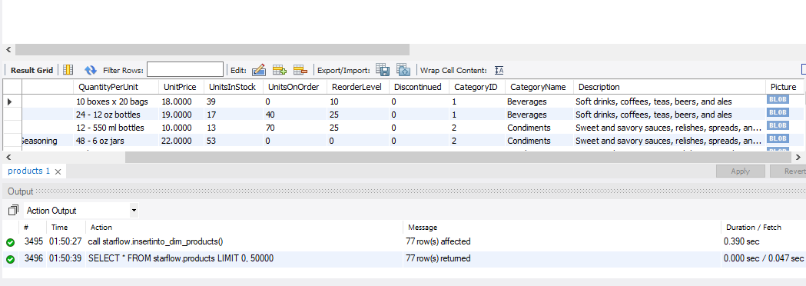

**Fact_order store procedure:**

DELIMITER //

Create procedure insertinto_dim_facts_order()

Begin

SET FOREIGN_KEY_CHECKS=0;

truncate table starflow.facts_order;

SET FOREIGN_KEY_CHECKS=1;

insert into starflow.facts_order(

OrderID, FK_CustomerID, FK_EmployeeID, OrderDate, RequiredDate, FK_TerritoryID, FK_CustomerTypeID, FK_CategoryID, Freight,

FK_ProductID, UnitPrice, Quantity, Discount

)

SELECT

orders.OrderID,

orders.CustomerID AS FK_CustomerID,

orders.EmployeeID AS FK_EmployeeID,

(YEAR(orders.OrderDate) * 10000 + MONTH(orders.OrderDate) * 100 + DAY(orders.OrderDate)) AS OrderDate,

(YEAR(orders.RequiredDate) * 10000 + MONTH(orders.RequiredDate) * 100 + DAY(orders.RequiredDate)) AS RequiredDate,

et.TerritoryID AS FK_TerritoryID,

cc.CustomerTypeID AS FK_CustomerTypeID,

orders.Freight,

p.categoryID AS FK_CategoryID,

od.ProductID AS FK_ProductID,

od.UnitPrice,

od.Quantity,

od.Discount

FROM

northwind.orders

LEFT JOIN

northwind.customers AS c ON c.CustomerID = orders.CustomerID

LEFT JOIN

northwind.employees AS e ON e.EmployeeID = orders.EmployeeID

LEFT JOIN

northwind.employeeterritories AS et ON et.EmployeeID = e.EmployeeID

LEFT JOIN

northwind.territories AS t ON t.TerritoryID = et.TerritoryID

LEFT JOIN

northwind.customercustomerdemo AS cc ON cc.CustomerID = c.CustomerID

LEFT JOIN

northwind.customerdemographics AS cd ON cd.CustomerTypeID = cc.CustomerTypeID

LEFT JOIN

northwind.orderdetails AS od ON od.OrderID = orders.OrderID

LEFT JOIN

northwind.products AS p ON p.ProductID = od.ProductID

LEFT JOIN

northwind.categories AS ct ON ct.categoryID = p.categoryID;

end

//

DELIMITER ;

call starflow.insertinto_dim_facts_order();

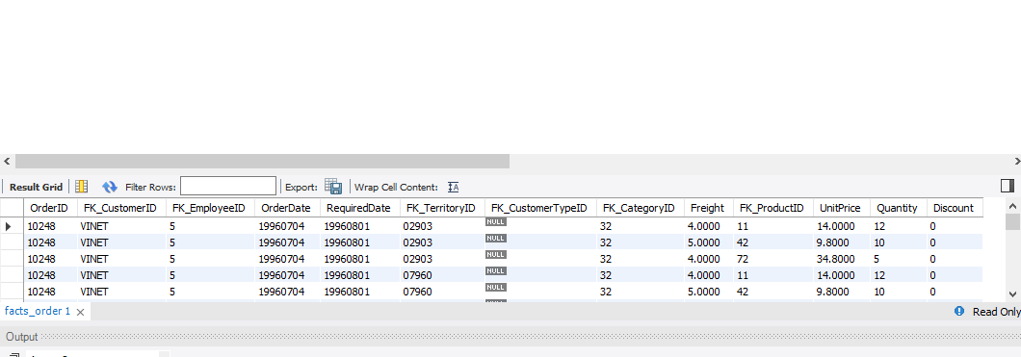

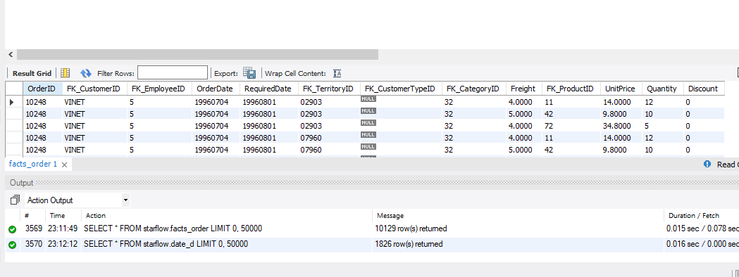

After bring data from oltp to olap now I add the sargate dimension , affected_date ,expiry_date ,is_current

**employees:**

ALTER TABLE `starflow`.`employees`

ADD COLUMN `employee_dimension_key` INT NOT NULL AUTO_INCREMENT AFTER `TerritoryDescription`,

ADD COLUMN `affected_date` DATETIME NOT NULL DEFAULT '2030-12-31 15:04:58' AFTER `employee_dimension_key`,

ADD COLUMN `expiry_date` DATETIME NOT NULL DEFAULT '2031-12-31 15:04:58' AFTER `affected_date`,

ADD COLUMN `iscurrent` INT NOT NULL DEFAULT 1 AFTER `expiry_date`,

ADD PRIMARY KEY (`employee_dimension_key`);

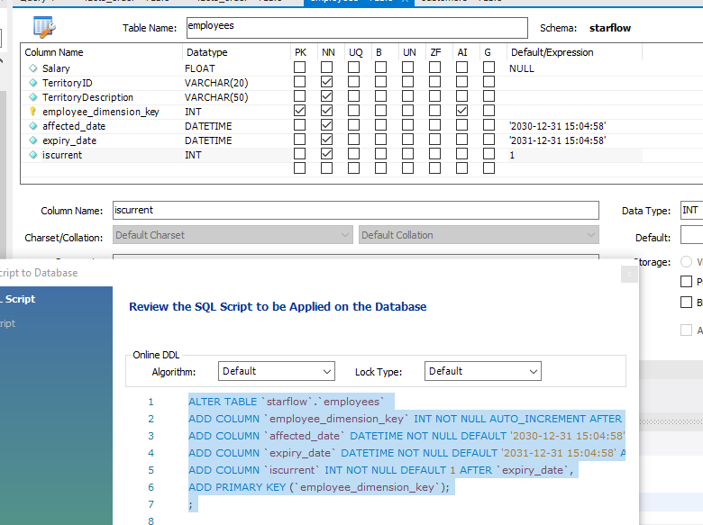

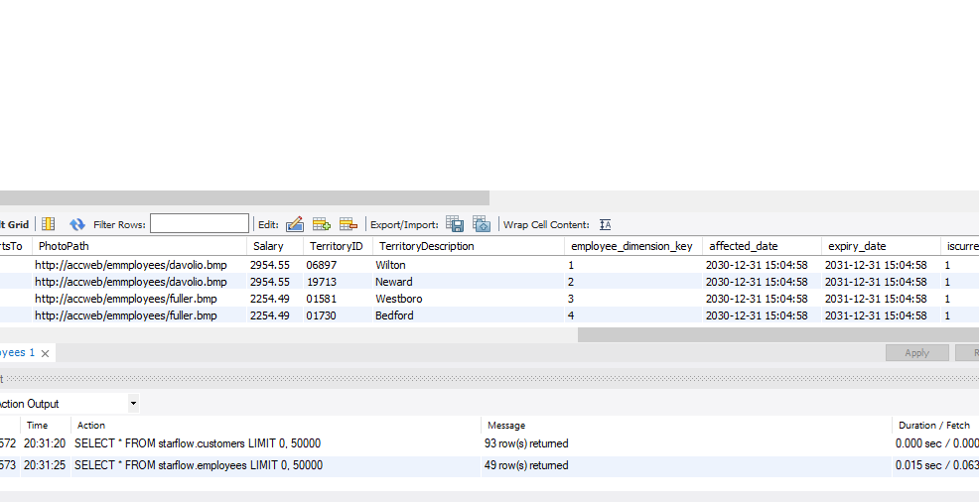

**Customer:**

ALTER TABLE `starflow`.`customers`

ADD COLUMN `customer_dimension_key` INT NOT NULL AUTO_INCREMENT AFTER `CustomerDesc`,

ADD COLUMN `affected_date` DATETIME NOT NULL DEFAULT '2030-12-31 15:04:58' AFTER `customer_dimension_key`,

ADD COLUMN `expiry_date` DATETIME NOT NULL DEFAULT '2031-12-31 15:04:58' AFTER `affected_date`,

ADD COLUMN `iscurrent` INT NOT NULL DEFAULT 1 AFTER `expiry_date`,

ADD PRIMARY KEY (`customer_dimension_key`);

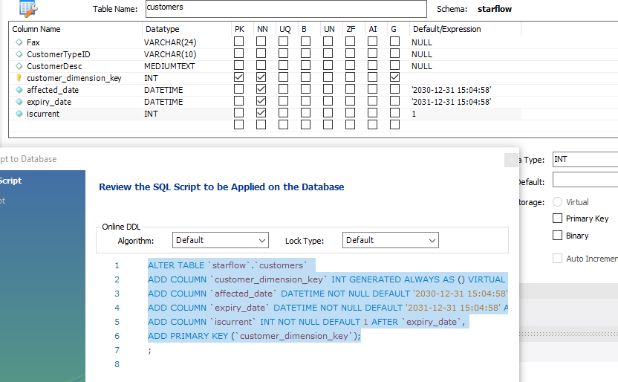

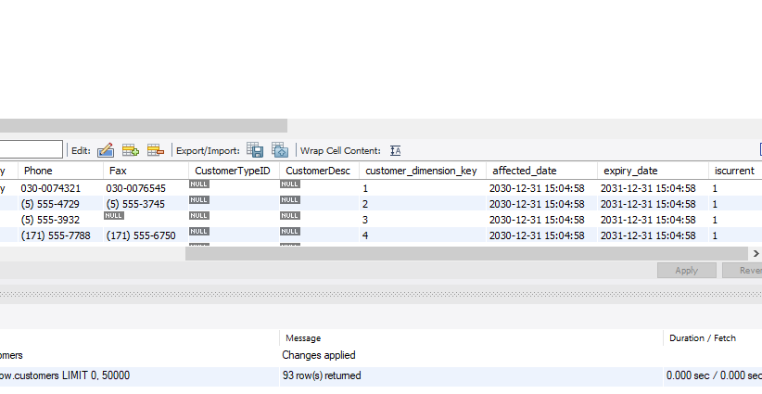

**Products:**

ALTER TABLE `starflow`.`products`

ADD COLUMN `product_dimension_key` INT NOT NULL AUTO_INCREMENT AFTER `Picture`,

ADD COLUMN `affected_date` DATETIME NOT NULL DEFAULT '2030-12-31 15:04:58' AFTER `product_dimension_key`,

ADD COLUMN `expiry_date` DATETIME NOT NULL DEFAULT '2031-12-31 15:04:58' AFTER `affected_date`,

ADD COLUMN `iscurrent` INT NOT NULL DEFAULT 1 AFTER `expiry_date`,

DROP PRIMARY KEY,

ADD PRIMARY KEY (`product_dimension_key`);

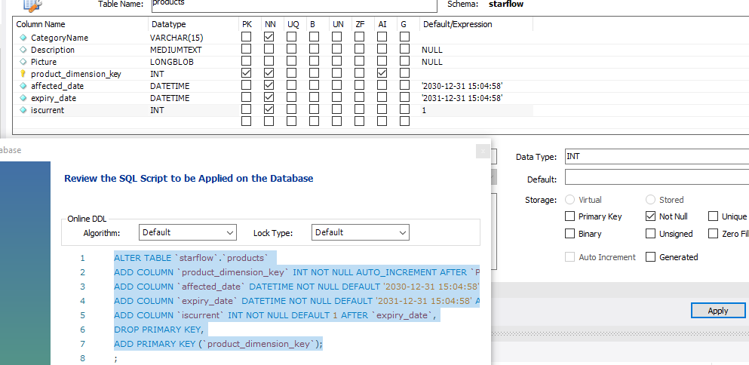

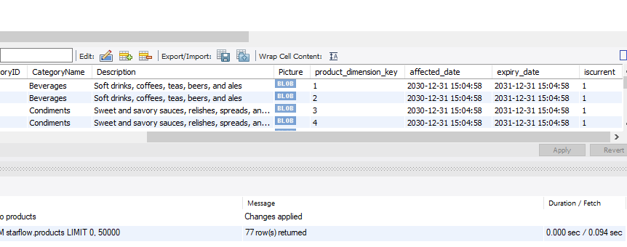

**NOW ERD column sarogate key , affected_date,expiry_date,current is also shown**

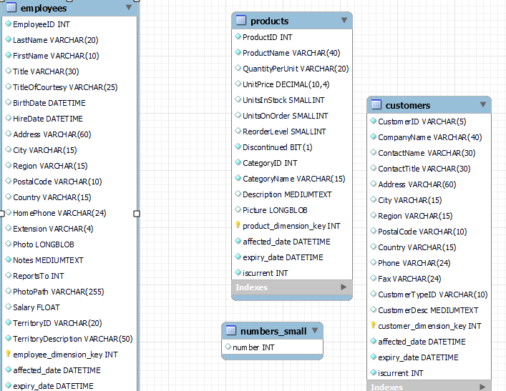

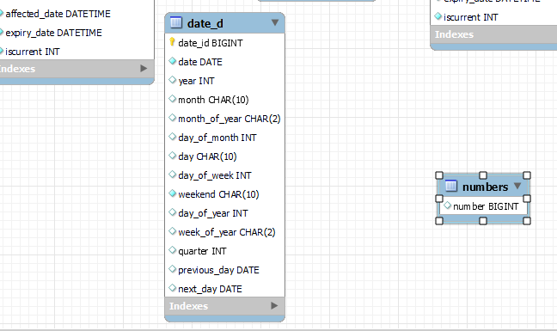

**SCD 2 implementation:**

**Update data:**

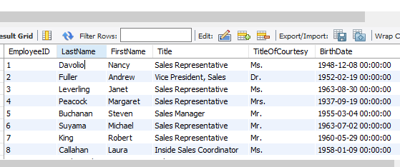

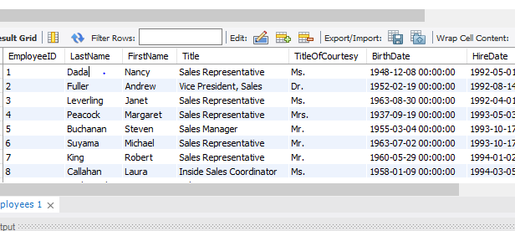

**Insert New Data:**

Now insert new data in employees and emploterritories of oltp (northwind).

**Employees:**

Insert into northwind.employees (

SELECT `employees`.`EmployeeID` +1,

'Raza',

'Mudassir',

`employees`.`Title`,

`employees`.`TitleOfCourtesy`,

`employees`.`BirthDate`,

`employees`.`HireDate`,

`employees`.`Address`,

`employees`.`City`,

`employees`.`Region`,

`employees`.`PostalCode`,

`employees`.`Country`,

`employees`.`HomePhone`,

`employees`.`Extension`,

`employees`.`Photo`,

`employees`.`Notes`,

`employees`.`ReportsTo`,

`employees`.`PhotoPath`,

`employees`.`Salary`

FROM `northwind`.`employees`

where EmployeeID = 9

)

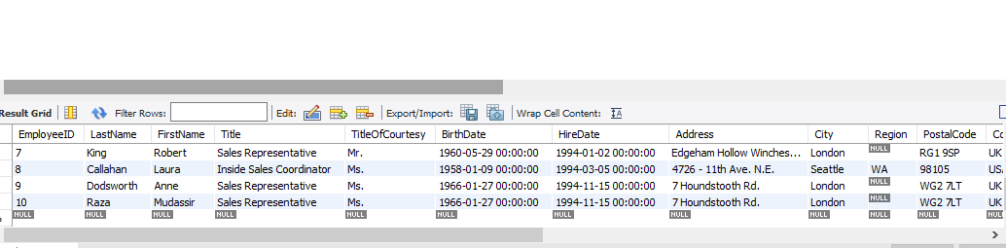

**Employeeterritories:**

Insert into northwind.employeeterritories (

SELECT `employeeterritories`.`EmployeeID` +1,

`employeeterritories`.`TerritoryID`

FROM `northwind`.`employeeterritories`

where EmployeeID =9

)

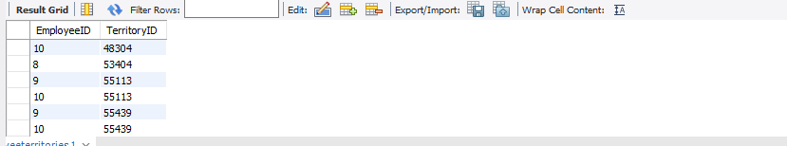

**Result:**

**Oltp data insert into olap**

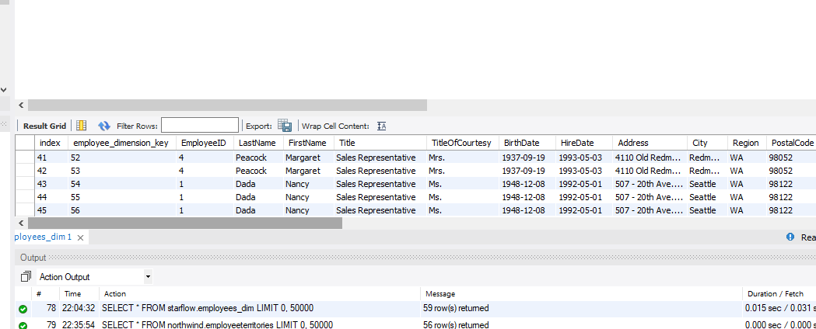

**Davalio update with dada in olap**

**And also new record insert in olap in which first name and last name is Mudassir and Raza is also insert.**

