University of Engineering and Technology

A brief description of Computer science and Engineering Department is here.

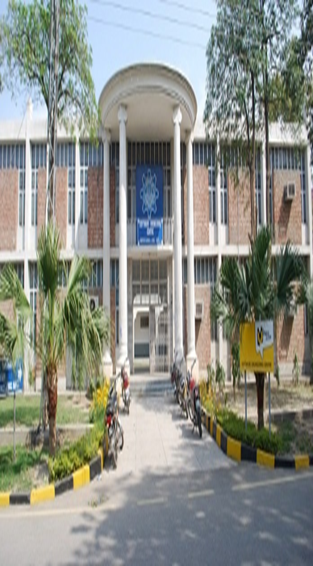

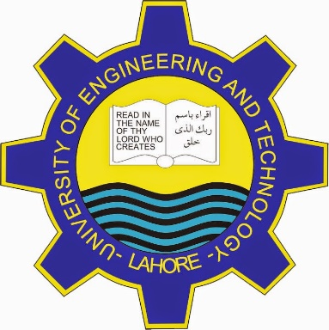 Faculty:

* Prof. Dr.khukdoon khurshid
* Prof. Dr. Shazad(chairman)
* Prof. Dr. Amaj Farooq

Contact Details:

For queries contact on official website

[www.uet.edu.pk](http://www.uet.edu.pk)

or

Call on

O327026115

Made BY:Muhammad Abubakar

Roll Number: 2023-CS-157

Facilities:

With the expansion in academic program, computer laboratories in the department has increased. The laboratories are equipped with

200+computersfully network.

Each student uses a single desktop system and as instructed by the teacher

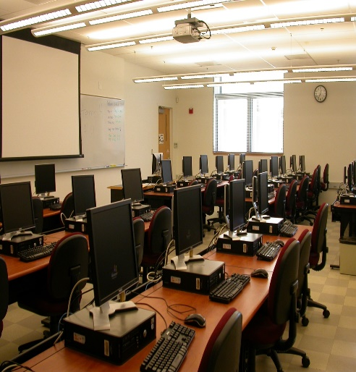

Computer to student ratio is 1:1. The department fells proud on its piracy privacy.

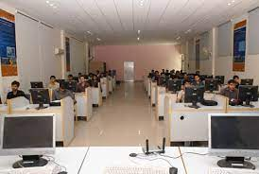

**Introduction:** The department of Computer Science and Engineering was originally established as Department of Computer Science in 1991. Its history dates back to the year 1968 when University of Engineering and Technology Lahore established a computer center. This center was responsible for planning and teaching courses in Computer Science and Numerical analysis, which formed an integral part of the circular for all the discipline of B.SC. The center also offered short term computer courses for other private and public sector organization.

**Mission:**

To disseminate computing education

To the students of the department emphasizing entrepreneurship and ethical standards while encouraging them to remain abreast with latest developments in computing tools and processes and use their skills to identify and find solution the society’s problems; And to use department’s resources and computing expertise to help industry, government & community in solving their problem.

Computer Science.. jobs should be way more interesting than even going to wall street or being a lawyer—or, I can argue, than anything but perhaps biology, and there it’s just be a tie.

“Bill Gates..”

**Degree & double degree Program:**

Here we offer four year degree programs in terms of Bs (hons) which was introduced by the department in 1999. The degree of this program is affiliated by **PEC** (Pakistan education council).

PhD. Program in computer science was launched in 2002.

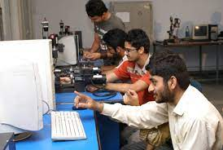

Here now we also offer double degree program. Three student each from the graduating class of computer science and computer engineering may opt for a second degree in computer engineering and science as the case may be subject to fulfillment of prescribe conditions, from fall semester 2011.

**Research:**

Estimate Theory, signals processing, modern control related areas, Data bases, semantic web and related areas. 