**Your name: Muhammad Abubakar** Abubakar

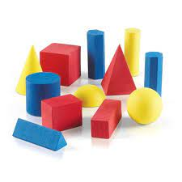

***Rectangle***

***Square***

***Triangle***

***Oval***

**Matching**

Match the shapes with their names.