**Your name: Muhammad Abubakar**

**Write the name of following fruits**

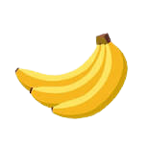

**1) ________________**



**2) ________________**

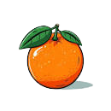

**3) ________________**

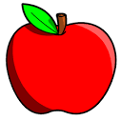

**4) ________________**