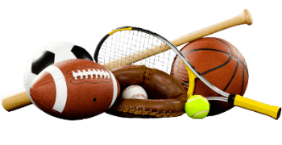 **SPORTS GALA2023**

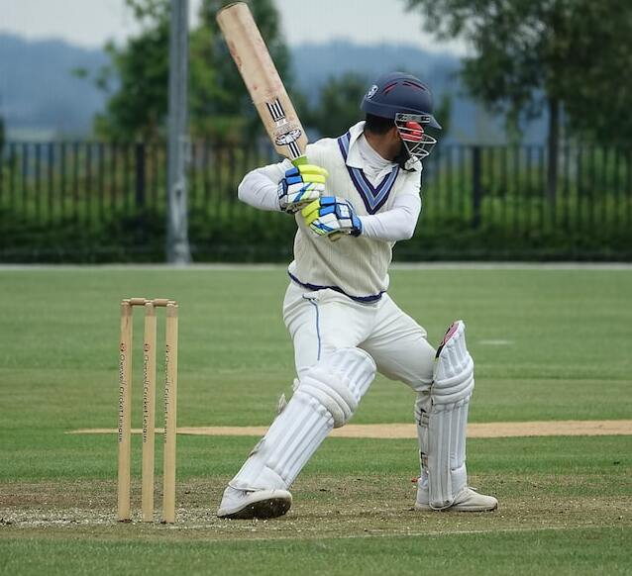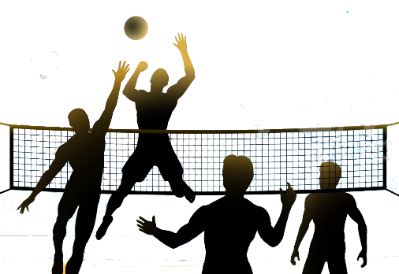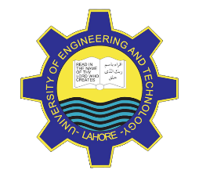

THIS YEAR…

IT’S BIGGER!

MORE FUN!

University of Engineering and Technology, Lahore

This Year we present awards in these categories.

* Top scorer- Soccer
* Man of the match- Cricket
* Best Player- Volley Ball

**Time:** From 10:00a.m

Until 12:00p.m

Sports Complex

**Date:** 30 Sep, 2023



Guest OF Honor:

SHAHID AFRIDI