|  |
| --- |
| Close-up image showing the leaf-sides of two oversized books side-by-side on a bookshelf, with additional books in soft focus background |
| ECCE 635 **Deep Learning Systems Design** Assignment no 1 |
| |  |  |  | | --- | --- | --- | | Muhammad Muneeb | 9/6/20 | ID 100052975@ku.ac.ae | |

**Part 1:** Conceptual Questions  
**1. What is a deep learning model? How is it different from machine learning models?**  
  
Deep learning is subset of machine learning but deep learning model has two major differences from classic machine learning model.  
  
In deep learning model, we rely on model for feature extraction which it extracts from data.  
In deep learning model number of layers are comparatively more as compared to machine learning model.  
In deep learning model even a small change in feature learned by model will cause major changes in weights learned by network.

**2. What is the difference between training, validation, and test sets?**   
Training data is used to train the model and weights of the network are updated based on loss function calculated using data points in training data.  
  
Test data is used to measure the performance of model. Model should be tested on unseen data that is why we need validation data to make various major changes to hyperparameters.   
  
Validation data is also a part of training. It is used to give an estimate of model performance while tuning hyperparameters. It is also used for cross-validation.

**3. What is the difference between classification and regression tasks? Give an example.**  
Classification and regression both are supervised machine learning. The main difference between them is that the output variable for classification is categorical (some class) while in regression it is numerical value.

Regression Example  
Weather forecasting (Temperature prediction) using data from previous days, Covid-19 cases prediction using cases in previous days.

Classification Example

Sentiment analysis using text (angry, happy, sad etc.).  
Speaker Recognition.

**4. What do we mean by one-hot encoding? Give an example**.   
One-hot encoding is the process of converting the Category (Class label) into some numerical value.  
It helps to convert the text into numerical value so network performance can be increased.  
One-hot encoding can be explained better with image.

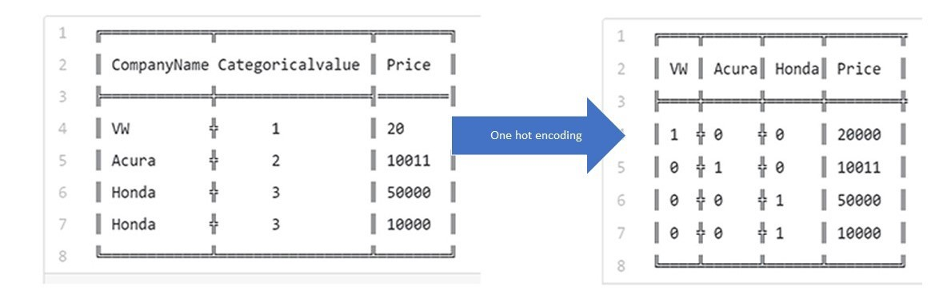

Figure : Source -https://hackernoon.com/what-is-one-hot-encoding-why-and-when-do-you-have-to-use-it-e3c6186d008f

Consider the above example.   
Company name is a label and we have converted each label to feature.  
In feature column if Company name appears, we will put 1 otherwise 0. By this transformation network performance will increase.

**5. How does splitting a dataset into training, validation, and test sets help identify overfitting?**We can trace overfitting on two steps.  
First we will train model using training dataset.  
Then we will use validation data to test network performance.  
If performance of network is not good on validation data then it means our model is overfit and we have to update the parameters.  
If performance of network on validation data is good then we test it using test data.  
If performance of network is not good on test data then it means our model is overfit and we have to update the parameters else our model will perform good on unseen data and is not overfit.  
  
So, we can trace overfitting on stages by spitting data into training, validation and test sets.

**6. Training a neural network revolves around different objects, what are they? Provide a brief**

**description of each object. Refer to the below diagram for your answer. List three objects.**  
These are three objects.  
Weights of layer (Back propagation) – In every iteration we will update weights of layers in neural network.  
Loss function (loss score)  
Optimizer – To minimize loss function.

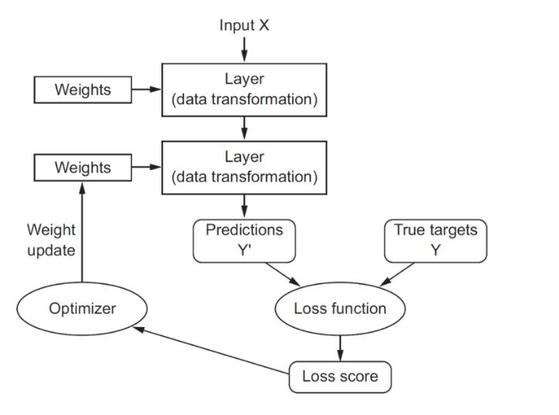**Input** - Input to machine learning model (Scalar, Vector, Matrix or n Dimension data)  
**Layer** – Layer is set of neurons and neural network consists of fully connected layers. Every connection between neurons has weight. Layers perform nonlinear transformations of the inputs entering the network using activation functions.  
**Weights** - As an input enters the node, it gets multiplied by a weight value and the resulting output is generated. Weights make decision boundary in classification machine learning algorithm. Knowledge in model is stored in form of weights. Each neuron has some weight.  
**Prediction** - Values of the samples(data points) prediction by machine learning model.(Yhat)  
**True Values** - The actual values of the samples(data points) in data set.(Y)  
**Loss function** - Loss function is used to determine how well our algorithm is working on data.  
(1/n(Y-Yhat)2)  
**Loss Score** – Value generated by loss function which measures how well our model is performing on data.  
**Optimizer** - It is algorithm used to change the parameters of the network such as weights and learning rate to reduce the losses.

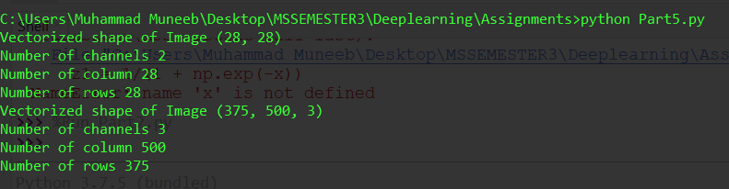**Part 2:** Programming Assignment

There are two images first is of number 7 and other is of cat.

**First Difference**  
“Number 7” image is grayscale image and it does not have RGB channels.  
“Cat” image is RBG image and it has 3 channels. Each of the dimension in array representation is representing 1 channel in this order Red, Blue and Green.  
 **Second Difference**  
If we look in detail we will notice that in “Number 7” image pixel is represented by one number [X] where X ranges from 0 to 255 whereas in “Cat” image pixel is defined array of 3 [R G B]. R G and B ranges from 0 to 255.   
  
**Input form**: Pass directory and image name with extension that you want to read.