|  |
| --- |
| **LECTURE -03**      **Cover Letter**    ***Course Instructor: Laiq Hasan*** |

**What is a Cover Letter?**

* It is a document that accompanies your CV when applying for a job.
* It is short ( usually 200-250) words and follows the layout of a letter. ▪ It is the answer to employer’s question “ Why should we hire you?“ ▪ Usually, the first thing that the recruiter sees.

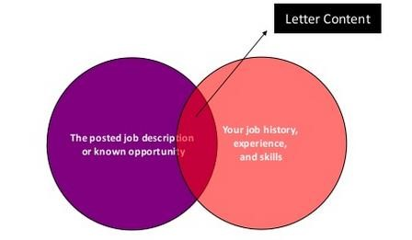

**Why do we need it?**

* Cover letter is a chance for the candidate to
* Highlight skills and achievements relevant to the particular employer.
* Demonstrate the knowledge about organization and the motivation to work there.
* Summarize the work experience till date tailored to the competencies required by the employer.
* Cover letter is sometimes used by the recruiters to assess your written communication skills.

**Example Scenario**

* Suppose you are looking for someone to walk your dog.
* You create a job ad.

Dog Walker Needed.

Must love dogs

**Alice Emails You**

I love dogs!

I have 6 of my own and we go for a walk everyday. For more information, please check the attached CV.

**Bob Emails You**

To whom it may concern.

Please find the attached CV.

Meanwhile Bob is thinking,

If I did not love dogs, why would I be applying for this job? I have already mentioned all the details in my CV. I hate writing cover letters!

**Think as an employer**

* Who are you more impressed of?
* Whose resume are you going to bother opening?
* As an employer, you not only want to know that the person you hire is a great person but also that (s)he is the **right person** for your **specific job.**

# Cover Letter Layout

* A cover letter typically follows the following layout.
* Sender’s details.
* Receiver’s details.
* Salutation.
* Paragraph 1. ▪ Paragraph 2. ▪ Paragraph 3. ▪ Paragraph 4.

# Sender’s Details

▪ Your name and contact details should either be written in the center or in top right corner of your cover letter.

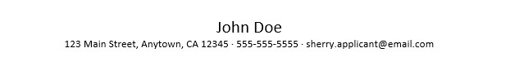

# Receiver’s Details

* Underneath, aligned left, the name, function, organization and address of the person you are writing to is written, after the date.
* It is better to know the name of the person who is going to read the letter. If you do not know, write the address of the organization.

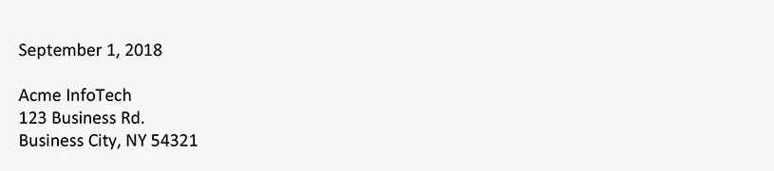

# Salutation

* If you know the name of the addressee, start your letter by Dear Mr,Ms,Mrs,Dr followed by the surname of the addressee ( Dear Dr Smith).
* If you do not know the name, write the position of the receiver.

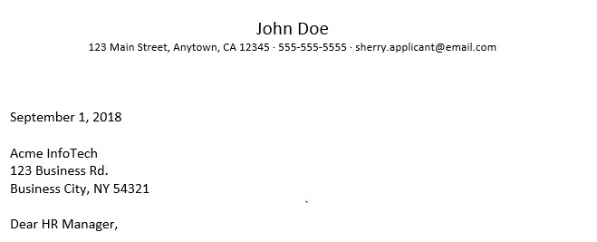

# Paragraph 1

Introduce yourself.

* Be brief.
* Talk from a professional perspective.
* Why the position and company interests you? Show your motivation.

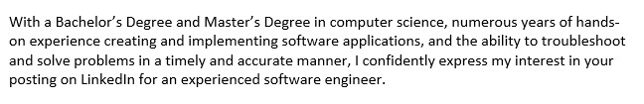

# Paragraph 2

Your competencies

* Study the job advert.
* Match the job requirements with your relevant competencies.
* Be concrete, give examples.

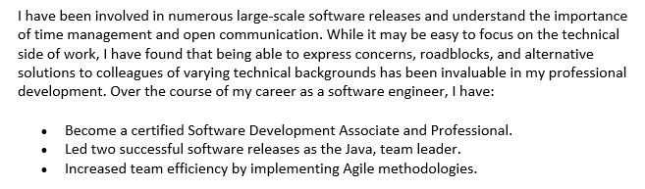

CE-318L:

# Paragraph 3

You as an employee

* Your personality.
* What do you bring to the table?

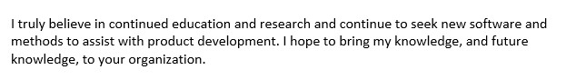

# Paragraph 4

* Final details
* Closing remarks.
* Suggest a concrete follow up for your application.
* Your availability and details for an interview.
* End salutation.

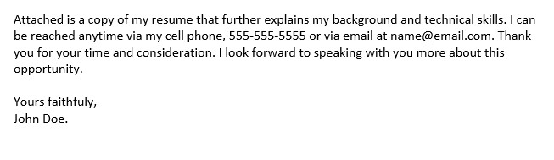

**Putting it all together**

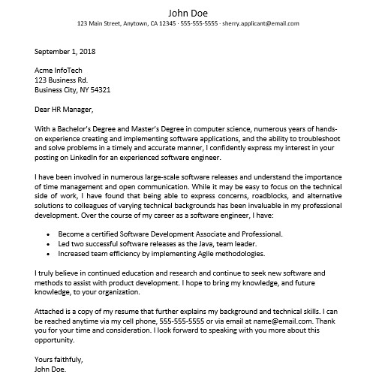

# Cover Letter Tips

* Keep it short.
* Be clear about what job you are applying to.
* Show that you have researched the company.
* Address it to the right person.
* Use standard business fonts (Times New Roman, Arial).

# Assignment

* You have already written a Motivation Letter in your previous assignment.
* Now, write a Cover Letter for a job and company of your choice.
* Compare and contrast your Motivation Letter with your Cover Letter.
* Submit your response to the 3rd bullet along with your cover letter by next Tuesday.