Lab Report No. 06



Submitted By: Muhammad Musa

Registration No: 22pwcse2157

Section: Section C

“On my honor , as student of University of Engineering and Technology, I have neither given nor received unauthorized assistance on this academic work”

Department of Computer Systems Engineering

University of Engineering and Technology Peshawar

## Task 6.1

## 

**Result:**

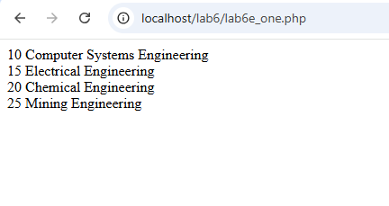

## Task Two:

## 

## Results:

## 

## Task Three:

## Results:

## 

## Example 4:

## Results:

## 

## Task a:

## Results:

## 

## Task b:

## 

## 

## Results:

## 

## Task C;

## 

## 

## 

## Results:

## 

## Task D: