**DBMS LAB PROJECT MOVENTUR:**

**SQL AND / OR NO-SQL**

**IMPLEMENTATION**

**KEY MILESTONE # 0****3**

**Spring 2024**

**CSE-403L**

**Database Management System Lab**

Submitted by:

**Muhammad Musa (22PWCSE2157)**

**Muhammad Jasim (22PWCSE2021)**

**YASEEN AHMED (21PWCSE2002)**

Class Section: **‘C’**

“We affirm that we have completed this work with integrity”

Submitted to:

**Engr. Sumayyea Salahuddin**

May 29, 2025

Department of Computer Systems Engineering

University of Engineering and Technology, Peshawar

**DBMS Lab Project: SQL Implementation**

**Implementation in NoSQL MongoDB:**

***CREATE DATABASE VotingElectionDB;***

***USE VotingElectionDB;***

***CREATE TABLE Voter (***

***VoterID INT AUTO_INCREMENT PRIMARY KEY,***

***Name VARCHAR(100) NOT NULL***

***);***

***CREATE TABLE Election (***

***ElectionID INT AUTO_INCREMENT PRIMARY KEY,***

***ElectionType VARCHAR(50) NOT NULL***

***);***

***CREATE TABLE Candidate (***

***CandidateID INT AUTO_INCREMENT PRIMARY KEY,***

***Name VARCHAR(100) NOT NULL,***

***Party VARCHAR(100) NOT NULL,***

***ElectionID INT,***

***FOREIGN KEY (ElectionID) REFERENCES Election(ElectionID)***

***);***

***CREATE TABLE PollingStation (***

***PollingStationID INT AUTO_INCREMENT PRIMARY KEY,***

***Location VARCHAR(100) NOT NULL***

***);***

***CREATE TABLE Vote (***

***VoteID INT AUTO_INCREMENT PRIMARY KEY,***

***VoterID INT,***

***CandidateID INT,***

***ElectionID INT,***

***PollingStationID INT,***

***FOREIGN KEY (VoterID) REFERENCES Voter(VoterID),***

***FOREIGN KEY (CandidateID) REFERENCES Candidate(CandidateID),***

***FOREIGN KEY (ElectionID) REFERENCES Election(ElectionID),***

***FOREIGN KEY (PollingStationID) REFERENCES PollingStation(PollingStationID),***

***UNIQUE (VoterID, ElectionID)***

***);***

***INSERT INTO Voter (Name) VALUES***

***('John Doe'),***

***('Jane Smith'),***

***('Alice Johnson');***

***INSERT INTO Election (ElectionType) VALUES***

***('Presidential'),***

***('Local');***

***INSERT INTO Candidate (Name, Party, ElectionID) VALUES***

***('Bob Brown', 'Party A', 1),***

***('Carol White', 'Party B', 1),***

***('David Green', 'Party C', 2);***

***INSERT INTO PollingStation (Location) VALUES***

***('City Hall'),***

***('Community Center');***

***INSERT INTO Vote (VoterID, CandidateID, ElectionID, PollingStationID) VALUES***

***(1, 1, 1, 1),***

***(2, 2, 1, 1),***

***(3, 3, 2, 2);***

**Database:**

**Implementation in SQL:**

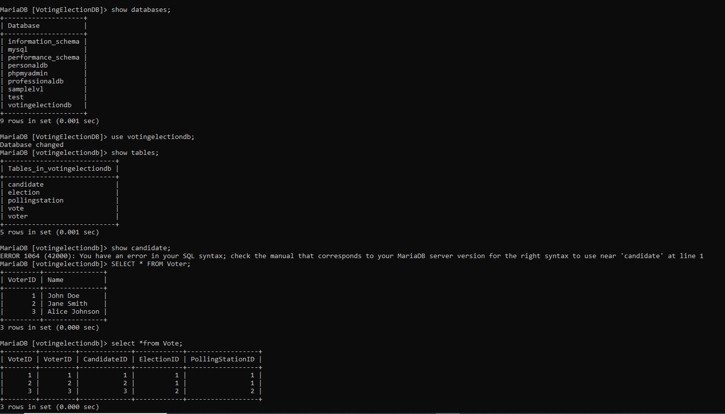

The End.