**Static Web Design using HTML**

**LAB REPORT # 02**



**Spring 2025**

**CSE-403L: Database Management System Lab**

Submitted by: **Muhammad Musa**

Registration # **22PWCSE2157**

Class Section: **C**

Submitted to:

**Engr. Summayea Salahuddin**

6 Feb 2025.

Department of Computer Systems Engineering

University of Engineering and Technology, Peshawar.

**Example 1:**

**OutPut of Task1:**

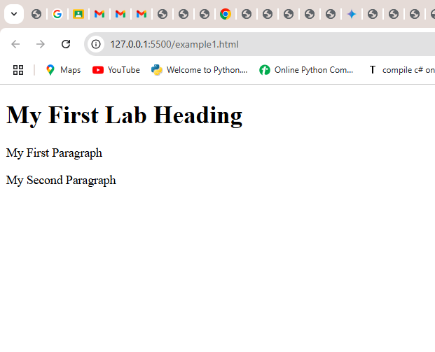

**Comment:** This HTML code makes a webpage where the text is white and there's a background picture. It shows you how to make text bold, *slanted*, bigger, smaller, and put letters up high or down low. It's a basic example of how to change the look of text on a webpage.

**Example 2:**

**Output of Eample :**

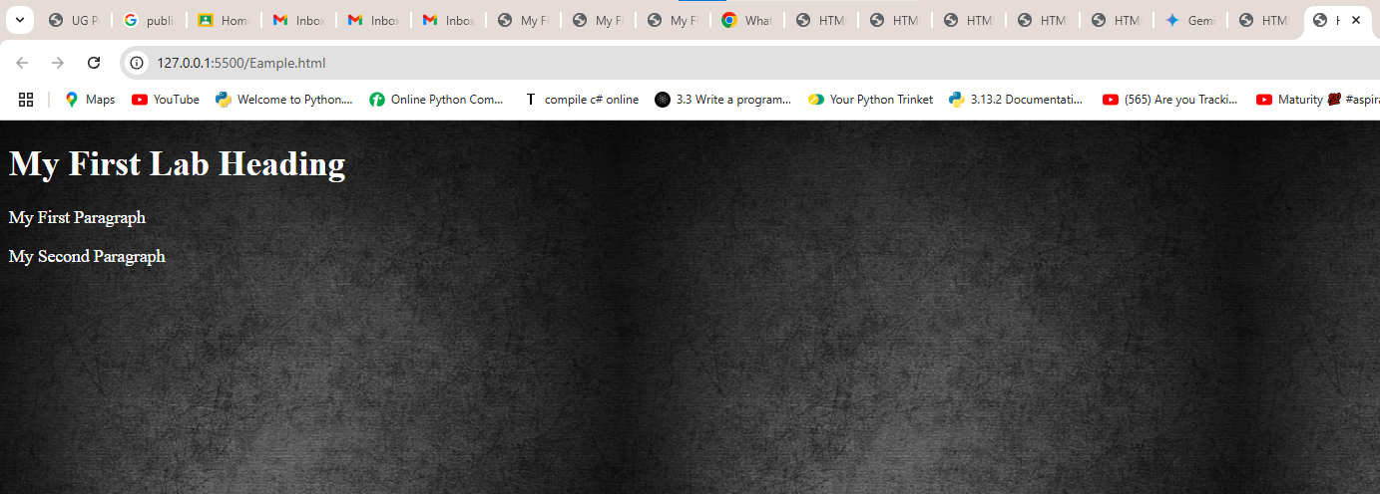

**Exmaple 3:**

**Output of Example3:**

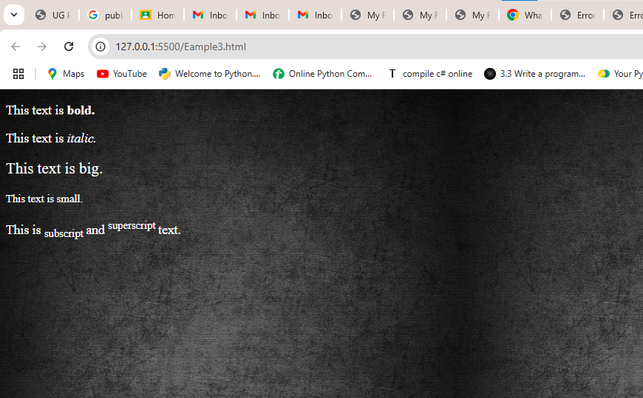

**Example 4:**

**Code:**

<!DOCTYPE html>

<html lang="en">

<head>

<meta charset="UTF-8">

<meta name="viewport" content="width=device-width, initial-scale=1.0">

<title>Using Preformatted Text in HTML</title>

</head>

<body>

<h2>Use of pre tag</h2>

<big><i><b> <pre>

a = 2;

for i = 1:10

i = i+a

end

</pre></b></i></big>

</body>

</html>

**Example 4 Output:**

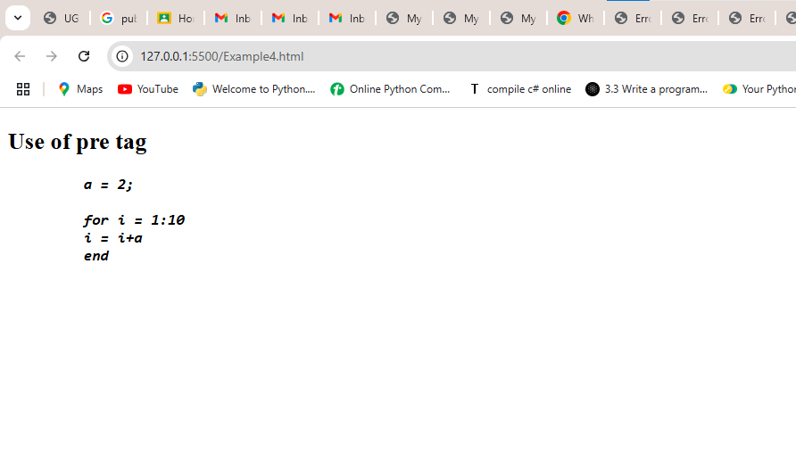

**Example 5 :**

**Output:**

**Example 06:**

**Output:**

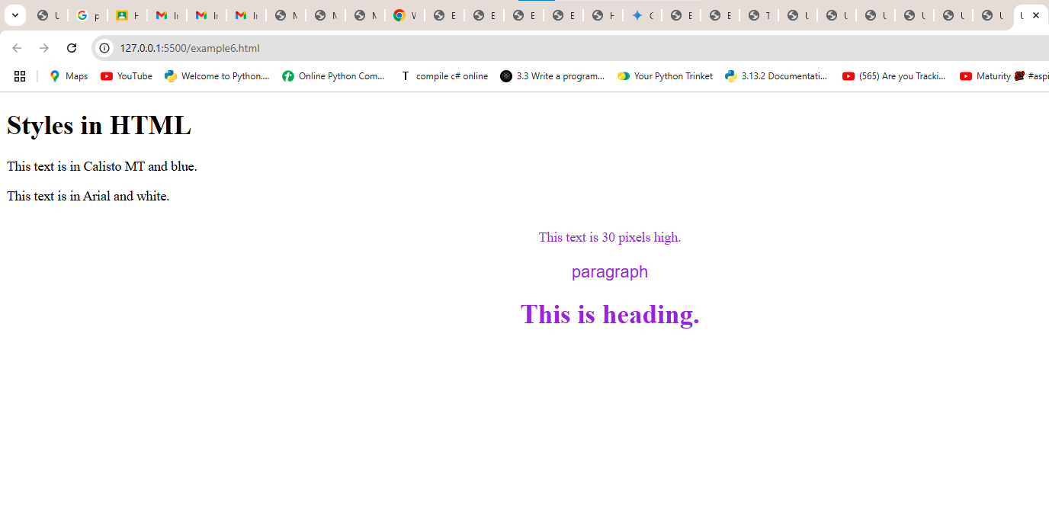

**Example 07:**

**Output:**

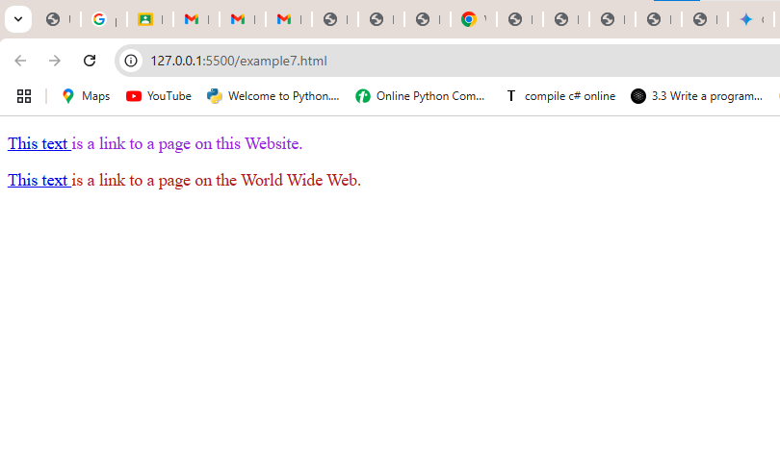

**Example 8:**

**output:**

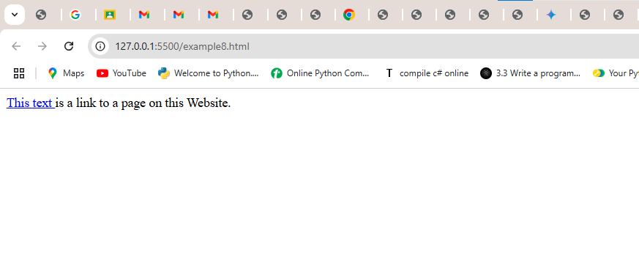

**Example 9:**

**Output:**

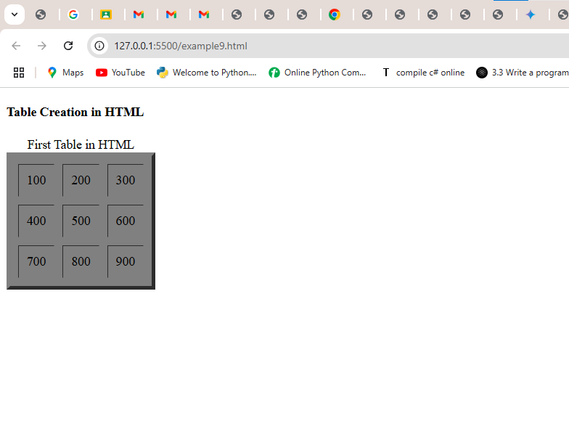

**Example 10:**

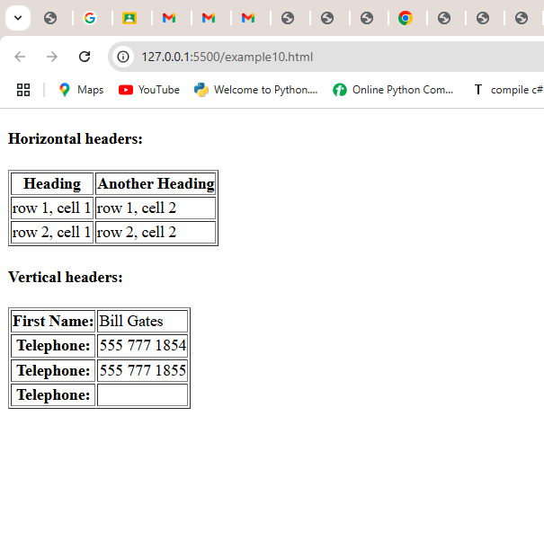

**Example 11:**

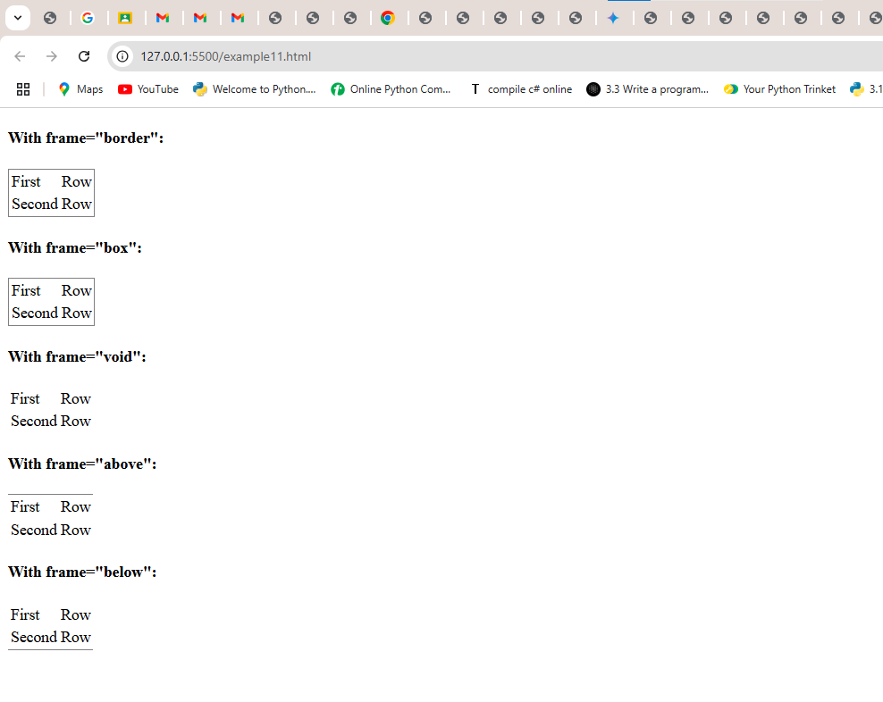

**Example 12:**

**Output:**

**Example 13:**

**Output:**

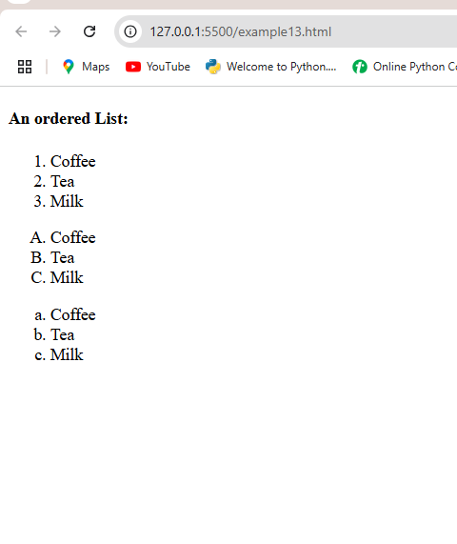

**Example 14:**

**Output:**

**Example 15:**

**Output:**

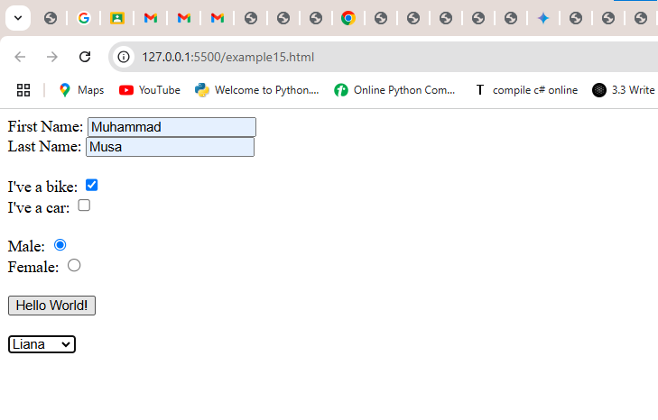

**Example 16:**

**output:**

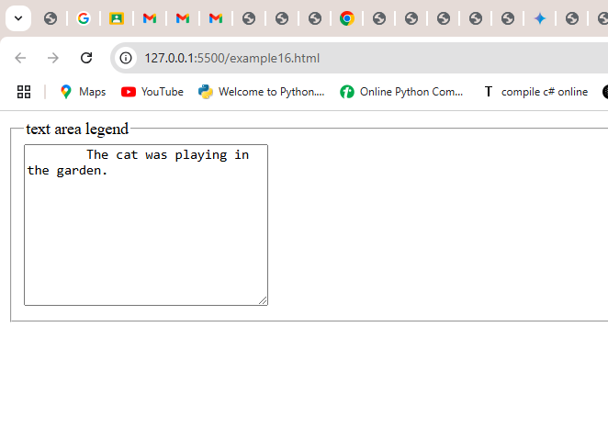

**Example 17:**

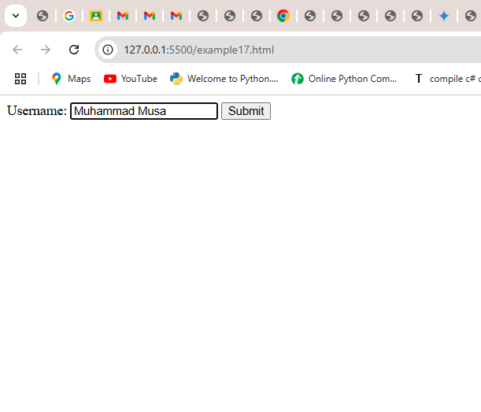

**Comments:**

**Website :**

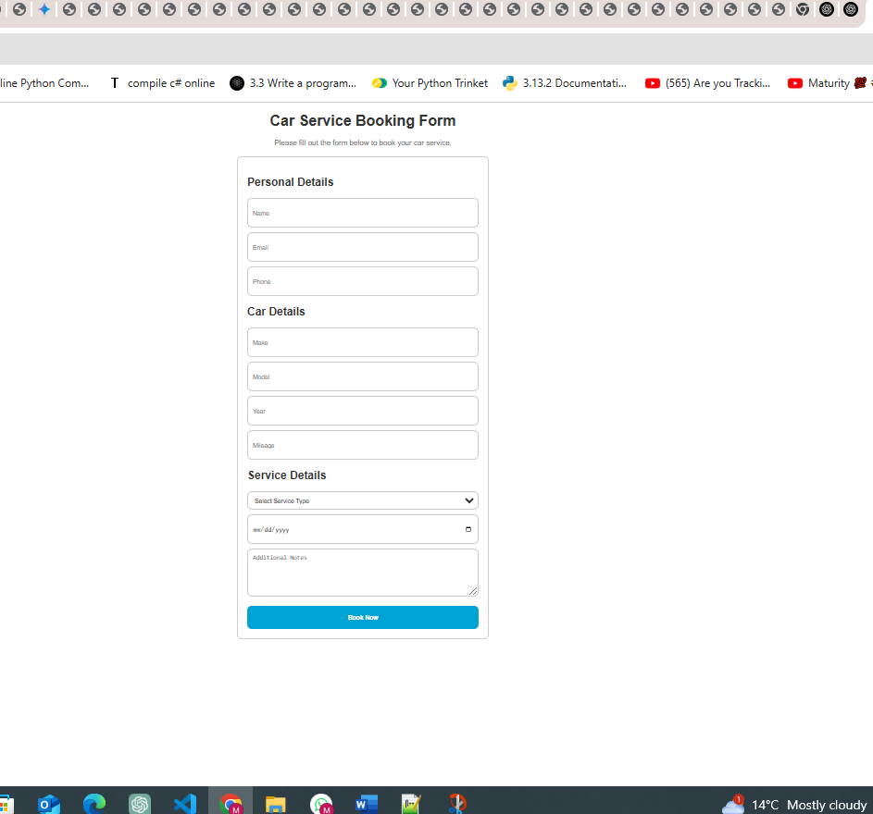

**a) Lab report as a Word document having both lab performance and homework tasks, and  
b) The html files of Task 2.1 part 3, Task 2.2, Task 2.3, and Task 2.4.  
c) Use the following naming format of your zip file: 2144_lab02.zip**

**Task 2.1**

**Theory: How HTML can be helpful for a SQL/NoSQL database? Write a short note in your lab**

**report. (1.5 Marks)**

Basically, HTML lets you build the "face" of a website or app that talks to a database. Think of it like this:

* Showing the info: If the database has a list of products, HTML makes that list look nice on a webpage.
* Letting you add stuff: If you want to add a new product to the database, HTML creates the form where you type in the product details.

So, HTML is how users see and interact with the data stored in a database

**Task 2.1 part 3:**

**Code :**

**<!DOCTYPE html>**

**<html lang="en">**

**<head>**

**<meta charset="UTF-8">**

**<meta name="viewport" content="width=device-width, initial-scale=1.0">**

**<title>Car Service Booking Form</title>**

**</head>**

**<body>**

**<form action="" style="font-family: Arial, sans-serif; font-size: 16px;">**

**<h1 style="text-align: center; color: #333333;">Car Service Booking Form</h1>**

**<p style="text-align: center; color: #666666;">Please fill out the form below to book your car service.</p>**

**<div style="display: flex; justify-content: center; margin: 20px;">**

**<div style="width: 500px; border: 2px solid #cccccc; border-radius: 10px; padding: 20px;">**

**<h2 style="color: #333333;">Personal Details</h2>**

**<div style="display: flex; flex-direction: column; gap: 10px;">**

**<input type="text" id="name" name="name" placeholder="Name" required style="height: 40px; border: 2px solid #cccccc; border-radius: 10px; padding: 10px; color: #333333;">**

**<input type="email" id="email" name="email" placeholder="Email" required style="height: 40px; border: 2px solid #cccccc; border-radius: 10px; padding: 10px; color: #333333;">**

**<input type="tel" id="phone" name="phone" placeholder="Phone" required style="height: 40px; border: 2px solid #cccccc; border-radius: 10px; padding: 10px; color: #333333;">**

**</div>**

**<h2 style="color: #333333;">Car Details</h2>**

**<div style="display: flex; flex-direction: column; gap: 10px;">**

**<input type="text" id="make" name="make" placeholder="Make" required style="height: 40px; border: 2px solid #cccccc; border-radius: 10px; padding: 10px; color: #333333;">**

**<input type="text" id="model" name="model" placeholder="Model" required style="height: 40px; border: 2px solid #cccccc; border-radius: 10px; padding: 10px; color: #333333;">**

**<input type="text" id="year" name="year" placeholder="Year" required style="height: 40px; border: 2px solid #cccccc; border-radius: 10px; padding: 10px; color: #333333;">**

**<input type="text" id="mileage" name="mileage" placeholder="Mileage" required style="height: 40px; border: 2px solid #cccccc; border-radius: 10px; padding: 10px; color: #333333;">**

**</div>**

**<h2 style="color: #333333;">Service Details</h2>**

**<div style="display: flex; flex-direction: column; gap: 10px;">**

**<select id="service-type" name="service-type" required style="height: 40px; border: 2px solid #cccccc; border-radius: 10px; padding: 10px; color: #333333;">**

**<option value="" disabled selected>Select Service Type</option>**

**<option value="Oil Change">Oil Change</option>**

**<option value="Tire Rotation">Tire Rotation</option>**

**<option value="Brake Inspection">Brake Inspection</option>**

**<option value="Battery Check">Battery Check</option>**

**<option value="Other">Other</option>**

**</select>**

**<input type="date" id="service-date" name="service-date" required style="height: 40px; border: 2px solid #cccccc; border-radius: 10px; padding: 10px; color: #333333;">**

**<textarea id="service-notes" name="service-notes" placeholder="Additional Notes" rows="5" cols="50" style="border: 2px solid #cccccc; border-radius: 10px; padding: 10px; color: #333333;"></textarea>**

**</div>**

**<input type="submit" value="Book Now" style="width: 100%; height: 50px; background-color: #00a0d2; border: none; border-radius: 10px; color: white; font-weight: bold; margin-top: 20px; cursor: pointer;">**

**</div>**

**</div>**

**</form>**

**</body>**

**</html>**

**Ouput:**

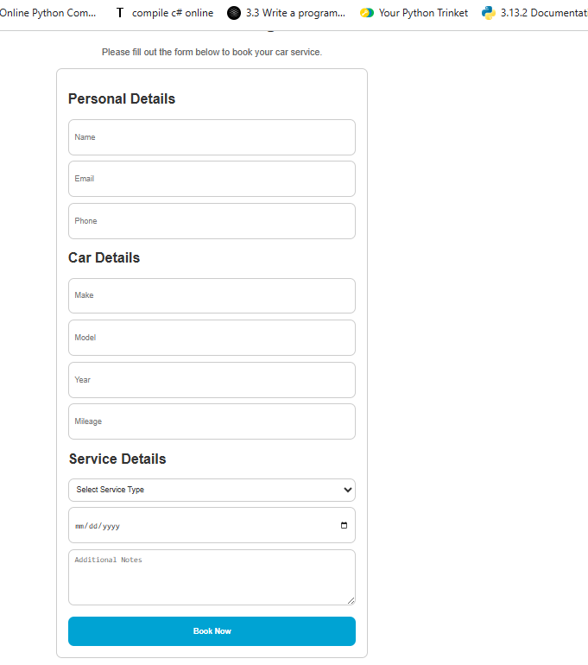

**Task 2.2:**

**Homework 1: Forms play critical role in taking data to and from users. To enhance this ability, design**

**three different types of forms using HTML Form. (Note: Don’t use CSS or Bootstrap. Only HTML.)**

**Example forms can be registration form, contact form, student feedback form, etc. Provide short**

**description and code of each form with its respective output in your lab report.**

**Code:**

**<!DOCTYPE html>**

**<html lang="en">**

**<head>**

**<meta charset="UTF-8">**

**<meta name="viewport" content="width=device-width, initial-scale=1.0">**

**<title>Document</title>**

**</head>**

**<body>**

**<h1 style=" color: #333333; text-align: center; font-weight: bold;font-family: sans-serif; ">Marriage Certificate</h1>**

**<div style="display: flex; justify-content: center; margin: 20px;">**

**<div style="width: 700px; border: 2px solid #cccccc; border-radius: 10px; padding: 20px;">**

**<div style=" color: #666666;">**

**<form action="" style="font-weight: bold; font-family: Arial, sans-serif;">**

**<h2 style="padding-left: 40px; color: #666666;">Name of the Wife: </h2>**

**<div style="text-align: center; display: flex; justify-content: center; flex-wrap: wrap; ">**

**<input type="text" name="Name of the Wife" placeholder="First Name" style="padding: 10px;text-align: center; border-radius: 10px; font-family:sans-serif; border: 2px solid black; font-weight: bold;">**

**<input type="text" name="Name of the Wife" placeholder="Middle Name" style="padding: 10px; text-align: center; border-radius: 10px; font-family:sans-serif; border: 2px solid black; font-weight: bold;">**

**<input type="text" name="Name of the Wife" placeholder="Last Name" style="padding: 10px; text-align: center; border-radius: 10px; font-family:sans-serif; border: 2px solid black; font-weight: bold;">**

**</div>**

**<h2 style="padding-left: 40px; color: #666666;">Name of the Husband: </h2>**

**<div style="text-align: center; display: flex; justify-content: center; flex-wrap: wrap;">**

**<input type="text" name="Name of the Husband" placeholder="First Name" style="padding: 10px;text-align: center; border-radius: 10px; font-family:sans-serif; border: 2px solid black; font-weight: bold;">**

**<input type="text" name="Name of the Husband" placeholder="Middle Name" style="padding: 10px; text-align: center; border-radius: 10px; font-family:sans-serif; border: 2px solid black; font-weight: bold;">**

**<input type="text" name="Name of the Husband" placeholder="Last Name" style="padding: 10px; text-align: center; border-radius: 10px; font-family:sans-serif; border: 2px solid black; font-weight: bold;">**

**</div>**

**<h2 style="padding-left: 40px; color: #666666;">Date of Marriage: </h2>**

**<div style="text-align: center; display: flex; justify-content: center; flex-wrap: wrap; ">**

**<select style="padding: 10px; justify-content: center; border-radius: 10px; font-family:sans-serif; border: 2px solid black; font-weight: bold;">**

**<option >Please select a month</option>**

**<option >January</option>**

**<option >Febraury</option>**

**<option >March</option>**

**<option >April</option>**

**<option >May</option>**

**<option >June</option>**

**<option >July</option>**

**<option >August</option>**

**<option >September</option>**

**<option >October</option>**

**<option >November</option>**

**<option >Decemeber</option>**

**</select>**

**<select style="padding: 10px;text-align: center; border-radius: 10px; font-family:sans-serif; border: 2px solid black; font-weight: bold; display: flex; justify-content: center; flex-wrap: wrap;">**

**<option >Please select a day</option>**

**<option >01</option>**

**<option >02</option>**

**<option >03</option>**

**<option >04</option>**

**<option >05</option>**

**<option >06</option>**

**<option >07</option>**

**<option >08</option>**

**<option >09</option>**

**<option >10</option>**

**<option >11</option>**

**<option >12</option>**

**<option >13</option>**

**<option >14</option>**

**<option >15</option>**

**<option >16</option>**

**<option >17</option>**

**<option >18</option>**

**<option >19</option>**

**<option >20</option>**

**<option >21</option>**

**<option >22</option>**

**<option >23</option>**

**<option >24</option>**

**<option >25</option>**

**<option >26</option>**

**<option >27</option>**

**<option >28</option>**

**<option >29</option>**

**<option >30</option>**

**<option >31</option>**

**</select>**

**<select style="padding: 10px;text-align: center; border-radius: 10px; font-family:sans-serif; border: 2px solid black; font-weight: bold; display: flex; justify-content: center; flex-wrap: wrap;">**

**<option >Please select a year</option>**

**<option >2020</option>**

**<option >2021</option>**

**<option >2022</option>**

**<option >2023</option>**

**<option >2024</option>**

**</select>**

**</div>**

**<h2 style="padding-left: 40px; color: #666666;">Place of Marriage: </h2>**

**<div style="text-align: center; display: flex; justify-content: center; flex-wrap: wrap; ">**

**<input type="text" name="Place of Marriage" placeholder="City" style="padding: 10px;text-align: center; border-radius: 10px; font-family:sans-serif; border: 2px solid black; font-weight: bold;">**

**<input type="text" name="Place of Marriage" placeholder="State" style="padding: 10px; text-align: center; border-radius: 10px; font-family:sans-serif; border: 2px solid black; font-weight: bold;">**

**<input type="text" name="Place of Marriage" placeholder="Country" style="padding: 10px; text-align: center; border-radius: 10px; font-family:sans-serif; border: 2px solid black; font-weight: bold;">**

**</div>**

**<h2 style="padding-left: 40px; color: #666666;">Witnesses: </h2>**

**<div style="text-align: center;  display: flex; justify-content: center; flex-wrap: wrap;">**

**<input type="text" name="Witness 1" placeholder="Name of Witness 1" style="padding: 10px;text-align: center; border-radius: 10px; font-family:sans-serif; border: 2px solid black; font-weight: bold;">**

**<input type="text" name="Witness 2" placeholder="Name of Witness 2" style="padding: 10px; text-align: center; border-radius: 10px; font-family:sans-serif; border: 2px solid black; font-weight: bold;">**

**</div>**

**<h2 style="padding-left: 40px; color: #666666;">Additional Information: </h2>**

**<div style="text-align: center; display: flex; justify-content: center; flex-wrap: wrap; ">**

**<textarea name="Additional Information" placeholder="Enter any other information here" rows="5" cols="50" style="padding: 10px; border-radius: 10px; font-family:sans-serif; border: 2px solid black; font-weight: bold;"></textarea>**

**</div>**

**<div style="text-align: center; margin-top: 20px; display: flex; justify-content: center; flex-wrap: wrap;">**

**<input type="submit" value="Submit" style="width: 100%; height: 50px; background-color: #00a0d2; border: none; border-radius: 10px; color: white; font-weight: bold; margin-top: 20px; cursor: pointer;">**

**</div>**

**</form>**

**</div>**

**</div>**

**</div>**

**</body>**

**</html>**

**Output task2.2:**

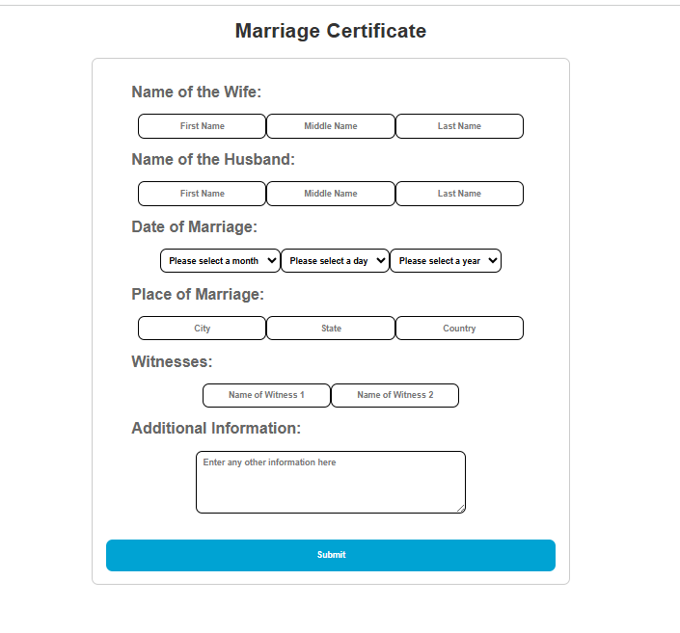

**Task 2.3:**

Homework 2: There are many new features available in HTML 5. Pick at least five features that are not

covered in this lab and introduce its usage through detailed examples and description. These features

include figure, audio, video, svg, regular expressions, GeoLocation, canvas, article, section, header,

footer, drag & drop, form validation, and web sockets. Provide short description and code of each

feature with its respective output in your lab report.

**Code:**

**<!DOCTYPE html>**

**<html lang="en">**

**<head>**

**<meta charset="UTF-8">**

**<meta name="viewport" content="width=device-width, initial-scale=1,0">**

**<title>Document</title>**

**</head>**

**<body>**

**<div style="display: flex; justify-content: center; margin: 20px; font-family: sans-serif;">**

**<div style="border: 2px solid #cccccc; border-radius: 10px; padding: 20px; width: 400px;">**

**Show: <select style="width: 25%; height: 25px; border-radius: 5px;" ><option >1</option><option >2</option><option >3</option><option >4</option><option >5</option><option >6</option><option >7</option><option >8</option><option >9</option><option >10</option></select>**

**Search : <input type="text" name="Search" >**

**<br><br>**

**<table border="1px solid black"  cellspacing = "0px" style="justify-content: center; color: white; width: 400px;">**

**<tr style="background-color: rgba(18, 197, 203, 0.845); ">**

**<th>Rank</th>**

**<th>Country</th>**

**<th>US $</th>**

**<th>Year</th>**

**</tr>**

**<tr style="color: black;">**

**<td>1</td>**

**<td style="color: rgba(18, 197, 203, 0.845); "> <img src="Luxemberg.png" style="width: 10%;">Luxemberg</td>**

**<td>113.533</td>**

**<td>2011</td>**

**</tr>**

**<tr style="color: black;">**

**<td>2</td>**

**<td style="color: rgba(18, 197, 203, 0.845);"> <img src="Qatar.png" style="width: 10%;">Qatar</td>**

**<td>96,329</td>**

**<td>2011</td>**

**</tr>**

**<tr style="color: black;">**

**<td>3</td>**

**<td style="color: rgba(18, 197, 203, 0.845);"><img src="Norwat.png" style="width: 10%;">Norway</td>**

**<td>97,225</td>**

**<td>2011</td>**

**</tr>**

**<tr style="color: black;">**

**<td>4</td>**

**<td style="color: rgba(18, 197, 203, 0.845);"><img src="Switzerland.png" style="width: 10%;">Switzerland</td>**

**<td>81,161</td>**

**<td>2011</td>**

**</tr>**

**<tr style="color: black;">**

**<td>5</td>**

**<td style="color: rgba(18, 197, 203, 0.845);"><img src="UAE.png" style="width: 10%;">United Arab Emirates</td>**

**<td>67,008</td>**

**<td>2011</td>**

**</tr>**

**<tr style="color: black;">**

**<td>6</td>**

**<td style="color: rgba(18, 197, 203, 0.845);"><img src="Australia.png" style="width: 10%;">Australia</td>**

**<td>65,447</td>**

**<td>2011</td>**

**</tr>**

**<tr style="color: black;">**

**<td>7</td>**

**<td style="color: rgba(18, 197, 203, 0.845);"><img src="Denmark.png" style="width: 10%;">Denmark</td>**

**<td>59,928</td>**

**<td>2011</td>**

**</tr>**

**<tr style="color: black;">**

**<td>8</td>**

**<td style="color: rgba(18, 197, 203, 0.845);"><img src="Swedon.png" style="width: 10%;">Swedon</td>**

**<td>56,956</td>**

**<td>2011</td>**

**</tr>**

**<tr style="color: black;">**

**<td>9</td>**

**<td style="color: rgba(18, 197, 203, 0.845);"><img src="Canada.png" style="width: 10%;">Canada</td>**

**<td>50,436</td>**

**<td>2011</td>**

**</tr>**

**<tr style="color: black;">**

**<td>10</td>**

**<td style="color: rgba(18, 197, 203, 0.845);"><img src="Netherlands.png" style="width: 10%;">Netherlands</td>**

**<td>50,355</td>**

**<td>2011</td>**

**</tr>**

**</table>**

**<span>Showing 1 to 10 of 186 records</span>**

**</div>**

**</div>**

**</body>**

**</html>**

**Homework 3:**

**Design your CV using HTML 5 only and host it on 000webhost.com. (Note: You can host**

**it on any other free hosting site of your choice.)**

**code:**

**<!DOCTYPE html>**

**<html lang="en">**

**<head>**

**<meta charset="UTF-8">**

**<meta name="viewport" content="width=device-width, initial-scale=1.0">**

**<title>Video and Audio Tag</title>**

**</head>**

**<body>**

**<div style="display: flex; justify-content: center; margin: 20px; font-family: sans-serif;">**

**<div style="border: 2px solid #cccccc; border-radius: 10px; padding: 20px; width: 400px;">**

**<h2>Example of video </h2>**

**<video width="300" height="200" controls >**

**<source src="pexels-ambientnature-atmosphere-5948574 (2160p).mp4" type="video/mp4"  />**

**</video>**

**<h2>Example of Audio Tag</h2>**

**<audio width="300" height="200" controls >**

**<source src="stomps-and-claps-percussion-and-rhythm-141190.mp3" type="audio/mp3" />**

**</audio>**

**</div>**

**<div>**

**</body>**

**Output:**

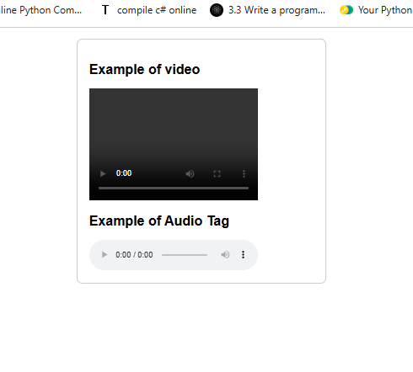

**Output of task 2.3:**

