**Improved Web Design using CSS/Bootstrap**

**LAB # 03**



**Spring 2025**

**CSE-403L DBMS LAB**

Submitted by: **Muhammad Musa**

Registration No.: **22PWCSE2157**

Class Section: C

Student Signature: ______________

Submitted to:

**Engr. Summayya Salahudin**

March 13, 2025

**Department of Computer Systems Engineering**

**University of Engineering and Technology, Peshawar**

**Objectives of The Lab:**

This lab aims at the understanding of:

* The concept of Dynamic HTML
* Cascaded Style Sheets (CSS)
* Various attributes of CSS such as font, color, background, text, border, margin, and list
* User-Defined Selectors including Class and ID
* Span and Div Tags
* External Style Sheets and their benefits.

**TASK # 3.2**

Write the HTML code that generates the output web page shown in Figure 3.9 with following

specification:

1) Heading 1 has font value of Garamond, size 26 pts, and red color.

2) Set top margin to 5%.

3) Create unordered list with values: HTML, JavaScript, CGI, Java, Oracle Developer 2000, and Oracle DBA. Use square list style type.

**Code:**

<html>

<head>

<meta charset="UTF-8">

<title>Working with Style Sheets</title>

<style type="text/css">

h1{

font-family: Garamond;

font-size: 26pts;

color: red;

margin-top: 5%;

}

</style>

</head>

<body>

<h1>Silicon Chip Technologies</h1>

<p>SCT provide Corporate Training for the following products

<ul style="list-style-type:square;">

<li>HTML</li>

<li>Javascript</li>

<li>CGI</li>

<li>Java</li>

<li>Oracle Developer 2000</li>

<li>Oracle DBA</li>

</ul>

</p>

</body>

</html>

**Output:**

**TASK # 3.3**

Write the HTML code along with CSS file that generates the output web page shown in Figure 3.9.

**Code:**

**HTML Code:**

<html>

<head>

<title>Working with Style Sheets</title>

<link rel=stylesheet href="task3.2.css">

</head>

<body>

<h1>Silicon Chip Technologies</h1>

<p>SCT provide Corporate Training for the following products

<ul>

<li>HTML</li>

<li>Javascript</li>

<li>CGI</li>

<li>Java</li>

<li>Oracle Developer 2000</li>

<li>Oracle DBA</li>

</ul>

</p>

</body>

</html>

**CSS Code:**

h1{

font-family: Garamond;

font-size: 26pts;

color: red;

margin-top: 5%;}

ul {

list-style: square:}

**Output:**

**TASK # 3.4**

Rewrite Example 5 using ID Selector instead of class Selector and show its output.

**Code:**

<html>

<head>

<title> Use of Margin Attributes </title>

<style type="text/css">

#para1 { font-size:12pt;

font-weight:bold;

text-align:justify;

margin-left:10%;

margin-right:10%;

color: brown; font-style: italic;}

#para2 { font-size:12pt;

font-weight:bold;

text-align:justify;

margin-left:10%;

margin-right:10%;

color: #23238e;

}

</style>

</head>

<body>

<p id="para1">How to create style sheet to alter an HTML element?</p>

<p id="para2" >The Style assignment process can be accomplished with

the &lt;STYLE&gt;...&lt;/STYLE&gt; tags. The syntax for making the

assignment is simple. Between &lt;STYLE&gt; and &lt;/STYLE&gt;, HTML tags

to which styles are to be assigned are to be listed ad each tag with a pair of

curly brackets in which specific style attributes are to be specified. This

&lt;STYLE&gt; tag should be within &lt;HEAD&gt;...&lt;/HEAD&gt;element.</p> <br>

<p id="para1">What are the attributes that can be specified? </p>

<p id="para2"> The attributes that can be specified are: Font attributes,

Color and Background attributes, Text attributes, Border attributes, Margin

attributes, and List attributes. </p>

</body>

</html>

**Output:**

**TASK # 3.5**

**Output:**

**Sign-in Page**

**Cover Page:**

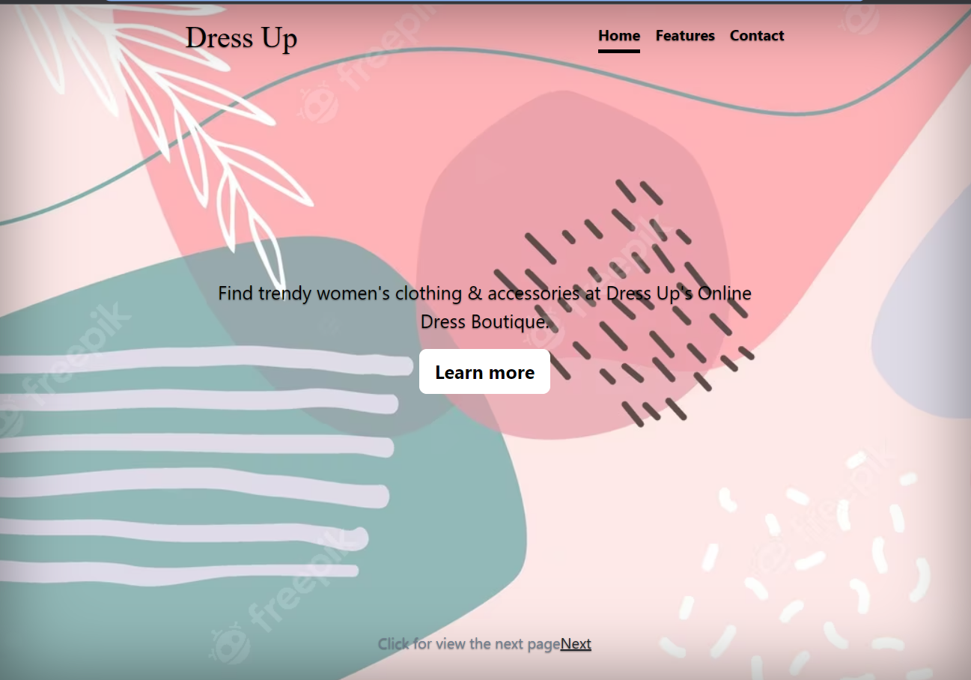

**Blog Page:**

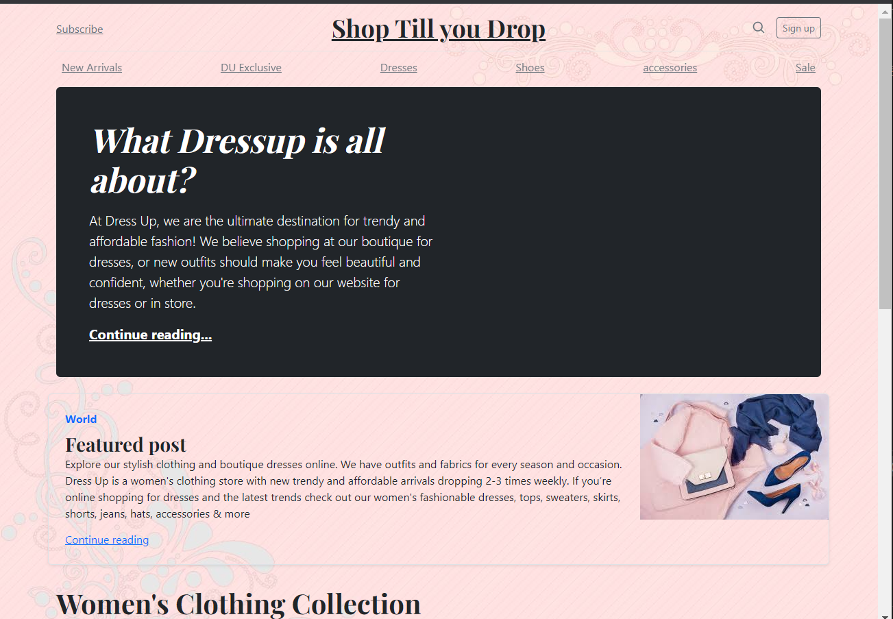

**Checkout Page:**

**TASK # 3.6**

Modify your CV designed using plain HTML in last lab by adding CSS and Bootstrap in it. Upload both original one and modified one on the hosting site. Provide the link.

**Output:**

**Link:**

Original:

https://github.com/MuhammadMusa2157/MY_ResumeModified: