**PC NETWORK TCP/IP**

**CONFIGURATION**

**LAB # 0****1**

**Spring 2025**

**CSE-303L**

**Data Communication & Networks Lab**

Submitted by: **Muhammad Musa**

Registration No.: **22PWCSE2157**

Section: **C**

“I affirm that I have completed this work with integrity”

Student Signature: ______________

Submitted to:

**Dr. Yasir Saleem Afridi**

Wednesday Marach 03, 2025

Department of Computer Systems Engineering

University of Engineering and Technology, Peshawar

**CSE-303L: DATA COMMUNICATION & NETWORKS LAB**

**LAB ASSESSMENT RUBRIC**

**Credit Hours: 1**

**Contact Hours: 3**

|  |  |  |  |  |
| --- | --- | --- | --- | --- |
| **Demonstration of Concepts** | **Poor (Does not meet expectation (1))**  The student failed to demonstrate a clear understanding of the assignment concepts | **Fair (Meet**  **Expectation (2-3))**  The student demonstrated a clear understanding of some of the assignment concepts | **Good (Exceeds**  **Expectation (4-5))**  The student demonstrated a clear understanding of the assignment concepts | **Score**  **30%** |
| **Accuracy** | The student misconfigured enough network settings that the lab computer couldn't function properly on the network | The student configured enough network settings that the lab computer partially functioned on  the network | The student configured the network settings that the lab computer fully functioned on the network |  |
| **30%** |
| **Following Directions** | The student clearly failed to follow the verbal and written instructions to successfully complete the lab | The student failed to follow the some of the verbal and written instructions to successfully complete all requirements of the lab | The student followed the verbal and written instructions to successfully complete requirements of the lab |
| **20%** |
| **Time**  **Utilization** | The student failed to complete even part of the lab in the allotted amount of time | The student failed to complete the entire lab in the allotted amount of time | The student completed the lab in its entirety in the al |  |
| **20%** |

**_________________________**

**Dr. Yasir Saleem Afridi.**

**PC Network TCP/IP Configuration**

**Objectives:**

Following topics will be covered in this lab

* Gather information including connection, host name, Layer 2 MAC address and Layer 3 TCP/IP network address information.
* Compare network information to other PCs on the network.
* Identify tool used for discovering a computer’s network configuration.

**Lab Tasks**:

**Task 1**: **Record the following TCP/IP information for atleast THREE computers** 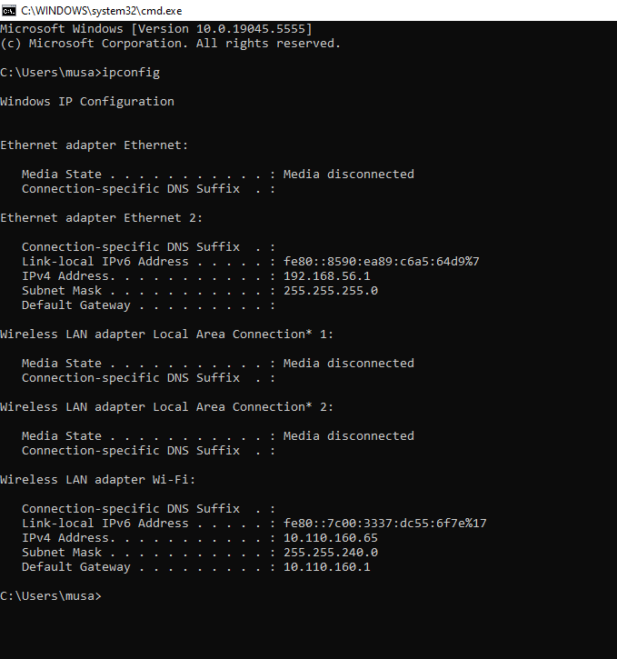

|  |  |  |  |
| --- | --- | --- | --- |
|  | **Computer 1** | **Computer 2 (Neighbor 1)** | **Computer 3**  **(Neighbor 1)** |
| **IP Address** | 10.110.173.24 | 10.110.173.18 | 10.110.173.31 |
| **Subnet Mask** | 255.255.255.0 | 255.255.255.0 | 255.255.255.0 |
| **Default Gateway** | 10.110.160.1 | 10.110.160.1 | 10.110.160.1 |
| **DNS Address** | 10.110.160.1 | 10.110.160.1 | 10.110.160.1 |
| **DHCP Address** | 10.110.160.1 | 10.110.160.1 | 10.110.160.1 |

**Are there any similarities?**

*Yes, all of them have the same Subnet Mask, Default Gateway, DNS Address, DHCP*

*Address and Network Address.*

**What is similar about the IP addresses?**

*The Network Portion of the IP addresses are similar.*

**What is similar about the default gateways?**

*All have the same Default Gateway.*

**Record a couple of the IP Addresses?**

* *Computer 1: 192.168.1.29*
* *Computer 2: 192.168.1.23*
* *Computer 3: 192.168.1.31*

**Task 2**: **Check additional TCP/IP configuration information**

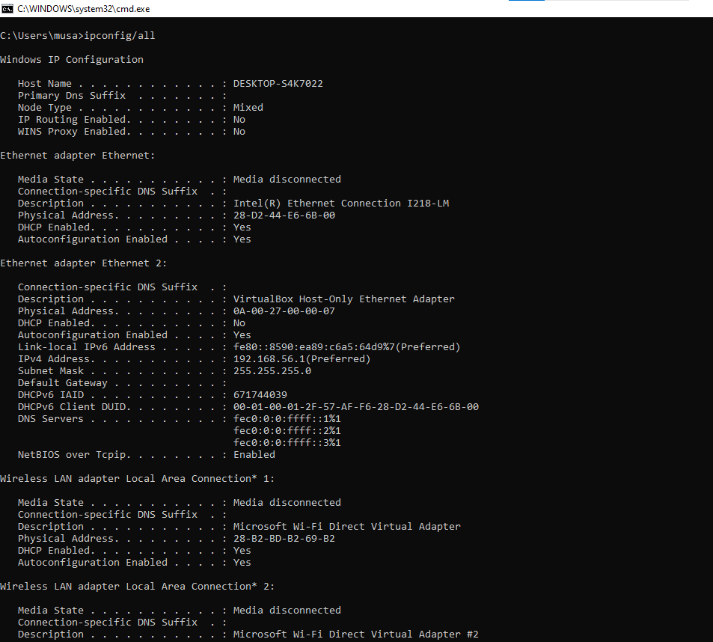

**Notice the Physical Address (MAC) and the NIC model (Description).**

*Physical Address (MAC): 68-A3-C4-03-41-AF*

*NIC model: Qualcomm Atheros AR9285 802.11b|g|n WiFi Adapter*

**Write down the IP addresses of any servers listed:**

**Write down the computer Host Name:**

*AimalKhans-PC*

**Write down the Host Names of a couple other computers:**

* *Computer 1: DESKTOP-S4K7022*
* *Computer 2: DESKTOP-K3R4TSE*
* *Computer 3: DESKTOP-8TKL60H*

**Do all of the servers and workstations share the same network portion of the IP address as the student workstation?**

*No.*

**Task 3**: **Based on observations, what can be deduced about the following results taken from three computers connected to one switch?**

**Computer 1**

IP Address: 192.168.5.13

Subnet Mask: 255.255.255.0

Default Gateway: 192.168.12.1

**Computer 2**

IP Address: 192.168.5.5

Subnet Mask: 255.255.255.0

Default Gateway: 192.168.12.1

**Computer 3**

IP Address: 192.168.11.97

Subnet Mask: 255.255.255.0

Default Gateway: 192.168.12.1

**Should they be able to talk to each other?**

*Computer 1 and Computer 2 should be able to communicate with each other since they have the same Network Address whereas Computer 3 has a different Network Address.*

**Are they all on the same network? Why or why not?**

*No, all are not on the same network. Only Computer 1 and Computer 2 are on the same Network. We came to this conclusion with the help of subnet mask. By And-ing the Subnet mask and IP address we can find the Network Address.*

**Conclusion:**

In conclusion, we have successfully accomplished the objectives set forth in this laboratory session. Through hands-on tasks and theoretical exploration, we have gained valuable insights into the **TCP/IP** domain. This experience has enriched our understanding of core concepts and their practical applications in the field. We look forward to applying this knowledge in future endeavors.