**“Use Wireshark to View Network Traffic**

**Topology”**

**LAB REPORT # 04**



# Spring 2025

**CSE 303L: Data Communication and Networks**

Submitted by: **Muhammad Musa**

Registration # **22PWCSE2157**

Class Section: **C**

Submitted to:

## Dr. Yasir Saleem Afridi

22 April, 2025.

Department of Computer Systems Engineering

University of Engineering and Technology, Peshawar.

**Use Wireshark to View Network Traffic**

**Topology**

**Part-1 Step-1 ……………**

**Step-2 ……………**

**Step-3:**

## ……………

**Does the source MAC address match your PC interface?**

**ANS: Yes! they match.**



**Does the destination MAC address in Wireshark match your team member MAC address?**

**ANS: Yes! They match.**

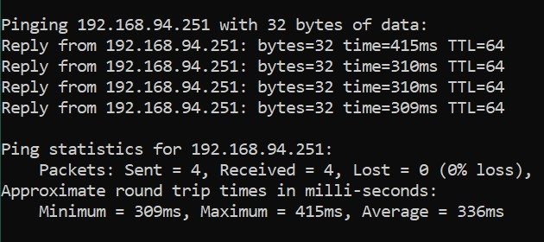

**How is the MAC address of the pinged PC obtained by your PC?**

**ANS: By Using ARP.**

**Part-2 Step-1 ………………**

## Step-2 ………………

**List the destination IP and MAC addresses for all three locations in the space provided.**

**IP address for www.yahoo.com:**

**74.6.231.20**

**MAC address for www.yahoo.com:**

**91:c6:a9:73:8a:08**

**IP address for www.cisco.com:**

**104.111.198.247**

**MAC address for www.cisco.com:**

**91:c6:a9:73:8a:08**

**IP address for www.google.com:**

**216.58.207.100**

**MAC address for www.google.com:**

## 92:c6:a9:73:8a:08

**What is significant about this information?**

**All have different IP-Addresses while same MAC-Address because of the same default Internet Gateway.**

**How does this information differ from the local ping information you received in Part 1?**

**In part-1 our two PCs were connected directly without any router on same Network, so the MAC-Addresses were obtained that of our PCs, while in part-2 there is router involved so the MAC-Addresses of the destination were that of the Default Internet Gateway.**