Ipconfig/?

Ipconfig/all

Write down the IP addresses of any servers listed:

2A-B2-BD-B2-69-B1

Write down the computer Host Name:

“0”

Write down the Host Names of a couple other computers:

3) ./ALLCOMPARTMENTS Display information for all compartments

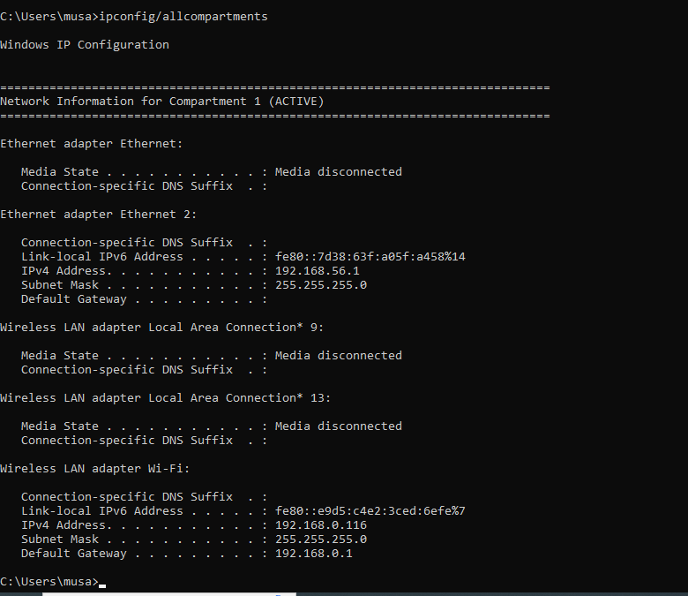

/release Release the IP address for the specified adapter

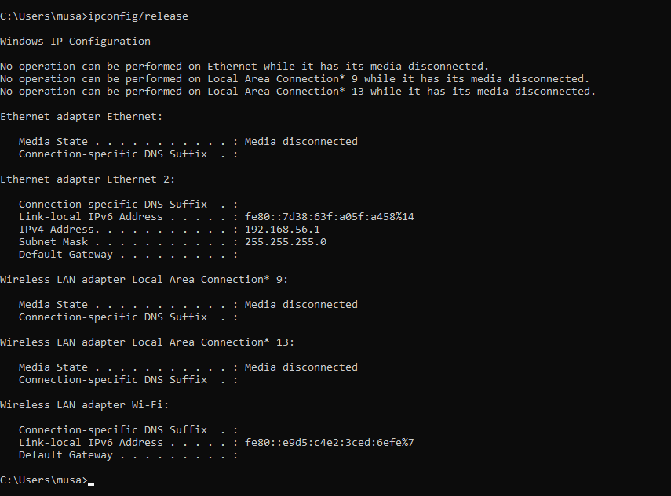

/renew Renew the IP address for the specified adapter

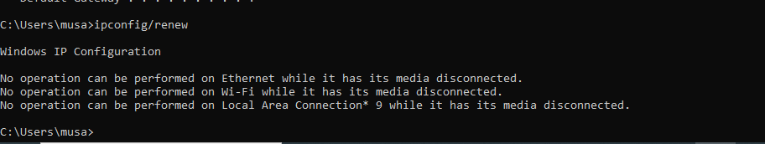

/flushdns Removes the DNS Resolver cache

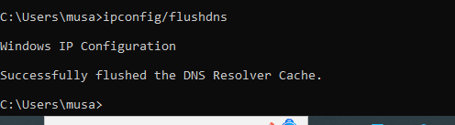

/registerdns Refreshes all DHCP leases and re-registers DNS name

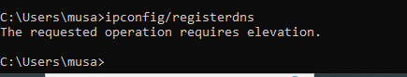

/displaydns Display the contents of the DNS Resolver Cache

