**TRACING DNS WITH**

**WIRESHARK**

**LAB # 0****5**

**Spring 2025**

**CSE-303L**

**Data Communication & Networks Lab**

Submitted by: **Muhammad Musa**

Registration No.: **22PWCSE2157**

Class Section: **C**

“I affirm that I have completed this work with integrity”



Student Signature: ______________

Submitted to:

**Dr. Yasir Saleem Afridi**

Tuesday, April 22, 2025

Department of Computer Systems Engineering

University of Engineering and Technology, Peshawar

**CSE-303L: DATA COMMUNICATION & NETWORKS LAB**

**LAB ASSESSMENT RUBRIC**

**Credit Hours: 1**

**Contact Hours: 3**

|  |  |  |  |  |
| --- | --- | --- | --- | --- |
| **Demonstration of Concepts** | **Poor (Does not meet expectation (1))**  The student failed to demonstrate a clear understanding of the assignment concepts | **Fair (Meet**  **Expectation (2-3))**  The student demonstrated a clear understanding of some of the assignment concepts | **Good (Exceeds**  **Expectation (4-5))**  The student demonstrated a clear understanding of the assignment concepts | **Score**  **30%** |
| **Accuracy** | The student misconfigured enough network settings that the lab computer couldn't function properly on the network | The student configured enough network settings that the lab computer partially functioned on  the network | The student configured the network settings that the lab computer fully functioned on the network |  |
| **30%** |
| **Following Directions** | The student clearly failed to follow the verbal and written instructions to successfully complete the lab | The student failed to follow the some of the verbal and written instructions to successfully complete all requirements of the lab | The student followed the verbal and written instructions to successfully complete requirements of the lab |
| **20%** |
| **Time**  **Utilization** | The student failed to complete even part of the lab in the allotted amount of time | The student failed to complete the entire lab in the allotted amount of time | The student completed the lab in its entirety in the al |  |
| **20%** |

**_________________________**

**Dr. Yasir Saleem Afridi.**

**Tracing DNS with Wireshark**

**Objectives:**

* To trace DNS packets
* Extract the info from each packet like ports, Ips, queries, answers etc.

**Lab Tasks**:

**Task 1**:

1. Locate the DNS query and response messages. Are then sent over UDP or TCP?



1. What is the destination port for the DNS query message? What is the source port of DNS response message?



1. To what IP address is the DNS query message sent? Use ipconfig to determine the IP address of your local DNS server. Are these two IP addresses the same?





1. Examine the DNS query message. What “Type” of DNS query is it? Does the query message contain any “answers”?

Type AAAA and it got one answer:

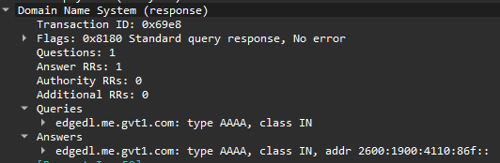

1. Examine the DNS response message. How many “answers” are provided? What do each of these answers contain?

It has got 1 answer. The content can be seen in the image

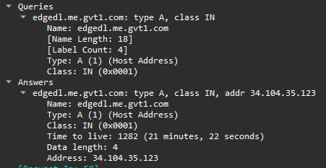

**Task 2**:

1. What is the destination port for the DNS query message? What is the source port of DNS response message?



1. To what IP address is the DNS query message sent? Is this the IP address of your default local DNS server?





1. Examine the DNS query message. What “Type” of DNS query is it? Does the query message contain any “answers”?

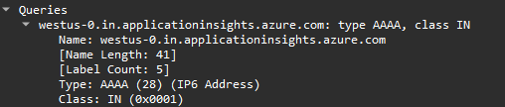

1. Examine the DNS response message. How many “answers” are provided? What do each of these answers contain?

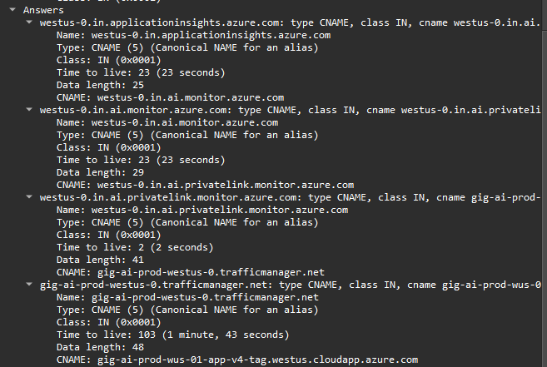

**Conclusion:**

In conclusion, we have successfully accomplished the objectives set forth in this laboratory session. Through hands-on tasks and theoretical exploration, we have gained valuable insights into the **Tracing of DNS packets via WireShark** domain. This experience has enriched our understanding of core concepts and their practical applications in the field. We look forward to applying this knowledge in future endeavors.

The End.