# Build, Test and Use Straight-Through and Cross-Over UTP Cable

**Lab 6**



# Spring 2025

Data Communications Network

Submitted by: **Muhammad Musa**

Registration No.: **22PWCSE2157**

Section: **C**

“On my honor, as student of University of Engineering and Technology, I have neither given nor received unauthorized assistance on this academic work.”

Submitted to:

**Engr. Yasir Saleem**

# April 22, 2025

**Department of Computer Systems Engineering**

**University of Engineering and Technology, Peshawar**

# CSE 303L: Data Communication and Computer Networks

|  |  |  |  |  |
| --- | --- | --- | --- | --- |
|  |  |  |  |  |
| **Demonstration of Concepts** | **Poor (Does not meet expectation (1))**  The student failed to demonstrate a clear understanding of the assignment concepts | **Fair (Meet Expectation (2-**  **3))**  The student demonstrated a clear understanding of some of the assignment concepts | **Good (Exceeds Expectation (4-**  **5)**  The student demonstrated a clear understanding of the assignment concepts | **Score** |
|  |  |  |  |  |
| **Accuracy** | The student mis- configured enough network settings that the lab computer couldn't function properly on the network | The student configured enough network settings that the lab computer partially functioned on the network | The student configured the network settings that the lab computer fully functioned on the network |  |
|  |  |  |  |  |
| **Following Directions** | The student clearly failed to follow the verbal and written instructions to successfully complete the lab | The student failed to follow the some of the verbal and written instructions to successfully complete all requirements of the lab | The student followed the verbal and written instructions to successfully complete requirements of the lab |  |
|  |  |  |  |  |
| **Time Utilization** | The student failed to complete even part of the lab in the allotted amount of time | The student failed to complete the entire lab in the allotted amount of time | The student completed the lab in its entirety in the al |  |

**Objectives of Lab:**

* Introduction to Transmission Media
* Build a Category 6 (CAT 6) Straight-Through Ethernet network cable
* Build a Category 6 (CAT 6) Cross-Over Ethernet network cable
* Test both cables for good connection using Cable Tester
* Connecting Computers via Switch using Straight Through Cable and Connecting two computers directly via Cross Over Cable

**Question:** What is difference between Hub, Switch and Router?

**Answer:**

A hub, switch, and router are all network devices used to connect devices together, but they differ in their functionality and capabilities.

A **hub** is a basic networking device that connects multiple devices together in a network. It operates on the physical layer of the OSI model and is a simple device that merely broadcasts incoming data to all connected devices. All devices connected to a hub share the same bandwidth, which can lead to network congestion and reduced performance

A **switch**, on the other hand, operates at the data link layer of the OSI model and is more advanced than a hub. It uses MAC addresses to identify and direct network traffic to specific devices. Unlike a hub, a switch creates a direct connection between two devices and sends data only to the intended recipient, making it more efficient and secure.

A **router** is a networking device that operates at the network layer of the OSI model and is more advanced than both hubs and switches. It uses IP addresses to direct network traffic between different networks, such as between the internet and a local area network (LAN). A router can also be used to manage network security by providing firewall and access control features.

**Question:** What should I buy for my network, Hub, Switch or Router?

**Answer:**

The type of device you should buy for your network depends on your specific networking needs and the size of your network.

If you have a small network with only a few devices and do not need to manage network traffic or prioritize certain types of data, a hub may be sufficient. However, hubs are generally outdated and are not commonly used in modern networks.

If you have a small to medium-sized network and want to improve network performance and security, a switch is a better option. Switches provide better performance than hubs as they create a direct connection between devices and only send data to the intended recipient.

If you have a larger network with multiple subnets or need to manage network security and prioritize certain types of data, a router is necessary. Routers can manage network traffic between different networks, provide security features like firewall and access control, and prioritize certain types of data for better network performance.

**Question:** List networking hardware vendors?

**Answer:**

There are many networking hardware vendors in the market, ranging from well-known global corporations to smaller, specialized companies. Here are some examples:

* Cisco Systems - A global leader in networking hardware, software, and services.
* Juniper Networks - A provider of high-performance networking equipment and services.
* Hewlett Packard Enterprise (HPE) - A provider of networking hardware, software, and services.
* Dell Technologies - A provider of networking hardware and solutions for businesses.
* Arista Networks - A provider of high-performance cloud networking solutions.
* Extreme Networks - A provider of cloud-driven networking solutions for enterprises.
* Netgear - A provider of networking hardware for small and medium-sized businesses.
* Ubiquiti Networks - A provider of wireless networking solutions for homes and businesses.
* Brocade Communications - A provider of data center networking solutions and services.
* D-Link Corporation - A provider of networking hardware for homes and businesses.

**Question:** 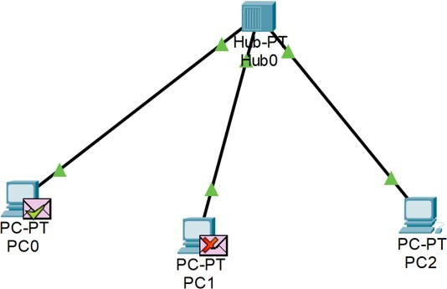Connect the devices as follows and ping to show theconnectivity.

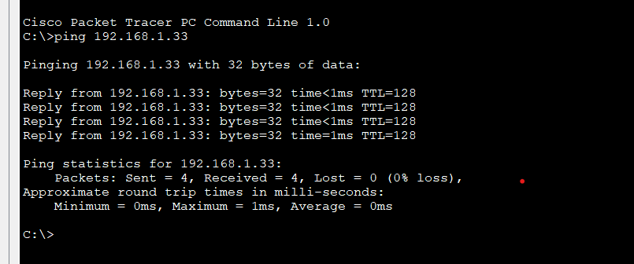

**Question:** In the above network, transfer the data from one computer to another. Have you

**Answer:**

* Yes.

**Question:** 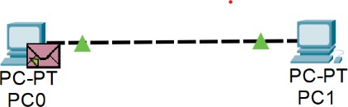Connect two computer directly as follows and ping to show the connectivity

**Answer:**

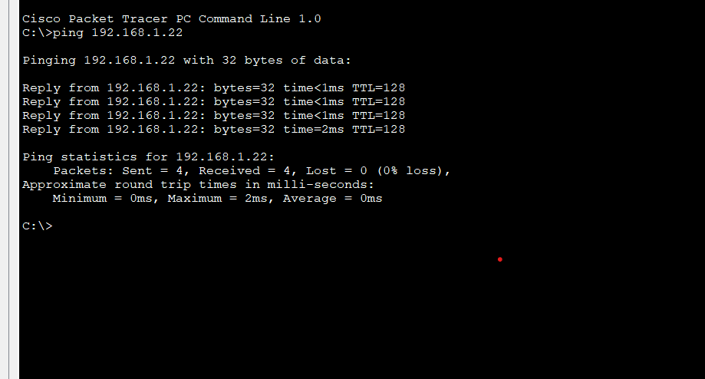

**Q.** In the above network, transfer the data from one computer to another. Have you!

**Answer:** Yes.