***Investigate the network using “ping” , “tracert” and other Network related***

***Commands***

# Lab no# 02



**Spring 2025**

**CSE-303L Data Communication & Networks Lab**

|  |  |
| --- | --- |
| ***Submitted By*** | ***Registration No.*** |
| *Hammad Ahmad* | *22PWCSE2157* |

Class Section: **C**

# Submitted To: Dr. Yasir Saleem Afridi

“On my honor, as student of University of Engineering and Technology, I have neither given nor received unauthorized assistance on this academic work.”

**Department of Computer Systems Engineering**

**University of Engineering and Technology Peshawar**

***OBJECTIVES OF THE LAB***

Following topics will be covered in this lab

* Learn to use the TCP/IP Packet Internet Groper (ping) command.
* Learn to use the Trace Route (tracert) command.
* Observe name resolution occurrences using WINS and/or DNS servers.

***Task #01 :***

1. ***Ping the IP address of the Default Gateway and DNS Servers. Was the result successful?***

***Step 1***

Use the Start menu to open the command-prompt:

* + Start>Programs>Accessories>Command Prompt or
  + Start>Program>Command Prompt

***Step 2***

* + Type ping, space Press Enter key.

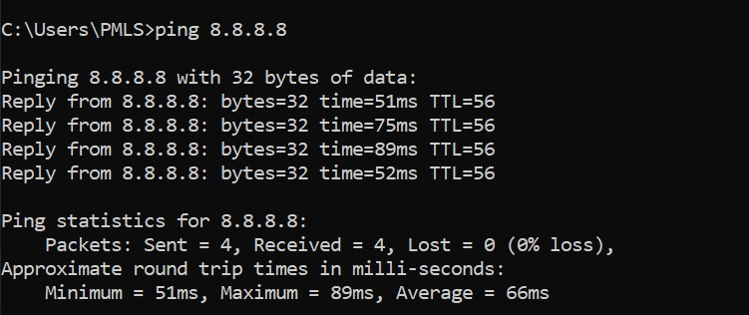

**Figure 2.1: Command Screen for ping DNS Server (8.8.8.8)**

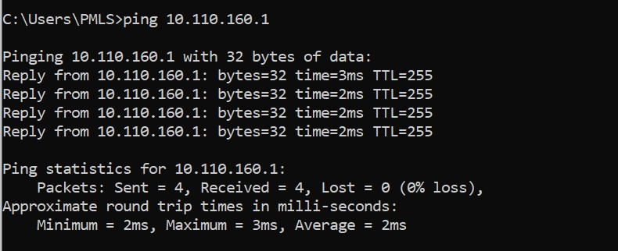

**Figure 2.2: Command Screen for ping Default Gateway (10.110.160.1)** Yes it was successful.

1. ***Ping the computer’s loop-back address. Type the following command: &gt;&gt; ping 127.0.0.1***

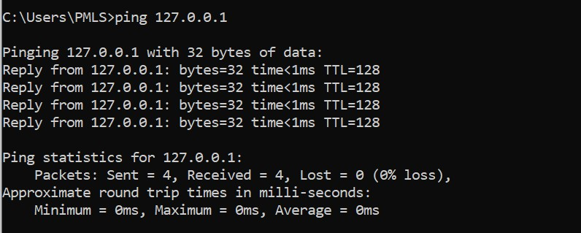

**Figure 2.3: Command Screen for ping *127.0.0.1***

***c ) What is the IP Address of*** [***www.yahoo.com:***](http://www.yahoo.com/)

* 87.248.119.252

***How much time did our ping took to reach www.yahoo.com:***

* The ping to [www.yahoo.com t](http://www.yahoo.com/)ook an average of 42 milliseconds (ms). The minimum time was 42ms and the maximum time was 43ms.

1. ***Ping the hostname of another computer. Try to ping the hostname of the computer that was recorded in the previous lab.***

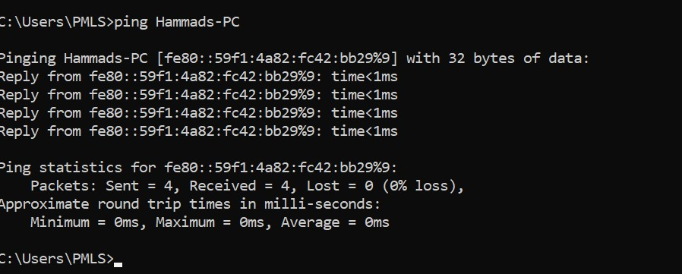

**Figure 2.4: Command Screen for ping *HAMMAD-PC***

1. ***Ping the hostname of another computer using –t. Try to ping repetitively, the hostname of the computer***

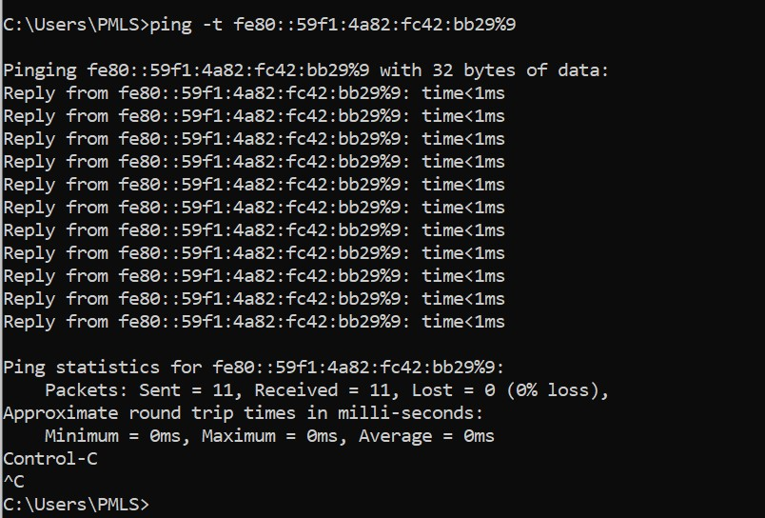

**Figure 2.5: Command Screen for ping fe80::59f1:4a82:fc42:bb29%9**

1. ***How can we stop the ping?***

• By pressing **Ctrl +c**

1. ***ping the IP address of the default gateway***



**Figure 2.6: Command Screen for ping Default Gateway (10.110.160.1)**

1. ***ping the IP address of a DHCP or DNS server***



**Figure 2.7: Command Screen for ping DNS Server (8.8.8.8)**

## Task # 02 Tracert

1. ***Trace the route to the GOOGLE PAKISTAN website by typing: tracert*** [***www.google.com.pk***](http://www.google.com.pk/)

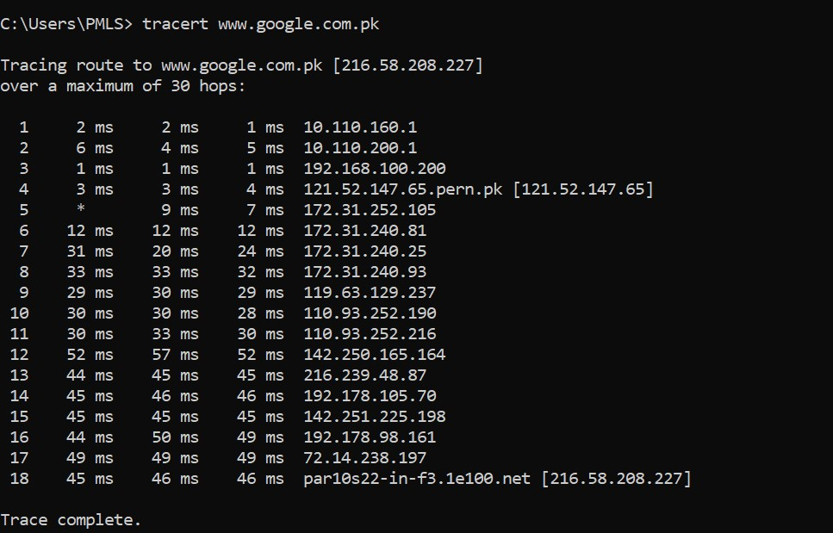

**Figure 2.8 Command Screen for *tracert*** [***www.google.com.pk***](http://www.google.com.pk/)

1. ***Trace the route to the UET website using options listed in option description table.***

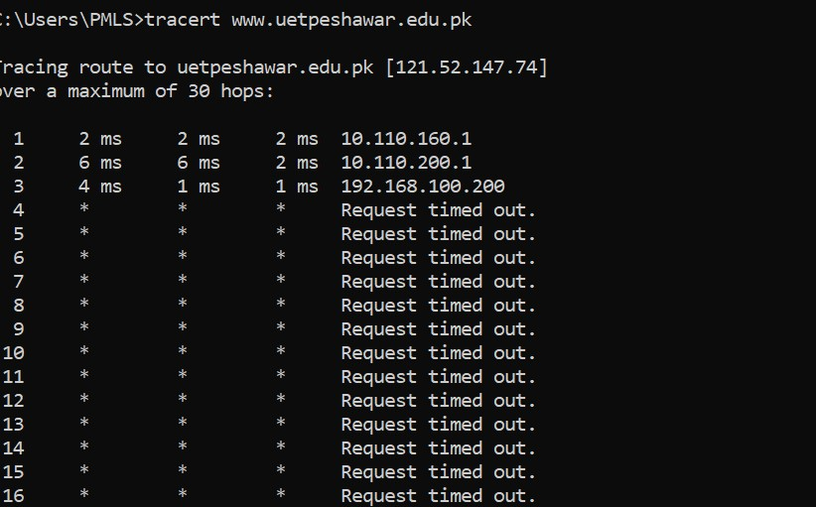

**Figure 2.9 Command Screen for *tracert*** [***www.uetpeshawar.edu.pk***](http://www.uetpeshawar.edu.pk/)

1. ***What is the difference between the following commands?*** 
   * Tracert www.yahoo.com
   * Tracert –h 20 www.yahoo.com
   1. ***Tracert www.yahoo.com:*** This command traces the route that packets take to get from your computer to www.yahoo.com. It will show you each hop along the way, including the IP address and hostname of each router, and the time it took for the packet to reach that router.
   2. ***Tracert -h 20 www.yahoo.com:*** This command does the same thing as the first command, but it limits the number of hops to 20. The -h option sets a maximum number of hops that the packet can take before the trace is aborted. In this case, if the packet hasn’t reached www.yahoo.com after 20 hops, the trace will stop.

So, the main difference between these two commands is that the second command limits the number of hops to 20, while the first command will keep tracing the route until it reaches the destination or until it has made 30 hops, which is the default maximum number of hops in Tracert.

***Task 04 (Long Life Learning):***

***i) netstat***

Displays active TCP connections, ports on which the computer is listening, Ethernet statistics, the IP routing table, IPv4 statistics (for the IP, ICMP, TCP, and UDP protocols), and IPv6 statistics (for the IPv6, ICMPv6, TCP over IPv6, and UDP over IPv6protocols). Used without parameters, netstat displays active TCP connections.

* 1. ***_ netstat -a:*** Shows the state of all sockets, routing table entries, and interfaces.

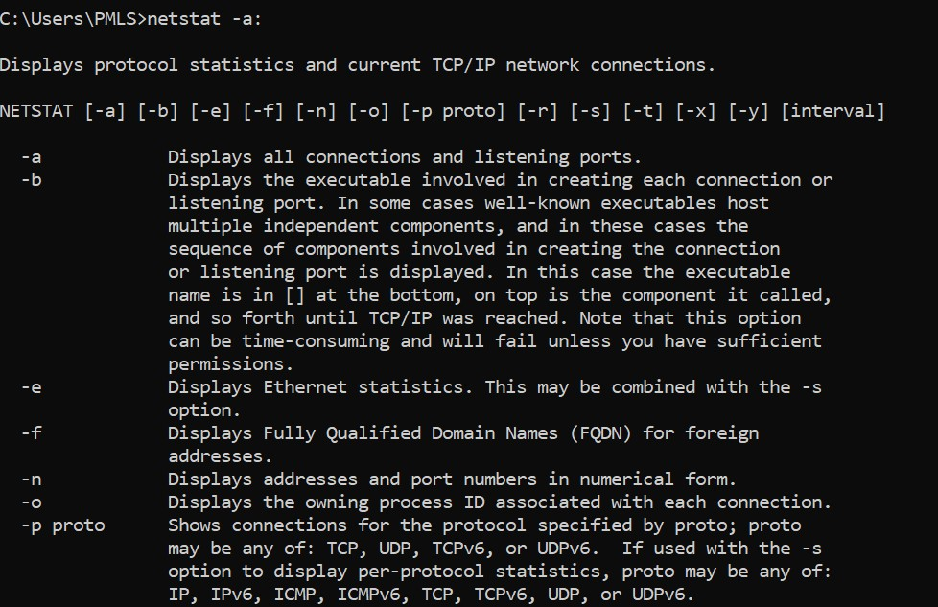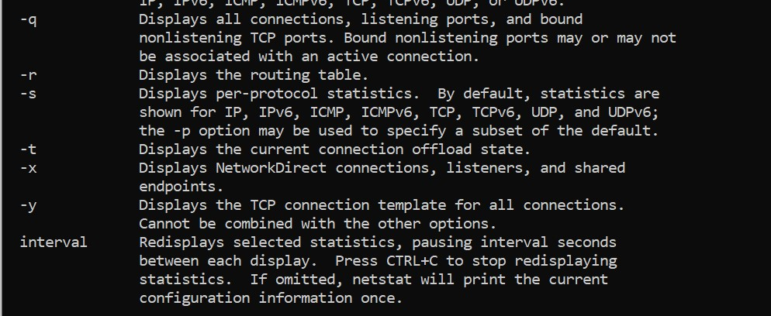

* 1. ***netstat -r:*** Displays the routing table.

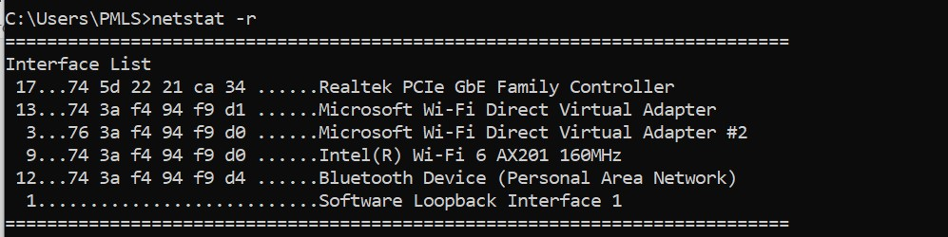

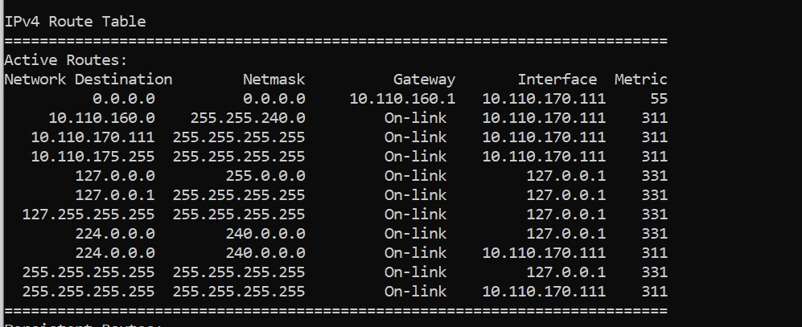

* 1. ***netstat -i:*** Displays the interface information.

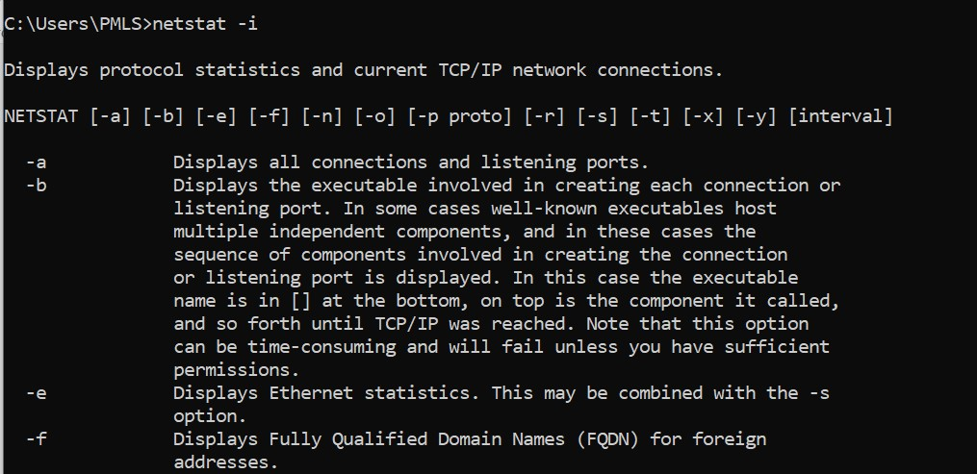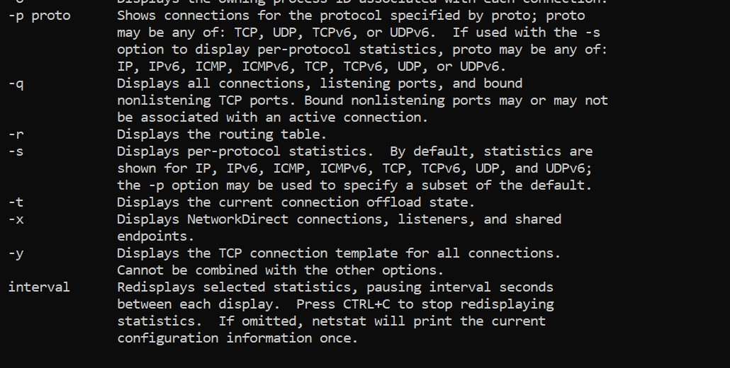

* 1. ***netstat -n:*** Displays numbers instead of names.

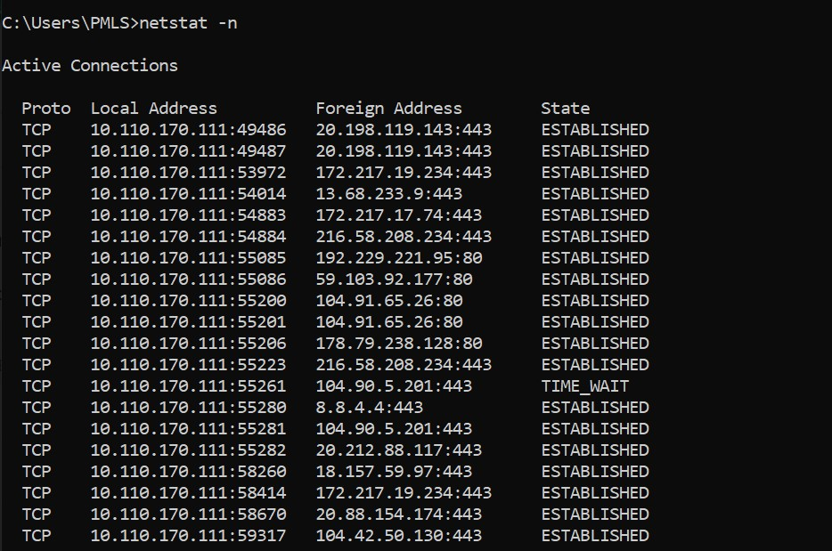

* 1. ***netstat -s:*** Displays per-protocol statistics.

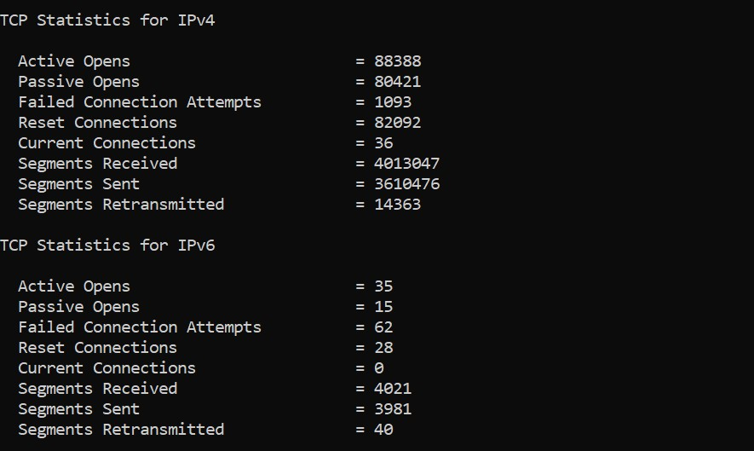

***ii. pathping***

Provides information about network latency and network loss at intermediate hops between a source and destination. Pathping sends multiple Echo Request messages to each router between a source and destination over a period of time and then computes results based on the packets returned from each ***router.***

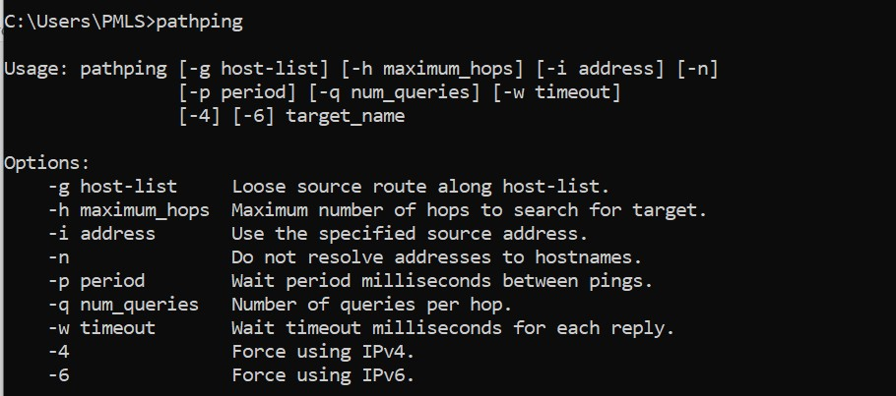 ***iii. telnet***

Telnet is software that allows users to remotely access another computer such as a server,network device, or other computer. With telnet users can connect to a device orcomputer, manage a network device, setup a device, transfer files, etc.

1. ***nslookup***

Displays information that you can use to diagnose Domain Name System (DNS) infrastructure. Before using this tool, you should be familiar with how DNS works. The Nslookup commandline tool is available only if you have installed the TCP/IP protocol.

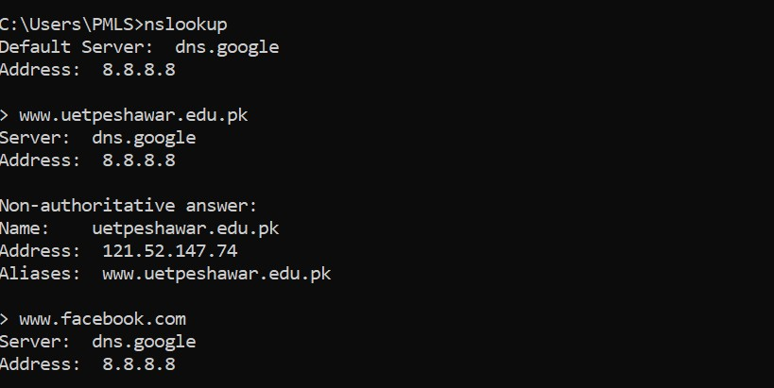

1. ***getmac***

Command used to show both local and remote MAC addresses. When run with no parameters (ie. getmac) it displays MAC addresses for the local system. When run with the /s parameter (eg. getmac /s \\foo) it displays MAC addresses for the remote computer.When the /v parameter is used, it also displays the associated connection name and network adapter name.

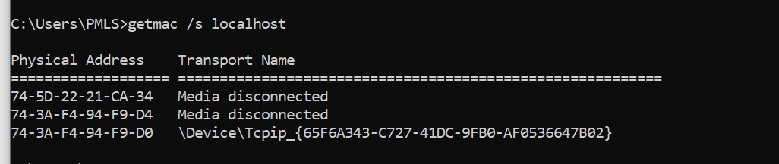 vi***) ARP Command.***

Using the arp command allows you to display and modify the Address Resolution Protocol (ARP) cache. An ARP cache is a simple mapping of IP addresses to MAC Addresses.

