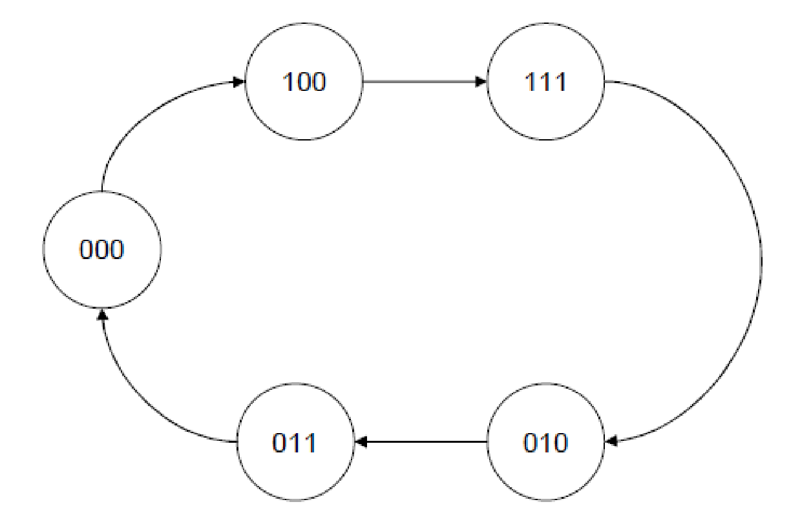

**module fsm_counter (count, clock);**

**input clock;**

**output [2:0] count;**

**reg [2:0] count;**

**//use parameter statement to define states**

**parameter A = 3'b000, B = 3'b100, C = 3'b111, D = 3'b010, E = 3'b011;**

**always @ (posedge clock)**

**//use case statement to implement state transitions**

**case(count)**

**A: count <= B;**

**B: count <= C;**

**C: count <= D;**

**D: count <= E;**

**E: count <= A;**

**default: count <= C;**

**endcase**

**endmodule**

**module test1_fsm_counter;**

**reg clock;**

**wire [2:0] count;**

**fsm_counter dut (count, clock);**

**initial**

**clock = 0;**

**always**

**#30 clock = ~clock;**

**endmodule**

**module test2_fsm_counter;**

**reg clock;**

**wire [2:0] count;**

**fsm_counter dut (count, clock);**

**initial**

**clock = 0;**

**always**

**#5 clock = ~clock;**

**initial begin**

**$display ("***********Time-----Output");**

**$monitor ($time, " Count = %d", count);**

**end**

**endmodule**