**ARITHMETIC OPERATIONS IN**

**QTSPIM (ASSEMBPLY**

**LANGUAGE)**

**LAB # 0****1**

**Fall 2023**

**CSE-304L**

**Computer Organization & Architecture Lab**

Submitted by: **AIMAL KHAN**

Registration No.: **21PWCSE1996**

Class Section: **A**

“On my honor, as student of University of Engineering and Technology, I have neither given nor received unauthorized assistance on this academic work.”

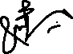

Student Signature: ______________

Submitted to:

**Dr. Bilal Habib**

Thursday, October 5, 2023

Department of Computer Systems Engineering

University of Engineering and Technology, Peshawar

**ASSESSMENT RUBRICS COA LABS**

|  |  |  |  |  |
| --- | --- | --- | --- | --- |
| **LAB REPORT ASSESSMENT** | | | | |
| **Criteria** | **Excellent** | **Average** | **Nill** | **Marks Obtained** |
| 1. **Objectives of Lab** | All objectives of lab are properly covered  [Marks 10] | Objectives of lab are partially covered  [Marks 5] | Objectives of lab are not shown  [Marks 0] |  |
| 1. **MIPS instructions with**   **Comments and proper indentations.** | All the instructions are well written with comments explaining the code and properly indented  [Marks 20] | Some instructions are missing are poorly commented code  [Marks 10] | The instructions are not properly written  [Marks 0] |  |
| 1. **Simulation run without error and warnings** | The code is running in the simulator without any error and warnings  [Marks 10] | The code is running but with some warnings or errors.  [Marks 5] | The code is written but not running due to errors  [Marks 0] |  |
| 1. **Procedure** | All the instructions are written with proper procedure  [Marks 20] | Some steps are missing  [Marks 10] | steps are totally missing  [Marks 0] |  |
| 1. **OUTPUT** | Proper output of the code written in assembly  [Marks 20] | Some of the outputs are missing  [Marks 10] | No or wrong output  [Marks 0] |  |
| 1. **Conclusion** | Conclusion about the lab is shown and written  [Marks 20] | Conclusion about the lab is partially shown  [Marks 10] | Conclusion about the lab is not shown[Marks0]  [Marks 0] |  |
| 1. **Cheating** |  |  | Any kind of cheating will lead to 0 Marks |  |
| Total Marks Obtained:__________  Instructor Signature: ______________________ | | | | |

**Arithmetic Operation in Qtspim**

**(Assembly Language)**

Objectives:

* Introduction to assembly language and Qtspim software
* How to write arithmetic operations
* How to write logical operations

Tasks:

**Task 1**: Write an assembly language program which takes two numbers from user and add them and show the result on console.

**Code:**

.text

.globl main

main:

li $v0, 4 # syscall 4 (print_str)

la $a0, prompt1 # argument: string

syscall # print the string

li $v0,5

syscall

move $t0,$v0

li $v0,4

la $a0, prompt2

syscall

li $v0,5

syscall

move $t1,$v0

li $v0,4

la $a0, answer

syscall

add $t2, $t0,$t1

li $v0, 1

move $a0, $t2

syscall

.data

prompt1: .asciiz "Enter first value? "

prompt2: .asciiz "Enter second value? "

answer: .asciiz "The answer is: "

**Output:**

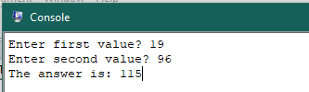

**Task 2**: Write an assembly language program which takes two numbers from user and subtract them and show the result on console

**Code:**

.text

.globl main

main:

li $v0, 4 # syscall 4 (print_str)

la $a0, prompt1 # argument: string

syscall # print the string

li $v0,5

syscall

move $t0,$v0

li $v0,4

la $a0, prompt2

syscall

li $v0,5

syscall

move $t1,$v0

li $v0,4

la $a0, answer

syscall

sub $t2, $t0,$t1

li $v0, 1

move $a0, $t2

syscall

.data

prompt1: .asciiz "Enter first value? "

prompt2: .asciiz "Enter second value? "

answer: .asciiz "The answer is: "

**Output:**

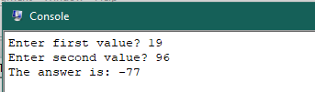

**Task 3**: Write an assembly language program which takes two numbers from user and multiply them and show the result on console.

**Code:**

.text

.globl main

main:

li $v0, 4 # syscall 4 (print_str)

la $a0, prompt1 # argument: string

syscall # print the string

li $v0,5

syscall

move $t0,$v0

li $v0,4

la $a0, prompt2

syscall

li $v0,5

syscall

move $t1,$v0

li $v0,4

la $a0, answer

syscall

mul $t2, $t0,$t1

li $v0, 1

move $a0, $t2

syscall

.data

prompt1: .asciiz "Enter first value? "

prompt2: .asciiz "Enter second value? "

answer: .asciiz "The answer is: "

**Output:**

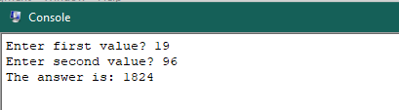

**Task 4**: Write an assembly language program which takes two numbers from user and divide them and show the result on console.

**Code:**

.text

.globl main

main:

li $v0, 4 # syscall 4 (print_str)

la $a0, prompt1 # argument: string

syscall # print the string

li $v0,5

syscall

move $t0,$v0

li $v0,4

la $a0, prompt2

syscall

li $v0,5

syscall

move $t1,$v0

li $v0,4

la $a0, answer

syscall

div $t2, $t0,$t1

li $v0, 1

move $a0, $t2

syscall

.data

prompt1: .asciiz "Enter first value? "

prompt2: .asciiz "Enter second value? "

answer: .asciiz "The answer is: "

**Output:**

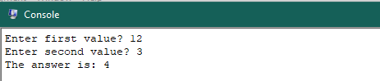

**Task 5**: Write assembly program to multiply two numbers using MULT and extract the bit from high and low registers to general purpose registers.

**Code:**

.text

.globl main

main:

li $v0, 4 # syscall 4 (print_str)

la $a0, prompt1 # argument: string

syscall # print the string

li $v0,5

syscall

move $t0,$v0

li $v0,4

la $a0, prompt2

syscall

li $v0,5

syscall

move $t1,$v0

li $v0,4

la $a0, low

syscall

mult $t0,$t1

li $v0, 1

mfhi $t3

syscall

li $v0,4

la $a0, high

syscall

mult $t0,$t1

li $v0, 1

mflo $t4

syscall

.data

prompt1: .asciiz "Enter first value? "

prompt2: .asciiz "Enter second value? "

low: .asciiz "The low register bit is: "

high: .asciiz "\nThe high register bit is: "

**Output:**

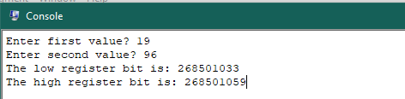

**Task 6**: Write program to perform AND, OR, NOT operations in MIPS.

**Code:**

.text

.globl main

main:

li $v0, 4

la $a0, prompt1

syscall

li $v0,5

syscall

move $t0,$v0

li $v0,4

la $a0, prompt2

syscall

li $v0,5

syscall

move $t1,$v0

li $v0,4

la $a0, AND

syscall

and $t2,$t0,$t1

li $v0, 1

move $a0, $t2

syscall

li $v0,4

la $a0, OR

syscall

or $t3,$t0,$t1

li $v0, 1

move $a0, $t3

syscall

li $v0,4

la $a0, NOT

syscall

not $t4,$t0

li $v0, 1

move $a0, $t4

syscall

.data

prompt1: .asciiz "Enter first value? "

prompt2: .asciiz "Enter second value? "

AND: .asciiz "Result of AND: "

OR: .asciiz "\nResult of OR: "

NOT: .asciiz "\nResult of NOT: "

**Output:**

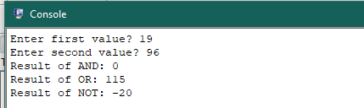

Reference:

To view my codes, please refer to my [GitHub Account.](https://github.com/aimalexe/DCSE/tree/main/semester_5_(fall-23)/computer_organization_and_architechure_lab/lab_reports/)

Conclusion:

In this lab I have learnt the basics of assembly language and how to perform arithmetic and logical operation on values taken from user and display the result on console.

The End.