**COA**

**DCSE, UET Peshawar**

**LAB 10**

**COUNTERS IN VERILOG:**

Q NO 1: Write a Verilog code to implement 4 BIT counter.

Q NO 2: Write a Verilog code to implement 8 BIT counter.

Q NO 3: Implement 4 BIT Uncontrolled Asynchronous UP COUNTER in Verilog using T FLIP FLOP:

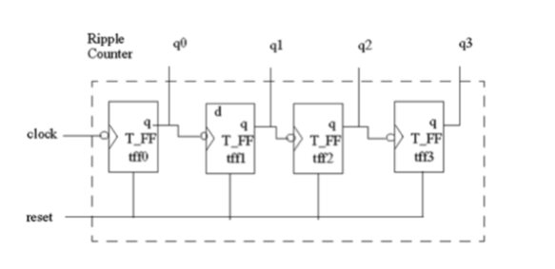

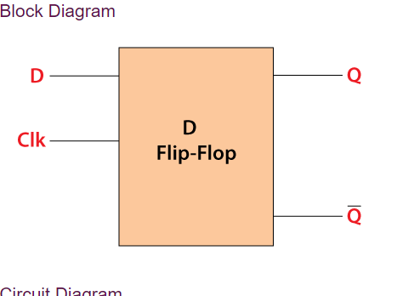

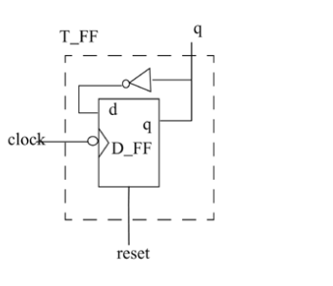

Q NO 4: Implement 4 BIT Controlled Asynchronous UP COUNTER in Verilog using T FLIP FLOP:

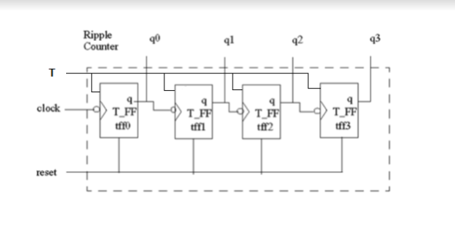

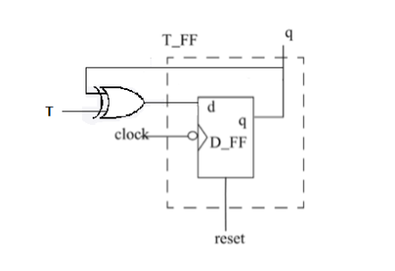

Q NO 5: Implement 16*8 RAM in Verilog.