**COUNTERS IN**

**VERILOG**

**LAB #** **10**

**Fall 2023**

**CSE-304L**

**Computer Organization & Architecture Lab**

Submitted by: **AIMAL KHAN**

Registration No.: **21PWCSE1996**

Class Section: **A**

“On my honor, as student of University of Engineering and Technology, I have neither given nor received unauthorized assistance on this academic work.”



Student Signature: ______________

Submitted to:

**Dr. Bilal Habib**

Monday, January 29, 2024

Department of Computer Systems Engineering

University of Engineering and Technology, Peshawar

**ASSESSMENT RUBRICS COA LABS**

|  |  |  |  |  |
| --- | --- | --- | --- | --- |
| **LAB REPORT ASSESSMENT** | | | | |
| **Criteria** | **Excellent** | **Average** | **Nill** | **Marks Obtained** |
| 1. **Objectives of Lab** | All objectives of lab are properly covered  [Marks 10] | Objectives of lab are partially covered  [Marks 5] | Objectives of lab are not shown  [Marks 0] |  |
| 1. **MIPS instructions with**   **Comments and proper indentations.** | All the instructions are well written with comments explaining the code and properly indented  [Marks 20] | Some instructions are missing are poorly commented code  [Marks 10] | The instructions are not properly written  [Marks 0] |  |
| 1. **Simulation run without error and warnings** | The code is running in the simulator without any error and warnings  [Marks 10] | The code is running but with some warnings or errors.  [Marks 5] | The code is written but not running due to errors  [Marks 0] |  |
| 1. **Procedure** | All the instructions are written with proper procedure  [Marks 20] | Some steps are missing  [Marks 10] | steps are totally missing  [Marks 0] |  |
| 1. **OUTPUT** | Proper output of the code written in assembly  [Marks 20] | Some of the outputs are missing  [Marks 10] | No or wrong output  [Marks 0] |  |
| 1. **Conclusion** | Conclusion about the lab is shown and written  [Marks 20] | Conclusion about the lab is partially shown  [Marks 10] | Conclusion about the lab is not shown [Marks0]  [Marks 0] |  |
| 1. **Cheating** |  |  | Any kind of cheating will lead to 0 Marks |  |
| Total Marks Obtained: __________  Instructor Signature: ______________________ | | | | |

**Counters in Verilog**

Objectives:

* Implement counters in Verilog
* Implement controlled and uncontrolled asynchronous counters
* Implement RAM

Tasks:

**Task 1**: Write a Verilog code to implement 4-bit counter

**DUT Code:**

module Counter_4_bit(

input wire clock,

input wire reset,

output reg [3:0] count

);

always @(posedge clock or posedge reset)

begin

if(reset) begin

count <= 4'b0000;

end else begin

count <= count +1;

end

end

endmodule

**Test Code:**

module test_Counter_4_bit();

reg clk;

reg rst;

wire [3:0] count;

Counter_4_bit counter(

.clock(clk),

.reset(rst),

.count(count)

);

always begin

#5

clk = ~clk;

end

initial begin

clk = 0;

rst = 0;

// Reset the counter initially

rst = 1;

#10 rst = 0;

#20;

$display("Time = 0, Count = %b", count);

#10;

$display("Time = 10, Count = %b", count);

#10;

$display("Time = 20, Count = %b", count);

#10;

$display("Time = 30, Count = %b", count);

end

endmodule

**Output:**

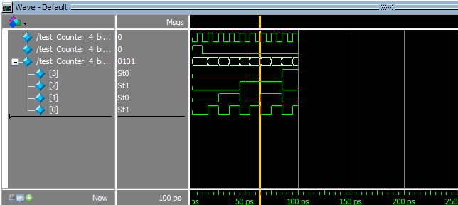

**Task 2**: Write a Verilog code to implement 8-bit counter

**DUT Code:**

module Counter_8_bit(

input wire clock,

input wire reset,

output reg [7:0] count

);

always @(posedge clock or posedge reset)

begin

if(reset)

count <= 8'b00000000;

else

count <= count +1;

end

endmodule

**Test Code:**

module test_Counter_8_bit();

reg clk;

reg rst;

wire [7:0] count;

Counter_8_bit counter(

clk, rst, count

);

always begin

#5 clk = ~clk;

end

initial begin

clk = 0;

rst = 0;

rst = 1;

#10 rst = 0;

#20;

$display("Time = 0, Count = %b", count);

#10;

$display("Time = 10, Count = %b", count);

#10;

$display("Time = 20, Count = %b", count);

#10;

$display("Time = 30, Count = %b", count);

#10;

$display("Time = 30, Count = %b", count);

#10;

$display("Time = 30, Count = %b", count);

#10;

$display("Time = 30, Count = %b", count);

#10;

$display("Time = 30, Count = %b", count);

end

endmodule

**Output:**

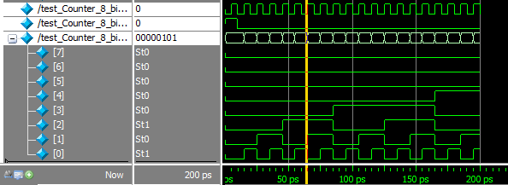

**Task 3**: Implement 4 BIT Uncontrolled Asynchronous UP COUNTER in Verilog using T FLIP FLOP.

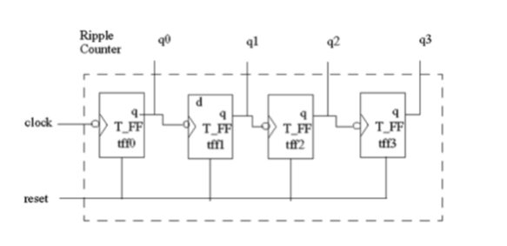

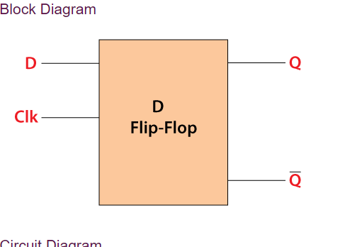 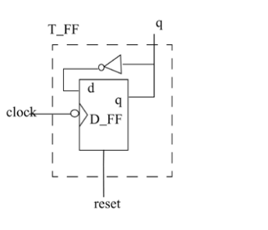

**DUT Code:**

module T_Uncontrolled_Async_Counter_4_bit(

input wire clock,

input wire reset,

output reg [3:0] count

);

reg [3:0] t_signals;

always @(posedge clock or posedge reset) begin

if (reset) begin

t_signals <= 4'b0000; // Reset T signals to 0 when reset is high

end else begin

t_signals <= t_signals + 1; // Increment T signals on each clock cycle

end

end

T_Flip_Flop tff0 (.T(t_signals[0]), .clock(clock), .Q(count[0]));

T_Flip_Flop tff1 (.T(t_signals[1]), .clock(clock), .Q(count[1]));

T_Flip_Flop tff2 (.T(t_signals[2]), .clock(clock), .Q(count[2]));

T_Flip_Flop tff3 (.T(t_signals[3]), .clock(clock), .Q(count[3]));

endmodule

**Test Code:**

module test_T_Uncontrolled_Async_Counter_4_bit();

reg clk;

reg rst;

wire [3:0] count;

T_Uncontrolled_Async_Counter_4_bit uut (

.clock(clk),

.reset(rst),

.count(count)

);

always begin

#5 clk = ~clk;

end

// Testbench initialization

initial begin

clk = 0;

rst = 0;

// Reset the counter initially

rst = 1;

#10 rst = 0;

// Wait for some clock cycles and observe the counter

#20;

$display("Time = 0, Count = %b", count);

#10;

$display("Time = 10, Count = %b", count);

#10;

$display("Time = 20, Count = %b", count);

#10;

$display("Time = 30, Count = %b", count);

end

endmodule;

**Output:**

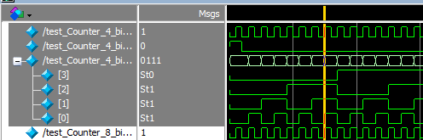

**Task 4**: Implement 4 BIT Controlled Asynchronous UP COUNTER in Verilog using T FLIP FLOP.

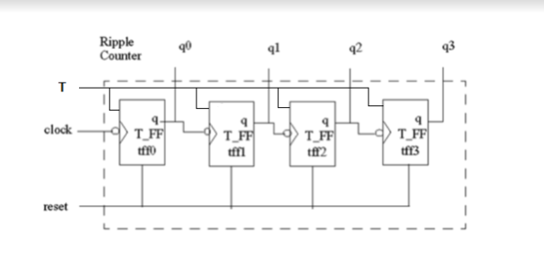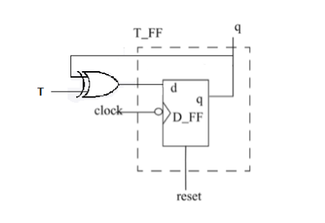

**DUT Code:**

module T_Controlled_Async_Counter_4_bit(

input wire clock,

input wire reset,

input wire enable,

output reg [3:0] count

);

reg [3:0] t_signals;

always @(posedge clock or posedge reset) begin

if (reset) begin

t_signals <= 4'b0000; // Reset T signals to 0 when reset is high

end else if (enable) begin

t_signals <= t_signals + 1; // Increment T signals on each clock cycle when enable is high

end

end

T_Flip_Flop tff0 (.T(t_signals[0]), .clock(clock), .Q(count[0]));

T_Flip_Flop tff1 (.T(t_signals[1]), .clock(clock), .Q(count[1]));

T_Flip_Flop tff2 (.T(t_signals[2]), .clock(clock), .Q(count[2]));

T_Flip_Flop tff3 (.T(t_signals[3]), .clock(clock), .Q(count[3]));

endmodule

**Test Code:**

module test_T_Controlled_Async_Counter_4_bit();

reg clk;

reg rst;

reg enable;

wire [3:0] count;

// Instantiate the controlled asynchronous up-counter module

T_Controlled_Async_Counter_4_bit uut (

.clock(clk),

.reset(rst),

.enable(enable),

.count(count)

);

// Clock generation

always begin

#5 clk = ~clk; // Toggle the clock every 5 time units

end

// Testbench initialization

initial begin

clk = 0;

rst = 0;

enable = 1; // Enable the counter

// Reset the counter initially

rst = 1;

#10 rst = 0;

// Wait for some clock cycles and observe the counter

#20;

// Test the counter for several clock cycles

$display("Time = 0, Count = %b", count);

#10;

$display("Time = 10, Count = %b", count);

#10;

$display("Time = 20, Count = %b", count);

#10;

$display("Time = 30, Count = %b", count);

// Finish simulation

$finish;

end

endmodule

**Output:**

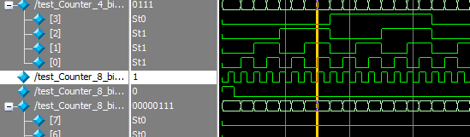

**Task 5**: Implement 16x8 RAM in Verilog.

**DUT Code:**

module RAM_16x8 (clk, addr, data_in, write_enable, data_out);

input wire clk;

input wire [3:0] addr;

input wire [7:0] data_in;

input wire write_enable;

output wire [7:0] data_out;

reg [7:0] memory [0:15]; // 16 words by 8 bits

// Read operation

assign data_out = (write_enable) ? 8'bzzzz_zzzz : memory[addr];

// Write operation

always @(posedge clk) begin

if (write_enable)

memory[addr] <= data_in;

end

endmodule

**Test Code:**

// Testbench for 16x8 RAM

module test_RAM_16x8;

// Inputs

reg clk;

reg [3:0] addr;

reg [7:0] data_in;

reg write_enable;

// Outputs

wire [7:0] data_out;

// Instantiate the RAM module

ram_16x8 uut (

.clk(clk),

.addr(addr),

.data_in(data_in),

.write_enable(write_enable),

.data_out(data_out)

);

// Clock generation

always begin

#5 clk = ~clk;

end

// Initial block

initial begin

// Initialize inputs

clk = 0;

addr = 4'b0000;

data_in = 8'b0000_0000;

write_enable = 0;

// Apply write operation to store data

addr = 4'b0001;

data_in = 8'b1010_1010;

write_enable = 1;

#10 write_enable = 0;

// Read from the RAM

addr = 4'b0001;

write_enable = 0;

// Monitor signals

$monitor("Time=%t, clk=%b, addr=%b, data_in=%b, write_enable=%b, data_out=%b", $time, clk, addr, data_in, write_enable, data_out);

// Run simulation for 100 clock cycles

#100 $finish;

end

endmodule

**Output:**

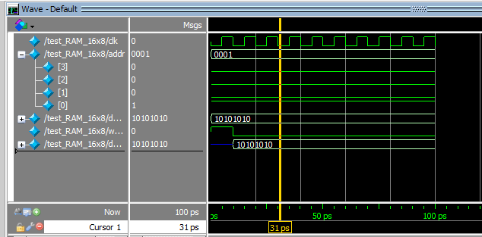

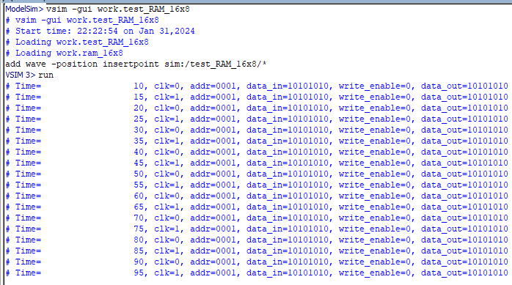

Reference:

To view my codes, please refer to my [GitHub Account.](https://github.com/aimalexe/DCSE/tree/main/semester_5_(fall-23)/computer_organization_and_architechure_lab/lab_reports/)

Conclusion:

In summary of this lab, I have learned how to implement simple counters, controlled and uncontrolled asynchronous T counters. I also learned how to implement RAM in Verilog. This lab will help in my future endeavors.

The End.