**COA**

**DCSE, UET Peshawar**

**LAB 9**

**FLIP FLOP AND LATCHES IN VERILOG:**

Q NO 1: Write a Verilog code to implement S R latch.

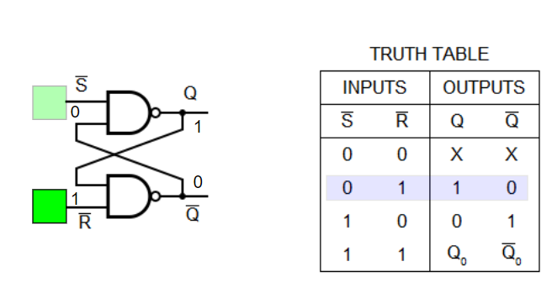

Q NO 2: Implement SR flip flop in Verilog .

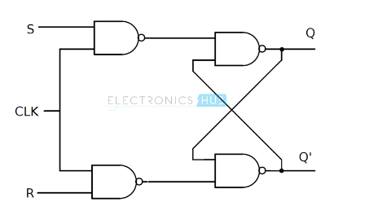

QNO 3: implement JK Flip Flop in Verilog

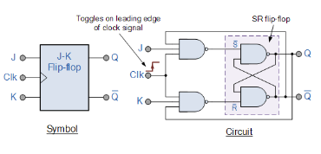

Q NO 4: Design D Flip Flop in Verilog

.

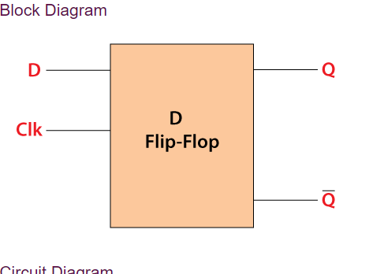

Q NO 5: Design T Flip Flop using D Flip Flop in Verilog.

