**Exponential Sequences**

**Assignment # 0****1**

**Fall 2023**

**CSE-402L**

**Digital Signal Processing Lab**

Submitted by: **AIMAL KHAN**

Registration No.: **21PWCSE1996**

Class Section: **A**

“On my honor, as student of University of Engineering and Technology, I have neither given nor received unauthorized assistance on this academic work.”

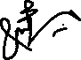

Student Signature: ______________

Submitted to:

**Dr. Ihsan Ul Haq**

Tuesday, October 24, 2023

Department of Computer Systems Engineering

University of Engineering and Technology, Peshawar

**Exponential Sequences**

Objectives:

The objective of studying exponential sequences lies in their pivotal role in signal analysis and processing. Real exponential sequences are fundamental in modeling signal dynamics, while complex exponentials are essential for frequency domain analysis. This knowledge is used for effective modeling and analysis of signal behavior.

Tasks:

**Write MATLAB code to generate output graphs for exponential sequences for Real and Complex parameters.**

**Task 1**: Using Equations x[n] = A α^n for Real Graphs. Let A=1.5, n= -10 to 10

1. for (-1 < alpha < 0), try alpha= -0.5
2. for (0 < alpha < 1), try alpha=0.7
3. for (|alpha| > 1), try alpha= 1.1

**Code:**

clc;

clear;

close all;

% Define parameters

A = 1.5;

n = -10:10;

% Real exponential sequences

alpha1 = -0.5;

x1 = A * alpha1.^n;

alpha2 = 0.7;

x2 = A * alpha2.^n;

alpha3 = 1.1;

x3 = A * alpha3.^n;

% Plot real exponential sequences

subplot(2, 3, 1);

stem(n, x1, 'r');

title('Real Sequence (\alpha = -0.5)');

xlabel('n');

ylabel('x[n]');

grid on;

subplot(2, 3, 2);

stem(n, x2, 'g');

title('Real Sequence (\alpha = 0.7)');

xlabel('n');

ylabel('x[n]');

grid on;

subplot(2, 3, 3);

stem(n, x3, 'b');

title('Real Sequence (\alpha = 1.1)');

xlabel('n');

ylabel('x[n]');

grid on;

**Output:**

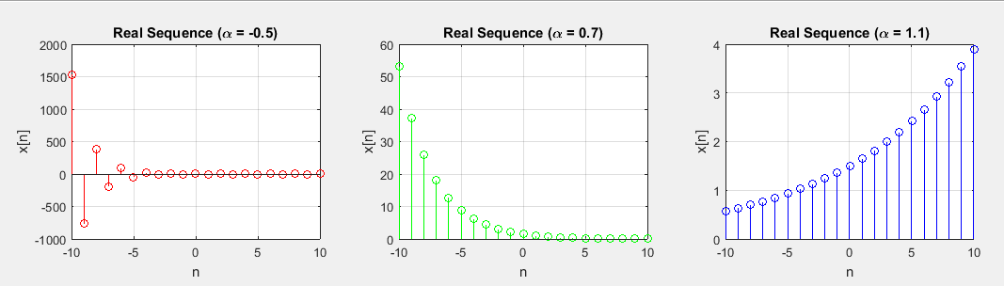

**Task 2**: Using Equations x[n]=|A |e j(ω0n+φ) = |A | cos (ω0n + φ) + j |A |sin (ω0n + φ) for Complex Graphs.

Let A=2, n= -10 to 10

1. for (-1 < alpha < 0), try alpha= -0.5
2. for (0 < alpha < 1), try alpha=0.7
3. for (|alpha| > 1), try alpha= 1.1

**Code:**

clc;

clear;

close all;

% Complex exponential sequences

A_complex = 2;

alpha_complex1 = -0.5;

x_complex1 = A_complex * exp(1j * 0.4 * n) .* alpha_complex1.^n;

alpha_complex2 = 0.7;

x_complex2 = A_complex * exp(1j * 0.4 * n) .* alpha_complex2.^n;

alpha_complex3 = 1.1;

x_complex3 = A_complex * exp(1j * 0.4 * n) .* alpha_complex3.^n;

% Plot complex exponential sequences

subplot(2, 3, 4);

stem(n, x_complex1, 'r');

title('Complex Signal (\alpha = -0.5)');

xlabel('n');

ylabel('x[n]');

grid on;

subplot(2, 3, 5);

stem(n, x_complex2, 'g');

title('Complex Signal (\alpha = 0.7)');

xlabel('n');

ylabel('x[n]');

grid on;

subplot(2, 3, 6);

stem(n, x_complex3, 'b');

title('Complex Signal (\alpha = 1.1)');

xlabel('n');

ylabel('x[n]');

grid on;

% Display imaginary parts of complex sequences

figure;

subplot(2, 3, 1);

stem(n, imag(x_complex1), 'r');

title('Imaginary Part (|\alpha| < 1)');

xlabel('n');

ylabel('Im\{x[n]\}');

grid on;

subplot(2, 3, 2);

stem(n, imag(x_complex2), 'g');

title('Imaginary Part (|\alpha| < 1)');

xlabel('n');

ylabel('Im\{x[n]\}');

grid on;

subplot(2, 3, 3);

stem(n, imag(x_complex3), 'b');

title('Imaginary Part (|\alpha| > 1)');

xlabel('n');

ylabel('Im\{x[n]\}');

grid on;

% Plot real parts of complex exponential sequences

subplot(2, 3, 4);

stem(n, real(x_complex1), 'r');

title('Real Part (|\alpha| < 1)');

xlabel('n');

ylabel('Re\{x[n]\}');

grid on;

subplot(2, 3, 5);

stem(n, real(x_complex2), 'g');

title('Real Part (|\alpha| < 1)');

xlabel('n');

ylabel('Re\{x[n]\}');

grid on;

subplot(2, 3, 6);

stem(n, real(x_complex3), 'b');

title('Real Part (|\alpha| > 1)');

xlabel('n');

ylabel('Re\{x[n]\}');

grid on;

**Output:**

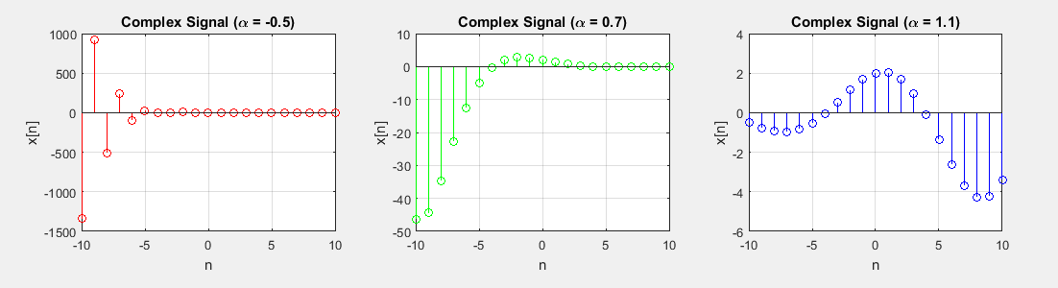

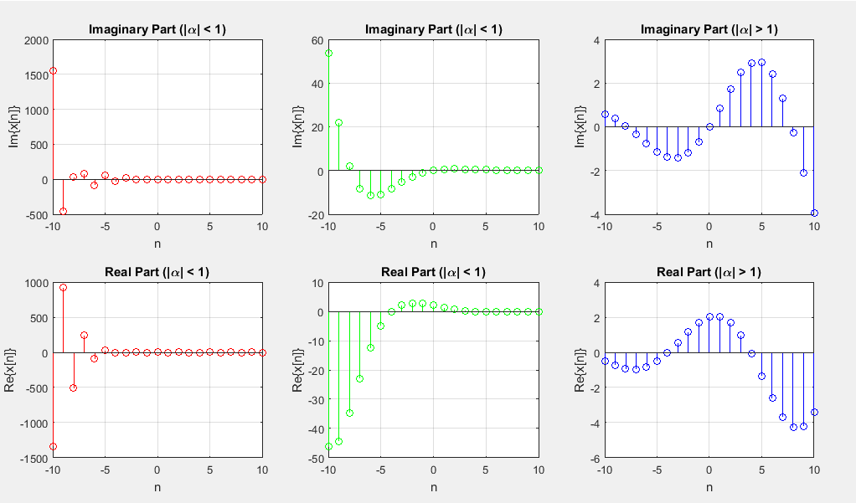

The End.