**SMOOTHING (IMPLEMENTING MOVING**

**AVERAGE) OUT NOISY SIGNAL**

**USING MATLAB**

**Assignment # 0****2**

**Fall 2023**

**CSE-402**

**Digital Signal Processing**

Submitted by: **AIMAL KHAN**

Registration No.: **21PWCSE1996**

Class Section: **A**

“On my honor, as student of University of Engineering and Technology, I have neither given nor received unauthorized assistance on this academic work.”

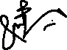

Student Signature: ______________

Submitted to:

**Engr. Ihsan Ul Haq.**

Sunday, November 5, 2023

Department of Computer Systems Engineering

University of Engineering and Technology, Peshawar

**Smoothing (Implementing Moving Average) Out Noisy Signal Using MATLAB**

MATLAB Code:

**Provide a .m file with detailed comments and detailed analysis?**

**Code:**

clc;

clear;

close all;

time = 0: 1/1000 : 1;

frequency = 5;

amplitude = 5;

signal = amplitude .* sin(2 * pi * frequency * time);

figure;

subplot(3, 1, 1);

plot(time, signal);

xlabel('Time');

ylabel('Amplitude');

title('Sin wave of 5 Hz');

grid on;

%% Gaussian Noise With Standard Deviation and Mean.

mean = 1;

std = 3;

[rows, cols] = size(time);

gaussian = mean + std * randn(cols, 1);

subplot(3, 1, 2);

plot(time, gaussian, 'k');

xlabel('Time');

ylabel('Amplitude');

title('Random Gaussian wave having \mu and \sigma');

grid on;

%% Add Gaussian with The Signal.

noisySignal = transpose(gaussian) + signal;

subplot(3, 1, 3);

plot(time, noisySignal);

xlabel('Time');

ylabel('Amplitude');

title('Random Gaussian + Sin Signal');

grid on;

%% Smoothing the noisy signal

figure;

smooth3 = smooth(noisySignal, 3);

subplot(3, 1, 1);

plot(time, smooth3, 'r');

xlabel('Time');

ylabel('Amplitude');

title('Smoothing Noisy Signal with window 3');

grid on;

smooth5 = smooth(noisySignal, 5);

subplot(3, 1, 2);

plot(time, smooth5, 'm');

xlabel('Time');

ylabel('Amplitude');

title('Smoothing Noisy Signal with window 5');

grid on;

smooth7 = smooth(noisySignal, 7);

subplot(3, 1, 3);

plot(time, smooth7, 'b');

xlabel('Time');

ylabel('Amplitude');

title('Smoothing Noisy Signal with window 7');

grid on;

Outputs:

**1**: Generate a sin wave of any desired frequency & amplitude and plot it in MATLAB as shown in Figure 1.

**Output:**

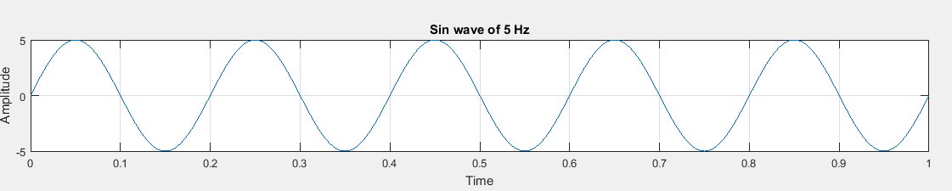

**2**: Generate a white Gaussian noisy signal with a three different mean and std, using MATLAB random function.

**Output:**

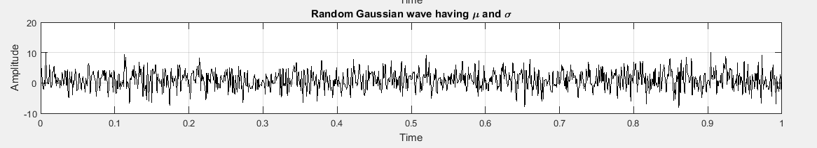

**3**: The next step is to add up your sin waveform with the noise generated in the above step with a specific mean and std and generate & plot the three noisy signals.

**Output:**

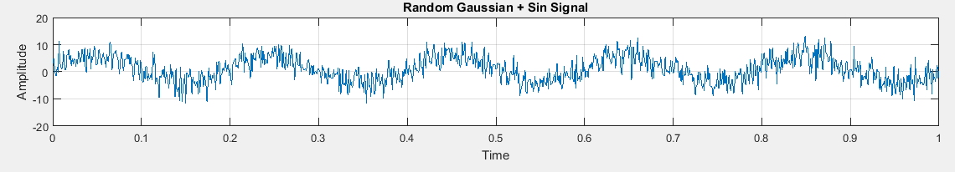

**4**: Next step is to smooth your noisy signals and for that, you will be using the ***movmean*** function from MATLAB. Make sure you plot the signal with three different window sizes, take 3,5 and 7.

Instead of ***movmean*** I have used another function ***smooth*** because in MATLAB v2015 the mentioned function is undefined.

**Output:**

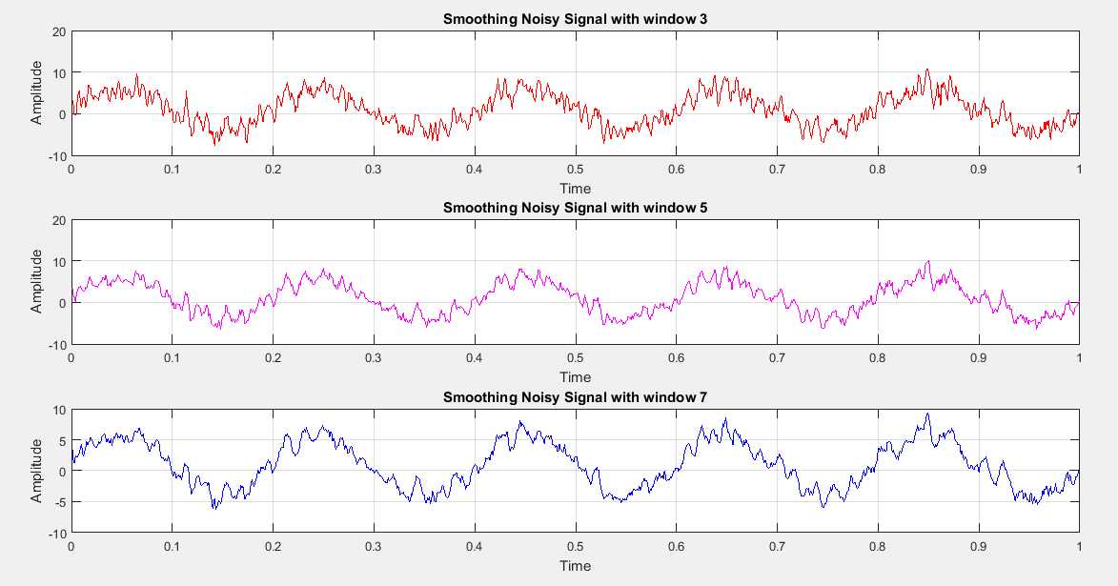

**5**: Analyze your results considering the Mean, Standards Deviation and Window size.

**Ans:** The mean (µ) has almost no affect it only shifts the signal up or down (y axis) when denoise. The standard deviation ($σ$)causes the signal to be more or less noisy if we change its value. If the value is high, it is difficult to denoise the signal to its original form if it is low the signal is restored back easily. Window size also affect the signal denoising process. If window size is increased it will give us the more accurate approximation of a signal while if it is kept low the approximation will be not as accurate.

The End.