**MATLAB TRAINING**

**LAB # 0****1**

**Fall 2023**

**CSE-402L**

**Digital Signal Processing Lab**

Submitted by: **AIMAL KHAN**

Registration No.: **21PWCSE1996**

Class Section: **A**

“On my honor, as student of University of Engineering and Technology, I have neither given nor received unauthorized assistance on this academic work.”

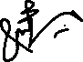

Student Signature: ______________

Submitted to:

**Dr. Yasir Saleem Afridi.**

Wednesday, September 27, 2023

Department of Computer Systems Engineering

University of Engineering and Technology, Peshawar

**CSE 402L: Digital Signals Processing**

|  |  |  |  |  |
| --- | --- | --- | --- | --- |
|  | **Poor (Does not meet expectation (1))** | **Fair (Meet**  **Expectation (2-3))** | **Good (Exceeds**  **Expectation (4-5)** | **Score** |
| **Demonstration**  **of**  **Concepts** | The student failed to demonstrate a clear understanding of the  assignment concepts | The student demonstrated a clear understanding of some of the assignment.  concepts | The student demonstrated a clear understanding of the assignment concepts | **30%** |
| **Accuracy** | The student mis-configured enough signal processing settings that the computer couldn't function properly. | The student configured enough signal processing settings that the computer partially functioned | The student configured the signal processing settings that the computer fully functioned | **30%** |
| **Following**  **Directions** | The student clearly failed to follow the verbal and written instructions to successfully complete the lab | The student failed to follow the some of the verbal and written instructions to successfully complete all requirements of the lab | The student followed the verbal and written instructions to successfully complete  requirements of the lab | **20%** |
| **Time Utilization** | The student failed to complete even part of the lab in the allotted amount of time | The student failed to complete the entire lab in the allotted amount of time | The student completed the lab in its entirety in the allotted amount of time | **20%** |

**MATLAB Training**

Tasks:

* **Course Overview**
  + Objective: Familiarize yourself with the course.
  + Remarks along with final snapshot

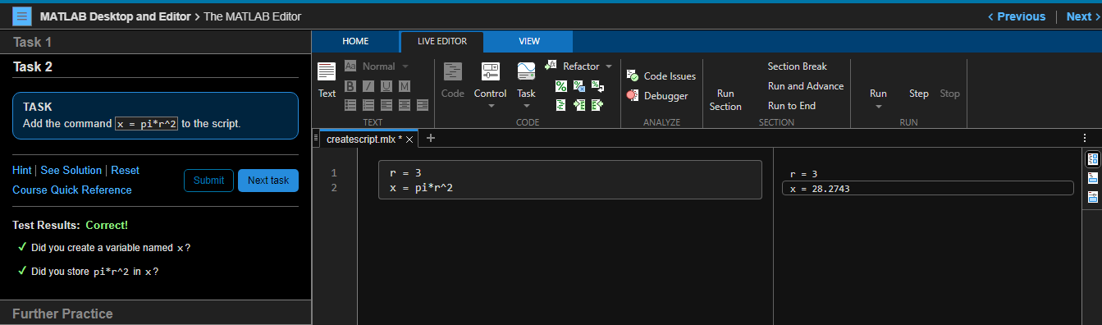

* **Commands**
  + Objective: Enter commands in MATLAB to perform calculations and create variables.
  + Remarks along with final snapshot

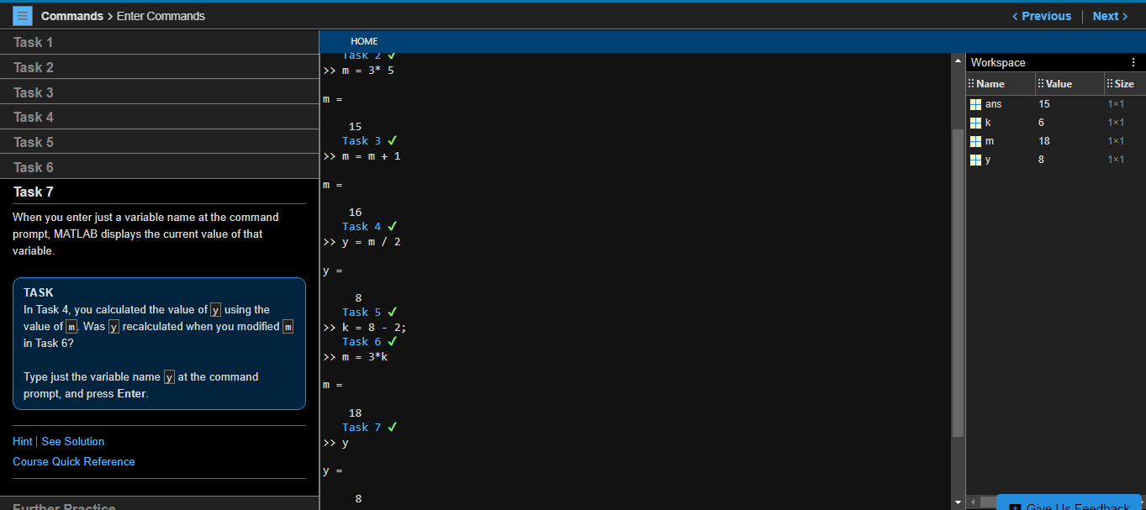

* **Vectors and Matrices**
  + Objective: Create MATLAB variables that contain multiple elements.
  + Remarks along with final snapshot

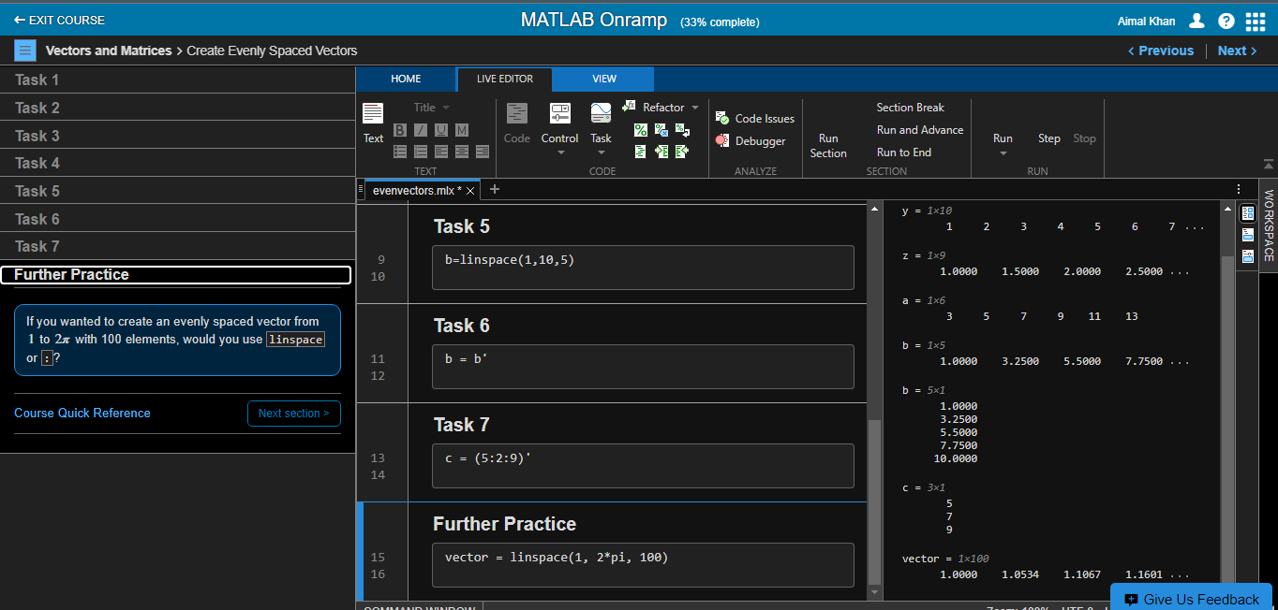

* **Importing Data**
  + Objective: Bring data from external files into MATLAB.
  + Remarks along with final snapshot
  + 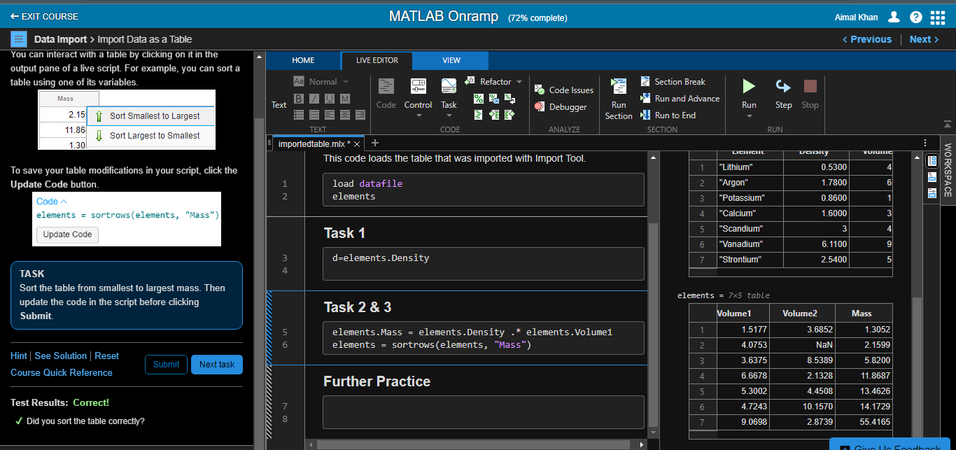
* **Indexing into Modifying Arrays**
  + Use indexing to extract and modify rows, columns, and elements of MATLAB arrays.
  + Remarks along with final snapshot

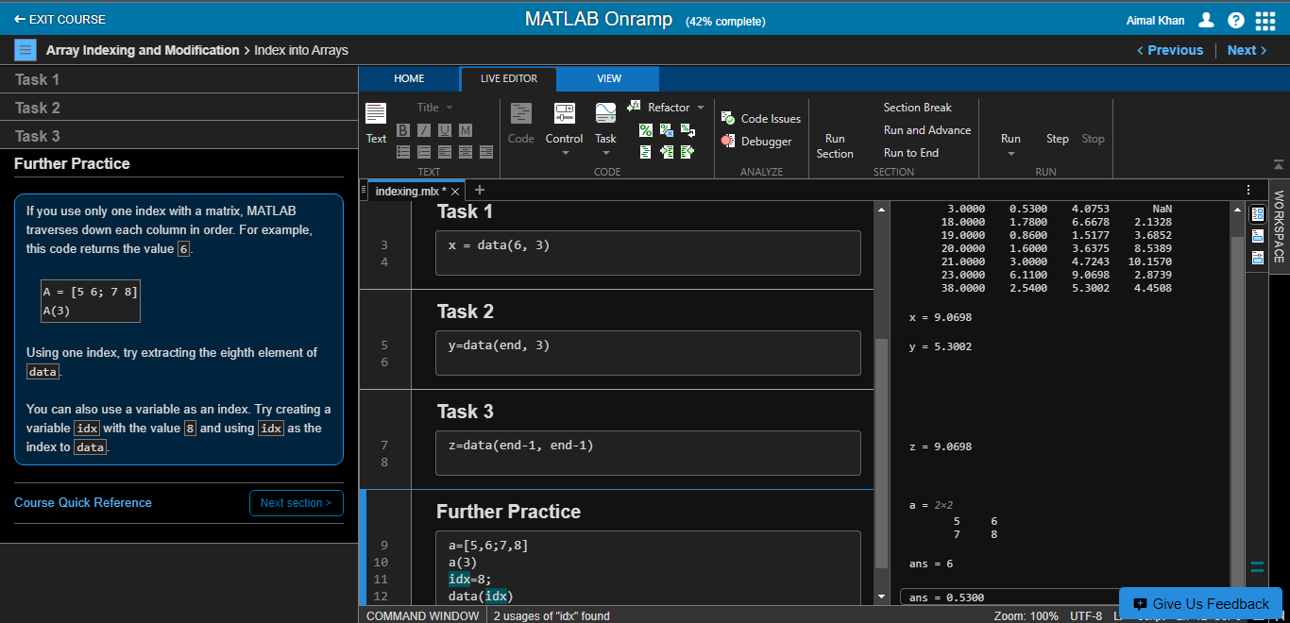

* **Array Calculations**
  + Objective: Perform calculations on entire arrays at once.
  + Remarks along with final snapshot

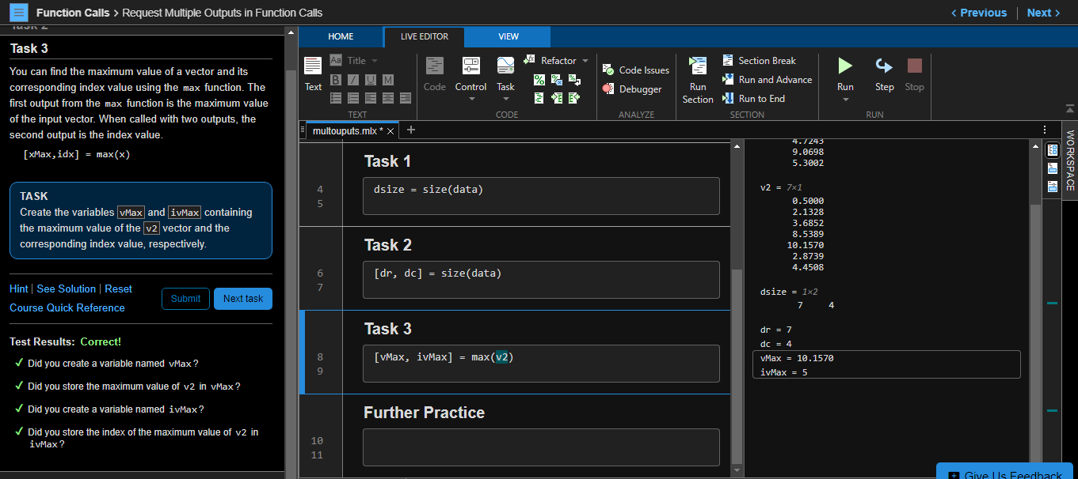

* **Calling Functions**
  + Objective: Call functions to obtain multiple outputs
  + Remarks along with final snapshot

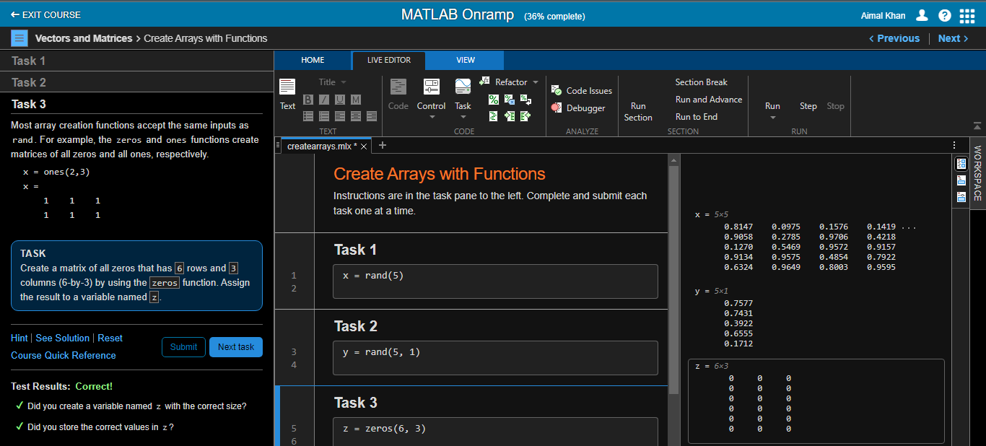

* **Obtaining Help**
  + Objective: Use the MATLAB documentation to discover information about MATLAB features.
  + Remarks along with final snapshot

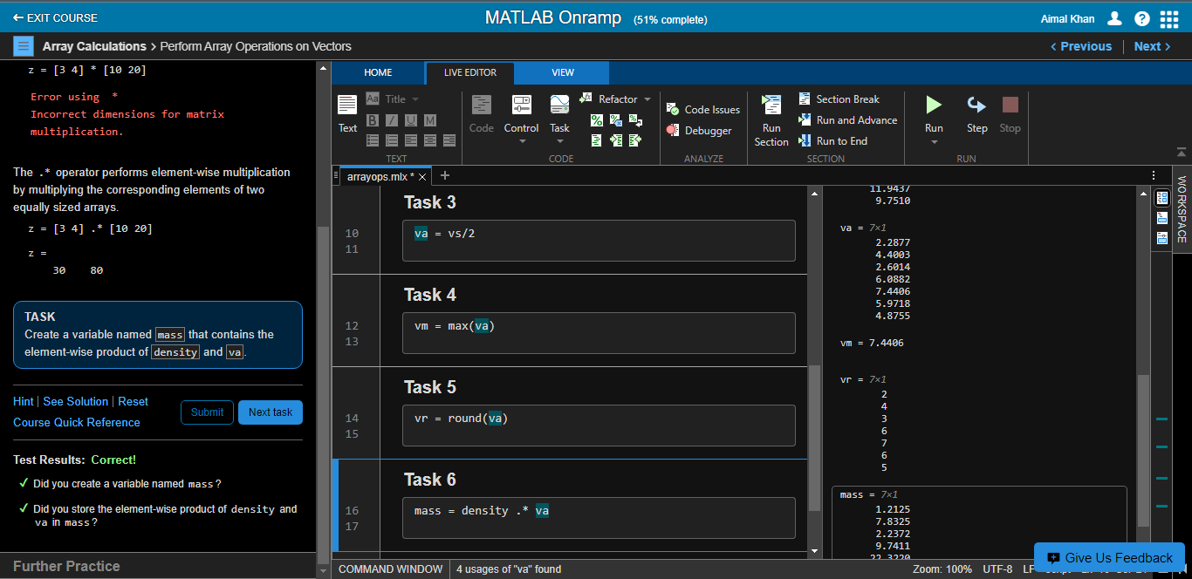

* **Plotting Data**
  + Visualize variables using MATLAB's plotting functions.
  + Remarks along with final snapshot

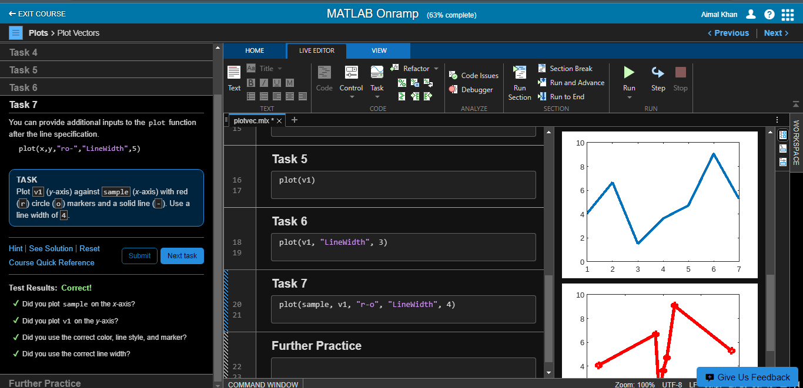

* **Review Problems**
  + Objective: Bring together concepts that you have learned with a project.
  + Remarks along with final snapshot

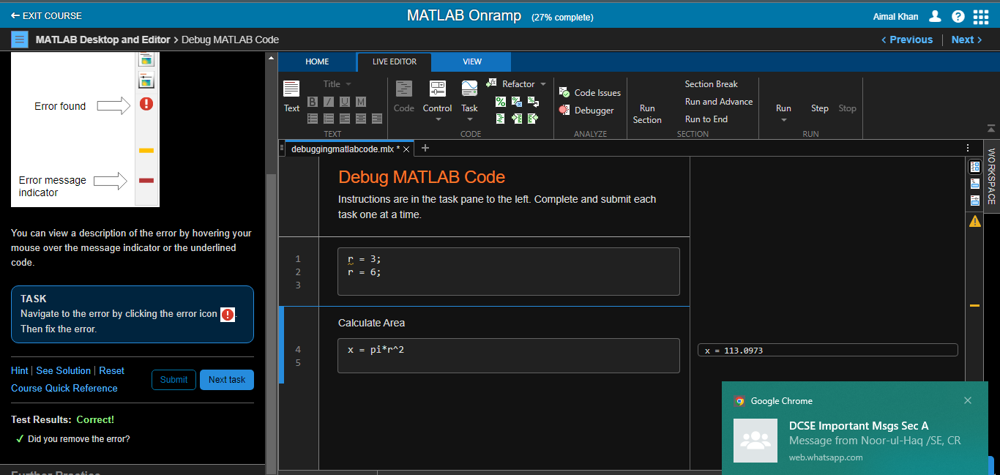

* **MATLAB Scripts**
  + Objective: Write and save your own MATLAB programs
  + Remarks along with final snapshot

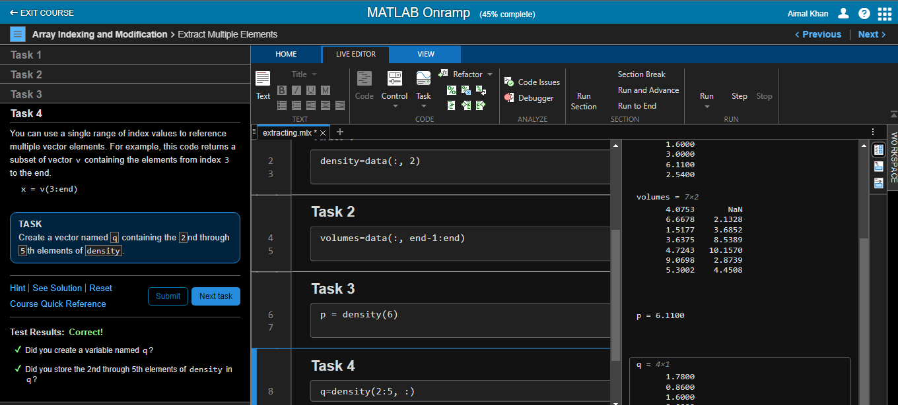

* **Logical Arrays**
  + Objective: Use logical expressions to help you to extract elements of interest from MATLAB arrays
  + Remarks along with final snapshot

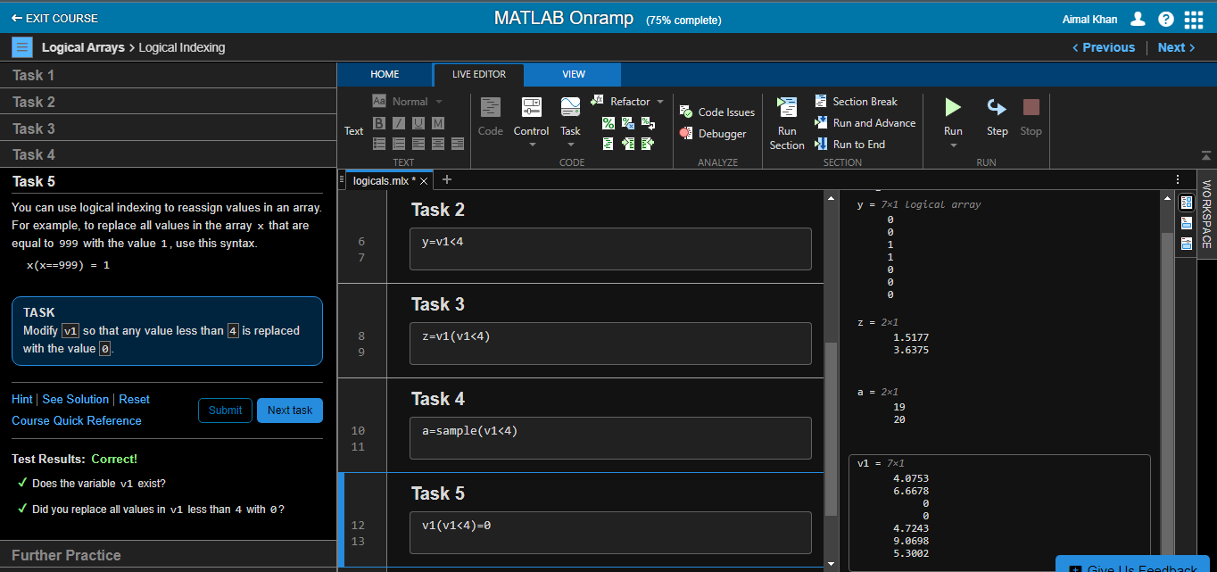

* **Programming**
  + Objective: Write programs that execute code based upon some condition.
  + Remarks along with final snapshot

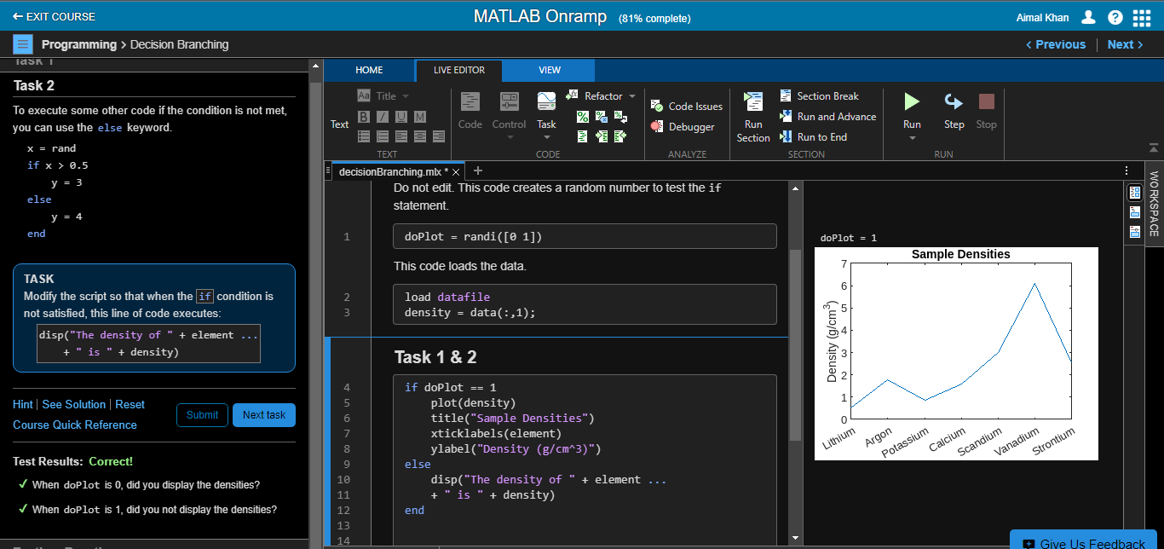

* **Final Project**
  + Objective: Bring together concepts that you have learned with a project
  + Remarks along with final snapshot

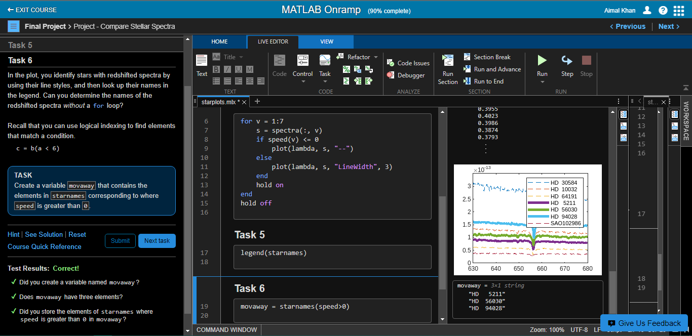

* **Certificates**

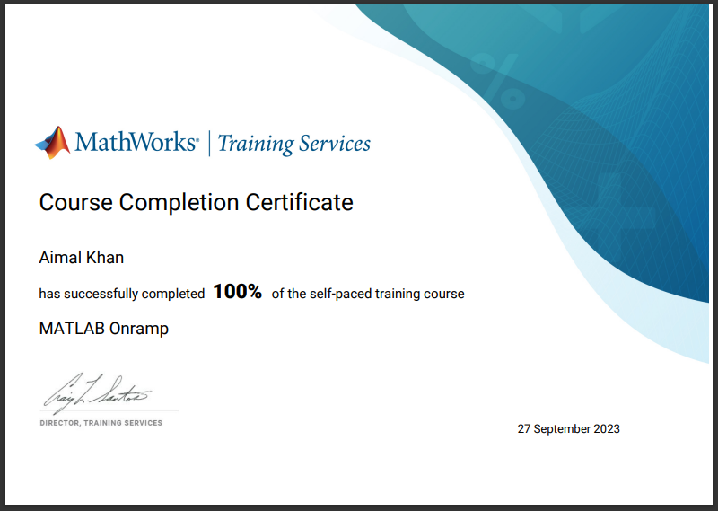

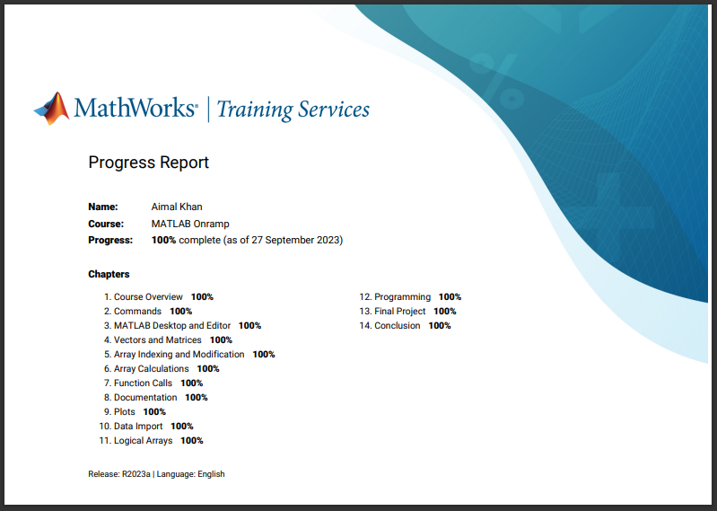

Reference:

<https://matlabacademy.mathworks.com/progress/share/certificate.html?id=7d515b56-6bf1-484c-9087-3f7d917f8f62&>

[**https://matlabacademy.mathworks.com/progress/share/report.html?id=7d515b56-6bf1-484c-9087-3f7d917f8f62&**](https://matlabacademy.mathworks.com/progress/share/report.html?id=7d515b56-6bf1-484c-9087-3f7d917f8f62&)

The End.