**PLAYING WITH**

**MATLAB**

**LAB # 0****2**

**Fall 2023**

**CSE-402L**

**Digital Signal Processing Lab**

Submitted by: **AIMAL KHAN**

Registration No.: **21PWCSE1996**

Class Section: **A**

“On my honor, as student of University of Engineering and Technology, I have neither given nor received unauthorized assistance on this academic work.”

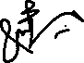

Student Signature: ______________

Submitted to:

**Dr. Yasir Saleem Afridi.**

Wednesday, October 11, 2023

Department of Computer Systems Engineering

University of Engineering and Technology, Peshawar

**CSE 402L: Digital Signal Processing**

|  |  |  |  |  |
| --- | --- | --- | --- | --- |
| **Demonstration of Concepts** | **Poor (Does not meet expectation (1))**  The student failed to demonstrate a clear understanding of the assignment concepts | **Fair (Meet Expectation (2-3))**  The student demonstrated a clear understanding of some of the assignment concepts | **Good (Exceeds Expectation (4-5)**  The student demonstrated a clear understanding of the assignment concepts | **Score**  **30%** |
| **Accuracy** | The student completed ( <50%) tasks and provided MATLAB code and/or Simulink models with errors. Outputs shown are not correct in form of graphs (no labels) and/or tables along with incorrect analysis or remarks. | The student completed partial tasks (50% - <90%) with accurate MATLAB code and/or Simulink models. Correct outputs are shown in form of graphs (without labels) and/or tables along with correct analysis or remarks. | The student completed all required tasks (90%-100%) with accurate MATLAB code and/or Simulink models. Correct outputs are shown in form of labeled graphs and/or tables along with correct analysis or remarks. | **30%** |
| **Following Directions** | The student clearly failed to follow the verbal and written instructions to successfully complete the lab | The student failed to follow the some of the verbal and written instructions to successfully complete all requirements of the lab | The student followed the verbal and written instructions to successfully complete requirements of the lab | **20%** |
| **Time Utilization** | The student failed to complete even part of the lab in the allotted amount of time | The student failed to complete the entire lab in the allotted amount of time | The student completed the lab in its entirety in the allotted amount of time | **20%** |

___________________

Dr. Yasir Saleem Afridi

**Playing With MATLAB**

Objectives:

* Revise matlab
* Assignment, variables, lopes, plot, sound, colon operators etc

Tasks:

**Task 1.1 (d)**: Use MATLAB as a calculator

**Code:**

clear all;

clc;

close all;

pi*pi - 10

sin(pi/4)

ans ^ 2

**Output:**

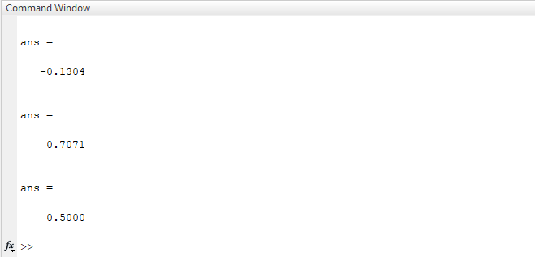

**Task 1.1 (e)**: Do variable name assignment in MATLAB.

**Code:**

clear all;

clc;

close all;

x = sin( pi/5 );

cos( pi/5 ) %<--- assigned to what?

y = sqrt( 1 - x*x )

ans

**Output:**

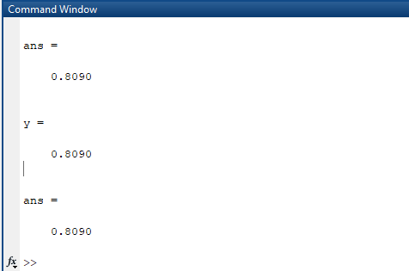

**Task 1.1(f)**: Complex numbers are natural in MATLAB.

**Code:**

clear all;

clc;

close all;

z = 3 + 4i, w = -3 + 4j

real(z), imag(z)

abs([z,w]) %<-- Vector constructor

conj(z+w)

angle(z)

exp( j*pi )

exp(j*[ pi/4, 0, -pi/4 ])

**Output:**

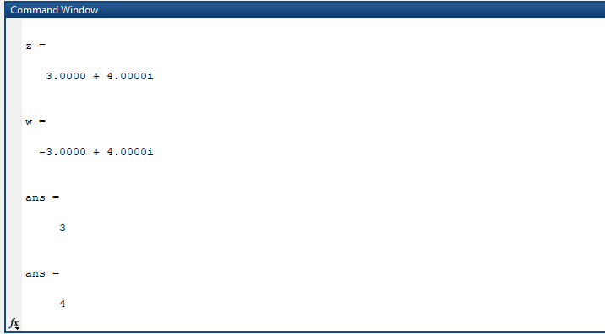

**Task 2.1**: **MATLAB Array Indexing**

**Code:**

clc;

clear all;

close all;

%% (a) Make sure that you understand the colon notation. In particular, explain in words what the following MATLAB code will produce

jkl = 0 : 6

jkl = 2 : 4 : 17

jkl = 99 : -1 : 88

ttt = 2 : (1/9) : 4

tpi = pi * [ 0:0.1:2 ];

%% (b) Extracting and/or inserting numbers into a vector is very easy to do.

xx = [ zeros(1,3), linspace(0,1,5), ones(1,4) ]

xx(4:6)

size(xx)

length(xx)

xx(2:2:length(xx))

xx(2:2:end)

%% (c) Observe the result of the following assignments

yy = xx;

yy(4:6) = pi*(1:3)

**Output:**

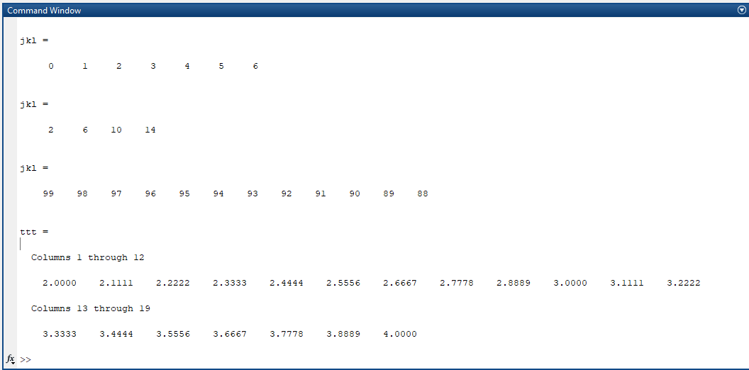

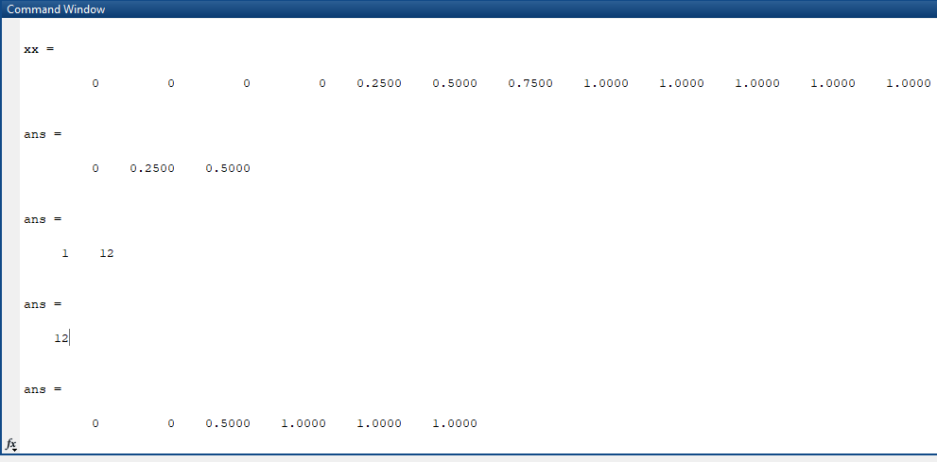

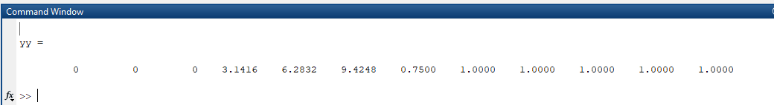

**Task 2.2**: **MATLAB Script Files**

**Code:**

clc;

clear all;

close all;

%% (a) Experiment with vectors in MATLAB. Think of the vector as a set of numbers.

xk = cos( pi*(0:11)/4 ) %<---comment: compute cosines

%% (b) Rewrite this computation without using the loop (follow the style in the previous part).

yy = [ ]; %<--- initialize the yy vector to be empty

for k=-5:5

yy(k+6) = cos( k*pi/3 )

end

yy_2 = cos(pi*(-5:5)/3)

%% (c) Plotting is easy in MATLAB for both real and complex numbers. The basic plot command will plot a vector y versus a vector x connecting successive points by straight lines.

x = [-3 -1 0 1 3];

y = x.*x - 3*x;

plot( x, y )

z = x + y*sqrt(-1)

plot( z ) %<---- complex values: plot imag vs. real

%% (d) Use the built-in MATLAB editor to create a script file called mylab1.m containing the following lines

tt = -1 : 0.01 : 1;

xx = cos(5*pi*tt);

zz = 1.4*exp(j*pi/2)*exp(j*5*pi*tt);

plot(tt, xx, 'b-', tt, real(zz), 'r--') %<--- plot a sinusoid

grid on

title('TEST PLOT of a S')

%% (e) Run your script from MATLAB. To run the file mylab1 that you created previously, try

mylab1 %<---will run the commands in the file

type mylab1 %<---will type out the contents of

% mylab1.m to the screen

**Output:**

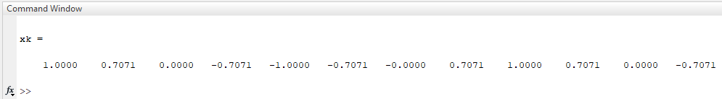

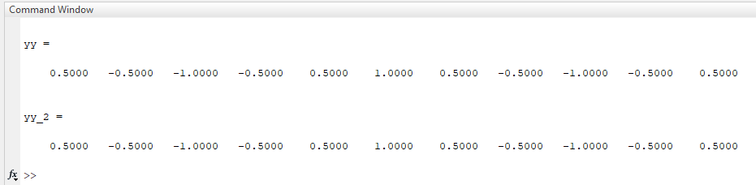

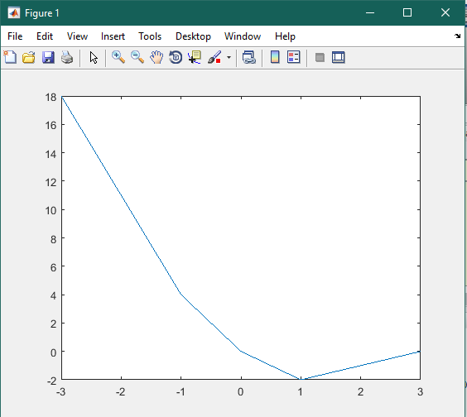

**Task 2.3: MATLAB Sound**

**Code:**

clc;

clear all;

close all;

%% (a) Run the MATLAB sound demo by typing xpsound at the MATLAB prompt. If you are unable to hear the sounds in the MATLAB demo then ask for help

xpsound

%% (b) Now generate a tone (i.e., a sinusoid) in MATLAB and listen to it with the soundsc() command.

fs = 11025;

dur = 1;

tt = 0:(1/fs):dur;

sound = sin(2*pi*2000*tt);

plot(sound);

soundsc(sound, fs);

**Output:**

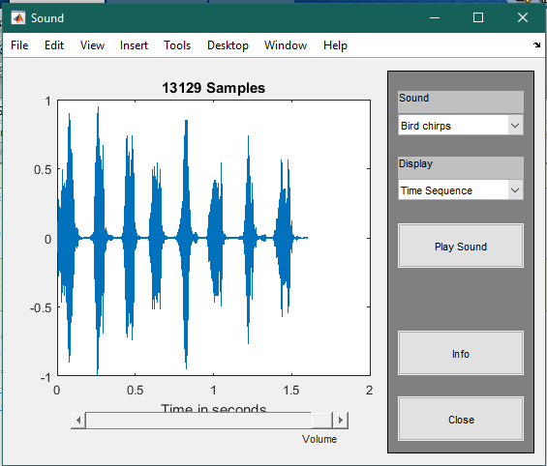

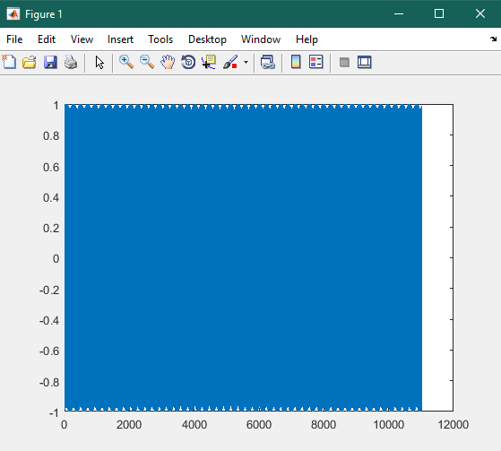

Conclusion:

In this lab we have revised the matlab concepts and syntax. We also learnt how can we replace a loop by colon operator, accessing via ans variable, and most significantly is how can we generate, play, pause and plot a sound using matlab.

The End.