**STUDY OF CONTINUOUS TIME**

**SIGNAL USING**

**MATLAB**

**LAB # 0****2**

**Fall 2023**

**CSE-402L**

**Digital Signal Processing Lab**

Submitted by: **AIMAL KHAN**

Registration No.: **21PWCSE1996**

Class Section: **A**

“On my honor, as student of University of Engineering and Technology, I have neither given nor received unauthorized assistance on this academic work.”

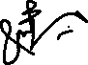

Student Signature: ______________

Submitted to:

**Dr. Yasir Saleem Afridi.**

Friday, October 13, 2023

Department of Computer Systems Engineering

University of Engineering and Technology, Peshawar

**CSE 402L: Digital Signal Processing**

|  |  |  |  |  |
| --- | --- | --- | --- | --- |
| **Demonstration of Concepts** | **Poor (Does not meet expectation (1))**  The student failed to demonstrate a clear understanding of the assignment concepts | **Fair (Meet Expectation (2-3))**  The student demonstrated a clear understanding of some of the assignment concepts | **Good (Exceeds Expectation (4-5)**  The student demonstrated a clear understanding of the assignment concepts | **Score**  **30%** |
| **Accuracy** | The student completed ( <50%) tasks and provided MATLAB code and/or Simulink models with errors. Outputs shown are not correct in form of graphs (no labels) and/or tables along with incorrect analysis or remarks. | The student completed partial tasks (50% - <90%) with accurate MATLAB code and/or Simulink models. Correct outputs are shown in form of graphs (without labels) and/or tables along with correct analysis or remarks. | The student completed all required tasks (90%-100%) with accurate MATLAB code and/or Simulink models. Correct outputs are shown in form of labeled graphs and/or tables along with correct analysis or remarks. | **30%** |
| **Following Directions** | The student clearly failed to follow the verbal and written instructions to successfully complete the lab | The student failed to follow the some of the verbal and written instructions to successfully complete all requirements of the lab | The student followed the verbal and written instructions to successfully complete requirements of the lab | **20%** |
| **Time Utilization** | The student failed to complete even part of the lab in the allotted amount of time | The student failed to complete the entire lab in the allotted amount of time | The student completed the lab in its entirety in the allotted amount of time | **20%** |

___________________

Dr. Yasir Saleem Afridi

**Study Of Continuous -Time Signal**

**Using MATLAB**

Objectives:

* In this lab, you will implement the following continuous-time signal using MATLAB and will explore briefly at least two characteristics of each signal.

Tasks:

**Task 1**: Unit Sample Sequence

**Code:**

clc;

clear;

close all;

% Unit Sample Sequence

time = -10:10;

unitImpulse = time == 0;

subplot(2, 1, 1)

plot(time, unitImpulse);

xlabel('time s');

ylabel('amplitude');

title('Unit Sample Continuous Signal');

subplot(2, 1, 2)

stem(time, unitImpulse);

xlabel('time s');

ylabel('amplitude mm');

title('Unit Sample Discrete Signal')

**Output:**

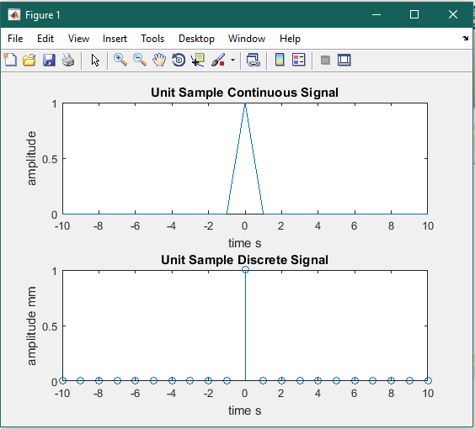

**Task 2**: Unit Step Signal

**Code:**

clc;

clear;

close all;

% Unit Step Signal

time = -10:10;

unitStep = time >= 0;

subplot(2, 1, 1)

plot(time, unitStep);

xlabel('time s');

ylabel('amplitude');

title('Unit Step Continuous Signal');

subplot(2, 1, 2)

stem(time, unitStep);

xlabel('time s');

ylabel('amplitude mm');

title('Unit Step Discrete Signal')

**Output:**

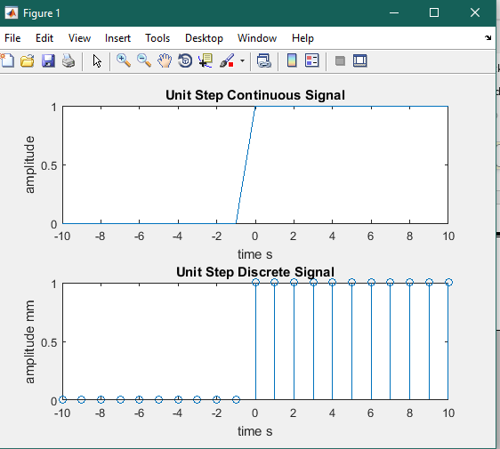

**Task 3**: Ramp Signal

**Code:**

clc;

clear;

close all;

% Ramp Signal

time = 0:10;

rampSignal = time;

subplot(2, 1, 1)

plot(time, rampSignal);

xlabel('time s');

ylabel('amplitude');

title('Ramp Continuous Signal');

subplot(2, 1, 2)

stem(time, rampSignal);

xlabel('time s');

ylabel('amplitude mm');

title('Ramp Discrete Signal')

**Output:**

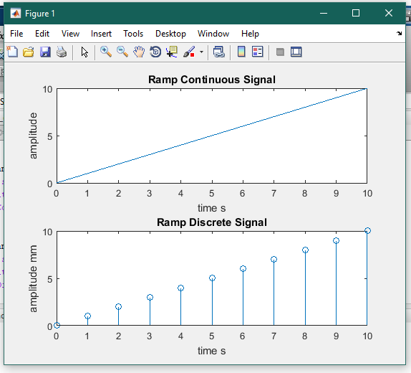

**Task 4**: Parabolic Signal

**Code:**

clc;

clear;

close all;

% Parabolic Signal

time = -10:10;

parabolicSignal = time.^2;

subplot(2, 1, 1)

plot(time, parabolicSignal);

xlabel('time s');

ylabel('amplitude');

title('Parabolic Continuous Signal');

subplot(2, 1, 2)

stem(time, parabolicSignal);

xlabel('time s');

ylabel('amplitude mm');

title('Parabolic Discrete Signal')

**Output:**

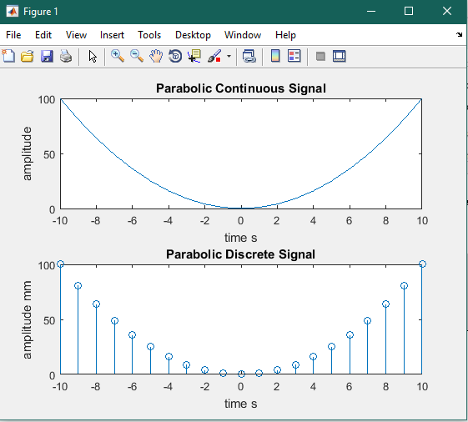

**Task 5**: Sinusoidal signal

**Code:**

clc;

clear;

close all;

% Sinusoidal Signal

time = -10:0.1:10;

frequency = 0.5;

amplitude = 2;

sinusoidalSignal = amplitude * sin(2*pi*frequency*time);

subplot(2, 1, 1)

plot(time, sinusoidalSignal);

xlabel('time s');

ylabel('amplitude');

title('Sinusoidal Continuous Signal');

subplot(2, 1, 2)

stem(time, sinusoidalSignal);

xlabel('time s');

ylabel('amplitude mm');

title('Sinusoidal Discrete Signal')

**Output:**

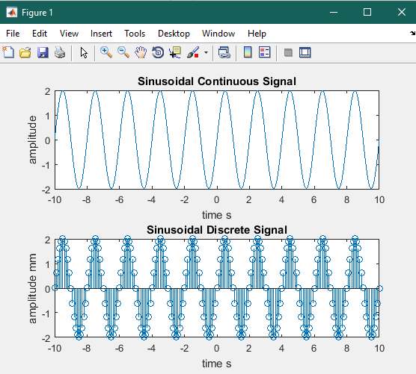

**Task 6**: Triangular Signal

**Code:**

clc;

clear;

close all;

% Triangular Signal

time = -10:0.5:10;

base = 2;

x1 = 1 - abs(time) / 2;

x2 = 0;

triangularSignal = x1 .* (abs(time) <= base) + x2 .* (abs(time)>base);

subplot(2, 1, 1)

plot(time, triangularSignal);

xlabel('time s');

ylabel('amplitude');

title('Triangular Continuous Signal');

subplot(2, 1, 2)

stem(time, triangularSignal);

xlabel('time s');

ylabel('amplitude mm');

title('Triangular Discrete Signal')

**Output:**

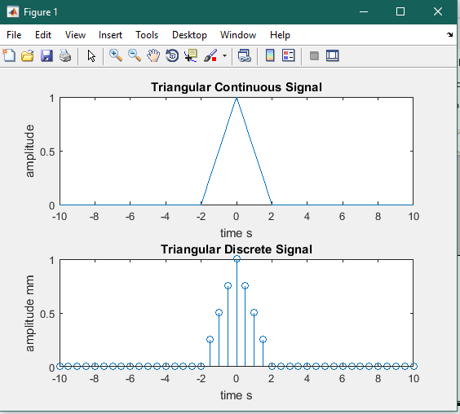

**Task 7**: Signum Signal

**Code:**

clc;

clear;

close all;

% Signum Signal

time = -10:1:10;

signumSignal = [-ones(1, 10) 0 ones(1,10)];

subplot(2, 1, 1)

plot(time, signumSignal);

xlabel('time s');

ylabel('amplitude');

title('Signum Continuous Signal');

subplot(2, 1, 2)

stem(time, signumSignal);

xlabel('time s');

ylabel('amplitude mm');

title('Signum Discrete Signal')

**Output:**

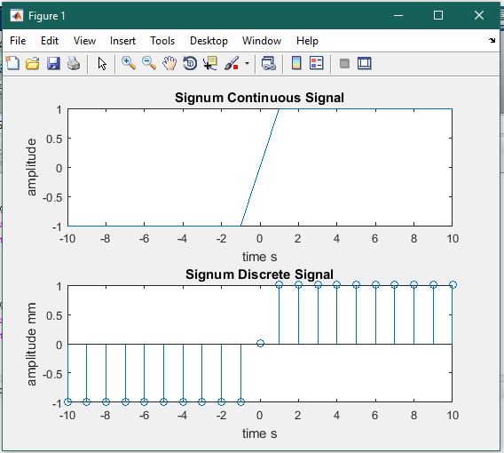

**Task 3**: Sinc Signal

**Code:**

clc;

clear;

close all;

% Sinc Signal

time = -10:0.1:10;

frequency = 1;

sincSignal = sin(2*pi*frequency*time) ./ (pi * time);

subplot(2, 1, 1)

plot(time, sincSignal);

xlabel('time s');

ylabel('amplitude');

title('Sinc Continuous Signal');

subplot(2, 1, 2)

stem(time, sincSignal);

xlabel('time s');

ylabel('amplitude mm');

title('Sinc Discrete Signal')

**Output:**

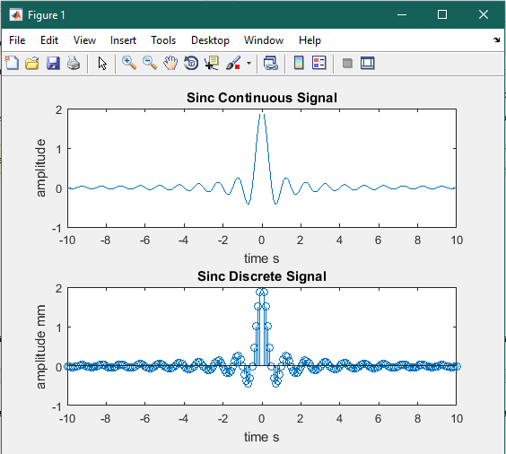

Reference:

To view my codes, please refer to my [GitHub Account.](https://github.com/aimalexe/DCSE/tree/main/semester_5_(fall-23)/digital_signal_processing_lab/)

Conclusion:

In This lab I have learnt how to generate and then plot various important signals using MATLAB. I have also learnt characteristics of each signal.

The End.