**SIGNAL ANALYSIS IN BOTH TIME**

**AND FREQUENCY DOMAIN**

**USING MATLAB**

**LAB # 0****4**

**Fall 2023**

**CSE-402L**

**Digital Signal Processing Lab**

Submitted by: **AIMAL KHAN**

Registration No.: **21PWCSE1996**

Class Section: **A**

“On my honor, as student of University of Engineering and Technology, I have neither given nor received unauthorized assistance on this academic work.”

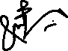

Student Signature: ______________

Submitted to:

**Dr. Yasir Saleem Afridi.**

Wednesday, October 18, 2023

Department of Computer Systems Engineering

University of Engineering and Technology, Peshawar

**CSE 402L: Digital Signal Processing**

|  |  |  |  |  |
| --- | --- | --- | --- | --- |
| **Demonstration of Concepts** | **Poor (Does not meet expectation (1))**  The student failed to demonstrate a clear understanding of the assignment concepts | **Fair (Meet Expectation (2-3))**  The student demonstrated a clear understanding of some of the assignment concepts | **Good (Exceeds Expectation (4-5)**  The student demonstrated a clear understanding of the assignment concepts | **Score**  **30%** |
| **Accuracy** | The student completed ( <50%) tasks and provided MATLAB code and/or Simulink models with errors. Outputs shown are not correct in form of graphs (no labels) and/or tables along with incorrect analysis or remarks. | The student completed partial tasks (50% - <90%) with accurate MATLAB code and/or Simulink models. Correct outputs are shown in form of graphs (without labels) and/or tables along with correct analysis or remarks. | The student completed all required tasks (90%-100%) with accurate MATLAB code and/or Simulink models. Correct outputs are shown in form of labeled graphs and/or tables along with correct analysis or remarks. | **30%** |
| **Following Directions** | The student clearly failed to follow the verbal and written instructions to successfully complete the lab | The student failed to follow the some of the verbal and written instructions to successfully complete all requirements of the lab | The student followed the verbal and written instructions to successfully complete requirements of the lab | **20%** |
| **Time Utilization** | The student failed to complete even part of the lab in the allotted amount of time | The student failed to complete the entire lab in the allotted amount of time | The student completed the lab in its entirety in the allotted amount of time | **20%** |

Dr. Yasir Saleem Afridi

**Signal Analysis in Both Time and Frequency**

**Domain Using MATLAB**

Objectives:

* Create a signal in frequency domain. Also create a signal in frequency domain.
* Transform a signal from time domain to frequency and vice versa
* Characteristics and properties of signal in each domains.

Code:

I have provided this all code of ***all_tasks.m*** file in which I have solved all the tasks. I did this so, because these tasks are closely interrelated with each other. Bellow is the commented code in separate sections.

**Code:**

% Sinusoidal Signals

clc

clear

close all

time = 0 : 0.001 : 1;

frequency_a = 10;

frequency_b = 20;

frequency_c = 30;

frequency_d = 40;

frequency_e = 50;

frequency_f = 60;

%% Time Domain Signals of given Frequencies

% for frequency = 10:

signal_a = sin(2*pi*frequency_a*time);

subplot(3, 2, 1)

plot(time, signal_a);

xlabel('Time (s)');

ylabel('Amplitude');

title('Sinusoidal Signal of 10 Hz');

axis([0, 1, -1.5, 1.5]);

grid on;

% for frequency = 20:

signal_b = sin(2*pi*frequency_b*time);

subplot(3, 2, 2)

plot(time, signal_b);

xlabel('Time (s)');

ylabel('Amplitude');

title('Sinusoidal Signal of 20 Hz');

axis([0, 1, -1.5, 1.5]);

grid on;

% for frequency = 30:

signal_c = sin(2*pi*frequency_c*time);

subplot(3, 2, 3)

plot(time, signal_c);

xlabel('Time (s)');

ylabel('Amplitude');

title('Sinusoidal Signal of 30 Hz');

axis([0, 1, -1.5, 1.5]);

grid on;

% for frequency = 40:

signal_d = sin(2*pi*frequency_d*time);

subplot(3, 2, 4)

plot(time, signal_d);

xlabel('Time (s)');

ylabel('Amplitude');

title('Sinusoidal Signal of 40 Hz');

axis([0, 1, -1.5, 1.5]);

grid on;

% for frequency = 50:

signal_e = sin(2*pi*frequency_e*time);

subplot(3, 2, 5)

plot(time, signal_e);

xlabel('Time (s)');

ylabel('Amplitude');

title('Sinusoidal Signal of 50 Hz');

axis([0, 1, -1.5, 1.5]);

grid on;

% for frequency = 60:

signal_f = sin(2*pi*frequency_f*time);

subplot(3, 2, 6)

plot(time, signal_f);

xlabel('Time (s)');

ylabel('Amplitude');

title('Sinusoidal Signal of 60 Hz');

axis([0, 1, -1.5, 1.5]);

grid on;

%% Frequency Domain Signals of Certain Frequencies

% fourier transform for frequency = 10:

N = length(signal_a);

fourierTransform_a = fft(signal_a);

freq_a = (0:N-1)*(frequency_a/N);

subplot(3, 2, 1)

plot(freq_a, abs(fourierTransform_a));

xlabel('X-axis');

ylabel('Amplitude');

title('Fourier transform of f = 10')

axis([-1, 11, -1.5, 700]);

grid on;

% fourier transform for frequency = 20:

N = length(signal_b);

fourierTransform_b = fft(signal_b);

freq_b = (0:N-1)*(frequency_b/N);

subplot(3, 2, 2)

plot(freq_b, abs(fourierTransform_b));

xlabel('X-axis');

ylabel('Amplitude');

title('Fourier transform of f = 20')

axis([-1, 21, -1.5, 700]);

grid on;

% fourier transform for frequency = 30:

N = length(signal_c);

fourierTransform_c = fft(signal_c);

freq_c = (0:N-1)*(frequency_c/N);

subplot(3, 2, 3)

plot(freq_c, abs(fourierTransform_c));

xlabel('X-axis');

ylabel('Amplitude');

title('Fourier transform of f = 30')

axis([-1, 31, -1.5, 700]);

grid on;

% fourier transform for frequency = 40:

N = length(signal_d);

fourierTransform_d = fft(signal_d);

freq_d = (0:N-1)*(frequency_d/N);

subplot(3, 2, 4)

plot(freq_d, abs(fourierTransform_d));

xlabel('X-axis');

ylabel('Amplitude');

title('Fourier transform f = 40')

axis([-1, 41, -1.5, 700]);

grid on;

% fourier transform for frequency = 50:

N = length(signal_e);

fourierTransform_e = fft(signal_e);

freq_e = (0:N-1)*(frequency_e/N);

subplot(3, 2, 5)

plot(freq_e, abs(fourierTransform_e));

xlabel('X-axis');

ylabel('Amplitude');

title('Fourier transform of f = 50')

axis([-1, 51, -1.5, 700]);

grid on;

% fourier transform for frequency = 60:

N = length(signal_f);

fourierTransform_F = fft(signal_f);

freq_f = (0:N-1)*(frequency_f/N);

subplot(3, 2, 6)

plot(freq_f, abs(fourierTransform_F));

xlabel('X-axis');

ylabel('Amplitude');

title('Fourier transform f = 60')

axis([-1, 61, -1.5, 700]);

grid on;

%% Seperate sum of time and frequency domain signals

subplot(2, 1, 1);

sum_of_time_signals = signal_a + signal_b + signal_c + signal_d + signal_e + signal_f;

plot(time, sum_of_time_signals);

xlabel('Time (s)');

ylabel('Amplitude');

title('Sum of time domain signals');

subplot(2, 1, 2);

sum_of_frequency_signals = fourierTransform_a + fourierTransform_b + fourierTransform_c + fourierTransform_d + fourierTransform_e + fourierTransform_F;

plot(abs(sum_of_frequency_signals));

xlabel('X-axis');

ylabel('Amplitude');

title('Sum of frequency domain signals');

%% Noise Signals

% create a noise signal

noise_frequency_1 = 100;

noise_amp_1 = 0.7;

noise_1 = noise_amp_1 * sin(2*pi*noise_frequency_1*time);

subplot(4, 1, 1);

plot(time, noise_1);

xlabel('Time (s)');

ylabel('Amplitude');

title('Noise Signal of f = 100 Hz and amp = 0.7')

grid on;

noise_frequency_2 = 80;

noise_amp_1 = 0.5;

noise_2 = noise_amp_1 * sin(2*pi*noise_frequency_1*time);

subplot(4, 1, 2);

plot(time, noise_2);

xlabel('Time (s)');

ylabel('Amplitude');

title('Noise Signal of f = 80 Hz and amp = 0.5');

grid on;

% put noise in time domain signals sum

subplot(4, 1, 3);

add_noise_to_time_signals = sum_of_time_signals + noise_1 + noise_2;

plot(time, add_noise_to_time_signals);

xlabel('Time (s)');

ylabel('Amplitude');

title('Noise + Time Signals')

% put noise in frequency domain signals sum

N = length(noise_1);

fft_noise_1 = fft(noise_1);

freq_noise_1 = (0:N-1)*(noise_frequency_1/N);

fft_noise_2 = fft(noise_2);

add_noise_to_frequency_signals = sum_of_frequency_signals + fft_noise_1 + fft_noise_2;

subplot(4, 1, 4)

plot(freq_noise_1, abs(add_noise_to_frequency_signals));

xlabel('X - axis');

ylabel('Amplitude');

title('Noise + Frequency Signals')

axis([-6 1, 61, -1.5, 700]);

grid on;

Tasks:

1. **Task 1**: Generate the signal of different frequencies say, 10,20,30,40,50,60 Hz (one second duration) using MATLAB as shown in figure 1 and transform the same signal in frequency domain using Fourier transform and will compare the frequencies with the time domain signal as shown in figure 2.

**Output:** This out put of time domain signal is same is given in lab manual. Here we can see as we increase frequency the cycles in each second also increase which is impossible to count manually as it is increased so much!

In Second figure I have add two figures, one from my code output and one from lab manual. This is frequency representation of the above discussed time domain signals. Here we can easily see the frequency of each signal.

|  |  |
| --- | --- |
| My Code Output of Time domain Signal | Given figure of Time Domain Signals |

|  |  |
| --- | --- |
| My Code Output of Frequency domain Signal | Given figure of Frequency Domain Signals |

1. **Task 2**: Compare the Figures 1 and 2 (Generated by your code)

**Answer:** This output of time domain signal is same is given in lab manual. Here we can see as we increase frequency the cycles in each second also increase which is impossible to count manually as it is increased so much!

In Second figure I have added two figures, one from my code output and one from lab manual. This is frequency representation of the above discussed time domain signals. Here we can easily see the frequency of each signal.

1. **Task 3**: Add all the signals generated in step 1 and get a composite signal. (which may be considered as a voice signal)

**Code:**

%% Seperate sum of time and frequency domain signals

subplot(2, 1, 1);

sum_of_time_signals = signal_a + signal_b + signal_c + signal_d + signal_e + signal_f;

plot(time, sum_of_time_signals);

xlabel('Time (s)');

ylabel('Amplitude');

title('Sum of time domain signals');

subplot(2, 1, 2);

sum_of_frequency_signals = fourierTransform_a + fourierTransform_b + fourierTransform_c + fourierTransform_d + fourierTransform_e + fourierTransform_F;

plot(abs(sum_of_frequency_signals));

xlabel('X-axis');

ylabel('Amplitude');

title('Sum of frequency domain signals');

1. **Task 4**: Plot the time and frequency domain representation of the composite signal as shown in Figure 3

**Output:**

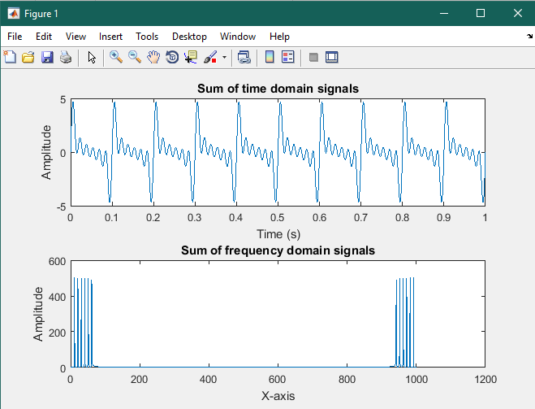

1. **Task 5**: Compare/Confirm that you are getting all the frequency generated in step 1 above.

**Answer:** I have conformed that the composite signal is sum of all the six generated signals because in frequency domain we can see easily the six different fundamental frequencies which add up to make the above output.

1. **Task 6**: Generate some unwanted signal having frequencies say 80Hz and 100Hz (assume these signals represent noise) and different amplitudes say 0.5 and 0.7

**Code:**

noise_frequency_1 = 100;

noise_amp_1 = 0.7;

noise_1 = noise_amp_1 * sin(2*pi*noise_frequency_1*time);

subplot(4, 1, 1);

plot(time, noise_1);

xlabel('Time (s)');

ylabel('Amplitude');

title('Noise Signal of f = 100 Hz and amp = 0.7')

grid on;

noise_frequency_2 = 80;

noise_amp_1 = 0.5;

noise_2 = noise_amp_1 * sin(2*pi*noise_frequency_1*time);

subplot(4, 1, 2);

plot(time, noise_2);

xlabel('Time (s)');

ylabel('Amplitude');

title('Noise Signal of f = 80 Hz and amp = 0.5');

grid on;

1. **Task 7**: Obtain both time and frequency representation of noise and confirm they have different power as shown in Figure 4

**Output:**

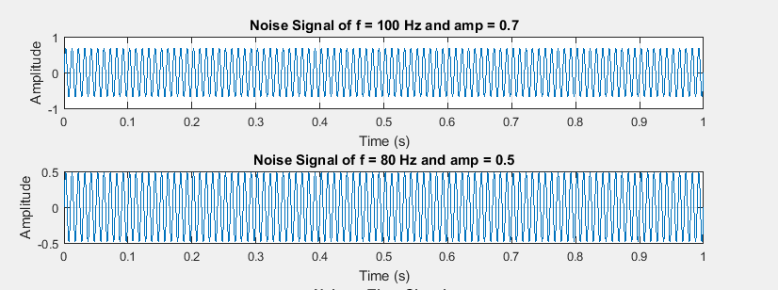

1. **Task 8**: Add the noise to the composite signal (assume the noise is added to the signal during transmission) and obtain frequency spectrum.

**Output:**

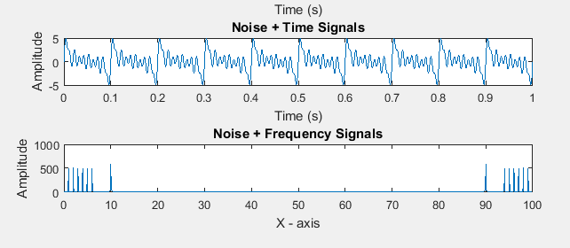

Reference:

To view my codes, please refer to [my GitHub account](https://github.com/aimalexe/DCSE/tree/main/semester_5_(fall-23)/digital_signal_processing_lab/).

Conclusion:

In conclusion, this lab provides me basic understanding of signal in different domains like time and frequency domain. I also learned where these domains are to be used by considering characteristics and properties of a signal in each domain. Also, I learnt how to transform signal from one domain to another and vice versa by using Fourier Transforms and Fast Fourier Transforms. At last, I also created some noise which I can filter in frequency domain easily.

The End.