**SIGNAL PROCESSING**

**TRAINING FROM**

**MATHWORKS**

**LAB # 0****5**

**Fall 2023**

**CSE-402L**

**Digital Signal Processing Lab**

Submitted by: **AIMAL KHAN**

Registration No.: **21PWCSE1996**

Class Section: **A**

“On my honor, as student of University of Engineering and Technology, I have neither given nor received unauthorized assistance on this academic work.”

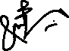

Student Signature: ______________

Submitted to:

**Dr. Yasir Saleem Afridi.**

Friday, October 27, 2023

Department of Computer Systems Engineering

University of Engineering and Technology, Peshawar

**CSE 402L: Digital Signal Processing**

|  |  |  |  |  |
| --- | --- | --- | --- | --- |
| **Demonstration of Concepts** | **Poor (Does not meet expectation (1))**  The student failed to demonstrate a clear understanding of the assignment concepts | **Fair (Meet Expectation (2-3))**  The student demonstrated a clear understanding of some of the assignment concepts | **Good (Exceeds Expectation (4-5)**  The student demonstrated a clear understanding of the assignment concepts | **Score**  **30%** |
| **Accuracy** | The student completed ( <50%) tasks and provided MATLAB code and/or Simulink models with errors. Outputs shown are not correct in form of graphs (no labels) and/or tables along with incorrect analysis or remarks. | The student completed partial tasks (50% - <90%) with accurate MATLAB code and/or Simulink models. Correct outputs are shown in form of graphs (without labels) and/or tables along with correct analysis or remarks. | The student completed all required tasks (90%-100%) with accurate MATLAB code and/or Simulink models. Correct outputs are shown in form of labeled graphs and/or tables along with correct analysis or remarks. | **30%** |
| **Following Directions** | The student clearly failed to follow the verbal and written instructions to successfully complete the lab | The student failed to follow the some of the verbal and written instructions to successfully complete all requirements of the lab | The student followed the verbal and written instructions to successfully complete requirements of the lab | **20%** |
| **Time Utilization** | The student failed to complete even part of the lab in the allotted amount of time | The student failed to complete the entire lab in the allotted amount of time | The student completed the lab in its entirety in the allotted amount of time | **20%** |

____________________

Dr. Yasir Saleem Afridi

**Signal Processing Training From MATHWORKS**

Objectives:

* Signal Processing training to demonstrate the use of MATLAB Signal Processing Tools
* In this lab you will be using seismic signal of Sumatra, Jakarta 2004 earthquake. The signal has been measured at three different seismic centers in Alaska, USA
* Visit the following website: <https://matlabacademy.mathworks.com/details/signal-processing-onramp/signalprocessing> perform the following tasks and attach the Certificate/ Progress Report acquired from MathWorks as part of the lab Report

Tasks:

1. **Task 1**: Spectral Analysis Workflow

Import signals into MATLAB and view power spectra

Write the MATLAB Script that is used to perform Spectral Analysis workflow tasks and display your output Here. Can you provide more context/info about what you have analyzed in this?

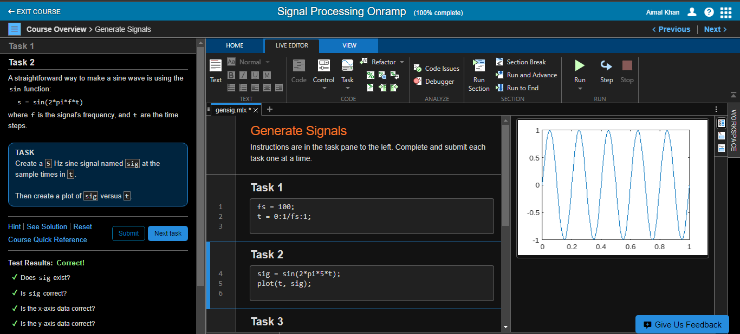

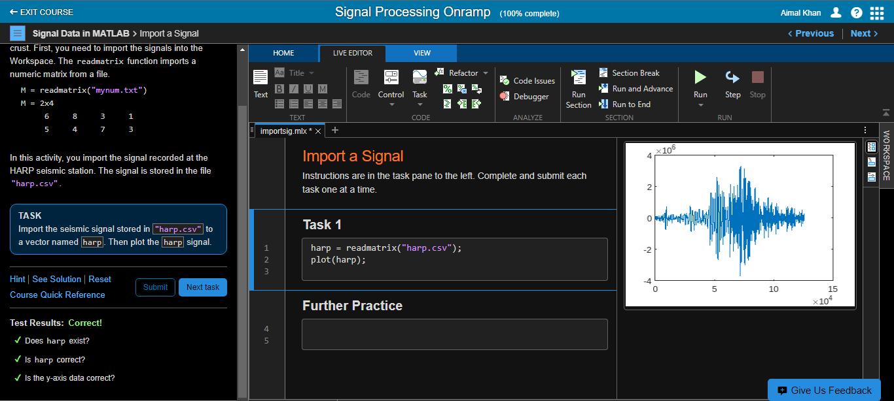

1. **Task 2**: Preprocessing Signals

Clean up time base and align signals.

Write the MATLAB Script that is used to perform Preprocessing Signal tasks and display your output Here. Mention you analyzed in this step

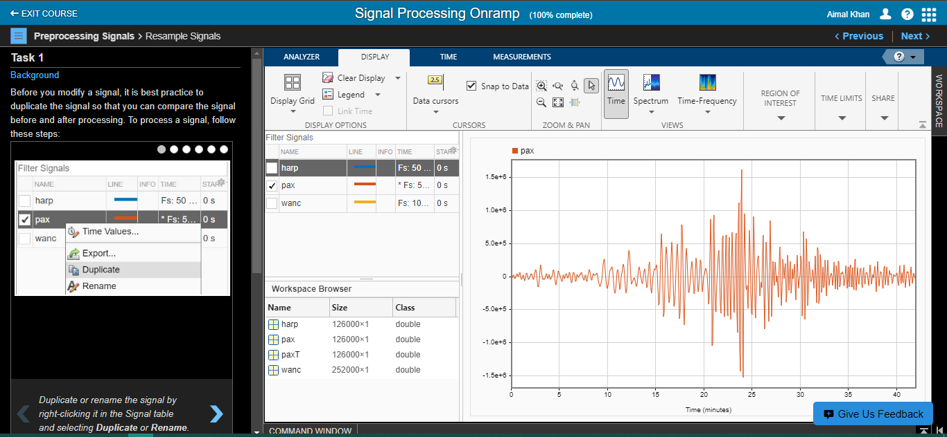

1. **Task 3**: Spectral Analysis

Perform spectral analysis to view signals in the frequency domain.

Write the MATLAB Script that is used to perform Spectral Analysis tasks and display your output Here. Mention you analyzed in this step

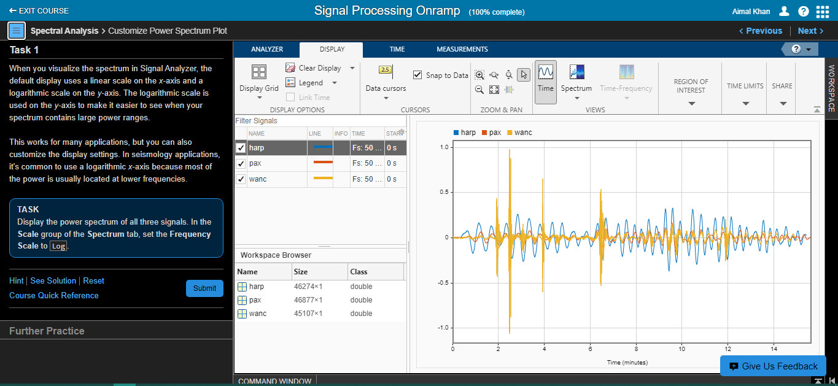

1. **Task 4**: Filtering

Filter signals using basic techniques.

Write the MATLAB Script that is used to perform Filtering tasks and display your output Here. Mention you analyzed in this step

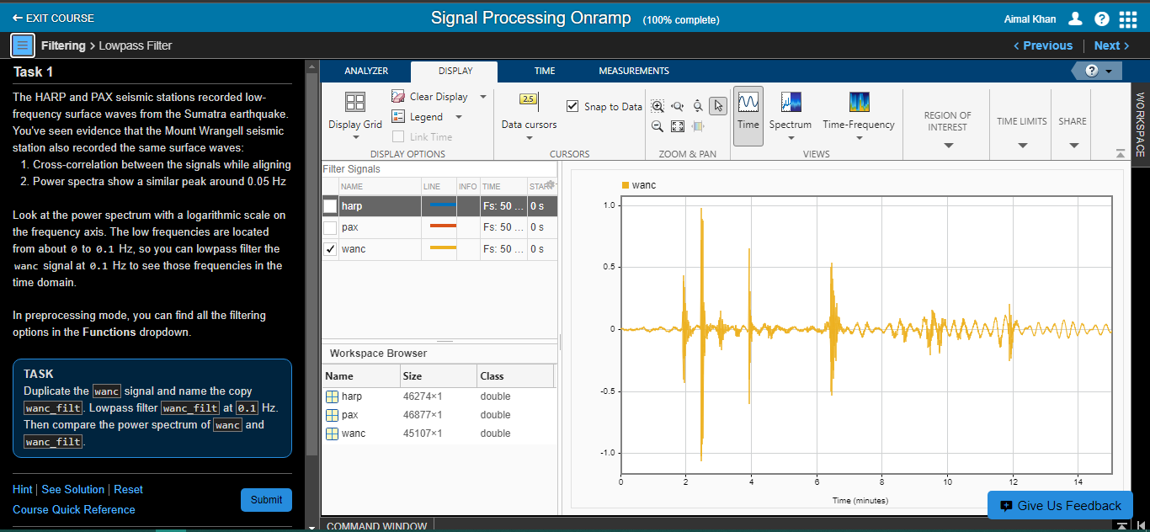

1. **Task 5**: Signal Measurement

Extract information from signals.

Write the MATLAB Script that is used to perform Signal Measurement tasks and display your output Here. Mention you analyzed in this step

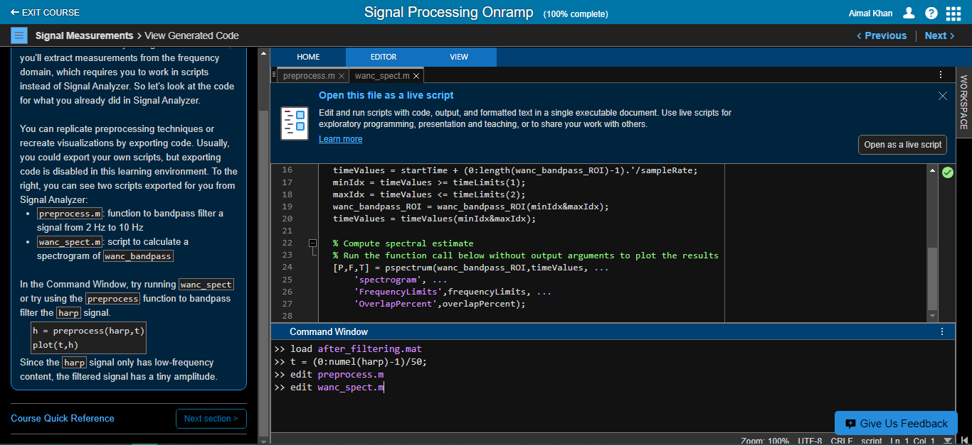

Certificates:

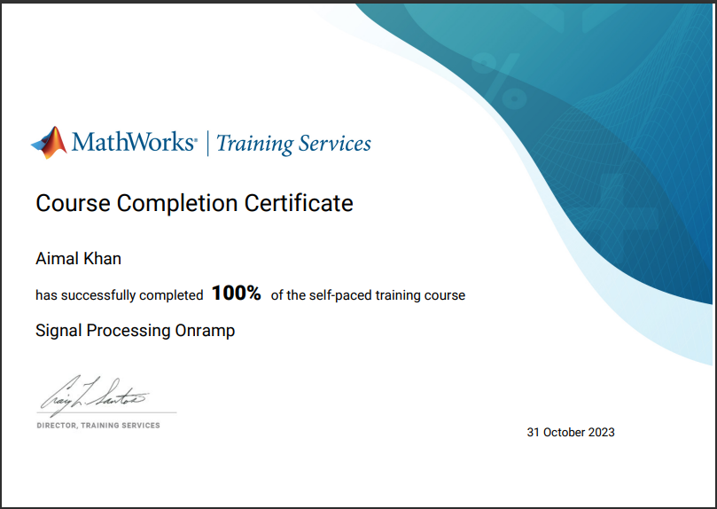



References:

<https://matlabacademy.mathworks.com/progress/share/certificate.html?id=94b6a6d8-8ad9-455e-bc2d-b724832b5e45&>

<https://matlabacademy.mathworks.com/progress/share/report.html?id=94b6a6d8-8ad9-455e-bc2d-b724832b5e45&>

The End.