**SPECTRAL ANALYSIS OF RANDOM**

**SIGNAL USING**

**MATLAB**

**LAB # 0****6**

**Fall 2023**

**CSE-402L**

**Digital Signal Processing Lab**

Submitted by: **AIMAL KHAN**

Registration No.: **21PWCSE1996**

Class Section: **A**

“On my honor, as student of University of Engineering and Technology, I have neither given nor received unauthorized assistance on this academic work.”

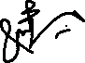

Student Signature: ______________

Submitted to:

**Dr. Yasir Saleem Afridi.**

Tuesday, December 5, 2023

Department of Computer Systems Engineering

University of Engineering and Technology, Peshawar

**CSE 402L: Digital Signal Processing**

|  |  |  |  |  |
| --- | --- | --- | --- | --- |
| **Demonstration of Concepts** | **Poor (Does not meet expectation (1))**  The student failed to demonstrate a clear understanding of the assignment concepts | **Fair (Meet Expectation (2-3))**  The student demonstrated a clear understanding of some of the assignment concepts | **Good (Exceeds Expectation (4-5)**  The student demonstrated a clear understanding of the assignment concepts | **Score**  **30%** |
| **Accuracy** | The student completed ( <50%) tasks and provided MATLAB code and/or Simulink models with errors. Outputs shown are not correct in form of graphs (no labels) and/or tables along with incorrect analysis or remarks. | The student completed partial tasks (50% - <90%) with accurate MATLAB code and/or Simulink models. Correct outputs are shown in form of graphs (without labels) and/or tables along with correct analysis or remarks. | The student completed all required tasks (90%-100%) with accurate MATLAB code and/or Simulink models. Correct outputs are shown in form of labeled graphs and/or tables along with correct analysis or remarks. | **30%** |
| **Following Directions** | The student clearly failed to follow the verbal and written instructions to successfully complete the lab | The student failed to follow the some of the verbal and written instructions to successfully complete all requirements of the lab | The student followed the verbal and written instructions to successfully complete requirements of the lab | **20%** |
| **Time Utilization** | The student failed to complete even part of the lab in the allotted amount of time | The student failed to complete the entire lab in the allotted amount of time | The student completed the lab in its entirety in the allotted amount of time | **20%** |

____________________

Dr. Yasir Saleem Afridi

**Spectral Analysis of Random Signal Using MATLAB**

Objectives:

* To find power spectral density, a measurement of energy at various frequencies.

Tasks:

**Provide .m file with detailed comments**

**Code:**

clc;

clear;

close all;

%% Data Generation

samples = 1000;

time = 0:1/samples:0.25;

signal = sin(2*pi*50*time) + sin(2*pi*120*time);

%% Adding Noise

% Noise standard deviation

sigma = 2;

noisySignal = signal + randn(size(time))*sigma;

%% Plotting Noisy Time Domain Signal

figure;

plot(time,noisySignal);

xlabel('Time (s)');

ylabel('Signal Amplitude');

title('Noisy Time Domain Signal');

%% Computing Discrete Fourier Transform

NOISY_SIGNAL = fft(noisySignal,251);

%% Computing Power Spectral Density

Pyy = NOISY_SIGNAL.*conj(NOISY_SIGNAL)/251;

freqAxis = 1000/251*(0:127);

%% Plotting Power Spectral Density

figure;

plot(freqAxis,10*log10(Pyy(1:128)));

xlabel('Frequency (Hz)');

ylabel('Power Spectral Density (dB)');

title('Power Spectral Density');

%% Computing and Plotting Periodogram

[Pyy2,w] = periodogram(noisySignal,rectwin(length(noisySignal)),length(noisySignal), 1000);

figure;

plot(w,10*log10(Pyy2));

xlabel('Frequency (Hz)');

ylabel('Periodogram (dB)');

title('Periodogram');

%% Zooming In to Show Peaks

figure;

plot(freqAxis(1:50),Pyy(1:50));

xlabel('Frequency (Hz)');

ylabel('Power Spectral Density (dB)');

title('Zoomed-In Power Spectral Density');

**Step 1**: First create some data. Consider data sampled at 1000 samples/sec. Start by forming a time axis for the data, running from t=0 until t=.25 in steps of 1 millisecond. Then form a signal, x, containing sine waves at 50 Hz and 120 Hz.

(Hint: x = sin(2*pi*50*t) + sin(2*pi*120*t

**Step 2**: Add some random noise with a standard deviation of 2 to produce a noisy signal y. Take a look at this noisy signal y by plotting it. (Hint: y = x + randn(size(t));)

**Output:**

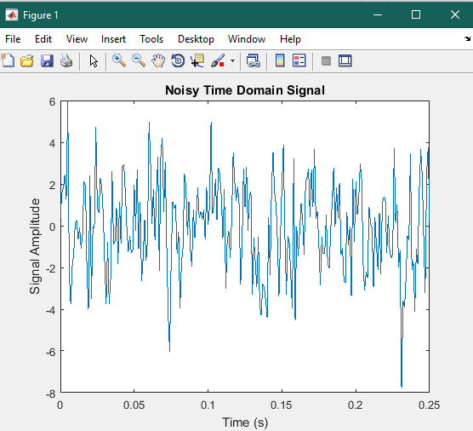

**Step 3**: Finding the discrete Fourier transform of the noisy signal y (Hint: Y = fft(y,251);)

**Step 4**: Compute the power spectral density, a measurement of the energy at various frequencies, using the complex conjugate (CONJ). Form a frequency axis for the first 127 points and use it to plot the result.  (Hint: Pyy = Y.*conj(Y)/251; f = 1000/251*(0:127);)

**Output:**

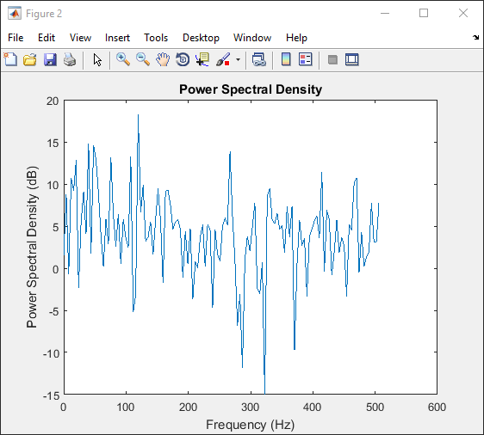

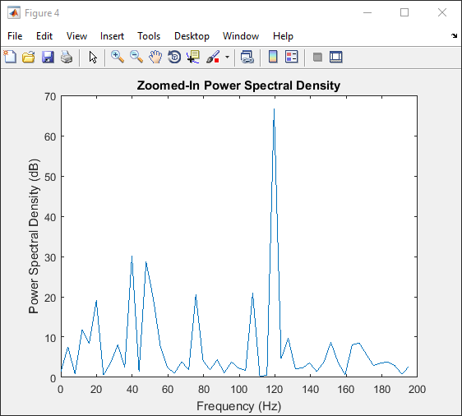

**Step 5**: Compute and plot the periodogram using periodogram. Show that the two results are identical.

[Pyy2,w] = periodogram(y,rectwin(length(y)),length(y),1000)

figure;

plot(w,10*log10(Pyy2))

**Output:**

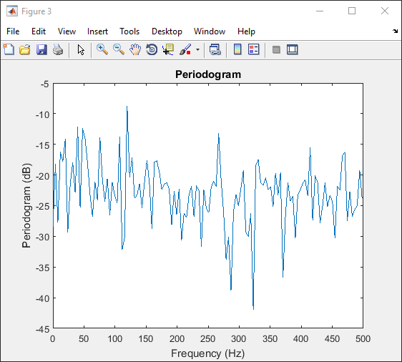

Reference:

To view my codes, please refer to [my GitHub account](https://github.com/aimalexe/DCSE/tree/main/semester_5_(fall-23)/digital_signal_processing_lab/).

Conclusion:

In conclusion, I have learned how to create periodogram and power spectral densities of signals in matlab.

The End.