**IMPLEMENTATION / ANALYSIS OF FREQUENCY**

**MODULATED AND DEMODULATED**

**SIGNAL USING MATLAB**

**LAB # 0****7**

**Fall 2023**

**CSE-402L**

**Digital Signal Processing Lab**

Submitted by: **AIMAL KHAN**

Registration No.: **21PWCSE1996**

Class Section: **A**

“On my honor, as student of University of Engineering and Technology, I have neither given nor received unauthorized assistance on this academic work.”



Student Signature: ______________

Submitted to:

**Dr. Yasir Saleem Afridi.**

Monday, December 11, 2023

Department of Computer Systems Engineering

University of Engineering and Technology, Peshawar

**CSE 402L: Digital Signal Processing**

|  |  |  |  |  |
| --- | --- | --- | --- | --- |
| **Demonstration of Concepts** | **Poor (Does not meet expectation (1))**  The student failed to demonstrate a clear understanding of the assignment concepts | **Fair (Meet Expectation (2-3))**  The student demonstrated a clear understanding of some of the assignment concepts | **Good (Exceeds Expectation (4-5)**  The student demonstrated a clear understanding of the assignment concepts | **Score**  **30%** |
| **Accuracy** | The student completed ( <50%) tasks and provided MATLAB code and/or Simulink models with errors. Outputs shown are not correct in form of graphs (no labels) and/or tables along with incorrect analysis or remarks. | The student completed partial tasks (50% - <90%) with accurate MATLAB code and/or Simulink models. Correct outputs are shown in form of graphs (without labels) and/or tables along with correct analysis or remarks. | The student completed all required tasks (90%-100%) with accurate MATLAB code and/or Simulink models. Correct outputs are shown in form of labeled graphs and/or tables along with correct analysis or remarks. | **30%** |
| **Following Directions** | The student clearly failed to follow the verbal and written instructions to successfully complete the lab | The student failed to follow the some of the verbal and written instructions to successfully complete all requirements of the lab | The student followed the verbal and written instructions to successfully complete requirements of the lab | **20%** |
| **Time Utilization** | The student failed to complete even part of the lab in the allotted amount of time | The student failed to complete the entire lab in the allotted amount of time | The student completed the lab in its entirety in the allotted amount of time | **20%** |

____________________

Dr. Yasir Saleem Afridi

**Implementation / Analysis of Frequency Modulated And Demodulated Signal Using MATLAB.**

Objectives:

* Modulate a baseband signal using carrier signal.
* Demodulate a modulated signal using carrier signal.

Tasks:

**Provide .m file with detailed comments**

**Code:**

clc;

clear;

close all

%% 1. Set the sampling frequency to 1kHz and carrier frequency to 200 Hz. Generate a time vector having a duration of 0.2 s.

samplingFrequency = 2000; % Sampling Frequency

carrierFrequency = 200; % Carrier Frequency

time = (0:1/samplingFrequency:0.2);

%% 2. Create two tone sinusoidal signal with frequencies 30 and 60 Hz

basebandSignal1 = cos(2*pi*30*time);

basebandSignal2 = cos(2*pi*60*time);

toneSignal = basebandSignal1 + basebandSignal2;

%% 3. Generate a Carrier Signal with the freq of 200Hz

carrierSignal = cos(2*pi*carrierFrequency*time);

%% 4. Plot the modulating Signal and Carrier Signal figures;

subplot(3, 1, 1);

plot(time, toneSignal, 'k*--', time, carrierSignal, 'r');

xlabel('Time (s)');

ylabel('Amplitude');

legend('baseband', 'carrier');

title('baseband and carrier signals');

%% 6. Set the frequency deviation to 50 Hz.

frequencyDeviation = 50;

%% 7. Frequency modulate x (Modulating Signal) using fmmod.

modulatedSignal = fmmod(toneSignal,carrierFrequency,samplingFrequency,frequencyDeviation);

%% 8. Plot the original and modulated signals.

subplot(3, 1, 2);

plot(time,toneSignal,'k*--',time,modulatedSignal,'g')

xlabel('Time (s)')

ylabel('Amplitude')

legend('Original Signal','Modulated Signal');

title('Original and Modulated Signal');

%% 11. Perform Frequency Demodulation using Matlab function fmdemod

demodulatedSignal = fmdemod(modulatedSignal,carrierFrequency,samplingFrequency,frequencyDeviation);

%% 12. Plot the original and demodulated signals

subplot(3, 1, 3);

plot(time,toneSignal,'k',time,demodulatedSignal,'co');

xlabel('Time (s)');

ylabel('Amplitude');

legend('Original Signal','Demodulated Signal');

title('Original and Demodulated Signals');

**Output 1**: Plot the modulating Signal and Carrier Signal figure.

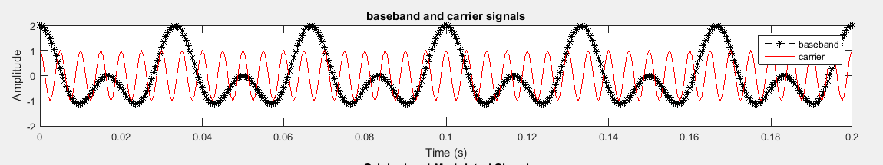

**Output 2**: Plot the original and modulated signals.

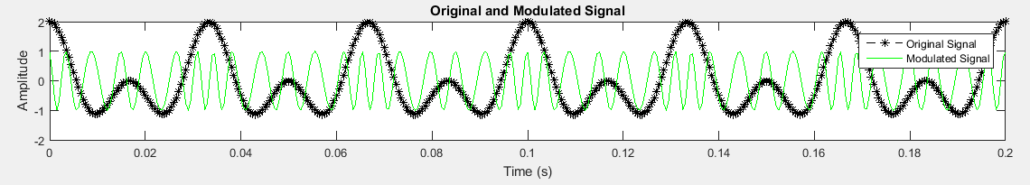

**Output 3**: Plot the original and demodulated signals.

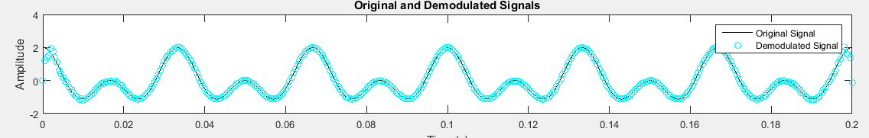

Reference:

To view my codes, please refer to [my GitHub account](https://github.com/aimalexe/DCSE/tree/main/semester_5_(fall-23)/digital_signal_processing_lab/).

Conclusion:

I have learned how to analyze modulation and demodulation of a signal. I have also learned about the built-in function of MATLAB used for modulation and demodulation.

The End.