**ANALYSIS OF AMPLITUDE MODULATED**

**AND DEMODULATED SIGNAL**

**USING MATLAB**

**LAB # 0****8**

**Fall 2023**

**CSE-402L**

**Digital Signal Processing Lab**

Submitted by: **AIMAL KHAN**

Registration No.: **21PWCSE1996**

Class Section: **A**

“On my honor, as student of University of Engineering and Technology, I have neither given nor received unauthorized assistance on this academic work.”



Student Signature: ______________

Submitted to:

**Dr. Yasir Saleem Afridi.**

Tuesday, December 26, 2023

Department of Computer Systems Engineering

University of Engineering and Technology, Peshawar

**CSE 402L: Digital Signal Processing**

|  |  |  |  |  |
| --- | --- | --- | --- | --- |
| **Demonstration of Concepts** | **Poor (Does not meet expectation (1))**  The student failed to demonstrate a clear understanding of the assignment concepts | **Fair (Meet Expectation (2-3))**  The student demonstrated a clear understanding of some of the assignment concepts | **Good (Exceeds Expectation (4-5)**  The student demonstrated a clear understanding of the assignment concepts | **Score**  **30%** |
| **Accuracy** | The student completed ( <50%) tasks and provided MATLAB code and/or Simulink models with errors. Outputs shown are not correct in form of graphs (no labels) and/or tables along with incorrect analysis or remarks. | The student completed partial tasks (50% - <90%) with accurate MATLAB code and/or Simulink models. Correct outputs are shown in form of graphs (without labels) and/or tables along with correct analysis or remarks. | The student completed all required tasks (90%-100%) with accurate MATLAB code and/or Simulink models. Correct outputs are shown in form of labeled graphs and/or tables along with correct analysis or remarks. | **30%** |
| **Following Directions** | The student clearly failed to follow the verbal and written instructions to successfully complete the lab | The student failed to follow the some of the verbal and written instructions to successfully complete all requirements of the lab | The student followed the verbal and written instructions to successfully complete requirements of the lab | **20%** |
| **Time Utilization** | The student failed to complete even part of the lab in the allotted amount of time | The student failed to complete the entire lab in the allotted amount of time | The student completed the lab in its entirety in the allotted amount of time | **20%** |

____________________

Dr. Yasir Saleem Afridi

**Analysis of Amplitude Modulated and Demodulated Signal using MATLAB**

Objectives:

* Amplitude Modulate a baseband signal using carrier signal.
* Demodulate an amplitude modulated signal using carrier signal.

Tasks:

**Task 1: Provide .m file with detailed comments**

**Code for time domain signals:**

clc;

clear;

close all;

m = 0.5;

fc = 2000;

fs = 8000;

t = (0:1/fs:0.01)';

s = 8*cos(2*pi*800*t)+8*cos(2*pi*1600*t);

c = (10*m)*cos(2*pi*fc*t);

modulated_signal = ammod(s, fc, fs, 0, 10*m);

demodulated_signal = amdemod(modulated_signal, fc, fs, 0, 10*m);

figure(1)

subplot(2,3,1);

plot(t, s);

xlabel('*Time* (s)');

ylabel('Amlitude');

legend('Original Signal');

subplot(2,3,2);

plot(t, c);

legend('Carier Signal');

xlabel('*Time* (s)');

ylabel('Amlitude');

subplot(2,3,3);

plot(t, modulated_signal);

legend('Amplitude Modulated Signal');

xlabel('*Time* (s)');

ylabel('Amlitude');

subplot(2,3,4);

plot(t, demodulated_signal);

legend('Amplitude DeModulated Signal');

xlabel('*Time* (s)');

ylabel('Amlitude');

subplot(2, 3, 5);

hold on;

plot(t, s, 'k--', 'LineWidth', 2);

plot(t, demodulated_signal, 'b');

hold off;

legend('Orignal Signal', 'Amplitude Modulated Signal');

xlabel('*Time* (s)');

ylabel('Amlitude');

N = length(t);

fca = (-N/2:N/2-1/N);

length(t)

length(fca)

figure(2)

title('Frequency Domain')

subplot(2,2,1);

plot(fca, abs(fft(s)), 'LineWidth', 2);

xlabel('*Frequency* (Hz)');

ylabel('Amlitude');

legend('Original sognal');

subplot(2,2, 2);

plot(fca, abs(fft(c)), 'LineWidth', 2);

xlabel('*Frequency* (Hz)');

ylabel('Amlitude');

legend('Carier signal');

subplot(2,2,3);

plot(fca, abs(fft(modulated_signal)), 'LineWidth', 2);

xlabel('*Frequency* (Hz)');

ylabel('Amlitude');

legend('Modulated signal');

title('Frequency Domain')

subplot(2,2,4);

plot(fca, abs(fft(demodulated_signal)), 'LineWidth', 2);

xlabel('*Frequency* (Hz)');

ylabel('Amlitude');

legend('Demodulated sognal');

**Output:**

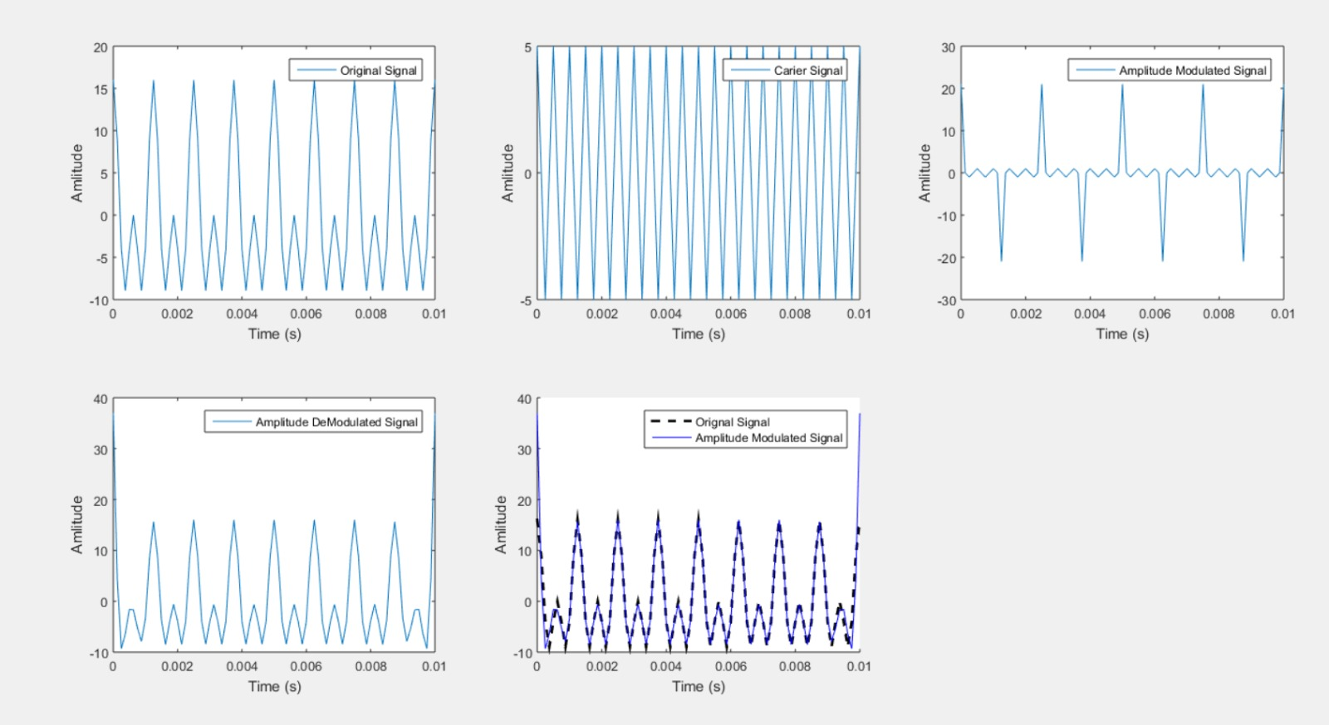

**Code for frequency domain signals:**

clc;

clear;

close all;

% Two-tone message signal

t = 0:1/8000:0.1;

s = 10\**sin*(2*pi*300*t)+10\**sin*(2*pi*600*t);

figure;

*subplot*(2,2,1);

*plot*(t,s);

*title*('Two-Tone Message Signal');

*xlabel*('Time (s)');

*ylabel*('Amplitude (V)');

% Carrier signal

m = 0.5;

fc = 10000;

fs = 80000;

t = (0:1/fs:0.01)';

c = 10/m*sin(2*pi*fc*t);

subplot(2,2,2);

plot(t,c);

title('Carrier Signal');

xlabel('*Time* (s)');

ylabel('*Amplitude* (V)');

% Modulated signal

y = ammod(s, fc, fs, 0, 10/m);

subplot(2,2,3);

plot(t,y);

title('Modulated Signal');

xlabel('*Time* (s)');

ylabel('*Amplitude* (V)');

% Demodulated signal

z = amdemod(y, fc, fs, 0, 10/m);

subplot(2,2,4);

plot(t,z);

title('Demodulated Signal');

xlabel('*Time* (s)');

ylabel('*Amplitude* (V)');

% Frequency domain plots

figure;

subplot(2,2,1);

plot(abs(fft(s)));

title('Frequency Domain Plot of Two-Tone Message Signal');

xlabel('*Frequency* (Hz)');

ylabel('Magnitude');

subplot(2,2,2);

plot(abs(fft(c)));

title('Frequency Domain Plot of Carrier Signal');

xlabel('*Frequency* (Hz)');

ylabel('Magnitude');

subplot(2,2,3);

plot(abs(fft(y)));

title('Frequency Domain Plot of Modulated Signal');

xlabel('*Frequency* (Hz)');

ylabel('Magnitude');

subplot(2,2,4);

plot(abs(fft(z)));

title('Frequency Domain Plot of Demodulated Signal');

xlabel('*Frequency* (Hz)');

ylabel('Magnitude');

**Output:**

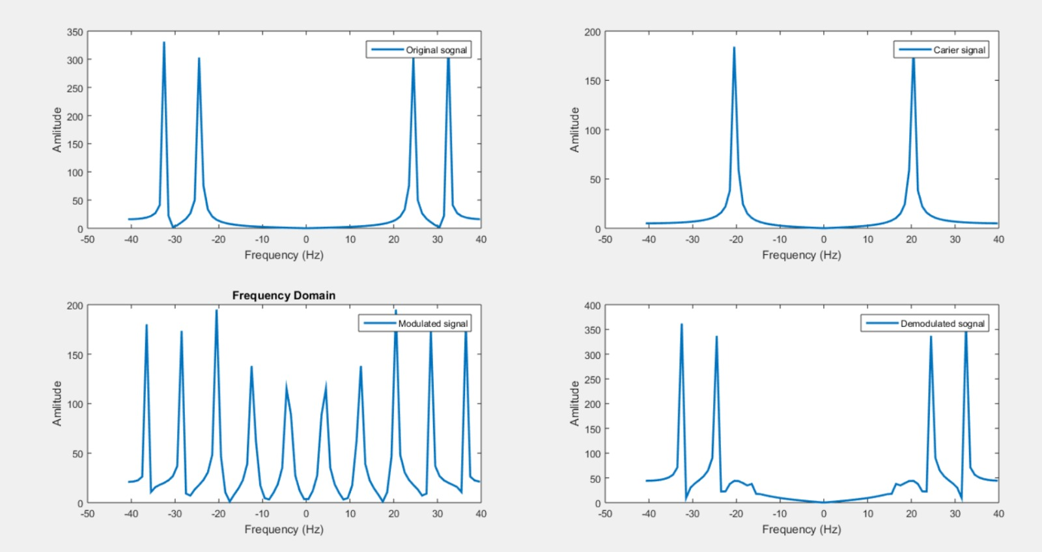

**Task 2**: Define Amplitude Modulation?

**Ans:** Amplitude modulation is a modulation technique used in electronic communication, most commonly for transmitting messages with a radio wave. In amplitude modulation, the amplitude of the wave is varied in proportion to that of the message signal, such as an audio signal

**Task 3**: Define Amplitude Demodulation?

**Ans:** Demodulation is the process of recovering the original data-carrying signal from a carrier wave. A demodulator is an electronic circuit (or software program in the case of software-defined radio) that recovers the information content from a modulated carrier wave

**Task 4**: List three reasons, why we implement Amplitude Modulation in Communication Systems?

* Amplitude modulation is used to transmit the signal over a long distance.
* It is also used for radio transmission.
* It is also applied in two-way communication for air traffic control.
* Amplitude modulation (AM) communication systems arose from the need to send an acoustic signal, a “message”, over the airwaves using a reasonably sized antenna to radiate it. The size of the antenna depends inversely on the highest frequency present in the message, and voice and music have relatively low frequencies.

**Task 5**: Define Modulation Index?

**Ans:** Modulation index is a measure of extent of modulation done on a carrier signal. In Amplitude modulation, it is defined as the ratio of the amplitude of modulating signal to that of the carrier signal.

Reference:

To view my codes, please refer to [my GitHub account](https://github.com/aimalexe/DCSE/tree/main/semester_5_(fall-23)/digital_signal_processing_lab/).

Conclusion:

In conclusion, I have learned why the AM is need and how to perform the AM on a signal using a carrier signal. I also learned how to perform demodulation of AM signals. I saw how modulated signal and demodulated signals both in frequency and time domains.

The End.