**MODELING FREQUENCY DIVISION MULTIPLEXING**

**AND DE-MULTIPLEXING**

**USING MATLAB**

**LAB # 0****9**

**Fall 2023**

**CSE-402L**

**Digital Signal Processing Lab**

Submitted by: **AIMAL KHAN**

Registration No.: **21PWCSE1996**

Class Section: **A**

“On my honor, as student of University of Engineering and Technology, I have neither given nor received unauthorized assistance on this academic work.”

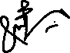

Student Signature: ______________

Submitted to:

**Dr. Yasir Saleem Afridi.**

Sunday, January 7, 2024

Department of Computer Systems Engineering

University of Engineering and Technology, Peshawar

**CSE 402L: Digital Signal Processing**

|  |  |  |  |  |
| --- | --- | --- | --- | --- |
| **Demonstration of Concepts** | **Poor (Does not meet expectation (1))**  The student failed to demonstrate a clear understanding of the assignment concepts | **Fair (Meet Expectation (2-3))**  The student demonstrated a clear understanding of some of the assignment concepts | **Good (Exceeds Expectation (4-5)**  The student demonstrated a clear understanding of the assignment concepts | **Score**  **30%** |
| **Accuracy** | The student completed ( <50%) tasks and provided MATLAB code and/or Simulink models with errors. Outputs shown are not correct in form of graphs (no labels) and/or tables along with incorrect analysis or remarks. | The student completed partial tasks (50% - <90%) with accurate MATLAB code and/or Simulink models. Correct outputs are shown in form of graphs (without labels) and/or tables along with correct analysis or remarks. | The student completed all required tasks (90%-100%) with accurate MATLAB code and/or Simulink models. Correct outputs are shown in form of labeled graphs and/or tables along with correct analysis or remarks. | **30%** |
| **Following Directions** | The student clearly failed to follow the verbal and written instructions to successfully complete the lab | The student failed to follow the some of the verbal and written instructions to successfully complete all requirements of the lab | The student followed the verbal and written instructions to successfully complete requirements of the lab | **20%** |
| **Time Utilization** | The student failed to complete even part of the lab in the allotted amount of time | The student failed to complete the entire lab in the allotted amount of time | The student completed the lab in its entirety in the allotted amount of time | **20%** |

____________________

Dr. Yasir Saleem Afridi

**Modeling Frequency Division Multiplexing and De-Multiplexing Using MATLAB**

Objectives:

Implement the following steps in Matlab to Multiplex three input voice signals at the transmitter end and Demultiplex and play them back at the Receiver end. Add random noise to the signal while propagating via the channel.

Tasks:

**Task**: Full code of the mentioned task…

**Code:**

clc;

clear;

close all;

% --- Transmitter Section ---

%% Import voice files

[maleVoice, Fs] = audioread('funniest-thing.wav');

[femaleVoice, ~] = audioread('self-destruct-sequence.wav');

[randomVoice, ~] = audioread('monkey-scream.wav');

%% Play each voice for a fixed duration (5 seconds)

playDuration = 5; % seconds

numSamples = Fs * playDuration; % Number of samples to play

% Play original voice segments

sound(maleVoice(1:numSamples), Fs);

pause(playDuration + 1);

sound(femaleVoice(1:numSamples), Fs);

pause(playDuration + 1);

sound(randomVoice(1:numSamples), Fs);

pause(playDuration + 1);

%% Spectrum Analysis

% Perform FFT and plot the spectrum of each voice

fftMaleVoice = fft(maleVoice);

fftFemaleVoice = fft(femaleVoice);

fftRandomVoice = fft(randomVoice);

% Calculate magnitude spectrum

magSpectrumMale = abs(fftMaleVoice/length(maleVoice));

magSpectrumFemale = abs(fftFemaleVoice/length(femaleVoice));

magSpectrumRandom = abs(fftRandomVoice/length(randomVoice));

% Only take the first half of frequencies (symmetry of FFT)

magSpectrumMale = magSpectrumMale(1:length(maleVoice)/2+1);

magSpectrumFemale = magSpectrumFemale(1:length(femaleVoice)/2+1);

magSpectrumRandom = magSpectrumRandom(1:length(randomVoice)/2+1);

% Double non-DC components

magSpectrumMale(2:end-1) = 2 * magSpectrumMale(2:end-1);

magSpectrumFemale(2:end-1) = 2 * magSpectrumFemale(2:end-1);

magSpectrumRandom(2:end-1) = 2 * magSpectrumRandom(2:end-1);

% Frequency vector for plotting

f = Fs*(0:(length(maleVoice)/2))/length(maleVoice);

% Plotting the spectrum and time-domain signal

figure;

subplot(3,2,1);

plot(maleVoice);

title('Male Voice (Time Domain)');

xlabel('Samples');

ylabel('Amplitude');

subplot(3,2,2);

plot(magSpectrumMale);

title('Spectrum of Male Voice');

xlabel('Frequency (Hz)');

ylabel('Magnitude');

subplot(3,2,3);

plot(femaleVoice);

title('Female Voice (Time Domain)');

xlabel('Samples');

ylabel('Amplitude');

subplot(3,2,4);

plot(magSpectrumFemale);

title('Spectrum of Female Voice');

xlabel('Frequency (Hz)');

ylabel('Magnitude');

subplot(3,2,5);

plot(randomVoice);

title('Random Voice (Time Domain)');

xlabel('Samples');

ylabel('Amplitude');

subplot(3,2,6);

plot(magSpectrumRandom);

title('Spectrum of Random Voice');

xlabel('Frequency (Hz)');

ylabel('Magnitude');

%% Low-Pass Filtering (LPF)

% Design LPF (Butterworth filter as example)

% Design LPF (Butterworth filter as example)

cutoffFrequency = 3000; % Hz

filterOrder = 6;

[b, a] = butter(filterOrder, cutoffFrequency/(Fs/2), 'low');

% Apply LPF to each voice

lpfMaleVoice = filter(b, a, maleVoice);

lpfFemaleVoice = filter(b, a, femaleVoice);

lpfRandomVoice = filter(b, a, randomVoice);

% Perform FFT on the filtered voices

fftLpfMaleVoice = fft(lpfMaleVoice);

fftLpfFemaleVoice = fft(lpfFemaleVoice);

fftLpfRandomVoice = fft(lpfRandomVoice);

% Calculate magnitude spectrum for each filtered voice

magSpectrumLpfMale = abs(fftLpfMaleVoice/length(lpfMaleVoice));

magSpectrumLpfFemale = abs(fftLpfFemaleVoice/length(lpfFemaleVoice));

magSpectrumLpfRandom = abs(fftLpfRandomVoice/length(lpfRandomVoice));

% Only take the first half of frequencies (due to FFT symmetry)

magSpectrumLpfMale = magSpectrumLpfMale(1:length(lpfMaleVoice)/2+1);

magSpectrumLpfFemale = magSpectrumLpfFemale(1:length(lpfFemaleVoice)/2+1);

magSpectrumLpfRandom = magSpectrumLpfRandom(1:length(lpfRandomVoice)/2+1);

% Double non-DC components for proper magnitude

magSpectrumLpfMale(2:end-1) = 2 * magSpectrumLpfMale(2:end-1);

magSpectrumLpfFemale(2:end-1) = 2 * magSpectrumLpfFemale(2:end-1);

magSpectrumLpfRandom(2:end-1) = 2 * magSpectrumLpfRandom(2:end-1);

% Frequency vector for plotting

fLpf = Fs*(0:(length(lpfMaleVoice)/2))/length(lpfMaleVoice);

% Plot the time-domain and frequency-domain signals

figure;

subplot(3,2,1);

plot(lpfMaleVoice);

title('Low-Pass Filtered Male Voice (Time Domain)');

xlabel('Samples');

ylabel('Amplitude');

subplot(3,2,2);

plot(magSpectrumLpfMale);

title('Spectrum of LPF Male Voice');

xlabel('Frequency (Hz)');

ylabel('Magnitude');

subplot(3,2,3);

plot(lpfFemaleVoice);

title('Low-Pass Filtered Female Voice (Time Domain)');

xlabel('Samples');

ylabel('Amplitude');

subplot(3,2,4);

plot(magSpectrumLpfFemale);

title('Spectrum of LPF Female Voice');

xlabel('Frequency (Hz)');

ylabel('Magnitude');

subplot(3,2,5);

plot(lpfRandomVoice);

title('Low-Pass Filtered Random Voice (Time Domain)');

xlabel('Samples');

ylabel('Amplitude');

subplot(3,2,6);

plot(magSpectrumLpfRandom);

title('Spectrum of LPF Random Voice');

xlabel('Frequency (Hz)');

ylabel('Magnitude');

%% Play the filtered voices for 5 seconds each

sound(lpfMaleVoice(1:numSamples), Fs);

pause(playDuration + 1);

sound(lpfFemaleVoice(1:numSamples), Fs);

pause(playDuration + 1);

sound(lpfRandomVoice(1:numSamples), Fs);

pause(playDuration + 1);

%% Modulation Section

% Define carrier frequencies (fraction of sampling rate)

carrierFreqMale = Fs/4;

carrierFreqFemale = Fs/5;

carrierFreqRandom = Fs/6;

% Amplitude Modulation (AM)

amMaleVoice = ammod(lpfMaleVoice, carrierFreqMale, Fs);

amFemaleVoice = ammod(lpfFemaleVoice, carrierFreqFemale, Fs);

amRandomVoice = ammod(lpfRandomVoice, carrierFreqRandom, Fs);

% Perform FFT on the AM modulated voices

fftAmMaleVoice = fft(amMaleVoice);

fftAmFemaleVoice = fft(amFemaleVoice);

fftAmRandomVoice = fft(amRandomVoice);

% Calculate magnitude spectrum for each AM voice

magSpectrumAmMale = abs(fftAmMaleVoice/length(amMaleVoice));

magSpectrumAmFemale = abs(fftAmFemaleVoice/length(amFemaleVoice));

magSpectrumAmRandom = abs(fftAmRandomVoice/length(amRandomVoice));

% Only take the first half of frequencies (due to FFT symmetry)

magSpectrumAmMale = magSpectrumAmMale(1:length(amMaleVoice)/2+1);

magSpectrumAmFemale = magSpectrumAmFemale(1:length(amFemaleVoice)/2+1);

magSpectrumAmRandom = magSpectrumAmRandom(1:length(amRandomVoice)/2+1);

% Double non-DC components for proper magnitude

magSpectrumAmMale(2:end-1) = 2 * magSpectrumAmMale(2:end-1);

magSpectrumAmFemale(2:end-1) = 2 * magSpectrumAmFemale(2:end-1);

magSpectrumAmRandom(2:end-1) = 2 * magSpectrumAmRandom(2:end-1);

% Frequency vector for plotting

fAm = Fs*(0:(length(amMaleVoice)/2))/length(amMaleVoice);

% Plot the time-domain and frequency-domain signals

figure;

subplot(3,2,1);

plot(amMaleVoice);

title('AM Modulated Male Voice (Time Domain)');

xlabel('Samples');

ylabel('Amplitude');

subplot(3,2,2);

plot(magSpectrumAmMale);

title('Spectrum of AM Male Voice');

xlabel('Frequency (Hz)');

ylabel('Magnitude');

subplot(3,2,3);

plot(amFemaleVoice);

title('AM Modulated Female Voice (Time Domain)');

xlabel('Samples');

ylabel('Amplitude');

subplot(3,2,4);

plot(magSpectrumAmFemale);

title('Spectrum of AM Female Voice');

xlabel('Frequency (Hz)');

ylabel('Magnitude');

subplot(3,2,5);

plot(amRandomVoice);

title('AM Modulated Random Voice (Time Domain)');

xlabel('Samples');

ylabel('Amplitude');

subplot(3,2,6);

plot(magSpectrumAmRandom);

title('Spectrum of AM Random Voice');

xlabel('Frequency (Hz)');

ylabel('Magnitude');

% --- Channel Section ---

%% Adding Noise

noiseLevel = 0.01; % Noise amplitude

noiseMale = noiseLevel * randn(size(amMaleVoice));

noiseFemale = noiseLevel * randn(size(amFemaleVoice));

noiseRandom = noiseLevel * randn(size(amRandomVoice));

% Noisy AM signals

noisyAmMaleVoice = amMaleVoice + noiseMale;

noisyAmFemaleVoice = amFemaleVoice + noiseFemale;

noisyAmRandomVoice = amRandomVoice + noiseRandom;

% Perform FFT on the noisy AM modulated voices

fftNoisyAmMaleVoice = fft(noisyAmMaleVoice);

fftNoisyAmFemaleVoice = fft(noisyAmFemaleVoice);

fftNoisyAmRandomVoice = fft(noisyAmRandomVoice);

% Calculate magnitude spectrum for each noisy AM voice

magSpectrumNoisyAmMale = abs(fftNoisyAmMaleVoice/length(noisyAmMaleVoice));

magSpectrumNoisyAmFemale = abs(fftNoisyAmFemaleVoice/length(noisyAmFemaleVoice));

magSpectrumNoisyAmRandom = abs(fftNoisyAmRandomVoice/length(noisyAmRandomVoice));

% Only take the first half of frequencies (due to FFT symmetry)

magSpectrumNoisyAmMale = magSpectrumNoisyAmMale(1:length(noisyAmMaleVoice)/2+1);

magSpectrumNoisyAmFemale = magSpectrumNoisyAmFemale(1:length(noisyAmFemaleVoice)/2+1);

magSpectrumNoisyAmRandom = magSpectrumNoisyAmRandom(1:length(noisyAmRandomVoice)/2+1);

% Double non-DC components for proper magnitude

magSpectrumNoisyAmMale(2:end-1) = 2 * magSpectrumNoisyAmMale(2:end-1);

magSpectrumNoisyAmFemale(2:end-1) = 2 * magSpectrumNoisyAmFemale(2:end-1);

magSpectrumNoisyAmRandom(2:end-1) = 2 * magSpectrumNoisyAmRandom(2:end-1);

% Frequency vector for plotting

fNoisyAm = Fs*(0:(length(noisyAmMaleVoice)/2))/length(noisyAmMaleVoice);

% Plot the time-domain and frequency-domain signals

figure;

subplot(3,2,1);

plot(noisyAmMaleVoice);

title('Noisy AM Male Voice (Time Domain)');

xlabel('Samples');

ylabel('Amplitude');

subplot(3,2,2);

plot(magSpectrumNoisyAmMale);

title('Spectrum of Noisy AM Male Voice');

xlabel('Frequency (Hz)');

ylabel('Magnitude');

subplot(3,2,3);

plot(noisyAmFemaleVoice);

title('Noisy AM Female Voice (Time Domain)');

xlabel('Samples');

ylabel('Amplitude');

subplot(3,2,4);

plot(magSpectrumNoisyAmFemale);

title('Spectrum of Noisy AM Female Voice');

xlabel('Frequency (Hz)');

ylabel('Magnitude');

subplot(3,2,5);

plot(noisyAmRandomVoice);

title('Noisy AM Random Voice (Time Domain)');

xlabel('Samples');

ylabel('Amplitude');

subplot(3,2,6);

plot(magSpectrumNoisyAmRandom);

title('Spectrum of Noisy AM Random Voice');

xlabel('Frequency (Hz)');

ylabel('Magnitude');

% --- Receiver Section ---

%% Demodulate the noisy signals

% Demodulate the noisy AM signals

demodMaleVoice = amdemod(noisyAmMaleVoice, carrierFreqMale, Fs);

demodFemaleVoice = amdemod(noisyAmFemaleVoice, carrierFreqFemale, Fs);

demodRandomVoice = amdemod(noisyAmRandomVoice, carrierFreqRandom, Fs);

% Perform FFT on the demodulated voices

fftDemodMaleVoice = fft(demodMaleVoice);

fftDemodFemaleVoice = fft(demodFemaleVoice);

fftDemodRandomVoice = fft(demodRandomVoice);

% Calculate magnitude spectrum for each demodulated voice

magSpectrumDemodMale = abs(fftDemodMaleVoice/length(demodMaleVoice));

magSpectrumDemodFemale = abs(fftDemodFemaleVoice/length(demodFemaleVoice));

magSpectrumDemodRandom = abs(fftDemodRandomVoice/length(demodRandomVoice));

% Only take the first half of frequencies (due to FFT symmetry)

magSpectrumDemodMale = magSpectrumDemodMale(1:length(demodMaleVoice)/2+1);

magSpectrumDemodFemale = magSpectrumDemodFemale(1:length(demodFemaleVoice)/2+1);

magSpectrumDemodRandom = magSpectrumDemodRandom(1:length(demodRandomVoice)/2+1);

% Double non-DC components for proper magnitude

magSpectrumDemodMale(2:end-1) = 2 * magSpectrumDemodMale(2:end-1);

magSpectrumDemodFemale(2:end-1) = 2 * magSpectrumDemodFemale(2:end-1);

magSpectrumDemodRandom(2:end-1) = 2 * magSpectrumDemodRandom(2:end-1);

% Frequency vector for plotting

fDemod = Fs*(0:(length(demodMaleVoice)/2))/length(demodMaleVoice);

% Plot the time-domain and frequency-domain signals

figure;

subplot(3,2,1);

plot(demodMaleVoice);

title('Demodulated Male Voice (Time Domain)');

xlabel('Samples');

ylabel('Amplitude');

subplot(3,2,2);

plot(magSpectrumDemodMale);

title('Spectrum of Demodulated Male Voice');

xlabel('Frequency (Hz)');

ylabel('Magnitude');

subplot(3,2,3);

plot(demodFemaleVoice);

title('Demodulated Female Voice (Time Domain)');

xlabel('Samples');

ylabel('Amplitude');

subplot(3,2,4);

plot(magSpectrumDemodFemale);

title('Spectrum of Demodulated Female Voice');

xlabel('Frequency (Hz)');

ylabel('Magnitude');

subplot(3,2,5);

plot(demodRandomVoice);

title('Demodulated Random Voice (Time Domain)');

xlabel('Samples');

ylabel('Amplitude');

subplot(3,2,6);

plot(magSpectrumDemodRandom);

title('Spectrum of Demodulated Random Voice');

xlabel('Frequency (Hz)');

ylabel('Magnitude');

%% Low-Pass Filtering on Demodulated Signals

% Second LPF (same parameters as before)

[b2, a2] = butter(filterOrder, cutoffFrequency/(Fs/2), 'low');

% Apply LPF to demodulated signals

lpfDemodMaleVoice = filter(b2, a2, demodMaleVoice);

lpfDemodFemaleVoice = filter(b2, a2, demodFemaleVoice);

lpfDemodRandomVoice = filter(b2, a2, demodRandomVoice);

% Perform FFT on the filtered, demodulated voices

fftLpfDemodMaleVoice = fft(lpfDemodMaleVoice);

fftLpfDemodFemaleVoice = fft(lpfDemodFemaleVoice);

fftLpfDemodRandomVoice = fft(lpfDemodRandomVoice);

% Calculate magnitude spectrum for each filtered, demodulated voice

magSpectrumLpfDemodMale = abs(fftLpfDemodMaleVoice/length(lpfDemodMaleVoice));

magSpectrumLpfDemodFemale = abs(fftLpfDemodFemaleVoice/length(lpfDemodFemaleVoice));

magSpectrumLpfDemodRandom = abs(fftLpfDemodRandomVoice/length(lpfDemodRandomVoice));

% Only take the first half of frequencies (due to FFT symmetry)

magSpectrumLpfDemodMale = magSpectrumLpfDemodMale(1:length(lpfDemodMaleVoice)/2+1);

magSpectrumLpfDemodFemale = magSpectrumLpfDemodFemale(1:length(lpfDemodFemaleVoice)/2+1);

magSpectrumLpfDemodRandom = magSpectrumLpfDemodRandom(1:length(lpfDemodRandomVoice)/2+1);

% Double non-DC components for proper magnitude

magSpectrumLpfDemodMale(2:end-1) = 2 * magSpectrumLpfDemodMale(2:end-1);

magSpectrumLpfDemodFemale(2:end-1) = 2 * magSpectrumLpfDemodFemale(2:end-1);

magSpectrumLpfDemodRandom(2:end-1) = 2 * magSpectrumLpfDemodRandom(2:end-1);

% Frequency vector for plotting

fLpfDemod = Fs*(0:(length(lpfDemodMaleVoice)/2))/length(lpfDemodMaleVoice);

% Plot the time-domain and frequency-domain signals

figure;

subplot(3,2,1);

plot(lpfDemodMaleVoice);

title('Filtered Demodulated Male Voice (Time Domain)');

xlabel('Samples');

ylabel('Amplitude');

subplot(3,2,2);

plot(magSpectrumLpfDemodMale);

title('Spectrum of Filtered Demodulated Male Voice');

xlabel('Frequency (Hz)');

ylabel('Magnitude');

subplot(3,2,3);

plot(lpfDemodFemaleVoice);

title('Filtered Demodulated Female Voice (Time Domain)');

xlabel('Samples');

ylabel('Amplitude');

subplot(3,2,4);

plot(magSpectrumLpfDemodFemale);

title('Spectrum of Filtered Demodulated Female Voice');

xlabel('Frequency (Hz)');

ylabel('Magnitude');

subplot(3,2,5);

plot(lpfDemodRandomVoice);

title('Filtered Demodulated Random Voice (Time Domain)');

xlabel('Samples');

ylabel('Amplitude');

subplot(3,2,6);

plot(magSpectrumLpfDemodRandom);

title('Spectrum of Filtered Demodulated Random Voice');

xlabel('Frequency (Hz)');

ylabel('Magnitude');

%% Play the filtered, demodulated voices

sound(lpfDemodMaleVoice, Fs);

pause(length(lpfDemodMaleVoice)/Fs + 1);

sound(lpfDemodFemaleVoice, Fs);

pause(length(lpfDemodFemaleVoice)/Fs + 1);

sound(lpfDemodRandomVoice, Fs);

**Output:**

Original Voices:

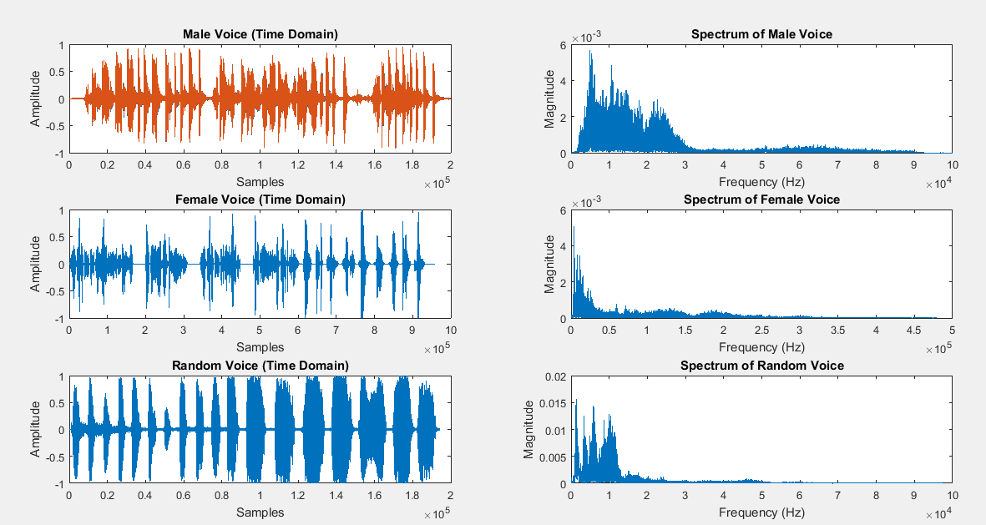

Passing original voices in low pass filter

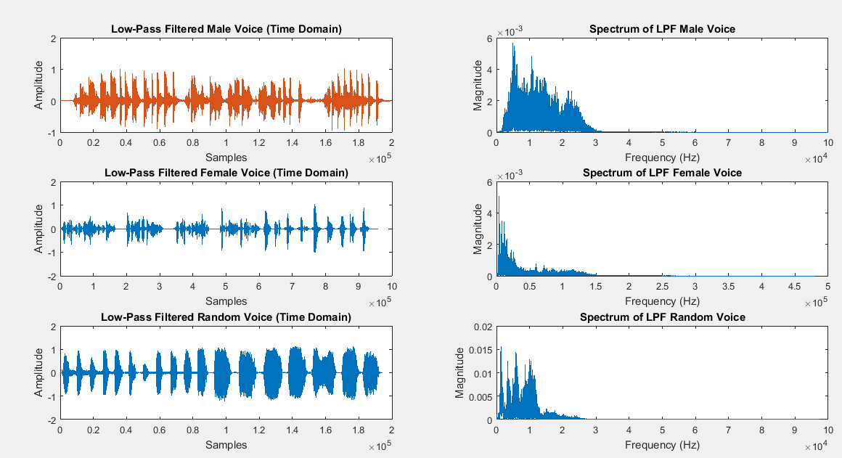

Modulating the voices using different carriers

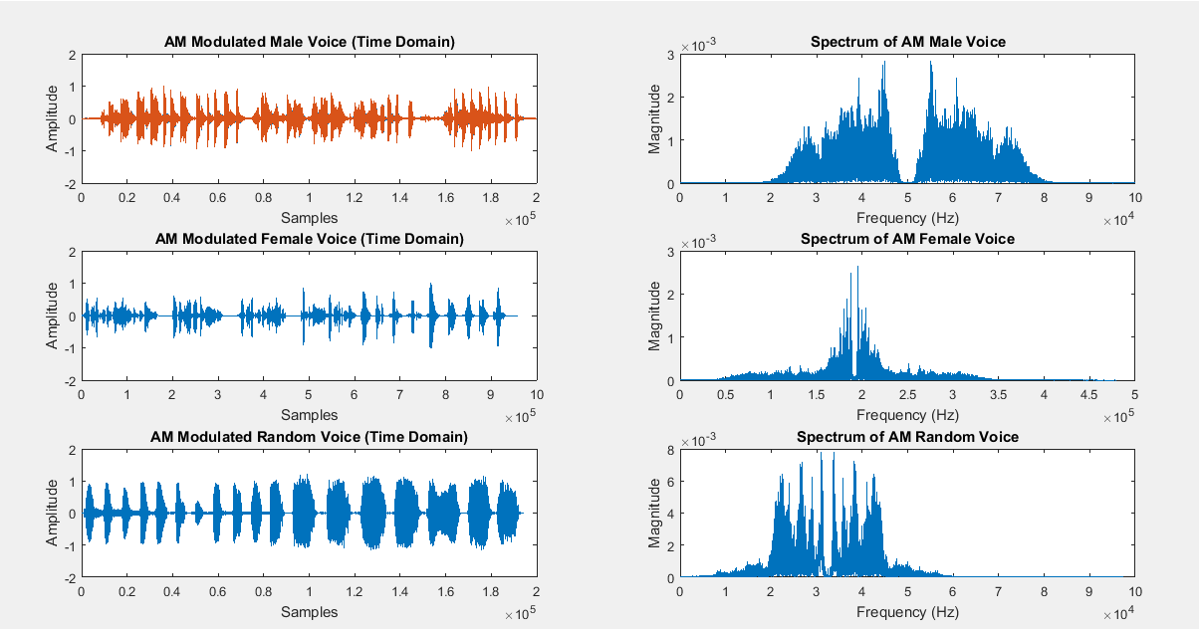

Adding noise from the channel in voices

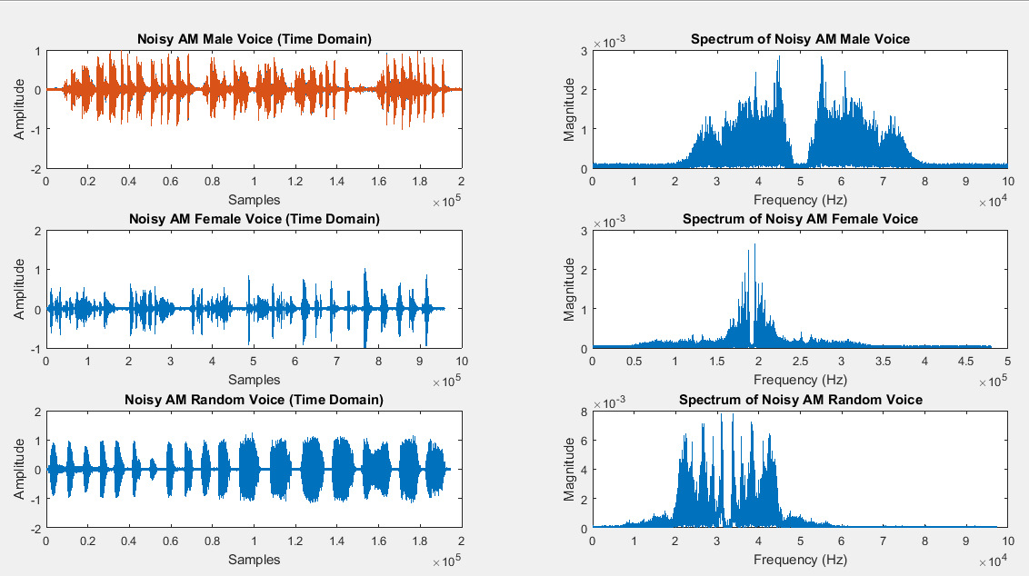

Demodulating the noisy signal at receiver end

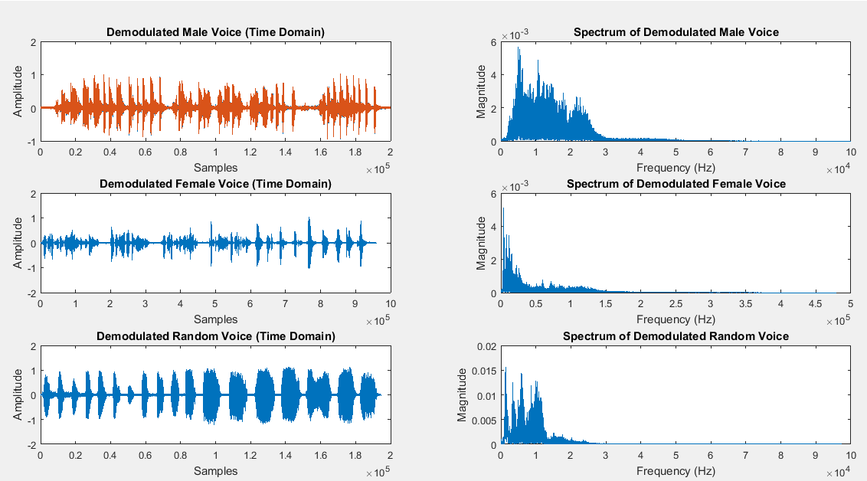

At last, passing the voices through low pass filter to recover the signal at receiver end.

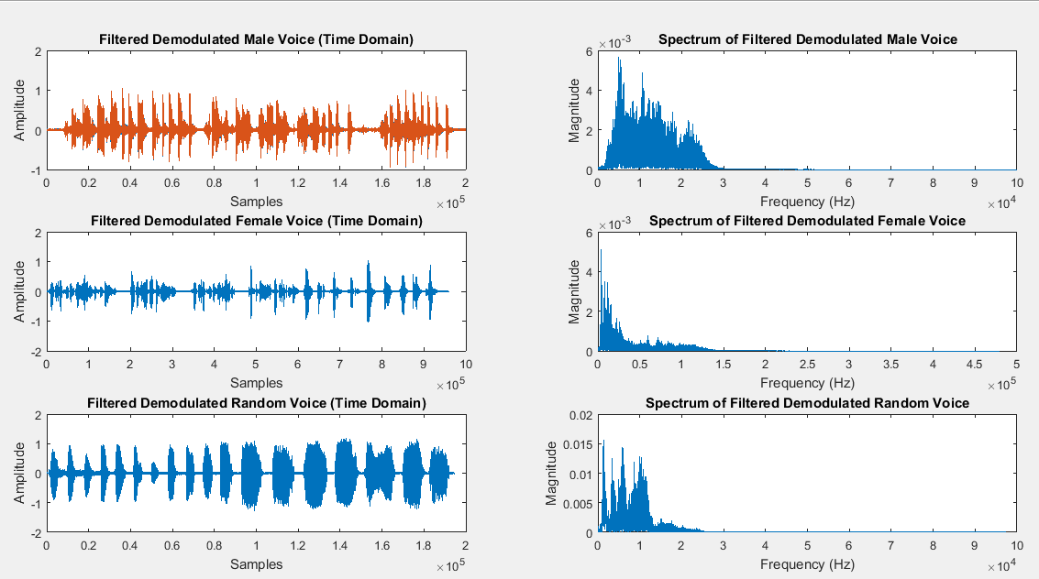

Reference:

To view my codes, please refer to [my GitHub account](https://github.com/aimalexe/DCSE/tree/main/semester_5_(fall-23)/digital_signal_processing_lab/).

Conclusion:

In conclusion, I have created voice signals. And then modulated it with different carriers of different frequencies. Then I have added some noise to each signal which resembles of channel noise. After that I have demodulated the signal and recover the original signal after passing it through LPF.

The End.