**LAYOUT OF PROGRAM, LIBRARY FUNCTION**

**CALLS AND ERROR**

**HANDLING**

**LAB # 02**



**Fall 2024**

**CSE-302L**

**Systems Programming Lab**

Submitted by: **AIMAL KHAN**

Registration No.: **21PWCSE1996**

Class Section: **A**

“On my honor, as student of University of Engineering and Technology, I have neither given nor received unauthorized assistance on this academic work.”

Student Signature: ______________

Submitted to:

**Engr. Abdullah Hamid**

Department of Computer Systems Engineering

University of Engineering and Technology, Peshawar

**CSE 302L: SYSTEMS PROGRAMMING LAB**

**LAB ASSESSMENT RUBRICS**

|  |  |  |  |  |  |
| --- | --- | --- | --- | --- | --- |
| **Criteria & Point Assigned** | **Outstanding 2** | **Acceptable 1.5** | **Considerable 1** | **Below Expectations 0.5** | **Score** |
| **Attendance and**  **Attentiveness in Lab**  PLO08 | Attended in proper Time and attentive in Lab | Attended in proper Time but not attentive in Lab | Attended late but attentive in Lab | Attended late not attentive in Lab |  |
| **Capability of writing Program/Algorithm/Drawing Flow Chart**  PLO1, PLO2, PLO3, PLO5 | Right attempt/ no errors and well formatted | Right attempt/ no errors but not well formatted | Right attempt/ minor errors and not well formatted | Wrong attempt |  |
| **Result or Output/ Completion of target in Lab**  PLO9 | 100% target has been completed and well formatted. | 75% target has been completed and well formatted. | 50% target has been completed but not well formatted. | None of the outputs are correct. |  |
| **Overall, Knowledge**  PLO10, | Demonstrates excellent knowledge of lab | Demonstrates good knowledge of lab | Has partial idea about the Lab and procedure followed | Has poor idea about the Lab and procedure followed |  |
| **Attention to Lab Report**  PLO4, | Submission of Lab Report in Proper Time i.e., in next day of lab, with proper documentation. | Submission of Lab Report in proper time but not with proper documentation. | Late Submission with proper documentation. | Late Submission very poor documentation |  |

**Instructor:**

|  |  |
| --- | --- |
| Name: _________________________ | Signature: ________________________ |
|  |  |

**Layout of Program, Library Function Calls and Error Handling**

Objectives:

In this lab we will learn about Layout of Program, Library Function Calls and error handling.

Tasks:

**Task 1**: . Write two C programs for the analysis of the difference in executable file sizes while using:

1. Uninitialized Static Variables

2. Initialized Static Variables

1. **Uninitialized Static Variables**

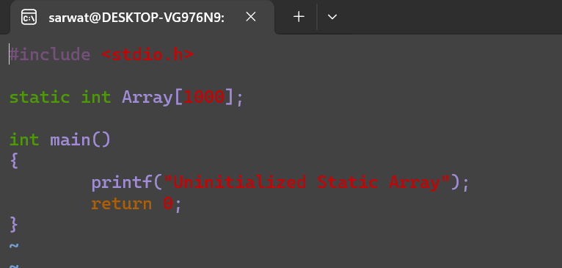

2. **Initialized Static Variables**

**Output:**

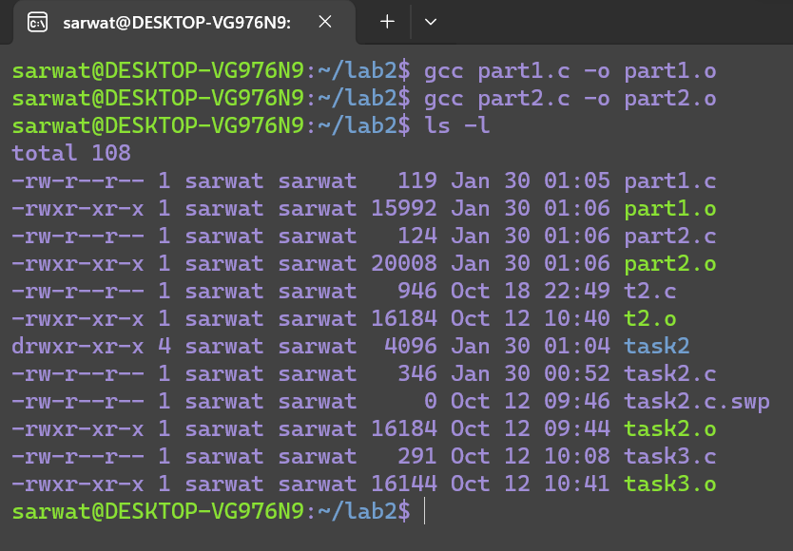

**Task 2**: Analyze the return values and error numbers/error stings of wait system call on:

1. Success

2. Failure Using:

1. Strerror

2. Perror

**1. Success**

**Strerror:**

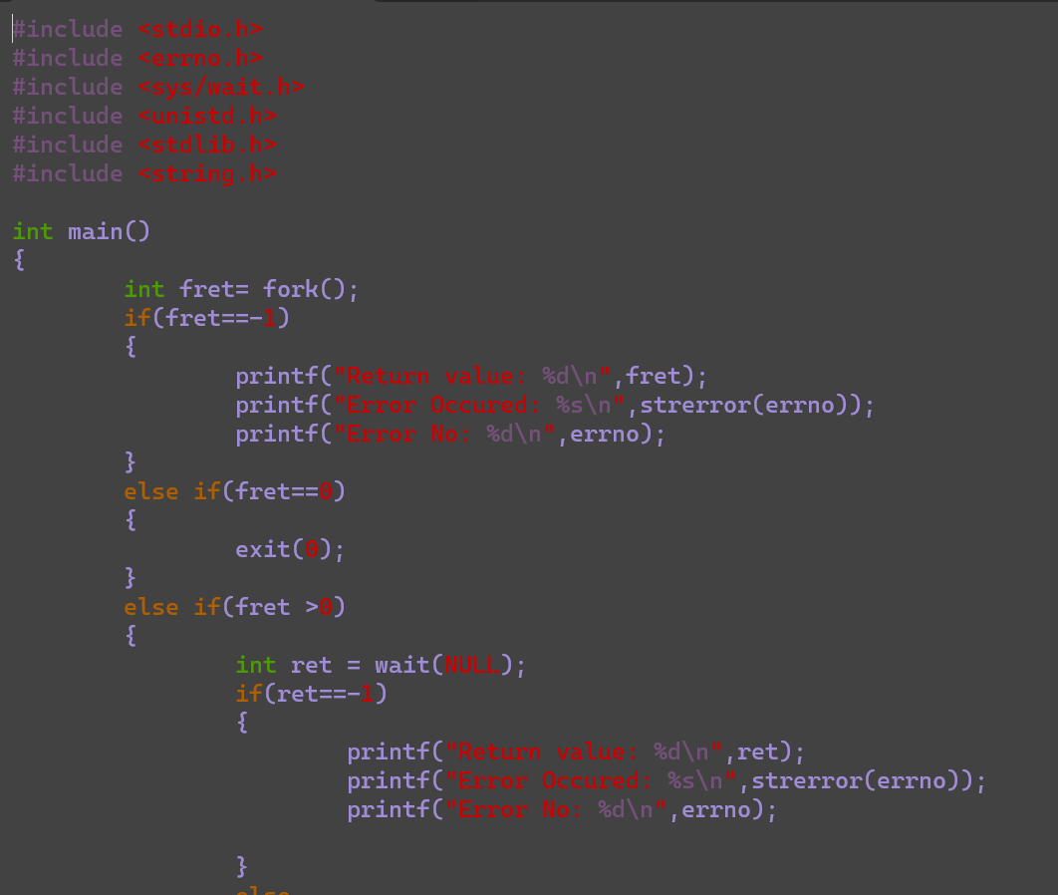

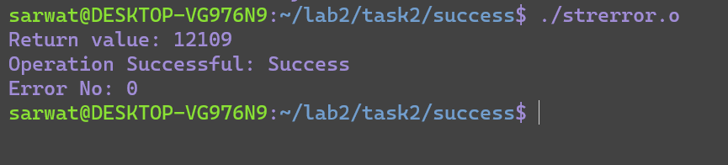

**Perror:**

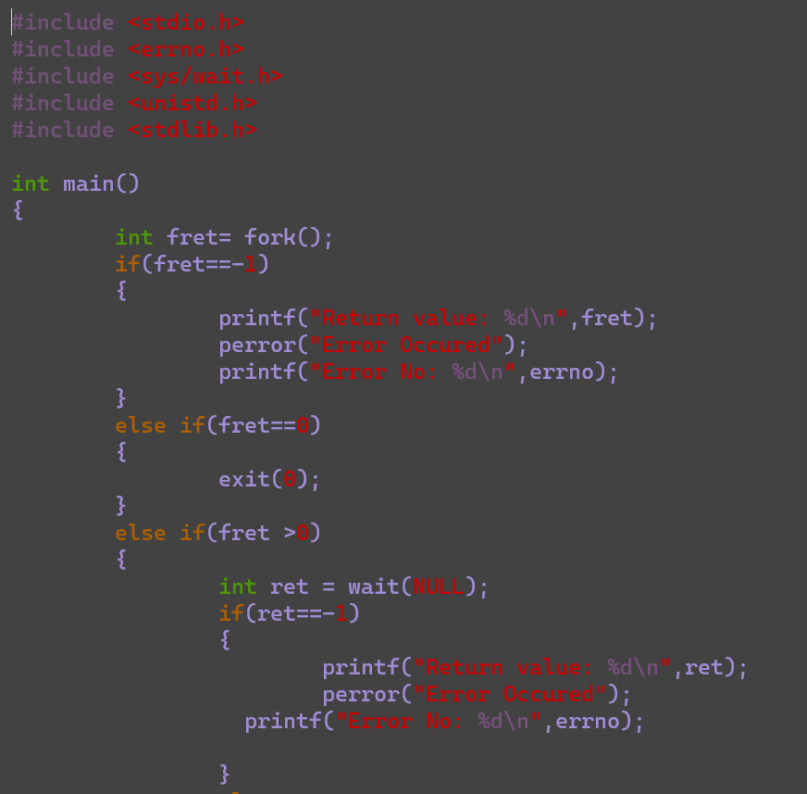

**Failure:**

**1: strerror**

**perror:**

**Output:**

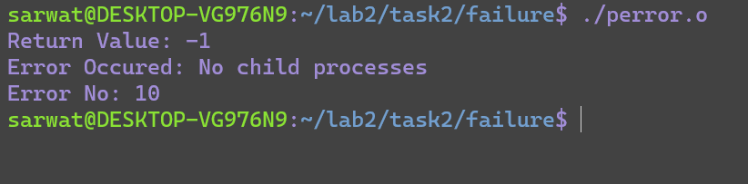

**Task3:**

Analyze the return values and error numbers/error stings of close system call on:

3. Success

4. Failure Using:

3. Strerror

4. Perror

1**:success**

**Strerror:**

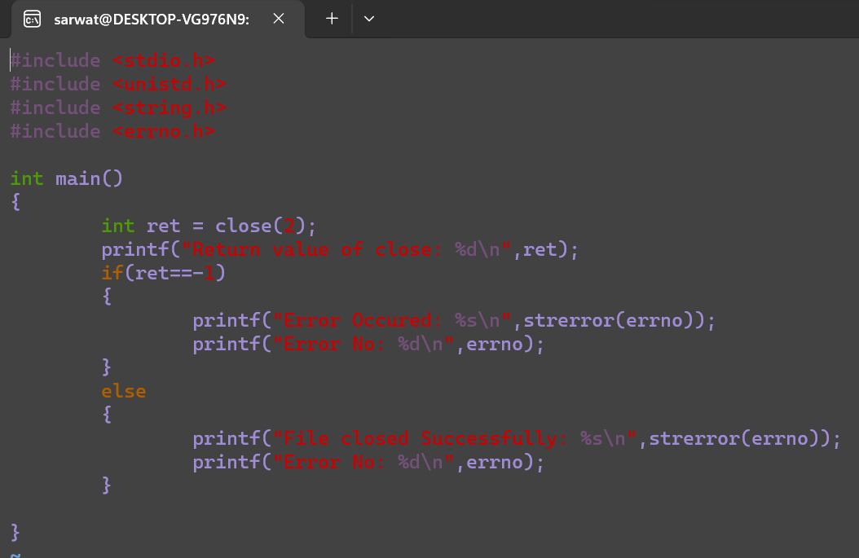

**Output:**

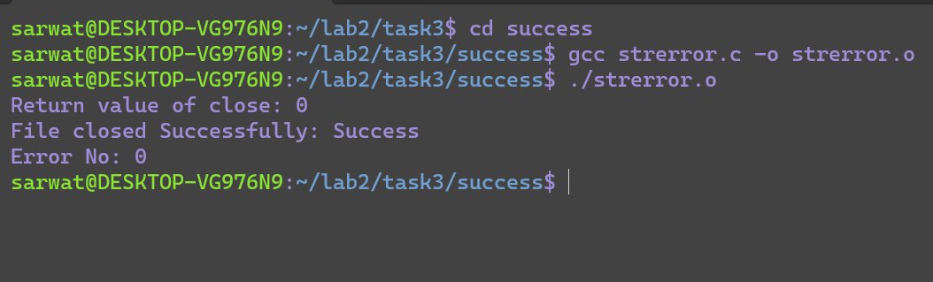

**Perror:**

**Output:**

**2 Failure**

**Strerror:**

**Output:**

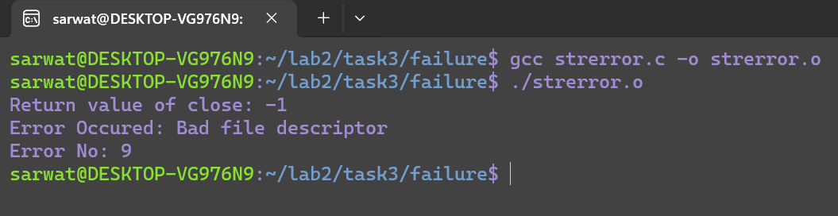

**Perror:**

**Output:**

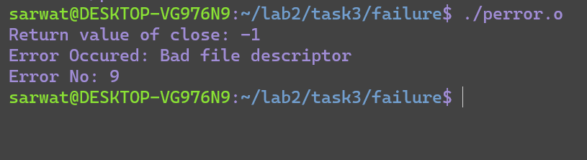

Conclusion:

In conclusion, I have learned about different library function calls.

The End.