**The exec Function**

**LAB # 04**



**Fall 2024**

**CSE-302L**

**Systems Programming Lab**

Submitted by: **AIMAL KHAN**

Registration No.: **21PWCSE1996**

Class Section: **A**

“On my honor, as student of University of Engineering and Technology, I have neither given nor received unauthorized assistance on this academic work.”

Student Signature: ______________

Submitted to:

**Engr. Abdullah Hamid**

Department of Computer Systems Engineering

University of Engineering and Technology, Peshawar

**CSE 302L: SYSTEMS PROGRAMMING LAB**

**LAB ASSESSMENT RUBRICS**

|  |  |  |  |  |  |
| --- | --- | --- | --- | --- | --- |
| **Criteria & Point Assigned** | **Outstanding 2** | **Acceptable 1.5** | **Considerable 1** | **Below Expectations 0.5** | **Score** |
| **Attendance and**  **Attentiveness in Lab**  PLO08 | Attended in proper Time and attentive in Lab | Attended in proper Time but not attentive in Lab | Attended late but attentive in Lab | Attended late not attentive in Lab |  |
| **Capability of writing Program/Algorithm/Drawing Flow Chart**  PLO1, PLO2, PLO3, PLO5 | Right attempt/ no errors and well formatted | Right attempt/ no errors but not well formatted | Right attempt/ minor errors and not well formatted | Wrong attempt |  |
| **Result or Output/ Completion of target in Lab**  PLO9 | 100% target has been completed and well formatted. | 75% target has been completed and well formatted. | 50% target has been completed but not well formatted. | None of the outputs are correct. |  |
| **Overall, Knowledge**  PLO10, | Demonstrates excellent knowledge of lab | Demonstrates good knowledge of lab | Has partial idea about the Lab and procedure followed | Has poor idea about the Lab and procedure followed |  |
| **Attention to Lab Report**  PLO4, | Submission of Lab Report in Proper Time i.e., in next day of lab, with proper documentation. | Submission of Lab Report in proper time but not with proper documentation. | Late Submission with proper documentation. | Late Submission very poor documentation |  |

**Instructor:**

|  |  |
| --- | --- |
| Name: _________________________ | Signature: ________________________ |
|  |  |

**The exec Function**

Objectives:

In this lab we will learn about the exec function.

Tasks:

**Task 1**:

Write a program that takes N UNIX commands as arguments, creates N child processes, each of them implementing their respective commands. Parent process shall wait for all the child processes and receive and print the exit status of the child processes.

**Code in C:**

**Output:**

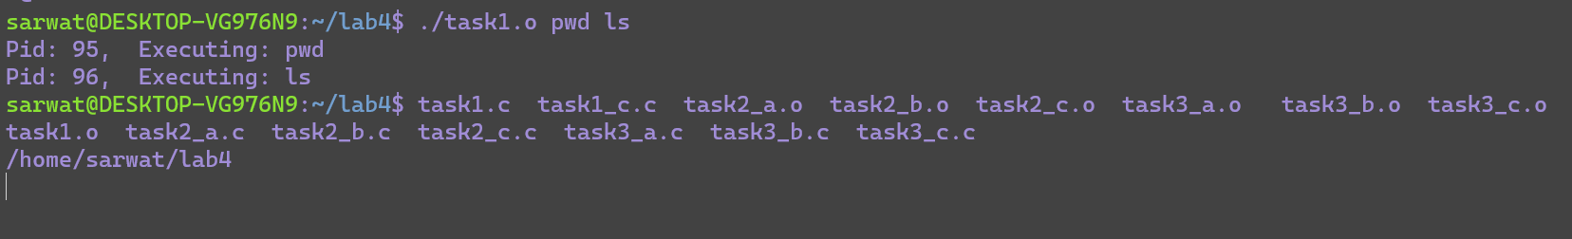

**Task 2**:

a. Write a program that takes integers as arguments and adds them. b. Write a program that takes integers as arguments and multiplies them. c. Write a program that takes integers as arguments & adds & multiplies them using the above two programs.

**Part a:**

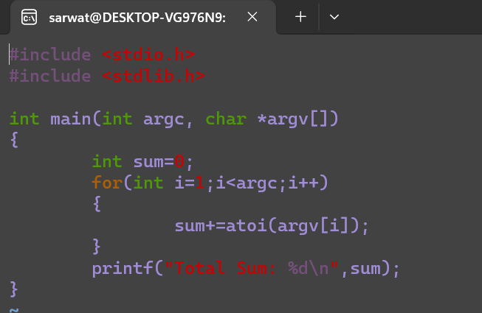

**Output:**

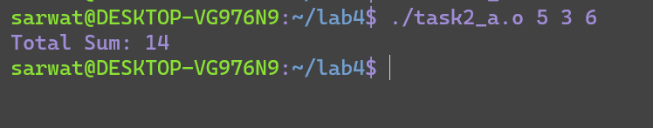

**Part b:**

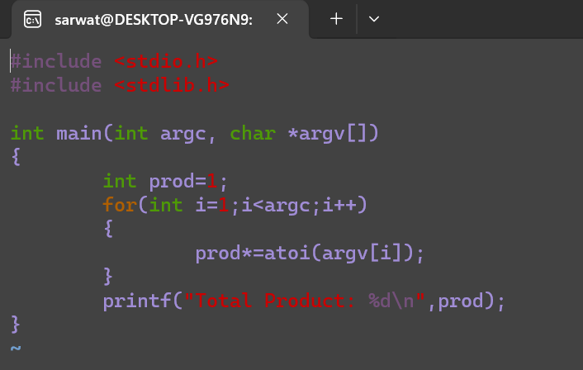

**Output:**

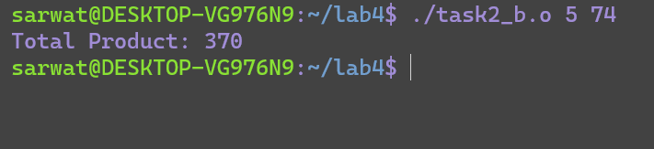

**Part c:**

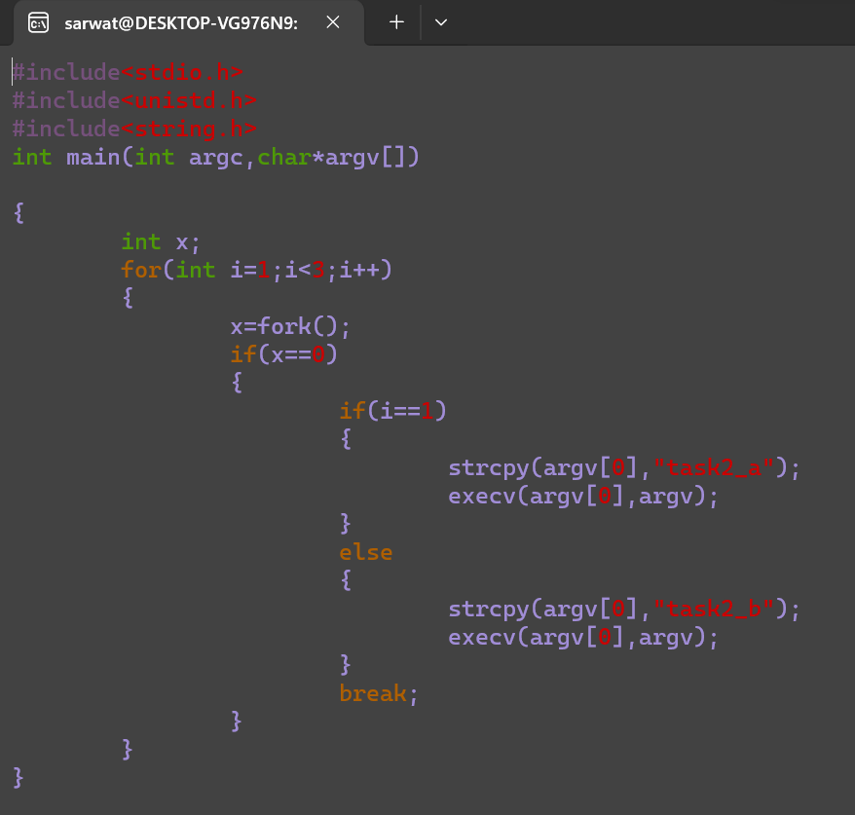

**Task 3**

Write a program “minmax.c” that takes an array as command line arguments. Program executes min.c and max.c programs in its two child processes. One child process calculates and returns the min value and other calculates and returns the max value in the array. The program “minmax.c” shall receive the values returned by the child processes and display these values.

**Part a:**

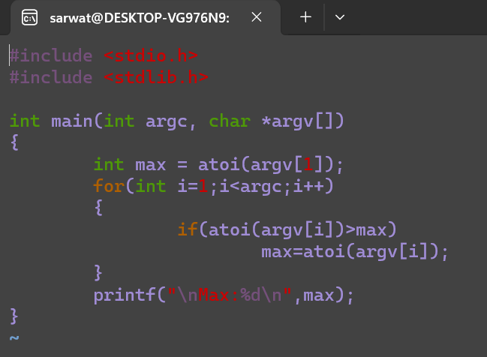

**Output:**

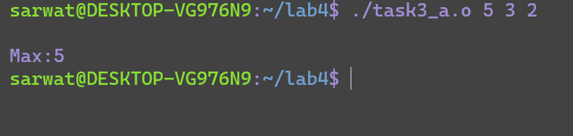

**Part b:**

**Code in c:**

**Output:**

**Part c:**

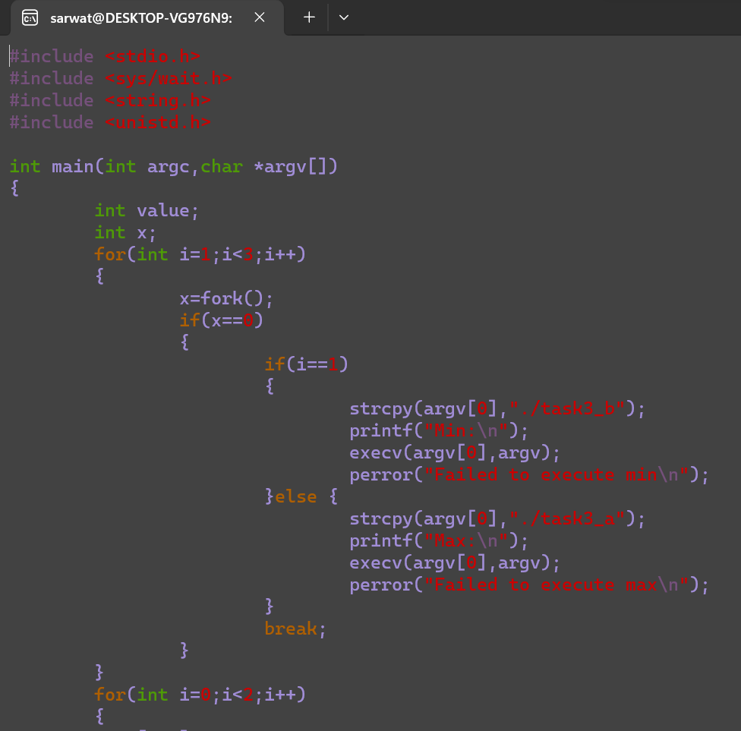

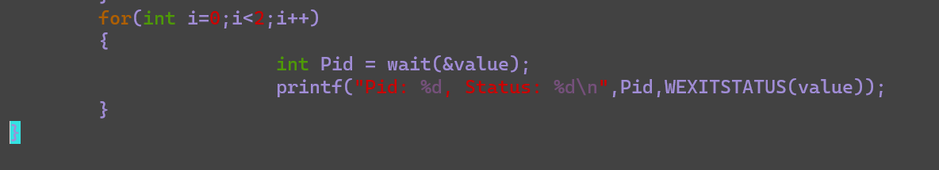

Conclusion:

In conclusion, I have learned about exec function.

The End.