**UNIX INPUT / OUTPUT**

**PART - 1**

**LAB # 0****5**

**Fall 2023**

**CSE-302L**

**Systems Programming Lab**

Submitted by: **AIMAL KHAN**

Registration No.: **21PWCSE1996**

Class Section: **A**

“On my honor, as student of University of Engineering and Technology, I have neither given nor received unauthorized assistance on this academic work.”

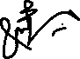

Student Signature: ______________

Submitted to:

**Engr. Abdullah Hamid**

Sunday, January 28, 2024

Department of Computer Systems Engineering

University of Engineering and Technology, Peshawar

**CSE 302L: SYSTEMS PROGRAMMING LAB**

**LAB ASSESSMENT RUBRICS**

|  |  |  |  |  |  |
| --- | --- | --- | --- | --- | --- |
| **Criteria & Point Assigned** | **Outstanding 2** | **Acceptable 1.5** | **Considerable 1** | **Below Expectations 0.5** | **Score** |
| **Attendance and**  **Attentiveness in Lab**  PLO08 | Attended in proper Time and attentive in Lab | Attended in proper Time but not attentive in Lab | Attended late but attentive in Lab | Attended late not attentive in Lab |  |
| **Capability of writing Program/Algorithm/Drawing Flow Chart**  PLO1, PLO2, PLO3, PLO5 | Right attempt/ no errors and well formatted | Right attempt/ no errors but not well formatted | Right attempt/ minor errors and not well formatted | Wrong attempt |  |
| **Result or Output/ Completion of target in Lab**  PLO9 | 100% target has been completed and well formatted. | 75% target has been completed and well formatted. | 50% target has been completed but not well formatted. | None of the outputs are correct. |  |
| **Overall, Knowledge**  PLO10, | Demonstrates excellent knowledge of lab | Demonstrates good knowledge of lab | Has partial idea about the Lab and procedure followed | Has poor idea about the Lab and procedure followed |  |
| **Attention to Lab Report**  PLO4, | Submission of Lab Report in Proper Time i.e., in next day of lab, with proper documentation. | Submission of Lab Report in proper time but not with proper documentation. | Late Submission with proper documentation. | Late Submission very poor documentation |  |

**Instructor:**

|  |  |
| --- | --- |
| Name: _________________________ | Signature: ________________________ |
|  |  |

**Unix I/O Part 1**

Objectives:

Learn about these systems calls

* Read
* Write
* Close
* Open

Tasks:

**Task 1**: Implement the **cp** command.

**Code in C:**

#*include* <stdlib.h>

#*include* <stdio.h>

#*include* <unistd.h>

#*include* <fcntl.h>

#*include* <errno.h>

#*include* <string.h>

#*include* <sys/stat.h>

#*include* "../../reusable_code_snippets/readWrite.h"

int *main*(int argc, char *argv*[]*)

{

*if* (argc != 3)

    {

*fprintf*(stderr, "Usage: %s SOURCE DESTINATION.\n", argv[0]);

*return* 1;

    }

    // *1. open sourc file (for reading only)*

    int srcFile = *open*(argv[1], O_RDONLY);

*if* (srcFile == -1)

    {

*fprintf*(stderr, "Something went wrong while opening the source file: %s due to %s\n", argv[1], *strerror*(errno));

*return* 1;

    }

    // *2. open destination file if not present create it (for writing only)*

    int destFile = *open*(argv[2], O_WRONLY | O_CREAT | O_APPEND, S_IRWXU | S_IRWXG | S_IRWXO);

*if* (destFile == -1)

    {

*fprintf*(stderr, "Something went wrong while opening the destination file: %s due to %s\n", argv[2], *strerror*(errno));

*return* 1;

    }

    // *3. Read from src file*

    // *4. write to destination from src file*

*if* (*readWriteOnly*(&srcFile, &destFile) < 0)

    {

*perror*("Something went wrong while reading or writing a file.\n");

*return* 1;

    }

    // *5. Close destination and src files*

    int closeSrc = *close*(srcFile);

    int closeDest = *close*(destFile);

*if* (closeSrc == -1 || closeDest == -1)

    {

*fprintf*(stderr, "Error while closing the file. %s\n", *strerror*(errno));

*return* 1;

    }

*printf*("Coping Successful :)\n");

*return* 0;

}

**Output:**

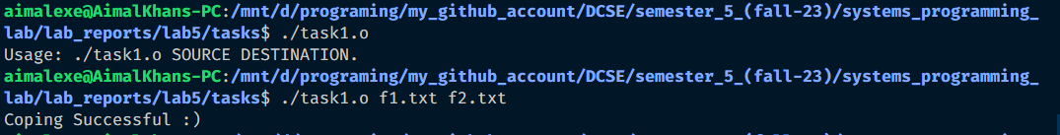

**Task 2**: Implement the **rm** command.

**Code in C:**

#*include* <stdlib.h>

#*include* <stdio.h>

#*include* <unistd.h>

#*include* <fcntl.h>

#*include* <errno.h>

#*include* <string.h>

#*include* <sys/stat.h>

int *main*(int argc, char *argv*[]*)

{

*if* (argc != 2)

    {

*fprintf*(*stderr*, "Usage: %s FILE_TO_DELETE.\n", argv[0]);

*return* 1;

    }

    int deleteFile = *unlink*(argv[1]);

*if* (deleteFile == -1)

    {

*fprintf*(*stderr*, "Something went wrong while deleting the file: %s due to %s\n", argv[1], *strerror*(*errno*));

*return* 1;

    }

*printf*("Removed Successfully :)\n");

*return* 0;

}

**Output:**

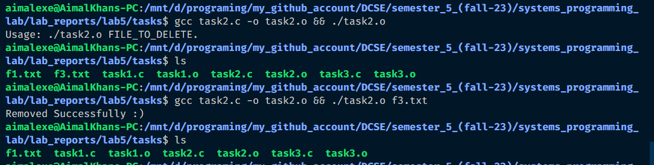

**Task 3**: Implement the **mv** command.

**Code in C:**

#*include* <stdlib.h>

#*include* <stdio.h>

#*include* <unistd.h>

#*include* <fcntl.h>

#*include* <errno.h>

#*include* <string.h>

#*include* <sys/stat.h>

#*include* "../../reusable_code_snippets/readWrite.h"

int *main*(int argc, char *argv*[]*)

{

*if* (argc != 3)

    {

*fprintf*(*stderr*, "Usage: %s SOURCE DESTINATION.\n", argv[0]);

*return* 1;

    }

*if* (*readWrite*(argv[1], argv[2]) < 0)

    {

*perror*("Something went wrong while reading or writing a file.\n");

*return* 1;

    }

    // *6. delete the source file*

    int removeSrc = *unlink*(argv[1]);

*if* (removeSrc == -1)

    {

*fprintf*(*stderr*, "Something went wrong while deleting the file: %s due to %s\n", argv[1], *strerror*(*errno*));

*return* 1;

    }

*printf*("Copied from SRC to DIST & SRC removed :)\n");

*return* 0;

}

**Output:**

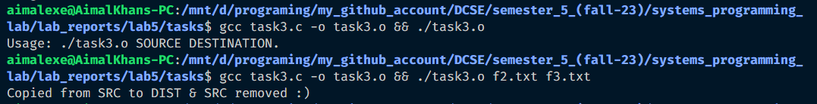

Reference:

To view my codes, please refer to my GitHub account:  [https://github.com/aimalexe/DCSE/tree/main/semester_5_(fall-23)/systems_programming_lab/lab_reports](%20https://github.com/aimalexe/DCSE/tree/main/semester_5_(fall-23)/systems_programming_lab/lab_reports) .

Conclusion:

In conclusion, I have learned in depth about these system calls like read, open, close, write, buffers, rm, cp mv and much more. Now I am able to use these in future projects.

The End.