**Unix Commands Overview**

**LAB # 01**



**Fall 2024**

**CSE-302L**

**Systems Programming Lab**

Submitted by: **Abdul Muqtadir**

Registration No.: **222PWCSE2186**

Class Section: **B**

“On my honor, as student of University of Engineering and Technology, I have neither given nor received unauthorized assistance on this academic work.”

Student Signature: ______________

Submitted to:

**Engr. Madiha Sher**

Department of Computer Systems Engineering

University of Engineering and Technology, Peshawar

**CSE 302L: SYSTEMS PROGRAMMING LAB**

**LAB ASSESSMENT RUBRICS**

|  |  |  |  |  |  |
| --- | --- | --- | --- | --- | --- |
| **Criteria & Point Assigned** | **Outstanding 2** | **Acceptable 1.5** | **Considerable 1** | **Below Expectations 0.5** | **Score** |
| **Attendance and**  **Attentiveness in Lab**  PLO08 | Attended in proper Time and attentive in Lab | Attended in proper Time but not attentive in Lab | Attended late but attentive in Lab | Attended late not attentive in Lab |  |
| **Capability of writing Program/Algorithm/Drawing Flow Chart**  PLO1, PLO2, PLO3, PLO5 | Right attempt/ no errors and well formatted | Right attempt/ no errors but not well formatted | Right attempt/ minor errors and not well formatted | Wrong attempt |  |
| **Result or Output/ Completion of target in Lab**  PLO9 | 100% target has been completed and well formatted. | 75% target has been completed and well formatted. | 50% target has been completed but not well formatted. | None of the outputs are correct. |  |
| **Overall, Knowledge**  PLO10, | Demonstrates excellent knowledge of lab | Demonstrates good knowledge of lab | Has partial idea about the Lab and procedure followed | Has poor idea about the Lab and procedure followed |  |
| **Attention to Lab Report**  PLO4, | Submission of Lab Report in Proper Time i.e., in next day of lab, with proper documentation. | Submission of Lab Report in proper time but not with proper documentation. | Late Submission with proper documentation. | Late Submission very poor documentation |  |

**Instructor:**

|  |  |
| --- | --- |
| Name: _________________________ | Signature: ________________________ |
|  |  |

**Unix Commands Overview**

Objectives:

We will learn about different commands of Linux for personal use. Editing, compiling, and executing the C programs.

Tasks:

**Task 1**: . In your home directory create the subdirectory ~/cse302/labs/lab1 . (Use multiple mkdir commands or consult the -p option for mkdir in the man page for mkdir).

1. cd ~/cse302/labs/lab1

2. Copy or create a file named myfile into ~/cse302/labs/lab1 (if you create it, type something into it). For information on how to create a quick empty file, man touch.

3. Create a soft link soft_link and a hard link hard_link to that file.

4. Based on the output returned by stat and ls commands (using all relevant options), explain in detail (but briefly) the differences between the three files.

**Output:**

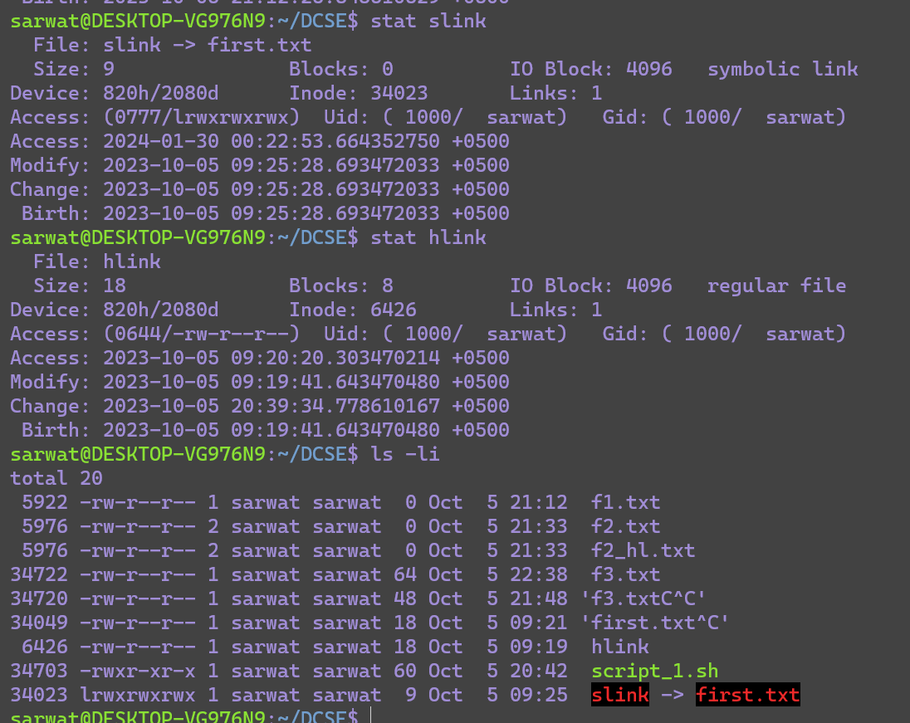

**Discussion and conclusion:**

hard links are multiple references to the same file with shared data blocks, while soft links are separate files that point to other files or directories by their paths.

**Task 2**: List the usernames and names of the people logged on the list returned should be sorted and should have the following format: 1 2 3 ... Hint: use the "nl" command to number lines

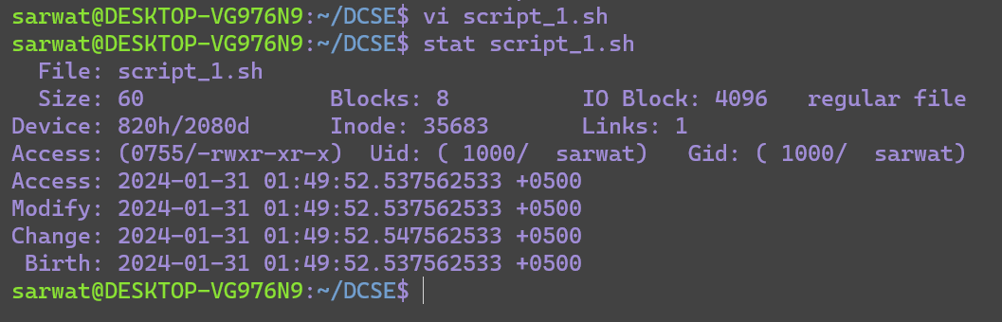

**Task3:**

Create a script and show how many usernames have logged in use pipelining, grep and who command also investigate wc in man.

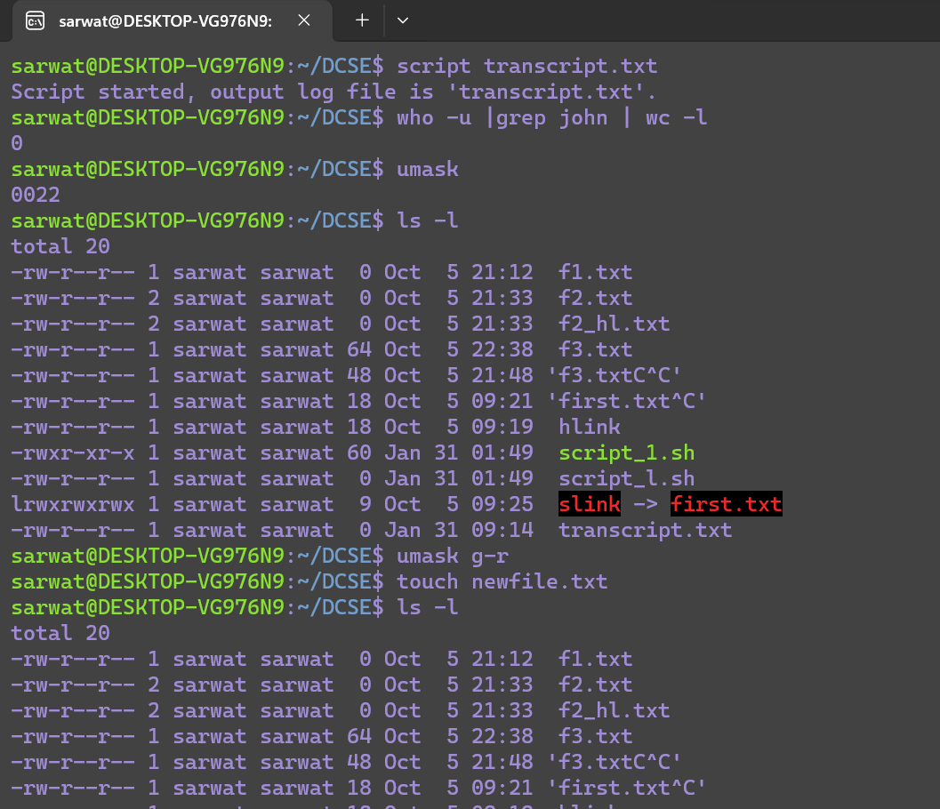

Conclusion:

In conclusion, I have learned about different linux commands its excuting and compiling.

The End.