Mohammad Mustafa Khalid
VR537699
AI_School_Verona
Academic Organization Ontology

1. Overview
The AI School Verona Ontology is designed to model the organizational and educational structure of a university department. It captures the hierarchy of individuals (Students and Staff), the distribution of academic subjects, and the specific relationships that define a university ecosystem, such as enrollment, teaching, and employment.
2. Ontology Architecture
The ontology is built using a hierarchical class structure, where University serves as the root concept.
2.1 Class Hierarchy
- University: The base class for all entities.
  - Person: Divided into Student (with subclasses like Masters_Student and PHD_Student) and Staff.
  - Staff: Further categorized into Academic and Administrative roles.
  - Course: Includes specific disciplines like CS, Software_Eng, and Business_Management.
  - Job: Defines roles such as Professor and Recruitment_Officer.
  - Department: Categorized into Informatica and Business.
2.2 Key Relationships (Object Properties)
The ontology defines how entities interact. Key properties include:
- admits: Connects University to Student.
- teaches: Connects Academic staff to Student.
- enrollsFor: Connects Student to Course.
- workAs: Connects Staff to a specific Job title.
2.3 Attributes (Data Properties)
Individuals in the system are described using specific data types:
- hasID_Number: A string identifier for all Person instances.
- ExperienceInYears: An integer tracking staff seniority.
- hasCredit: An integer representing a student's academic progress.
- joined_on: A dateTime stamp for student registration.

3. Implementation
The ontology includes several individuals to demonstrate its logic, specifically within the context of the AI School Verona instance.
Individual | Type | Key Associations
Alberto Castellini | Academic | Teaches Deep Learning; Has 20 years experience.
Matteo Cristani | Academic | Teaches NLP; Works as a Professor.
Carlo, Gautam, etc. | Student | Enrolled in CS; Have 36 credits each.
Deep Learning | Subject | Taught by Alberto Castellini.

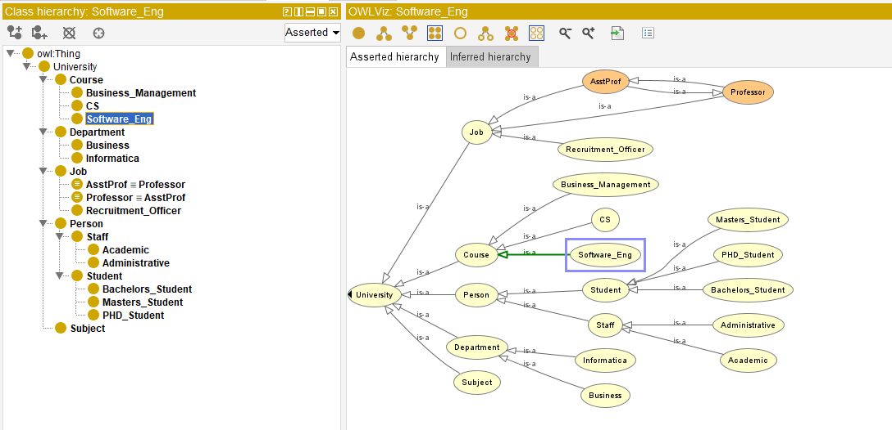
4. Logical Constraints & Features
- Inversion: The property enrollsFor is defined as its own inverse, suggesting a bidirectional relationship between students and courses.
- Equivalence: AsstProf is defined as an equivalentClass to Professor, allowing the reasoner to treat them as semantically identical.
- Domain & Range: Strict definitions ensure that only a University can employ a member of the Staff, maintaining data integrity.

5. Potential Use Cases
- Automated Reasoning: Using a reasoner (like HermiT or Pellet) to automatically classify students into Master's or PhD levels based on their credits or ID.
- Semantic Search: Querying the data with SPARQL to find all students taught by a specific professor with more than 15 years of experience.
- Knowledge Graph Integration: This ontology can serve as the schema for a larger knowledge graph representing the University of Verona's entire academic catalog

6. Conclusion:
The AI School Verona Ontology serves as a formal Knowledge Representation of a university’s academic and administrative domain. By utilizing OWL (Web Ontology Language), the model moves beyond simple data storage to create a machine understandable knowledge base where the relationships between individuals, like the teaching links between Alberto Castellini and students such as Gautam or Mustafa, are explicitly defined. The inclusion of inverse properties and equivalent classes (such as AsstProf and Professor) demonstrates how logic can be used to infer new knowledge without manual entry. Ultimately, this project illustrates how semantic technologies can bridge the gap between raw data and actionable institutional intelligence.

