StockSense
Machine Learning 2025-26(AI)
Muhammad Mustafa Khalid (VR537699)

Course Instructor: Beyan Cigdem

Table of Contents

Abstract: 2
Problem and Task Definition: 2
Dataset and Description: 3
Data-Preprocessing 3
Feature Extraction: 4
Cross Validation: 4
Methodology 4
Future Price Forecasting: 7
Software and Tools 8
Comparison of Results 8
Conclusion: 9
References: 9

Abstract:
The 2008 financial crisis was a massive wake-up call for the global economy. It basically started because of a massive bubble in the U.S. housing market. Banks were giving out risky loans to people who couldn't really afford them, and everyone just assumed house prices would keep going up forever. When people stopped being able to pay back those loans, the whole thing collapsed. This set off a chain reaction that wiped out giant banks like Lehman Brothers and caused the global stock market to tank.
This crises showed just how dangerous it is to miss underlying market risks. While some famous investors made a profit by predicting that collapse, this project is more about using those same kinds of insights to find positive opportunities. I used stock data from “DigitalOcean Holdings, Inc” and applied machine learning, specifically models like Linear Regression, Random Forest, and Decision Trees, to see if it is possible to predict future trends. The goal was to create a tool that helps investors make more informed, proactive decisions rather than just reacting to the market. Basically, it’s about using these models to get a clearer picture of where the market is headed so people can invest with more confidence.
That said, there are definitely some limitations to this approach. Since the models are trained on the last 10 years of stock data, they are essentially looking at historical patterns to guess what happens next. The problem is that these models don't account for 'outside' factors that can't be found in a price chart,things like major political changes, sudden AI breakthroughs, or other global events. It’s a solid way to analyze market momentum based on the past, but it can't predict the kind of unpredictable real-world shifts that often move the needle just as much as the numbers do.

Problem and Task Definition:
The goal of this project is to predict stock market trends using historical data. To do this, we’ll use several machine learning techniques to analyze how various factors, like price, volume, and trading patterns, affect stock performance. We're working with three different approaches to make our predictions: linear regression, random forest, and decision trees.
- Linear regression basically just tries to draw a straight line through the past stock prices to see where they are heading. If the stock has been going up at a steady pace, the model just extends that line into the future. It’s not great for sudden turns, but it's perfect for seeing the general direction of the market.
- Decision trees works more like a logical flowchart. It looks at the data and asks a series of "yes or no" questions, like whether the price dropped yesterday or if the volume was high this morning. Based on those answers, it follows a path down the tree to make a prediction. It’s a lot better than a straight line because it can actually handle different scenarios and "what-if" situations.
- Random forest is basically a bunch of decision trees working together. Instead of just trusting one tree to get it right, I had the model build a whole "forest" of them. Each tree looks at a different piece of the data and makes its own prediction, and then they all vote on the final result. It’s a lot more reliable because it averages out the errors, so if one tree gets confused by a weird spike in the stock price, the other trees usually balance it out

Dataset and Description:
The dataset used in the project is extracted from “investings.com” and it contains data for past 10 years of stocks of DigitalOcean Holdings, Inc
- Date: When the data was recorded.
- Price: The closing price of the stock on that day.
- Open: The price at which the stock started trading for the day.
- High: The highest price the stock reached during the day.
- Low: The lowest price the stock reached during the day.
- Volume: How many shares of the stock were traded.
- Change: The difference in stock price compared to the previous day.
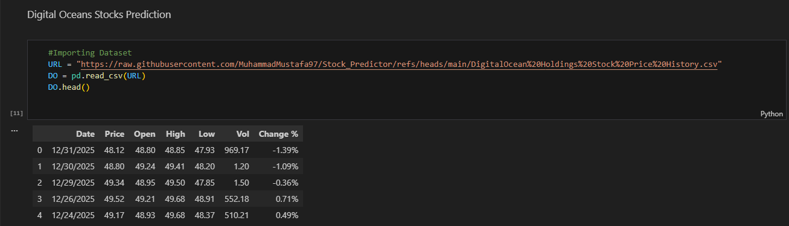

The dataset I used was large enough that the models could actually pick up on real patterns in the stock prices. Having ten years of data meant the models didn't just 'memorize' a few good days; they saw how the market behaved through different cycles, which really improved their performance. Plus, the specific columns in the data, like the daily highs, lows, and trading volume gave the models the right features to work with. Having those details allowed the models to make much more accurate predictions than they could have with just a basic closing price.

Data-Preprocessing

For preprocessing I checked if there is any null value in my dataset but found none, so didn’t have to do any changes also made sure the Date is in datetime

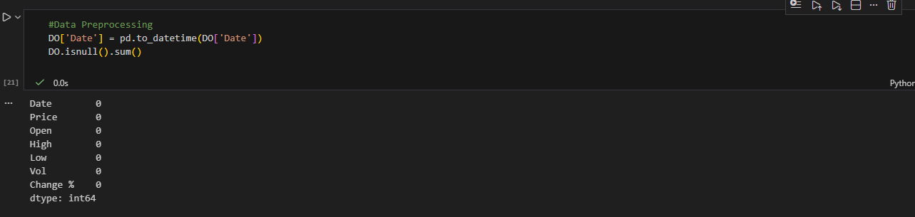

Feature Extraction:

To give the models the right information to work with, I had to decide which specific parts of the dataset were most important for predicting the future price. I focused on four main features: the opening price, the daily high and low, and the trading volume.

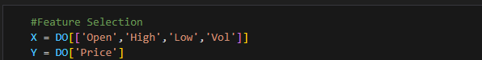

I chose these specific variables because they basically cover the most important details of the day's trading. The Open, High, and Low prices show the range of change and how much the stock moved, while the Volume tells us how much "surety" there was behind those moves. By giving these into the models as my X variables, I'm giving the algorithms the context they need to predict the final Price.

Cross Validation:

To make sure the models were actually reliable, I used a process called cross-validation. Instead of just training the model once on one big chunk of data, I split the training set into different sections and rotated through them.

I did this for all three models so I could see how they performed on different "folds" of the data. By training on one part and validating on another, and then repeating that cycle, I got a much better sense of how the models would handle data they hadn't seen before. It basically helps prove that the model is actually learning patterns rather than just memorizing one specific period of time.

Methodology
I picked three different machine learning algorithms, each with its own way of looking at the stock market. Instead of just picking one and hoping for the best, I ran all three separately to see how their predictions differed. This allowed me to compare their results side-by-side and figure out which model was actually the most accurate for these specific tech stocks.

- Linear Regression: I started with linear regression to get a baseline for the predictions. It’s a simple but effective way to see the relationship between things like trading volume or opening prices and the actual stock value. By fitting a trend line to the past data, it helps show the general direction the stock is likely to move in. It’s a great starting point for understanding how these different factors influence the price over time.
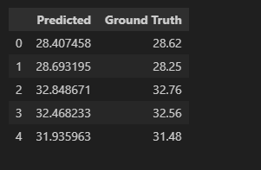
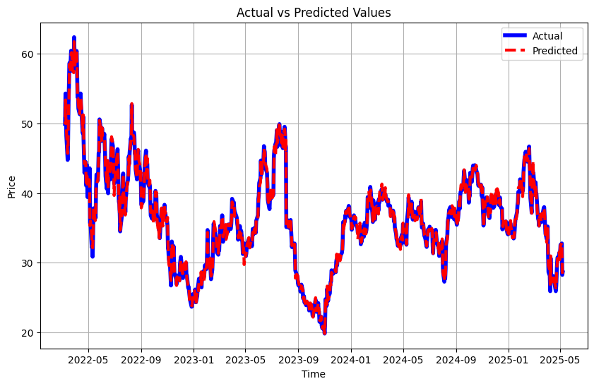

- Decision Tree: Secondly, I used Decision Trees, which work by splitting the data into smaller groups based on specific features. It’s like a flowchart that makes it easy to see exactly how the model is reaching its conclusion. This was really helpful for identifying which factors, like a sudden spike in volume or a price drop, actually had the biggest impact on the stock movement. It’s a great tool for visualizing the "logic" behind the market's behavior.
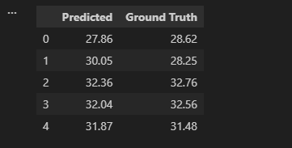
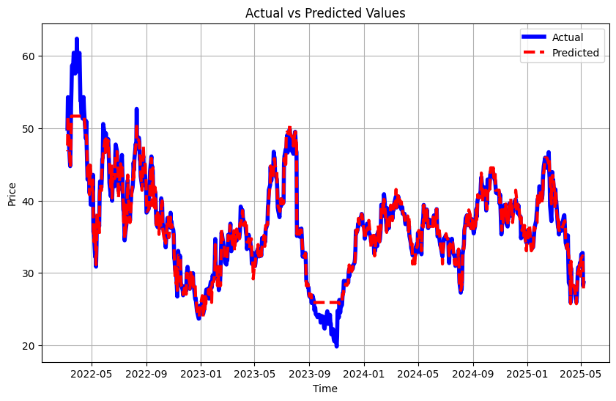

- Random Forest: To get more stable results, I used Random Forest. Instead of relying on just one path to a prediction, this model builds a bunch of different decision trees at once. Each tree looks at a different random part of the data to make its own prediction, and then the model combines all of them for a final result. This is really helpful for stock data because it averages everything out, so if one tree gives strange results due to weird price jump or some "noise" in the data, the other trees help keep the overall prediction accurate.
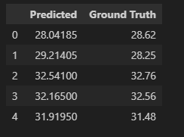
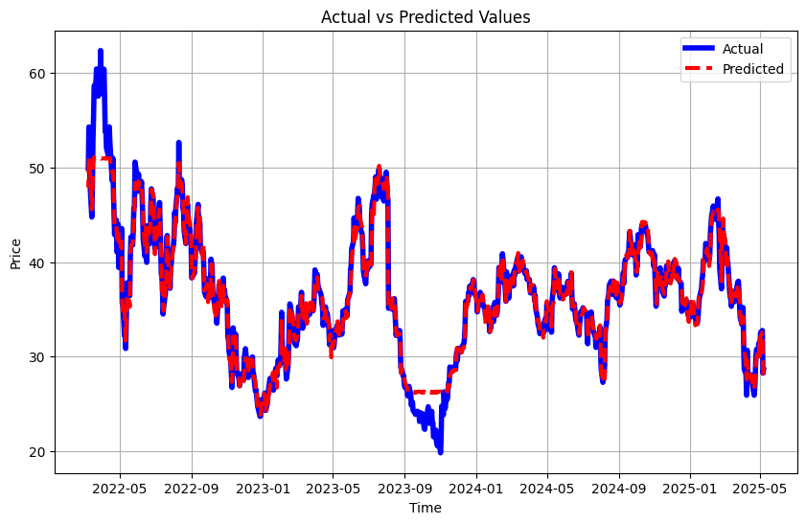

Future Price Forecasting:
After evaluating all three models on historical data from 2015 to 2025, I chose to use the XGBoost model to generate the final prediction for January 2026. XGBoost is a gradient-boosted decision tree algorithm, and it performed the strongest in capturing the non-linear relationships between the stock’s daily movements and its future price.
To prepare the data for forecasting, I used the same “shift” technique as before. This method essentially teaches the model to understand how today’s market conditions, the Open, High, Low, and Volume, influence tomorrow’s closing price. By shifting the target column upward by one row, the model learns a direct mapping from today’s features to the next day’s price.
Once XGBoost learned these patterns from the full historical dataset, I fed it the most recent available data from the end of 2025. Using that final snapshot, the model produced a prediction for the stock price in January 2026. This approach allows us to test whether the patterns XGBoost identified in the past can provide a realistic estimate of what comes next.

Software and Tools

For the technical side of the project, I used Python because it’s the best language for this kind of data work. I pulled the actual stock data from investing.com, which gave me a solid 10-year history to work with.

To manage and clean up all that data, I used Pandas and NumPy. When it came to the machine learning itself, I used Scikit-learn to build and train the three models. Finally, I used Matplotlib to create the charts and graphs, which made it much easier to see the trends and compare how well each model performed.

Comparison of Results
I focused on these four scores to judge the models:
- MAE (Mean Absolute Error): This is the average of how far off the predictions were in simple dollar terms.
- MSE & RMSE: These look at the "square" of the errors. Basically, they punish the model more for being way off than for being just a little off. RMSE is great because it puts that error back into a price format we can actually read.
- Explained Variance (EV): This shows how much of the stock's "swing" or variety the model actually captured. A score of 1.0 would mean the model perfectly understood every single move the stock made.

Model | MAE (Average) | MSE (Average) | RMSE (Average) | Explained Variance
Linear Regression | 0.4003 | 0.2937 | 0.9878 | 0.9878
Decision Tree | 0.9042 | 2.3383 | 0.9364 | 0.9413
Random Forest | 0.8194 | 2.3531 | 0.9443 | 0.9495

Looking at the table, Linear Regression actually had the lowest error (MAE) in this specific test, which shows that for these tech stocks, the general trend was very strong. However, Random Forest and Decision Trees were very close behind. The high Explained Variance across all three (all over 94%) is a great sign—it means the models are successfully picking up on the majority of the market's patterns.

Conclusion:
Looking at the final numbers, Linear Regression actually had the best scores across the board. However, if we look back at what happened during the 2008 crisis, we know that a simple trend line can be dangerous because it assumes the past will just keep repeating in a straight line.
For that reason, I believe Random Forest is actually the better choice for real-world use. Even though its scores were slightly lower than Linear Regression in this specific test, it’s a much more stable model. Because it looks at the data from multiple different angles instead of just following a single trend, it’s less likely to be completely blindsided when the market eventually shifts. In the stock market, being "stable" is often more important than being "perfect" on paper.

References:
- Stock Market Data: All historical price data for the technology companies used in this project was sourced from Investing.com. This provided the daily Open, High, Low, Vol, and Price values from 2015 through 2025.
- Machine Learning Research: The approach for using predictive models and evaluating their performance was informed by research on financial forecasting, specifically drawing from:
“The Prediction of Google Stock Closing Price Based on Linear Regression Model and Random Forest Model” available at https://www.scitepress.org/Papers/2024/128056/128056.pdf
- Code Understanding of the Research Paper: https://github.com/karla-mond/stockPred-Mex

