NATIONAL UNIVERSITY OF SCIENCES AND TECHNOLOGY
School of Electrical Engineering and Computer Science
CS-250: Data Structures and Algorithms
Laboratory Report — Experiment No. 02
Dynamic Memory Allocation with Git and Unit Testing

Student Name | Muhammad Muthar
Registration No. | 540395
Class | BESE-16A
Semester | Fall 2026 — 3rd Semester
Instructor | Dr Faisal Shafait
Lab Engineer | Hamza Fayyaz
Date | 18 September 2026
GitHub Repository | MuhammadMuthar/DSA-Lab-2

Objectives
- Understand the difference between stack and heap memory in C++.
- Learn how to allocate and deallocate memory dynamically using new and delete.
- Practice version control using GitHub (init, clone, add, commit, push, pull, branch, merge).
- Learn to write basic unit tests to verify correctness of C++ functions.
- Integrate coding, testing, and version control into a complete workflow.

TASK 1 — GitHub Account & Repository Setup
A public repository named DSA-Lab2 was created on GitHub, cloned locally, and configured with the student's Git identity. A starter program (hello.cpp) was added, compiled, and pushed to the main branch to confirm the workflow end-to-end.
Commands Used

git init
cd DSA-Lab2

g++ hello.cpp -o hello
./hello

git add hello.cpp
git commit -m "Add hello.cpp starter program"
git push origin main

Screenshot — Repository Created on GitHub
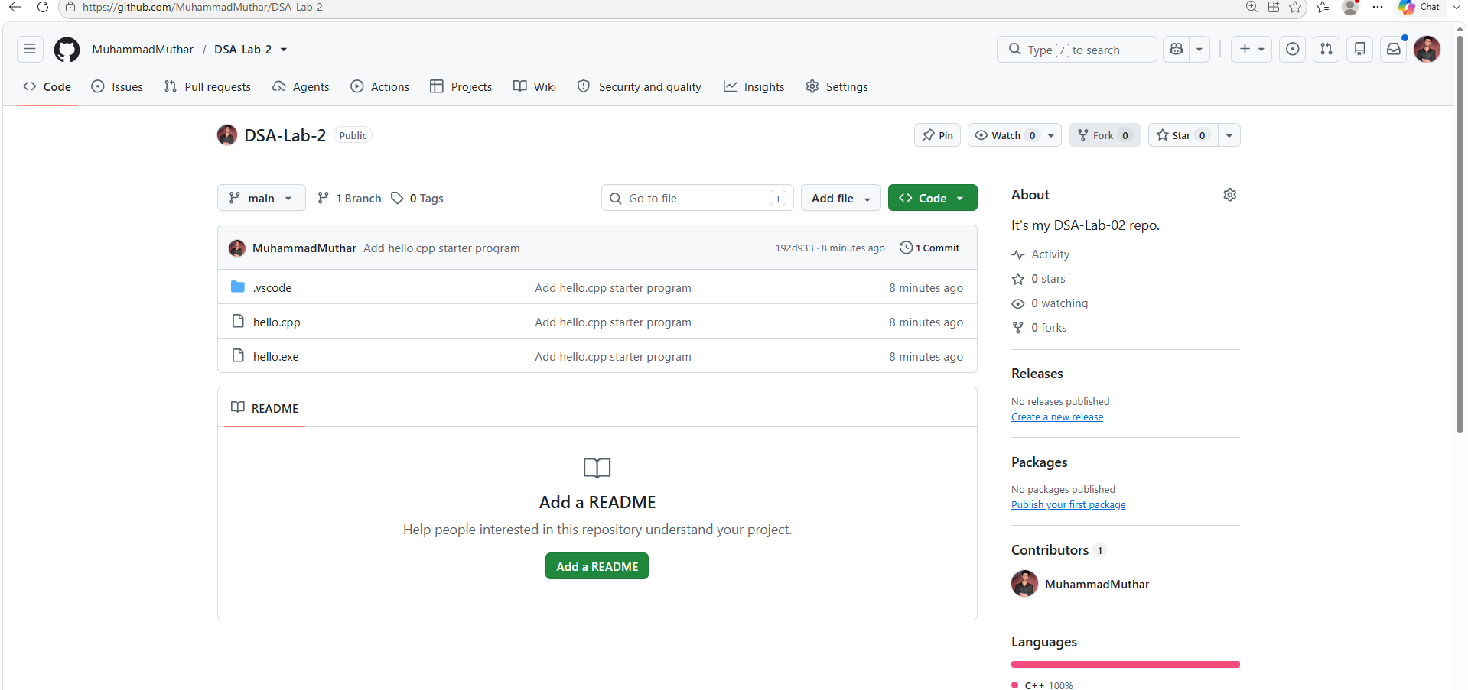
Screenshot — hello.cpp Compiled and Run
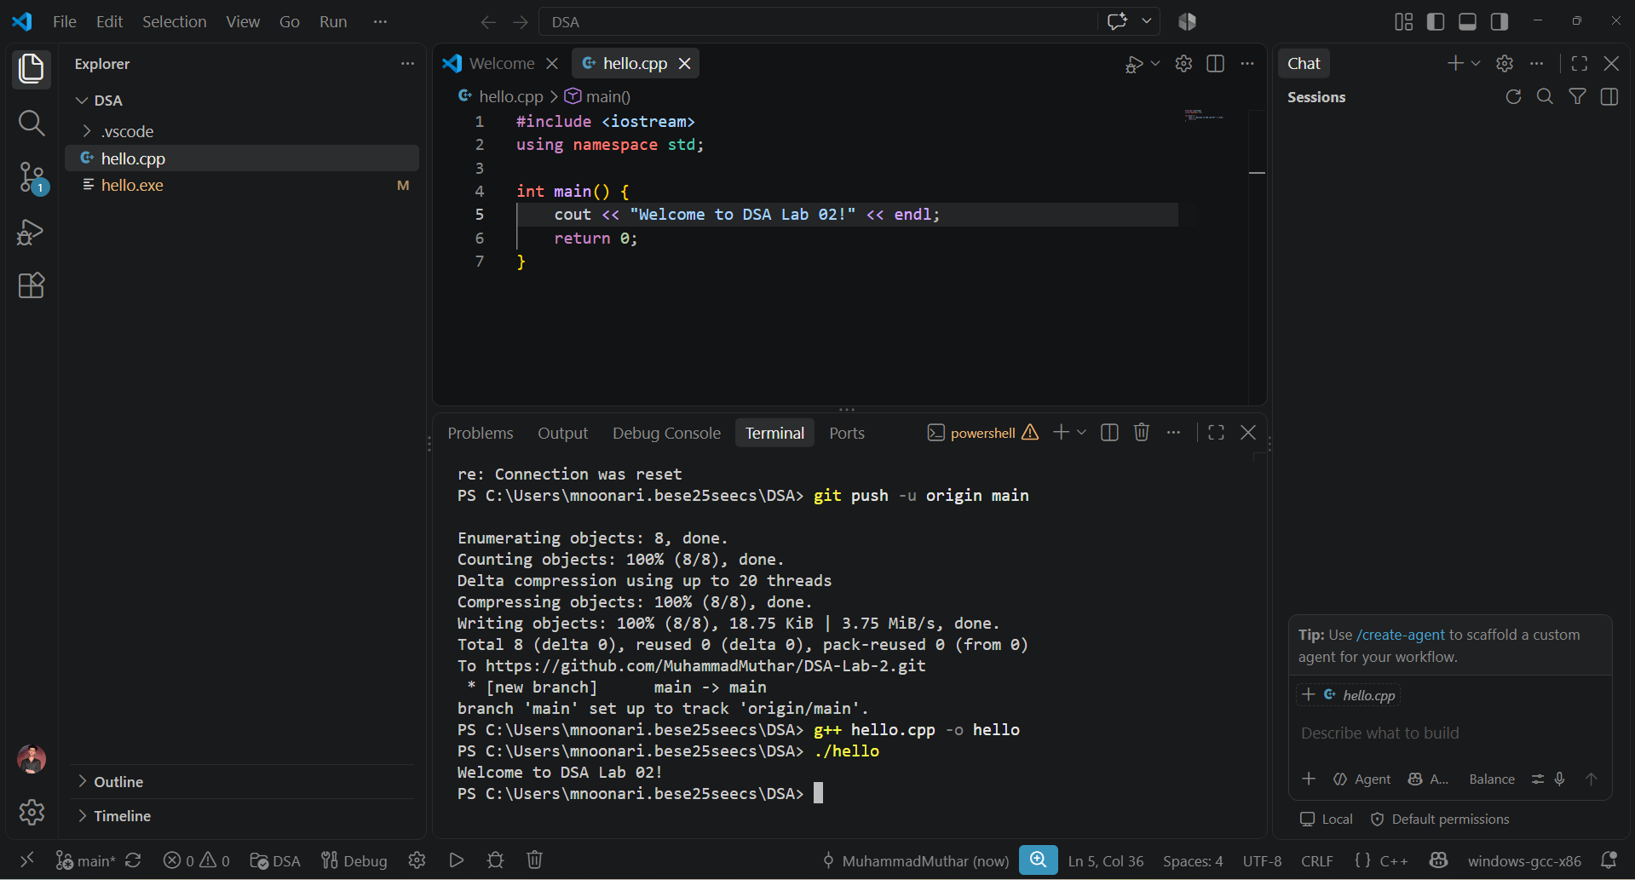
Screenshot — Commit to GitHub
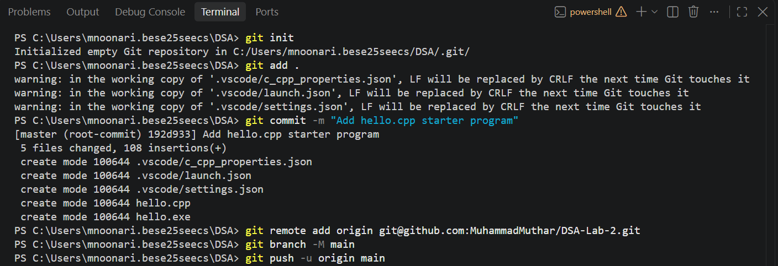
Screenshot — Pushed to GitHub
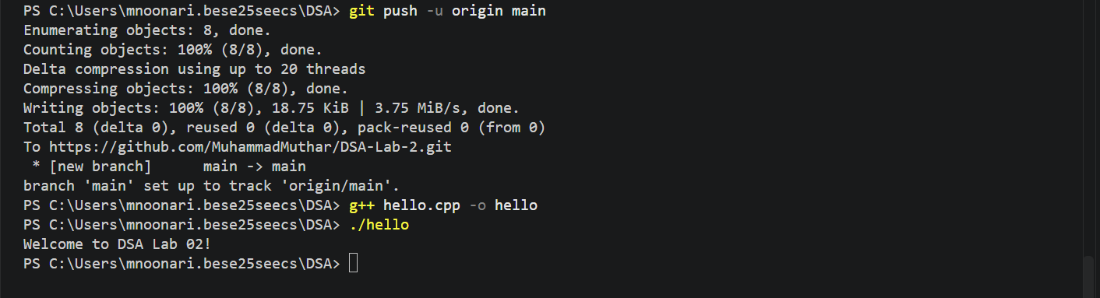
TASK 2 — Dynamic Salary Program with Git Workflow
The original program used a fixed-size stack array (int salArray[size]) to store and update employee salaries. It was rewritten in salary.cpp to use a pointer with dynamic heap allocation, so the number of employees can be decided at runtime instead of being a compile-time constant.
salary.cpp
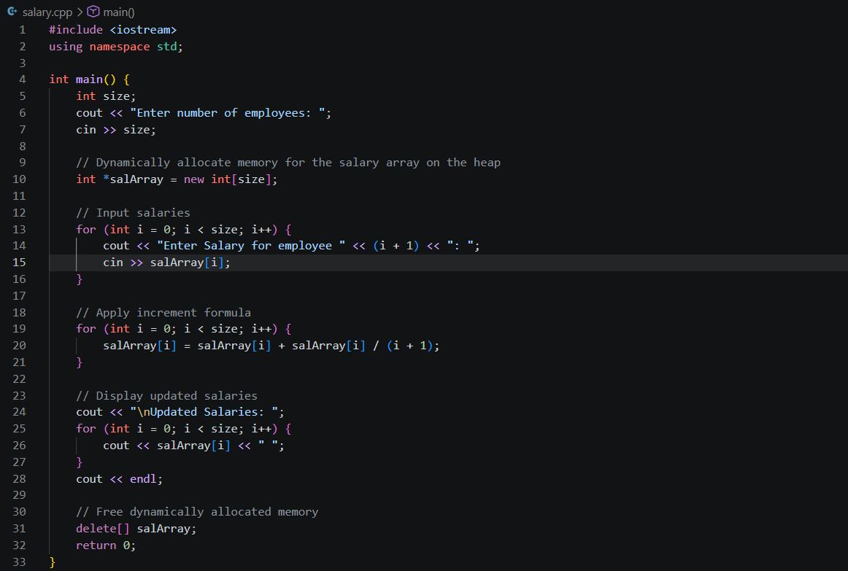

Sample Output
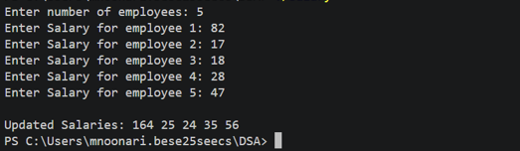

Screenshot — Program Output
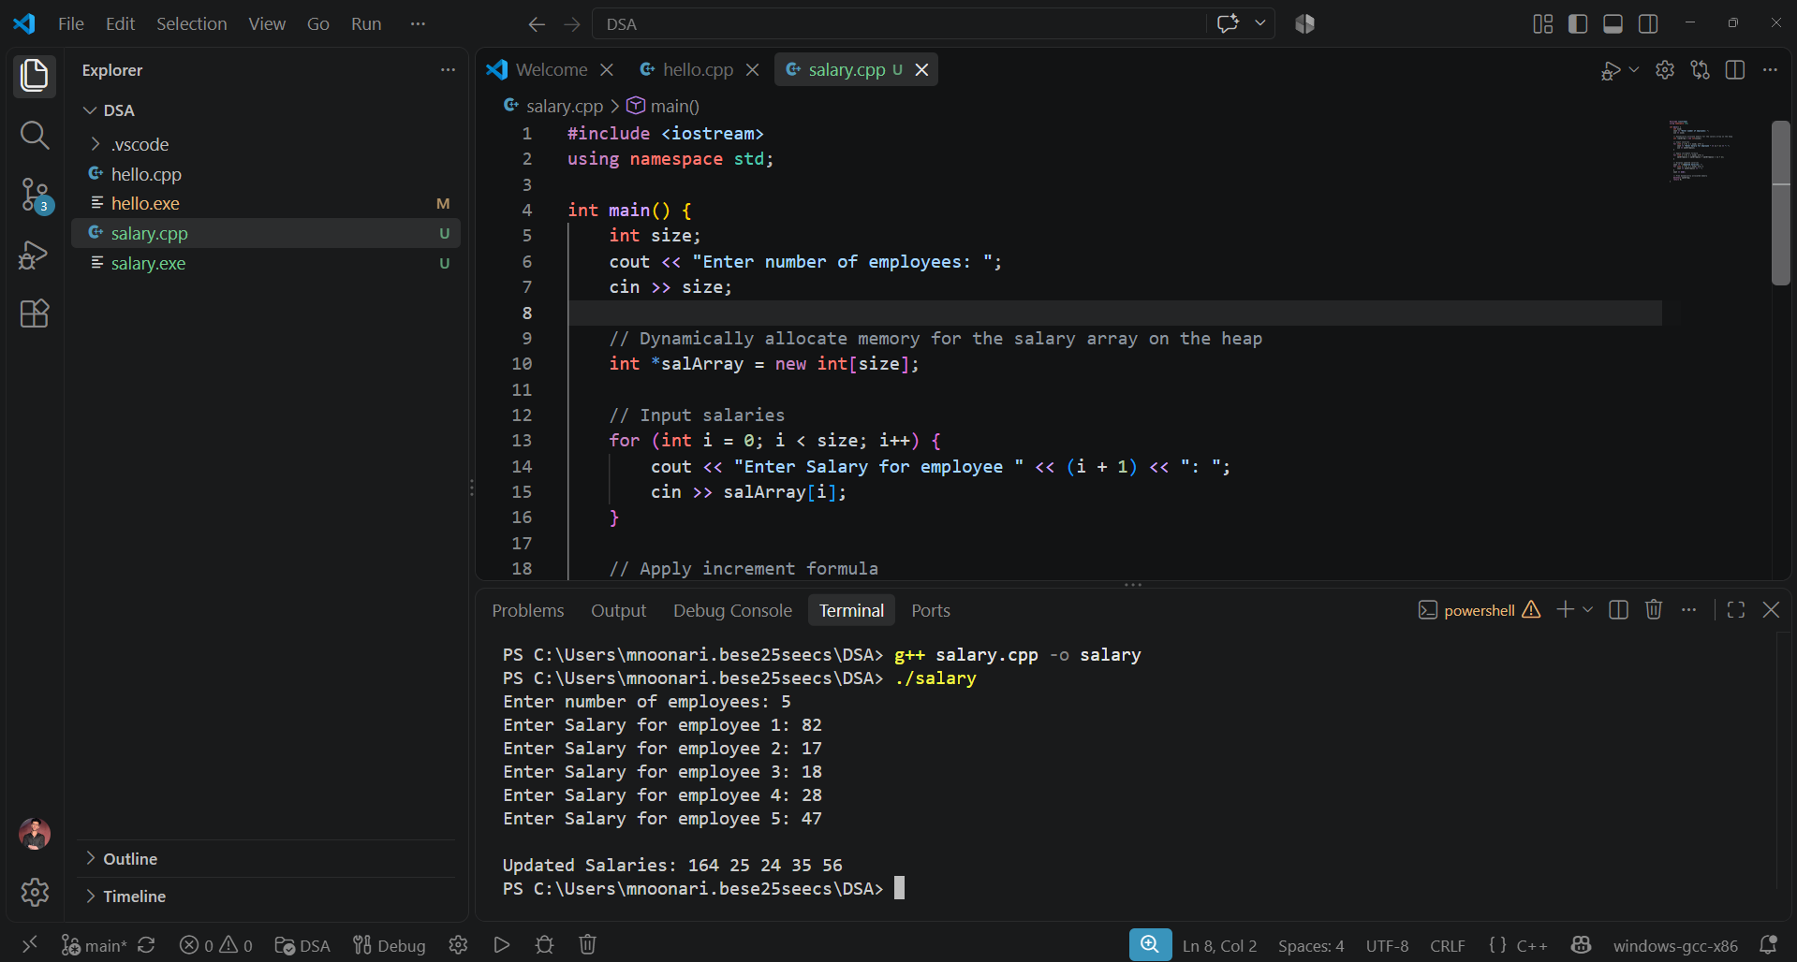
Screenshot — Commit Pushed to GitHub
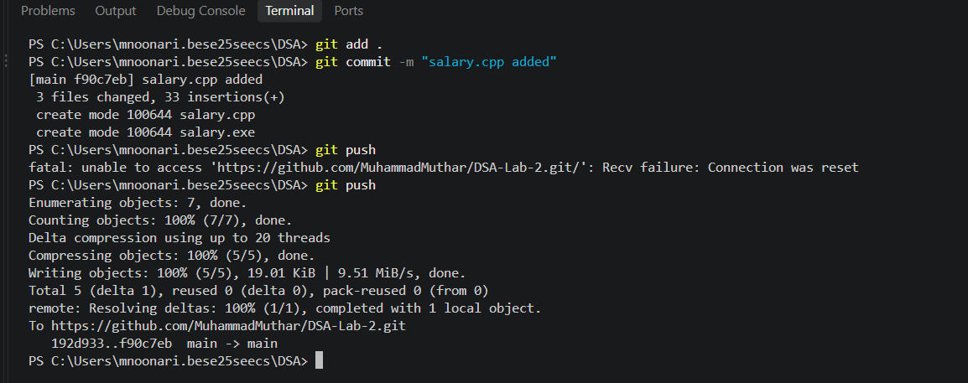
TASK 3 — Analyze Pointer Program with Git Workflow
The analyze_pointer() function accepts an int pointer and prints both the memory address it holds and the value stored at that address. It is then used with an integer allocated on the stack and one allocated on the heap, to compare the two.
analyze_pointer.cpp
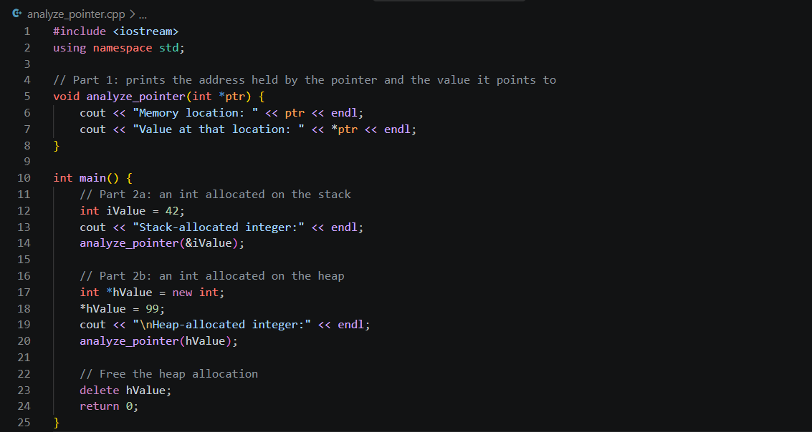

Sample Output
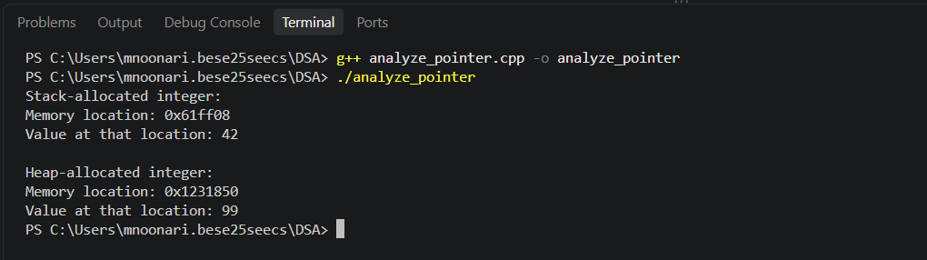

Note: the exact addresses printed will differ on every run — the stack address and heap address will always fall in visibly different ranges, which is the point of this comparison.

Git Workflow
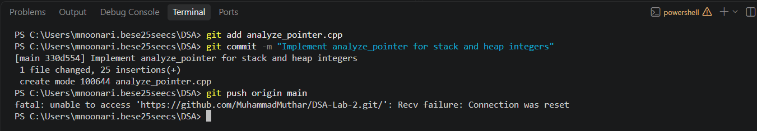

TASK 4 — Dynamic String Reversal with Git Workflow
string_reverse.cpp dynamically allocates a character buffer sized to the user's input, reads a line of text into it, builds a second dynamically-allocated buffer holding the characters in reverse order, prints both strings, and frees both buffers before exiting.
string_reverse.cpp

#include <iostream>
#include <cstring>
using namespace std;

int main() {
int len;
cout << "Enter the maximum length of your string: ";
cin >> len;
cin.ignore(); // discard the leftover newline before getline

// Dynamically allocate memory for the input string
char *str = new char[len + 1];
cout << "Enter a string (up to " << len << " characters): ";
cin.getline(str, len + 1);

int actualLen = strlen(str);

// Dynamically allocate memory for the reversed string
char *reversed = new char[actualLen + 1];
for (int i = 0; i < actualLen; i++) {
reversed[i] = str[actualLen - 1 - i];
}
reversed[actualLen] = '\0';

cout << "Original string: " << str << endl;
cout << "Reversed string: " << reversed << endl;

// Free dynamically allocated memory
delete[] str;
delete[] reversed;
return 0;
}

Sample Output

Enter the maximum length of your string: 20
Enter a string (up to 20 characters): NUST SEECS
Original string: NUST SEECS
Reversed string: SCEES TSUN

Git Workflow

git add string_reverse.cpp
git commit -m "Implement dynamic string reversal"
git push origin main

Screenshot — Program Output
📷 Insert screenshot of string_reverse.cpp running in the terminal

Screenshot — Commit Pushed to GitHub
📷 Insert screenshot of the string_reverse.cpp commit on GitHub

TASK 5 — Test-Driven Development — Checking a Sorted Array
This task follows the TDD cycle: write the tests first, watch them fail against an incomplete implementation, then modify the implementation until every test passes.

Part 1 — Tests Written First
The following test functions were written using assert() before isSorted() was implemented. Each targets a specific case called for in the lab manual, plus two additional edge cases.
test_isSorted.cpp

#include <iostream>
#include <cassert>
using namespace std;

bool isSorted(const int* arr, const int size); // declared, not yet implemented

void testSortedArray() {
int arr[] = {1, 2, 3, 4, 5};
assert(isSorted(arr, 5) == true);
}

void testUnsortedArray() {
int arr[] = {1, 4, 3, 5, 6};
assert(isSorted(arr, 5) == false);
}

void testDuplicateValues() {
int arr[] = {1, 2, 2, 3, 5};
assert(isSorted(arr, 5) == true);
}

void testSingleElement() {
int arr[] = {7};
assert(isSorted(arr, 1) == true);
}

void testDescendingArray() {
int arr[] = {5, 4, 3, 2, 1};
assert(isSorted(arr, 5) == false);
}

void testNegativeValues() {
int arr[] = {-5, -3, -1, 0, 2};
assert(isSorted(arr, 5) == true);
}

// Additional test 1: an empty array is vacuously sorted
void testEmptyArray() {
int arr[] = {};
assert(isSorted(arr, 0) == true);
}

// Additional test 2: all elements equal counts as non-decreasing
void testAllEqualElements() {
int arr[] = {4, 4, 4, 4};
assert(isSorted(arr, 4) == true);
}

int main() {
testSortedArray();
testUnsortedArray();
testDuplicateValues();
testSingleElement();
testDescendingArray();
testNegativeValues();
testEmptyArray();
testAllEqualElements();

cout << "All tests passed!" << endl;
return 0;
}

Part 2 — Implementing isSorted()
An initial version of isSorted() was written to make the tests compile and run. It compares each element with its neighbour and returns false as soon as a decrease is found.
First attempt (fails one test)

bool isSorted(const int* arr, const int size) {
for (int i = 0; i < size; i++) { // BUG: should stop at size - 1
if (arr[i] > arr[i + 1]) {
return false;
}
}
return true;
}

Final, corrected version

bool isSorted(const int* arr, const int size) {
for (int i = 0; i < size - 1; i++) {
if (arr[i] > arr[i + 1]) {
return false;
}
}
return true;
}

Part 3 — Demonstrating the TDD Cycle
Write Test → Run Test → Test Fails → Modify Code → Run Test Again → Test Passes

Step | Detail
Test written | testSingleElement — asserts isSorted({7}, 1) == true
Initial result | Fail (undefined/incorrect behavior)
Why it failed | The first version of isSorted() looped with the condition i < size instead of i < size - 1. For a single-element array this compared arr[0] with arr[1], reading one element past the end of the array — an out-of-bounds access that produced an unreliable result.
Modification made | Changed the loop bound from i < size to i < size - 1, so the last valid comparison is between arr[size-2] and arr[size-1].
Result after fix | Pass — testSingleElement, and all other test cases, now pass consistently.

Final results across all test cases, after the fix:
Test Case | Description | Result
testSortedArray | Ascending array {1,2,3,4,5} | Pass
testUnsortedArray | Out-of-order array {1,4,3,5,6} | Pass
testDuplicateValues | Ascending with duplicates {1,2,2,3,5} | Pass
testSingleElement | Single-element array {7} | Pass (after fix)
testDescendingArray | Descending array {5,4,3,2,1} | Pass
testNegativeValues | Mixed negative/positive {-5,-3,-1,0,2} | Pass
testEmptyArray | Zero-length array (vacuously sorted) | Pass
testAllEqualElements | All elements equal {4,4,4,4} | Pass

Screenshot — Failing Test (Before Fix)
📷 Insert screenshot of the assertion failure / terminal crash for testSingleElement

Screenshot — All Tests Passing (After Fix)
📷 Insert screenshot of terminal showing "All tests passed!"

Part 4 — Git Workflow
The commit history below shows the tests being written and committed before the implementation, followed by the fix once the failing test was diagnosed.

git add test_isSorted.cpp
git commit -m "Add initial tests for isSorted function"

git add isSorted.cpp
git commit -m "Implement isSorted function"

git add test_isSorted.cpp
git commit -m "Add edge case tests for isSorted"

git add isSorted.cpp
git commit -m "Handle additional edge cases"

git push origin main

Screenshot — Commit History on GitHub
📷 Insert screenshot of the commit history showing tests before implementation

Conclusion
This lab reinforced the practical difference between stack and heap memory in C++ and demonstrated how new and delete give a program control over memory allocated at runtime rather than at compile time. Rewriting the salary program with a pointer, analyzing stack versus heap addresses, and building a dynamically-sized string reversal all required careful pairing of every new with a matching delete or delete[] to avoid memory leaks.
The isSorted() task additionally demonstrated Test-Driven Development: writing tests before the implementation surfaced an off-by-one boundary bug that a single common-case test would have missed, and the fix was driven directly by the failing edge case rather than by guesswork. Throughout, Git commits were used to record the professional workflow of staging, committing, and pushing incremental progress to a shared repository.

