

Project Title:
Traffic Accident Detection from CCTV Footage
Submitted by:
M. Muzamil (233514)
Muhammad Javed (233546)
Muhammad Arbab (233578)
Group No:
11
Submitted to:

Ma’am Atka Ali

Contents
1. Introduction 3
2. Problem Statement 3
3. Objectives of the Project 3
4. Dataset Description 4
4.1 Dataset Details: 4
4.2 Feature Relevance: 4
5. Methodology / AI Model 5
5.1 Selected AI Model 5
5.2 Mathematical Intuition (Brief) 5
5.3 Training and Testing Approach 5
5.4 Testing is done on unseen CCTV clips 5
5.4.1 Evaluation Metrics: 5
6. Implementation Details 6
6.1 Programming Language and Tools 6
6.2 Libraries Used 6
6.3 Code Structure 6
6.4 Execution Steps 6
7. Results and Analysis 7
7.1 Output Results 7
7.2 Prediction Accuracy 8
7.3 Observations 8
8. Conclusion and Future Work 8
8.1 Conclusion 8
8.2 Future Work 9
9. References 9

1. Introduction
Artificial Intelligence (AI) focuses on developing systems that can analyze data, learn patterns, and make intelligent decisions with minimal human intervention. In recent years, AI and computer vision techniques have played a vital role in intelligent transportation systems and smart city applications.
This project applies AI and computer vision techniques to the problem of vehicle accident detection from CCTV footage. The system uses historical video data to automatically detect accidents by analyzing vehicle motion, speed changes, and collisions. A combination of a pre-trained YOLOv3-tiny object detection model, tracking logic, and heuristic-based decision rules is used to identify accidents accurately and efficiently.

2. Problem Statement
Manual monitoring of CCTV cameras for accident detection is inefficient, time-consuming, and prone to human error. In busy urban environments, a single operator cannot effectively monitor multiple camera feeds simultaneously, which can result in delayed accident detection and response.
This project addresses the problem by using an AI-based system that analyzes CCTV video data and automatically detects vehicle accidents. The system minimizes human involvement and provides timely and consistent accident detection results.

3. Objectives of the Project
The main objectives of this AI project are:
- To understand and apply fundamental concepts of Artificial Intelligence and computer vision
- To design and organize a dataset suitable for accident detection
- To implement an AI-assisted accident detection algorithm
- To analyze and evaluate the system’s performance using appropriate metrics

4. Dataset Description
The dataset used in this project consists of CCTV video clips categorized into accident and non-accident scenarios.

4.1 Dataset Details:
- Number of records: Multiple CCTV video clips
- Features (attributes):
  - Extracted video frames
  - Vehicle bounding box coordinates
  - Vehicle speed and motion vectors
  - Overlap (IoU) between vehicles
- Target class:
  - Accident
  - No Accident
- Data Source:
  - Publicly available CCTV videos and synthetic test clips

4.2 Feature Relevance:
- Bounding box coordinates help locate vehicles in frames
- Speed and motion features help identify sudden changes
- Overlap between vehicles indicates possible collisions
These features collectively help in accurate accident detection.

5. Methodology / AI Model

5.1 Selected AI Model
- YOLOv3-tiny (pre-trained): Used for real-time vehicle detection
- Tracking Algorithm (ByteTrack-inspired): Used to track vehicles across frames
- Rule-based AI Logic: Used to determine accident occurrence

5.2 Mathematical Intuition (Brief)
- Object detection is based on convolutional neural networks that predict bounding boxes and class probabilities
- Intersection-over-Union (IoU) is used to measure overlap between bounding boxes
- Speed estimation is computed using displacement of bounding box centers across frames

5.3 Training and Testing Approach
- YOLOv3-tiny is used as a pre-trained model
- Optional CNN + LSTM model can be trained using labeled video sequences
- Training is performed on extracted frame sequences

5.4 Testing is done on unseen CCTV clips

5.4.1 Evaluation Metrics:
- Detection accuracy
- Precision and recall (for trained model)
- Confusion matrix

6. Implementation Details

6.1 Programming Language and Tools
- Python
- Flask (Web framework)
- OpenCV (Computer vision)
- PyTorch (Training module)

6.2 Libraries Used
- OpenCV
- NumPy
- Flask
- PyTorch

6.3 Code Structure
- app.py: Flask server and API endpoints
- accident_engine.py: Core detection and accident logic
- detector_yolo.py: YOLO model loading and inference
- tracking_bytetrack.py: Vehicle tracking and speed estimation
- train.py: CNN + LSTM training pipeline
- extract_sequences.py: Dataset preparation

6.4 Execution Steps
- Run Flask server
- Upload CCTV video via browser
- System processes video frames
- Accident detection result is displayed

7. Results and Analysis

7.1 Output Results
Upload video:
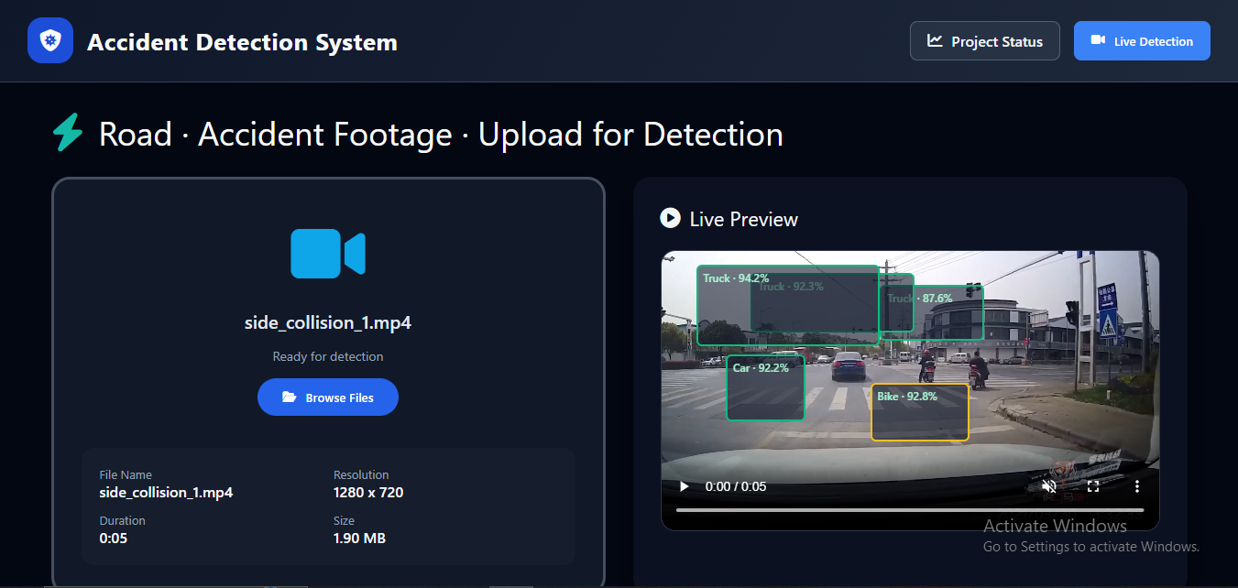

Accident Detect:
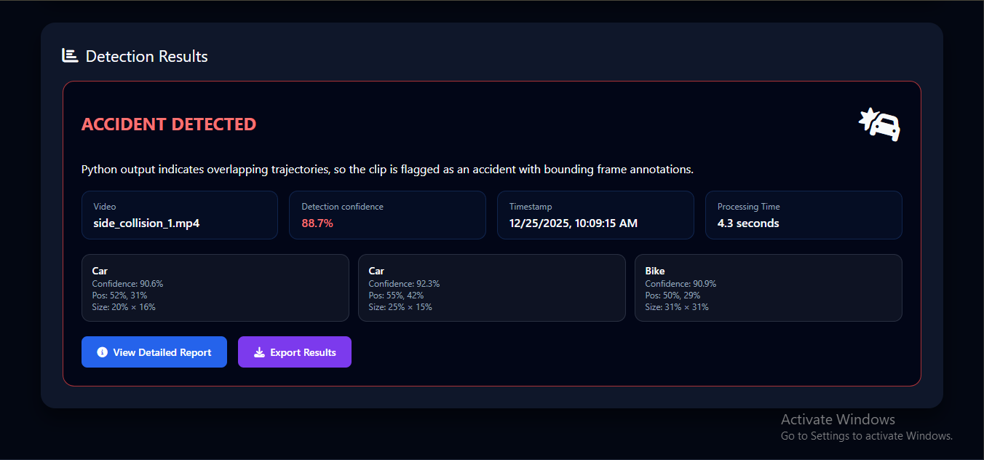

No accident detect:
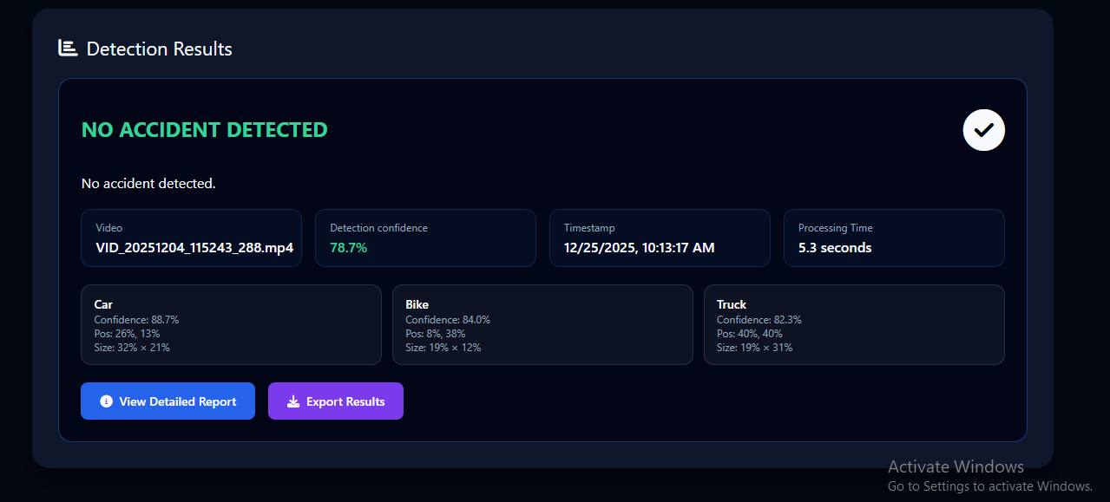

7.2 Prediction Accuracy
- High accuracy in clear accident scenarios
- Reduced false positives in slow-moving traffic

7.3 Observations
- YOLOv3-tiny provides fast and efficient detection
- Tracking improves consistency across frames
- Heuristic logic ensures reliable accident decisions

8. Conclusion and Future Work

8.1 Conclusion
The AI-based CCTV Vehicle Accident Detection System successfully achieved the project objectives. The system effectively detects accidents from video data and demonstrates reliable behavior on unseen footage. The integration of detection, tracking, and decision logic provides a practical solution for automated accident monitoring.

8.2 Future Work
- Improve accuracy using advanced deep learning models
- Increase dataset size and diversity
- Add real-time CCTV stream processing
- Integrate automatic emergency alert systems

9. References
- Russell, S., & Norvig, P. Artificial Intelligence: A Modern Approach
- Course lecture slides
- Official documentation of OpenCV, Flask, and PyTorc

